Object-based Land Cover Classification
with Deep Learning Framework
Yifang Ban, PhD, Professor
KTH-Royal Institute of Technology
Objective:
The purpose of this tutorial is to implement an object-based land cover classification using deep learning technique such as Convolutional Neural Networks (CNN). You will be introduced an image segmentation method named SLIC, and how to use Tensorflow to conduct CNN-based image classification and how to visualize data and network architecture with TensorBoard. At the completion of the tutorial, you will be able to classify remote sensing images with deep learning and conduct accuracy assessment.
(Note: It is recommended to run “Step0_Data_Preparation.py” in advance, because the data sampling procedure may take 25min.)
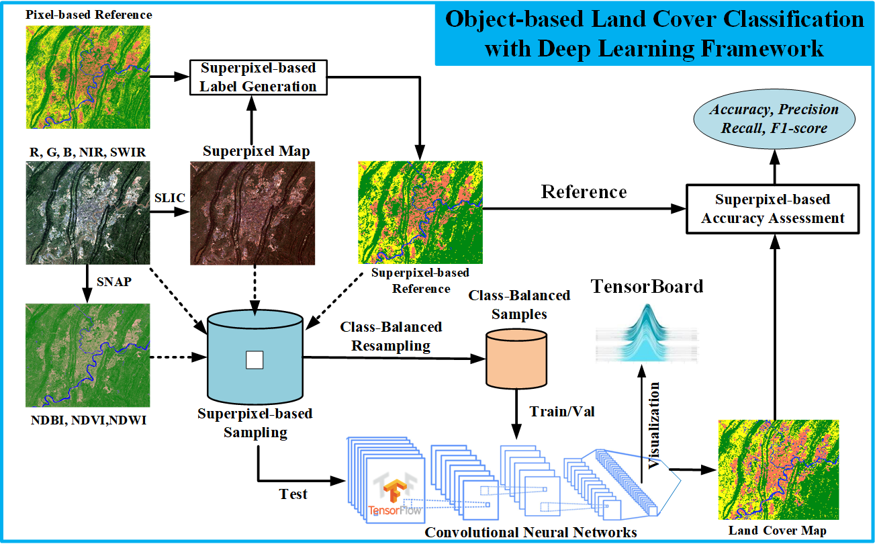
- Check Environment and Run code “Step0_Data_Preparation.py”
Open pyCharm, and click the Terminal, find and set your work path with “cd dataPath”.
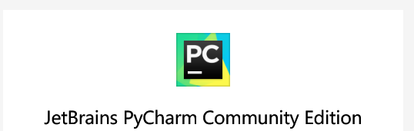 (wechat group)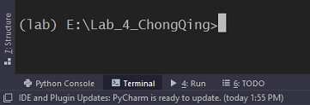
List all conda environment with “conda list env”, and then select the lab environment and activate it with “conda activate lab”, then check tensorflow version as follows.
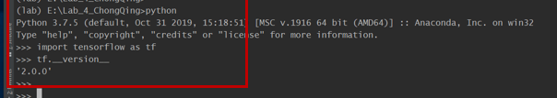
Find the path that stores data and codes, use pyCharm to open this directory. Double-click “Step0_..._.py”, select python.exe belongs to environment lab, then run with
by right clicking mouse, and the code can automatically obtain its current working directory with os.getcwd().
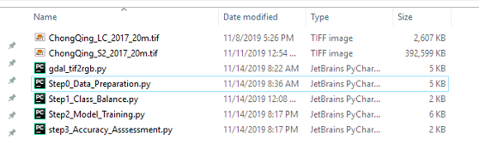
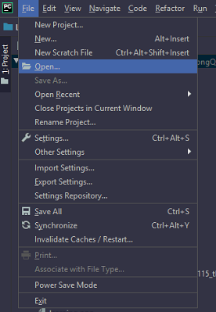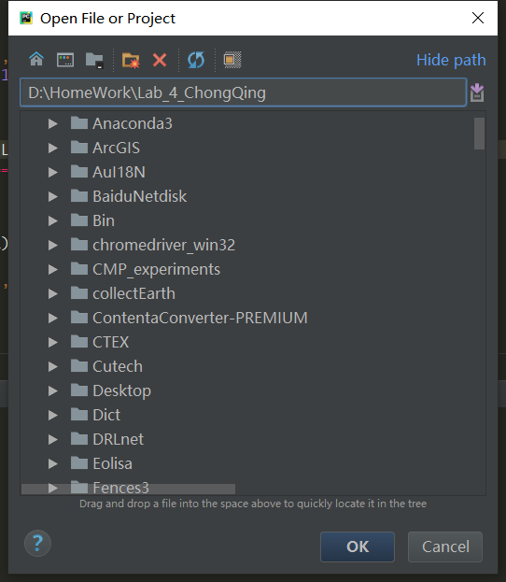
1. Sentinel-2 Multispectral Data Visualization using Spectral Indexes
This are two image files in “.tif” format:
- “ChongQing_S2_2017_20m.tif” is the mosiaced Sentienl-2 image mosaic containing five bands (Red, Green, Blue, NIR and SWIR) and three spectral indexes including NDVI, NDWI and NDBI (see Table 1)
Band_1 | Band_2 | Band_3 | Band_4 | Band_5 | Band_6 | Band_7 | Band_8
Blue | Green | Red | NIR | SWIR | NDVI | NDWI | NDBI
Table 1: Bands contained in “ChongQing_S2_2017_20m.tif”

- “ChongQing_LC_2017_20m.tif” is the reference land cover types including urban, vegetation, crop ad water.

1.1 Check Sentienl-2 Data with SNAP
- When you load the S2 data in SNAP, you will see 8 bands; double click one of these bands to visualize the corresponding grey scale image in the main window and its histogram in the lower left window (see Fig 1.1).
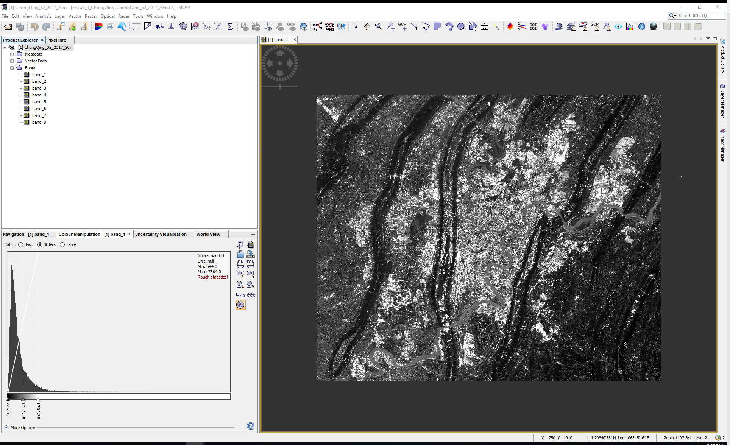
Fig 1.1 Visualize image band and histogram using SNAP

- In the file browser window, right click the “ChongQing_S2_2017_20m” file, and select “Open RGB Image Window”, then select Red = band3, Green=band2 and Blue=band1 to visualize a true color image. Try to visualize different bands composites such as [NIR, Green, Blue] and [SWIR, Geeen, Blue] etc.
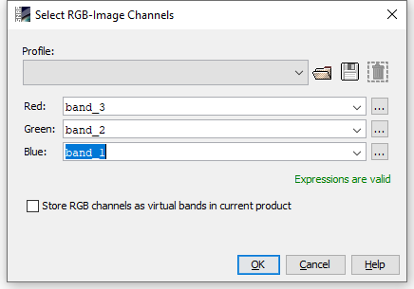
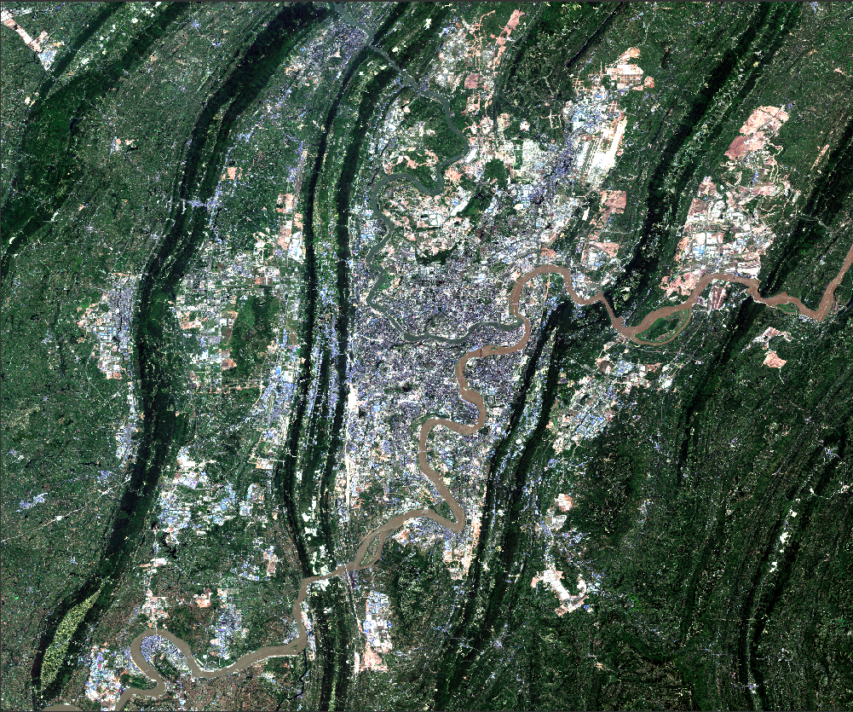
Fig 1.2 Open RGB composite
1.2 Compute a spectral index such as NDVI, NDWI and NDBI
Considering the following formulas for each of the spectral indexes:
- NDVI (Normalized Difference Vegetation Index)
NDVI = (NIR - Red)/(NIR+Red)
- NDWI (Normalized Difference Water Index)
NDWI = (Green - SWIR)/ (Geen + SWIR)
- NDBI (Normalized Difference Built-up Index)
NDBI = (SWIR - NIR)/(SWIR + NIR)
To compute a spectral index using the Band Maths tool provided by SNAP (Note: These three spectral indexes have been contained in ChongQing_S2_2017_20m.tif to run code Step0, try to produce them by yourself):
Raster -> Band Maths -> Edit expression, and another NDVI band will be produced, set palette for NDVI and have a look. Similarly, NDWI and NDBI can be generated.
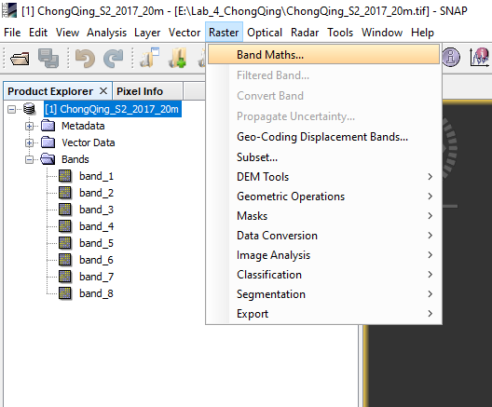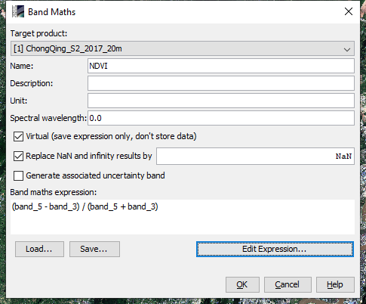
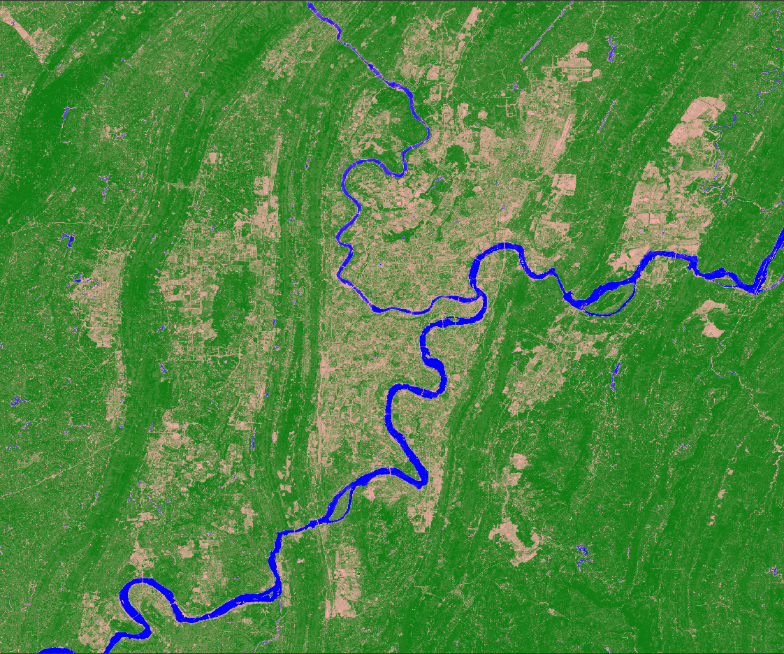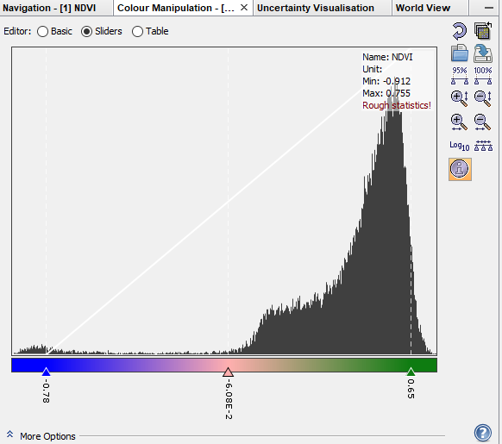
2. SLIC-based Superpixel Segmentation and Sampling
2.1 SLIC segmentation
In this section you will investigate different input parameters of the SLIC technique to understand the segmentation process.
Here is the code line where the slic function is used to generate the segments.
segments = slic(image, n_segments=30000, compactness=30)
- image can be 2d or 3d, and grayscale or multichannel,
- n_segments denotes the approximate number of labels in the segmented output image, - compactness balances color proximity and space proximity: Higher values give more weight to space proximity, making superpixel shapes more square/cubic.
It is recommended to explore possible n_segments and compactness values on a log scale, e.g., 0.01, 0.1, 1, 10, 100 to find a good dimension and shape of the segments (see Fig 2.1)
(Ref:https://scikitimage.org/docs/dev/api/skimage.segmentation.html#skimage.segmentation.slic)
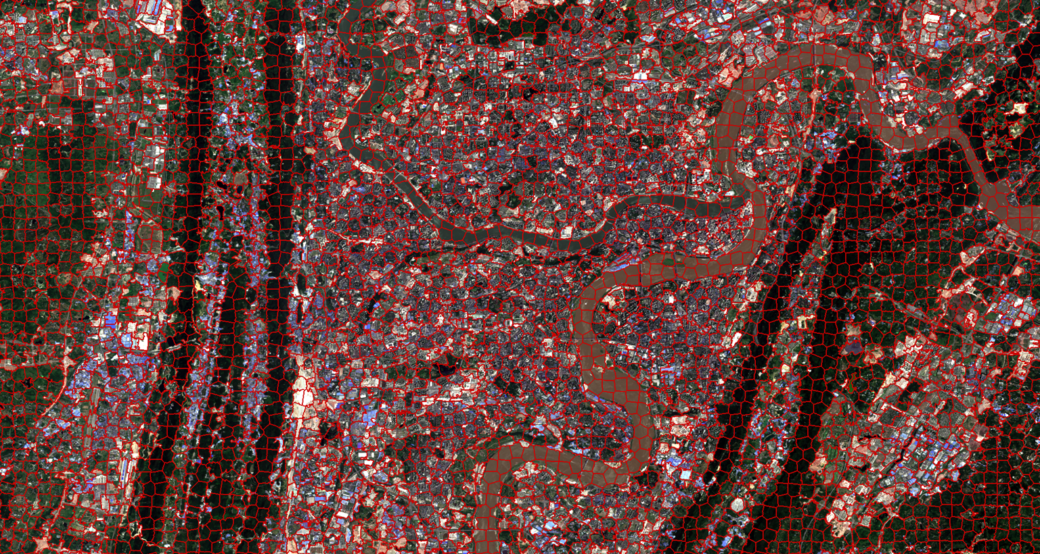
Fig. 2.1 Superpixel Segmentation Map
2.2 Superpixel-based Data Sampling
Centering at the geometric centroid of each superpixel, a cubic neighborhood of size w*w*c can be sampled, where w denotes the neighborhood window while c denotes the number of channels. (Note: The sampling procedure may take 25min or more, please get familiar to the following material.)
samples, labels = superpixel_based_patch_sampling(segments, Data, winSize, refMap)
- samples: n*w*w*c
- labels: n*1
2.3 Balance Training Data
Due to the fact that the number of training samples belongs to different classes is so different, it is recommended to transform them into class-balanced one. Here, 2000 samples are randomly chosen for each class, and they will be taken as the training samples for deep neural networks.
3. Convolutional Neural Networks (CNN)
3.3 Data/Feature Visualization
Tensorboard Projector can be exploited to visualize the sample distribution with t-distributed stochastic neighbor embedding (t-SNE)
[TensorboardX : https://tensorboardx.readthedocs.io/en/latest/tensorboard.html ].

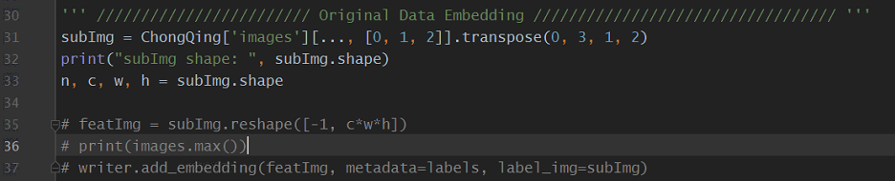
writer.add_embedding(featImg, metadata=labels, label_img = subImg)
-featImg: n*d, where n is the number of samples, d is the dimension of features
-metadata: labels corresponding to featImg, of size n*1
-label_img: n*w*h*c, where w, h and c denote width, height and number of channels of image set to visualize.
Try different bands for training and visualization via band4train and band4projector.
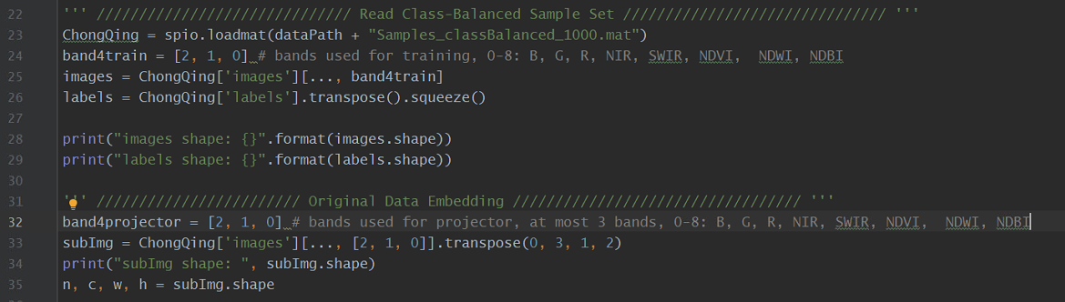

3.2 CNN Model
The follow codes show how to use keras layers to build a simple CNN model, taking the input data of shape 25*25*3 as example, and all samples belong to four classes, i.e., urban, crop, vegetation and water.
Please refer to TensorFlow https://tensorflow.google.cn/ if more details are needed. Choose an optimizer and loss function for your model.

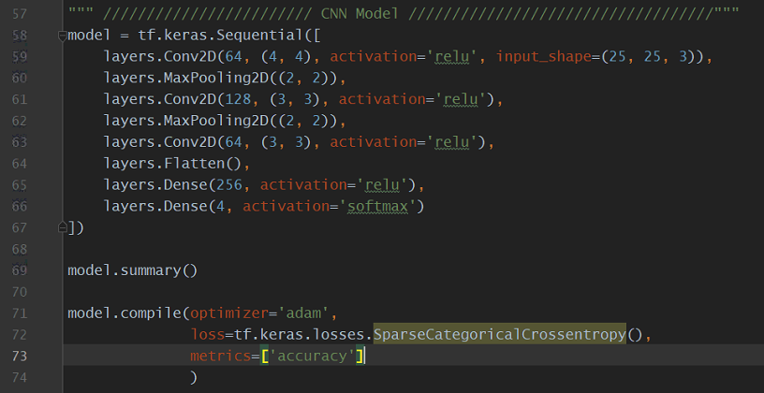
3.3 Model Training
Configure parameters for your model fitting such as epoch and callback.
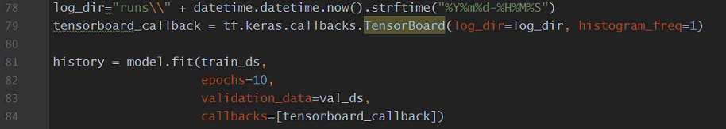
3.4 Visualize Your Model
By using tensorboard_callback and writer.add_embeddings, try to run your tensorboard server in your local machine by inputing the following code in Terminal (in red box).

> tensorboard –logdir runs

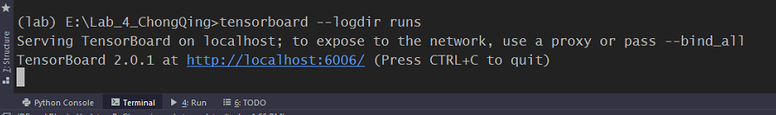

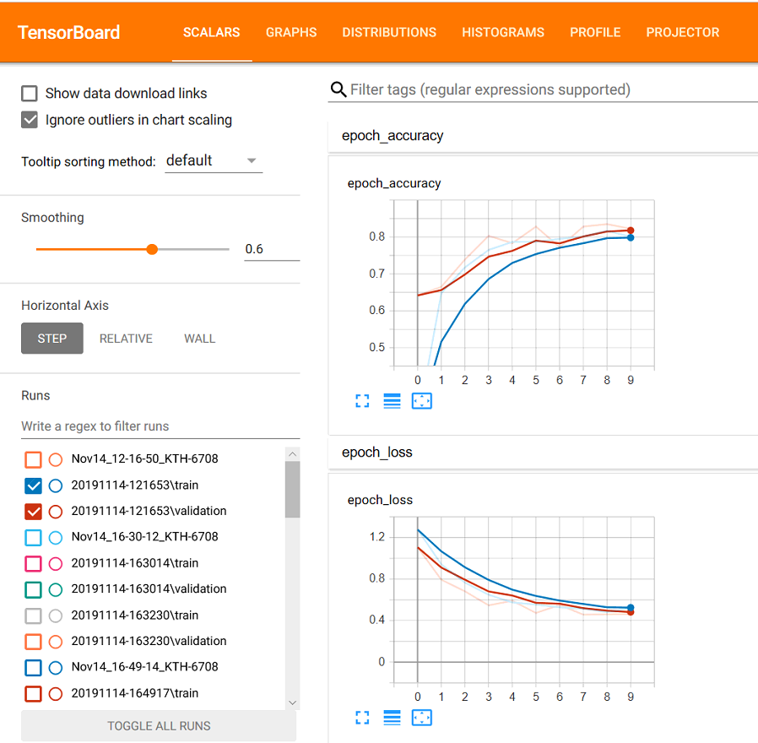
Fig 3.1 Learning Curve
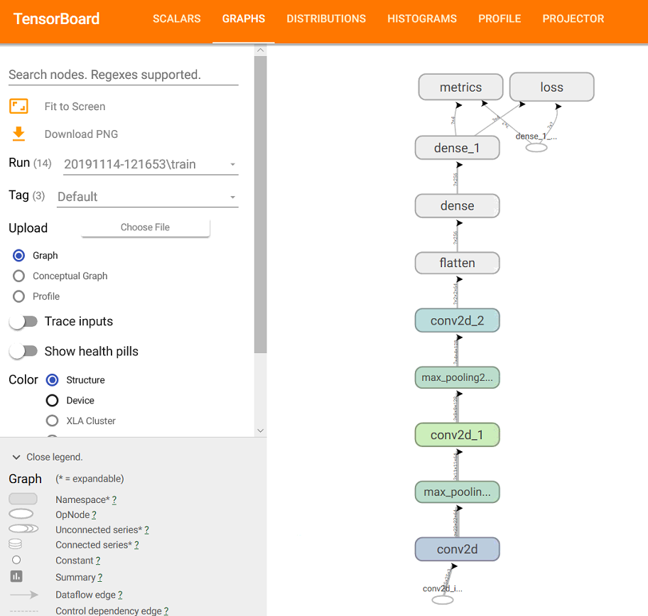
Fig 3.2 Network Archtecture
Open the url localhost://6006 via your browser (it is recommended to use Google Chrome). Fig 3.1 shows the learning curve with scalars, Fig 3.2 shows the network architecture with graphs, and Fig 3.3 visualize the data distribution with Projector, try different dimension reduction methods, check the difference. The Projector may not work well in other browsers except google chrome.
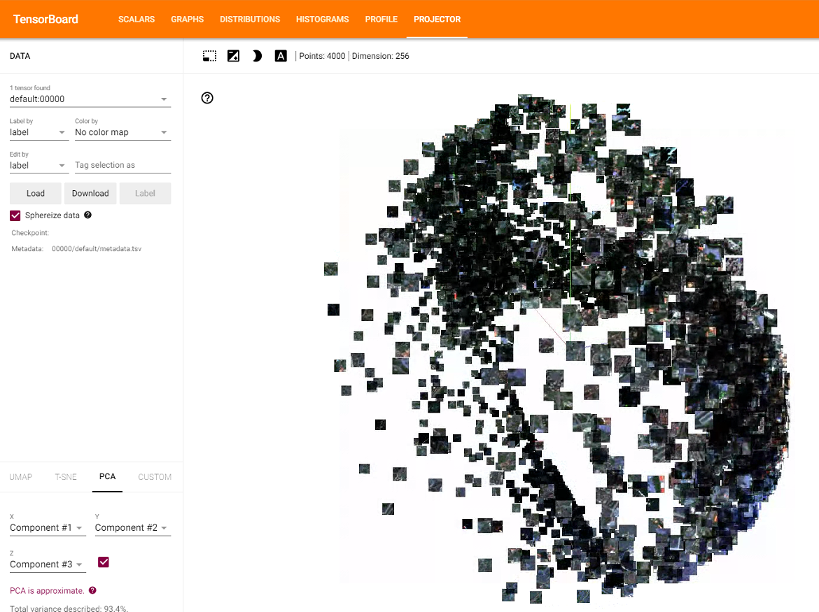
Fig 3.3 Data Visualization with Projector

4. Apply the trained model
In this section, we will apply the trained model to predict a label for each superpixel, and transform the labeled superpixels label into a land cover map.
4.1 Predict labels for superpixel with the trained model
Apply the trained model on all superpixel samples, and obtain the corresponding labels.

pred = model.predict(dataset0)
predLabels = np.argmax(pred, axis=1)

4.2 Transform labeled superpixel into a land cover map
How will you transform labeled superpixels into a land cover map?
The easiest way is to find the indexes for each superpixel, and then assign them with the same superpixel label predicted by the trained model. However, it is quite slow in practice. Another more efficient way is to find the indexes for all superpixels (segments) with the same predicted label (see the following code).
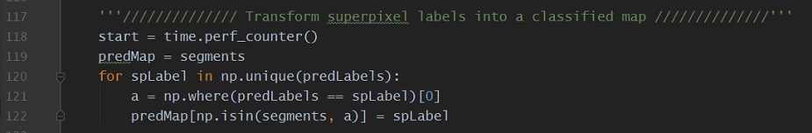
Fig 4.1 shows the superpixel-based classification results predicted by CNN. Try to adjust the parameters such as network architecture, optimizer, and epoch, how will the predicted map look?

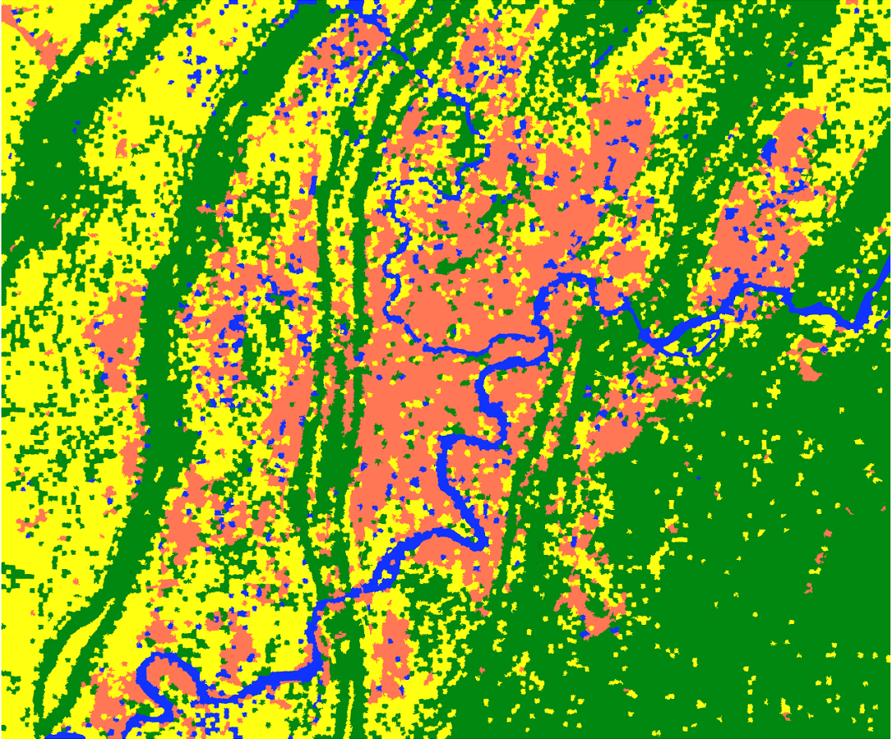
Fig 5.1 Map predicted by CNN (epoch=10)
5. Accuracy Assessment
In this section, we will conduct accuracy assessment by comparing the classified map with the reference map. There are two accuracy assessment schemes: pixel-based and superpixel-based accuracy assessment, which do you think is more reliable to assess the CNN results?
“Step3_Accuracy_Assessment.py” show how to visualize pixel-based and superpixel-based reference maps, and a superpixel-based accuracy assessment method is given.
Fig 5.1 shows the pixel-based reference map, while Fig 5.2 shows the superpixel-based reference map, try to discuss their characteristic and difference between them.
Fig 5.3 presents the code for conducting accuracy assessment with sklearn.metrics.
Plese refer to the following url: http://lijiancheng0614.github.io/scikit-learn/modules/classes.html#module-sklearn.metrics
C_ij: number of superpixels belong to class-i are classified into class-j.
- | True Label
Predicted  Label | - | Urban | Crop | Vegetation | Water | Recall
 | Urban | C00 | C01 | C02 | C03
 | Crop | C10 | C11 | C12 | C13
 | Vegetation | C20 | C21 | C22 | C23
 | Water | C30 | C31 | C32 | C33
 | Precision |  |  |  |  | Acc/F1
Table 3. Four-Class Confusion Matrix.
The accuracy, precision, recall and F1-score can be computed with the formula:
$acc= \frac{\sum_{k=0}^{3}{C_kk}}{\sum_{i=0}^{3}{\sum_{j=0}^{3}{C_ij}}}$ ${precision}_{k}=\frac{C_kk}{\sum_{i=0}^{3}{C_ik}}$ ${recall}_{k}=\frac{C_kk}{\sum_{j=0}^{3}{C_kj}}$ k=0,1,2,3.
$\left[class k F_{1}\right]: F1_{k}= \frac{2*Precision_{k}*Recall_{k}}{Precision_{k}+Recall_{k}}$ 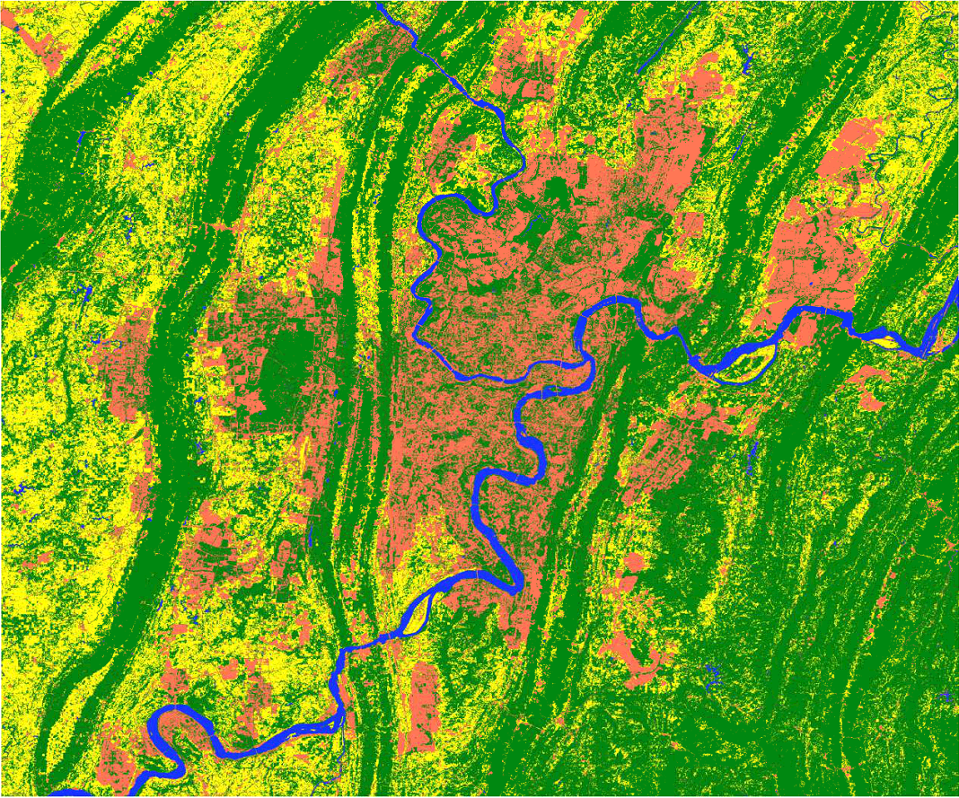
Fig 5.1 Pixel-based reference map
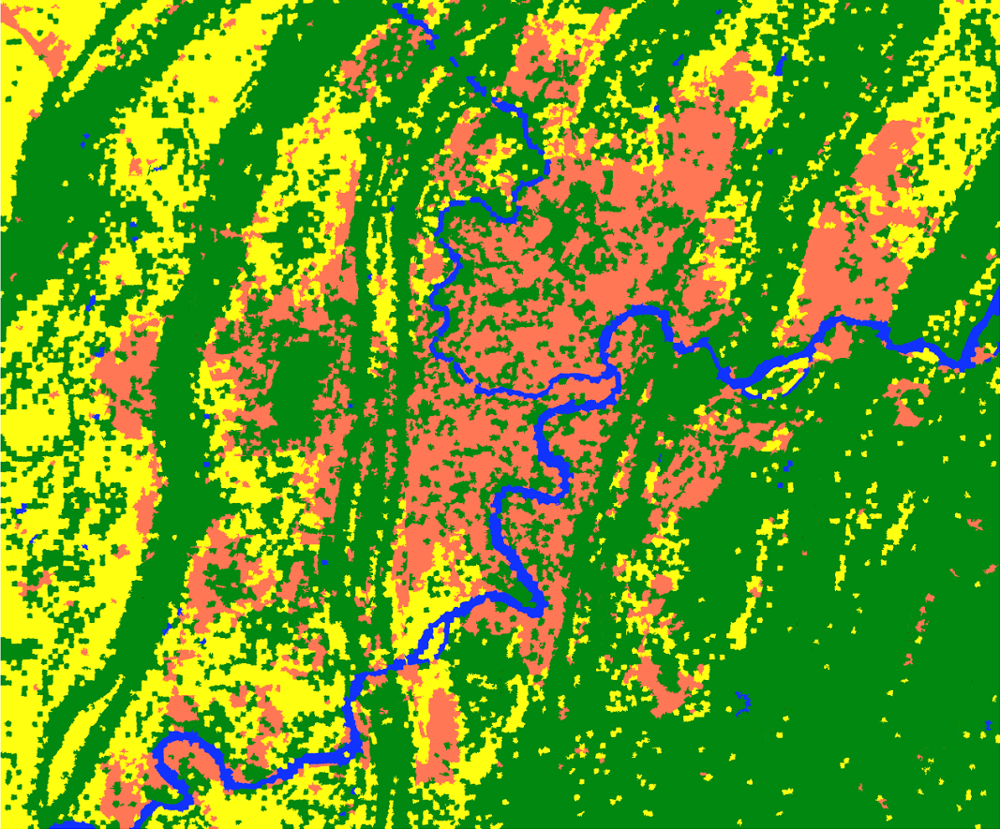
Fig 5.2 Superpixel-based reference map

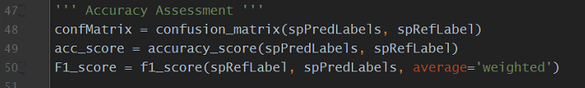
Fig 5.3 Code for accuracy assessment

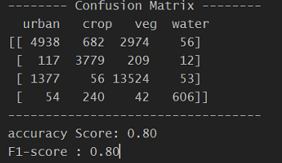
Fig 5.4 Accuracy Statistics

Congratulations!
=================> End <=================
Appendix: Python Environment Configuration
puzhao@kth.se

Step 0: Install Anaconda and PyCharm
Anaconda (Python 3.7 64-bit) https://www.anaconda.com/distribution/#windows
PyCharm-Community https://www.jetbrains.com/pycharm/download/#section=windows

Test conda: It works well if it looks like the following picture, otherwise you need to add the path of “conda.bat” into the system environment variable (see the second picture).
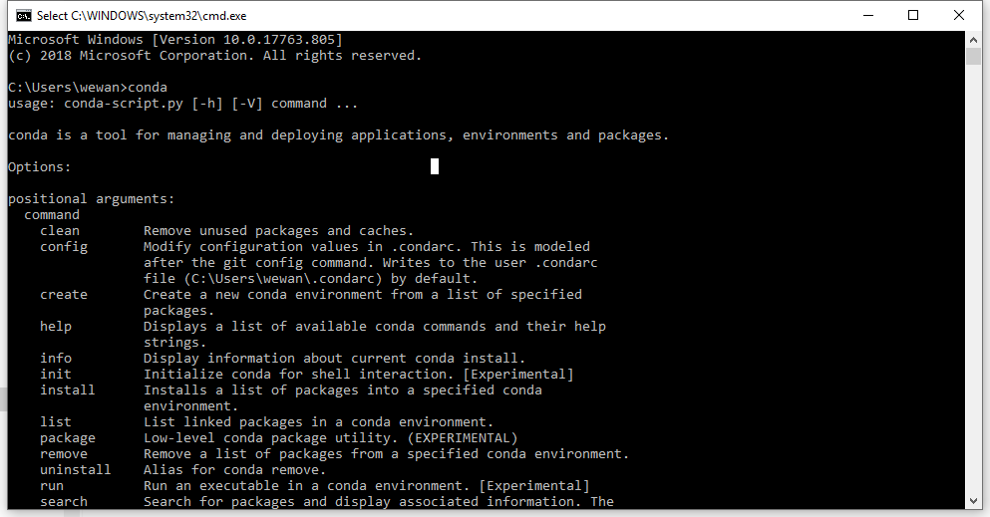
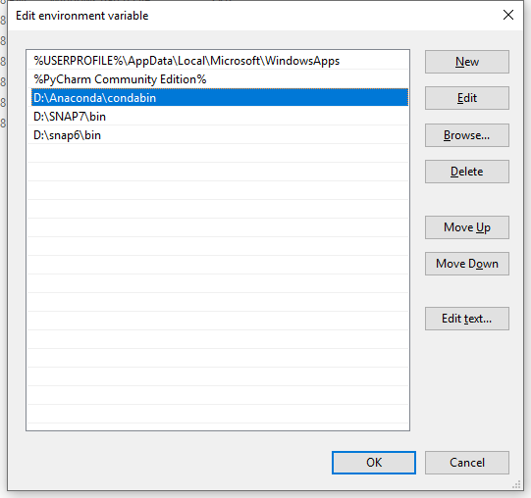

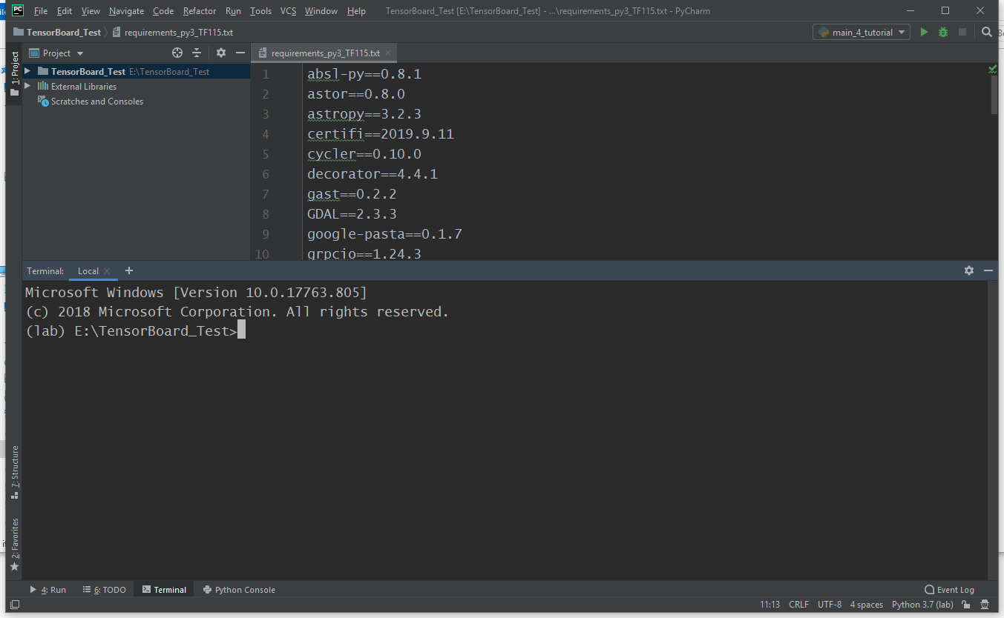

Step 1: Create an environment named “lab” and activate it (in Pycharm Terminal)
> conda create –name lab
> activate lab
(base) E:\ Lab_4_ChongQing >activate lab
(lab) E:\ Lab_4_ChongQing >

Step 2: Install python libraries required for lab (in Pycharm Terminal)
> conda install pip==19.1.1
> conda install gdal
> conda install cytoolz
> pip install –r (Path to the file) requirements_tbx.txt

------------------- Validation ---------------------------
> python
(lab) E:\Lab_4_ChongQing>python
Python 3.7.5 (default, Oct 31 2019, 15:18:51) [MSC v.1916 64 bit (AMD64)] :: Anaconda, Inc. on win32 Type "help", "copyright", "credits" or "license" for more information.
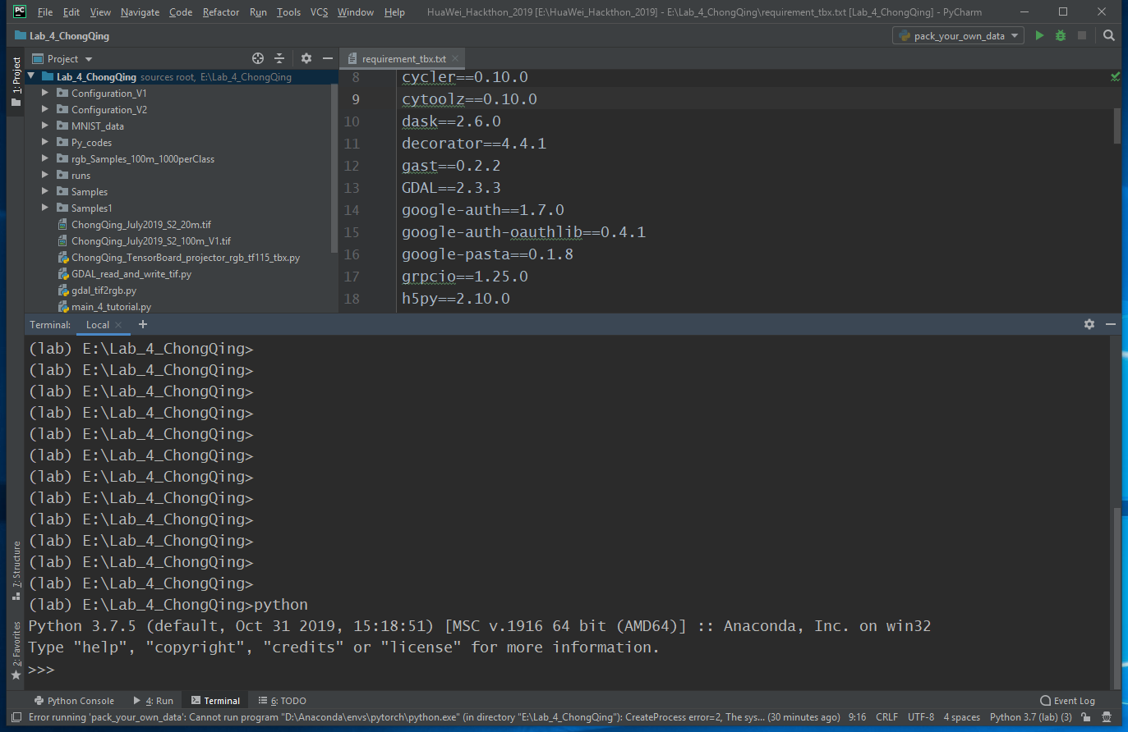

>>> import tensorflow as tf
>>> tf.__version__
'2.0.0'
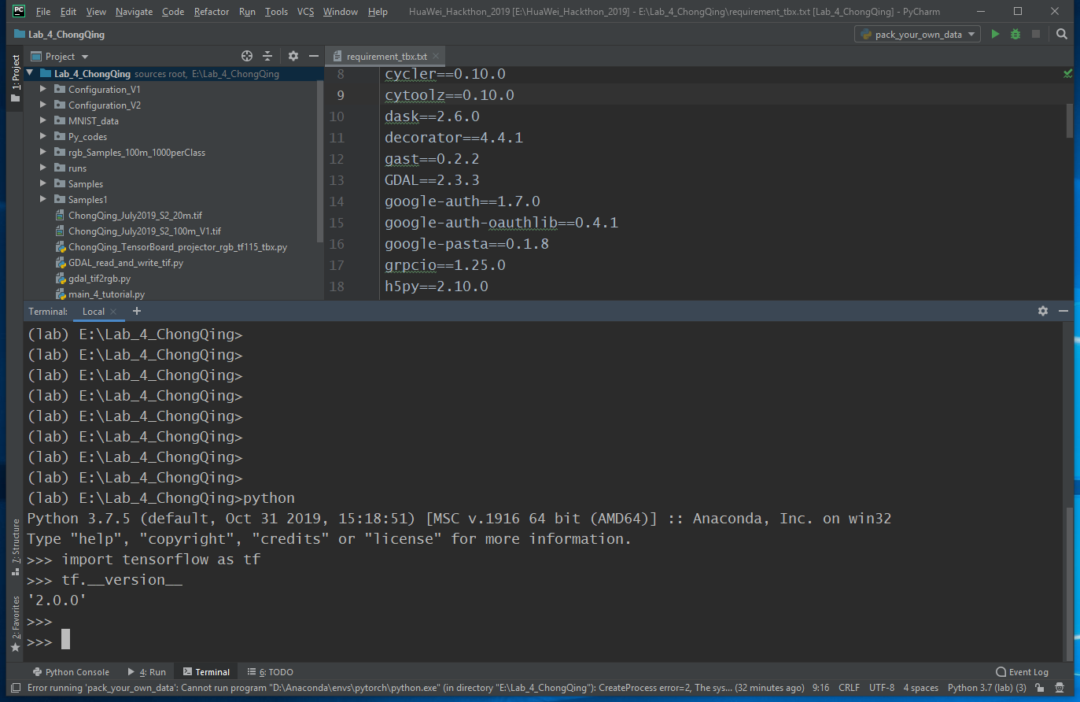

>>> import tensorboardX
>>> tensorboardX.__version__
'1.9'
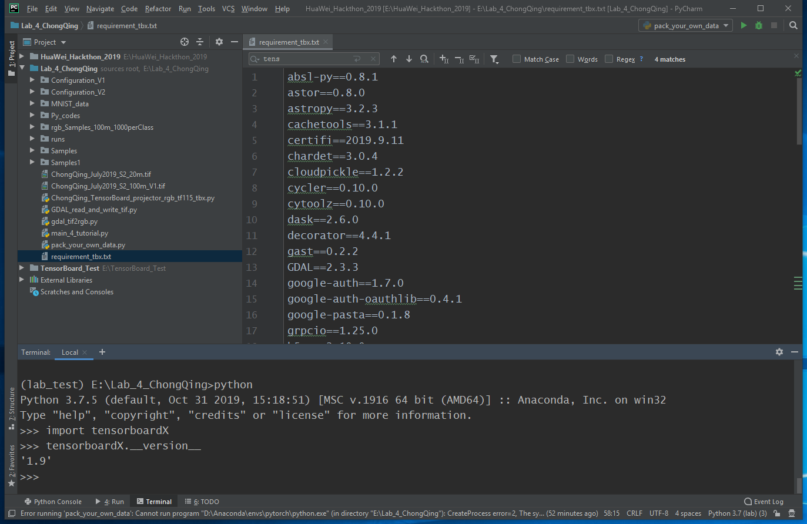

If there is any problem, please contact me: puzhao@kth.se

