ESA SNAP 6.0.0
http://step.esa.int/main/download/snap-download/previous-versions/
(EAS SNAP 7 may have some problem for now)

Python Environment Configuration

Step 0: Install Anaconda and PyCharm
Anaconda (Python 3.7 64-bit) https://www.anaconda.com/distribution/#windows
PyCharm-Community https://www.jetbrains.com/pycharm/download/#section=windows

Test conda: It works well if it looks like the following picture, otherwise you need to add the path of “conda.bat” into the system environment variable (see the second picture).
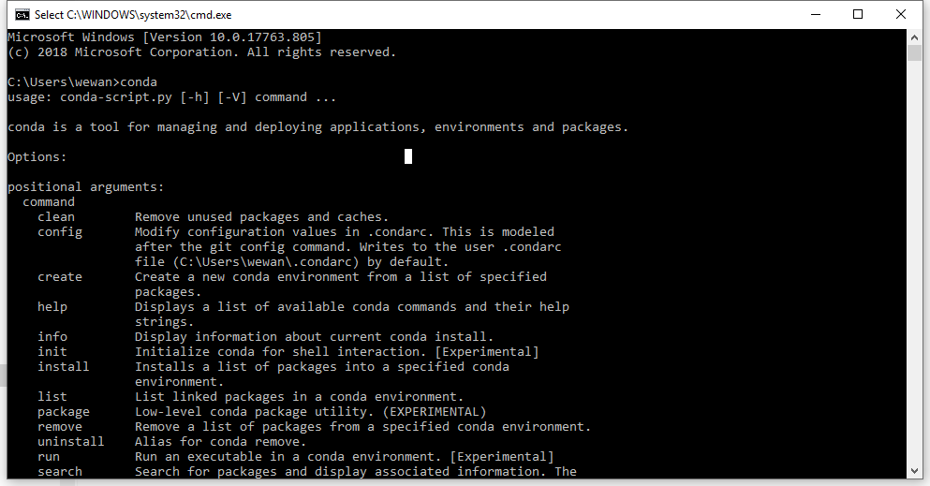
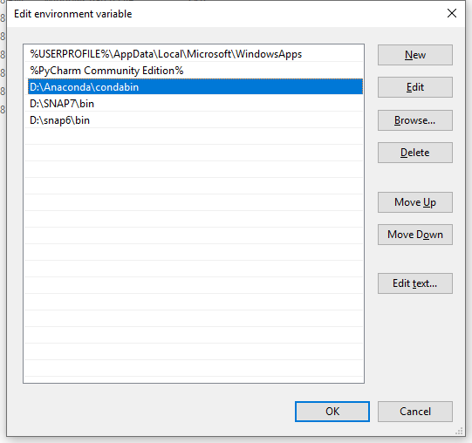

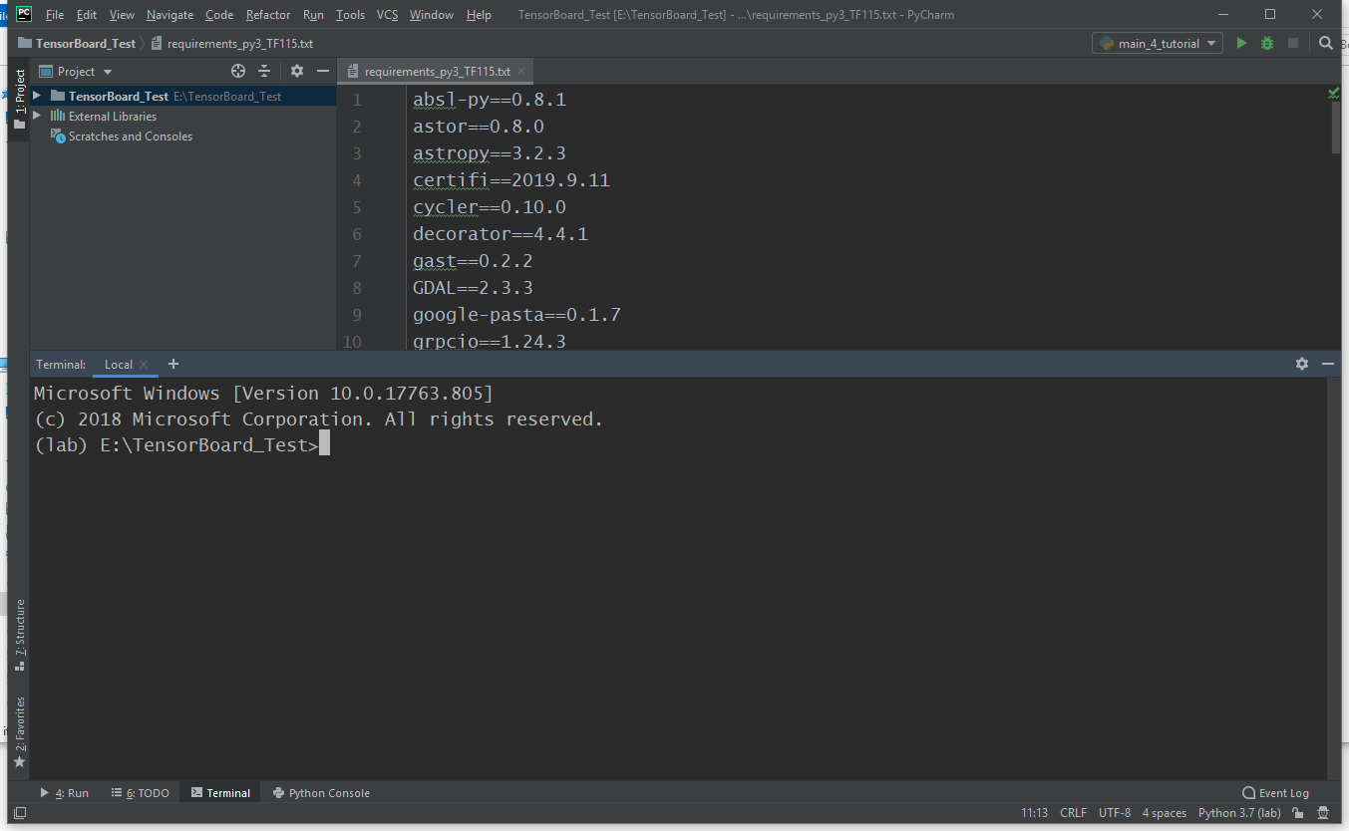

Step 1: Create an environment named “lab” and activate it (in Pycharm Terminal)
> conda create –name lab
> activate lab
(base) E:\TensorBoard_Test>activate lab
(lab) E:\TensorBoard_Test>

Step 2: Install python libraries required for lab (in Pycharm Terminal)
> conda install pip==19.1.1
> conda install gdal
> pip install –r (Path to the file) requirements_py3_TF115.txt

> python
(lab) E:\TensorBoard_Test>python
Python 3.7.5 (default, Oct 31 2019, 15:18:51) [MSC v.1916 64 bit (AMD64)] :: Anaconda, Inc. on win32 Type "help", "copyright", "credits" or "license" for more information.
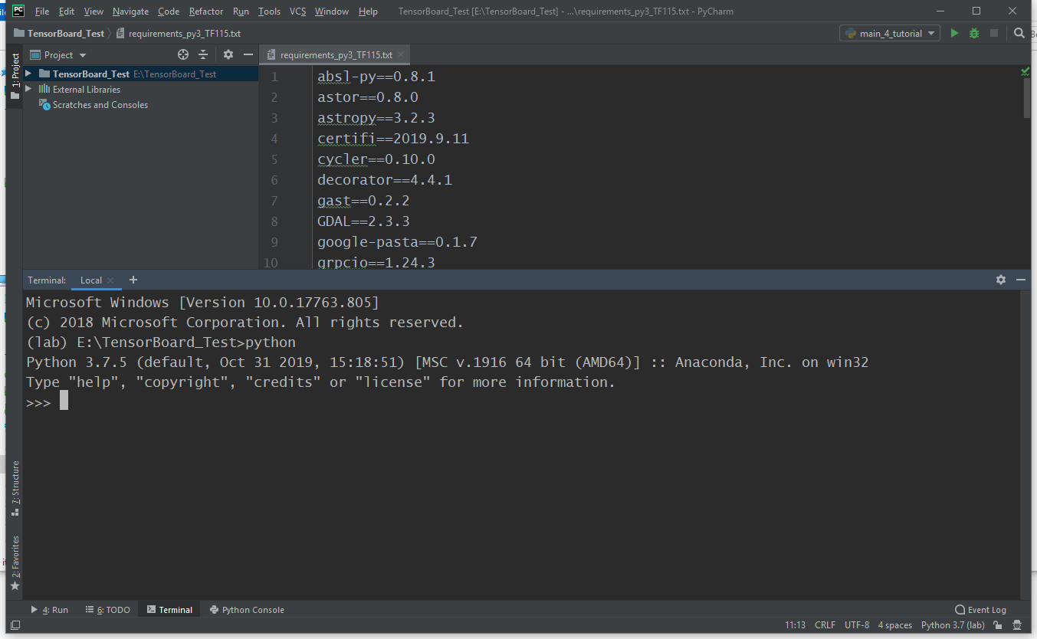

>>> import tensorflow as tf
>>> tf.__version__
'1.15.0'
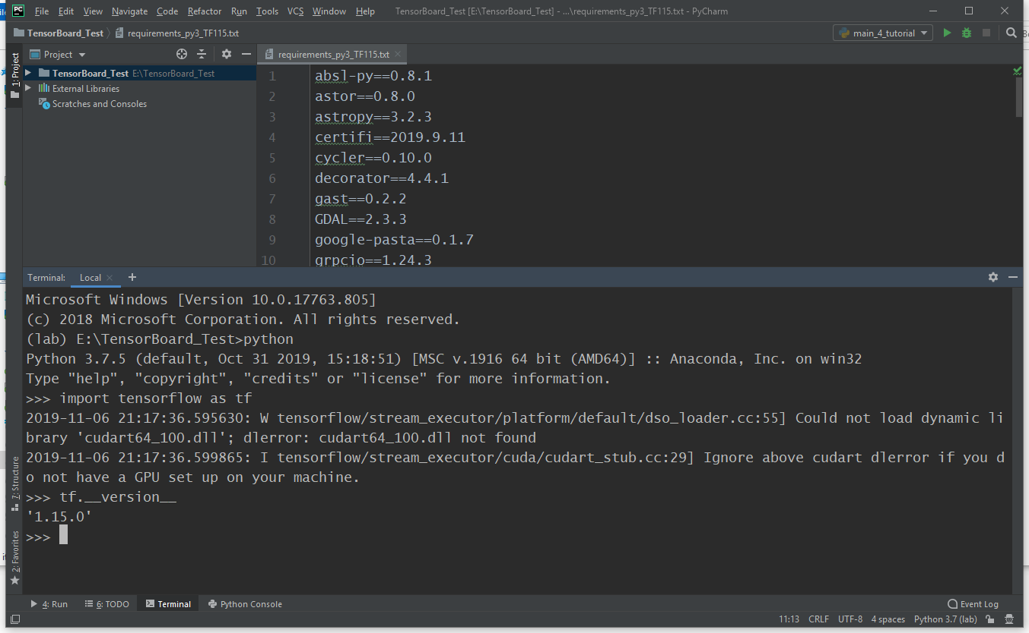

If there is any problem, please contact Puzhao Zhang: puzhao@kth.se

