https://ieeexplore.ieee.org/stamp/stamp.jsp?arnumber=7579570
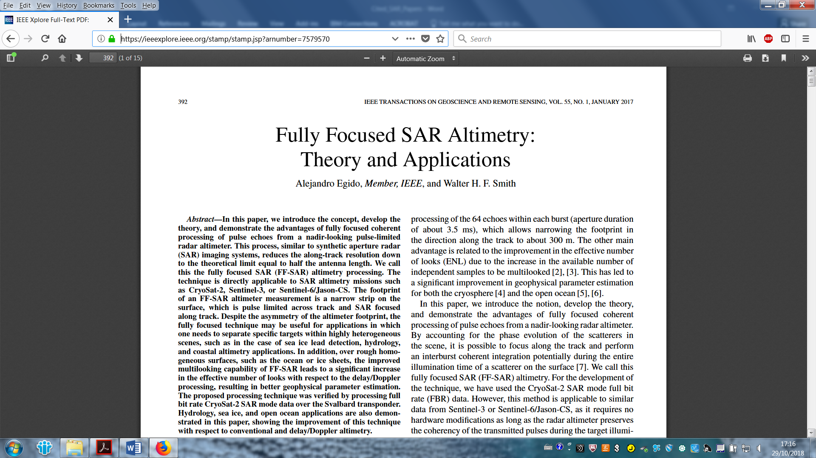
https://ieeexplore.ieee.org/stamp/stamp.jsp?arnumber=718861
