DROUGHT MONITORING

Lichun Wang & Prof. Bob Su
ITC, University of Twente, The Netherlands

www.itc.nl/wrs

Drought monitoring

General objectives
In this exercise, drought indices are used to assess the spatial and temporal distribution of drought for the regions of south-west/north/north-east China (e.g. Chongqing, Chengdu, Inner Mongolia, and North China Plain) for the time period from 2003 to 2010. For this you need to perform the following tasks:

- Calculate the drought indices:
- Soil moisture deficit index (SMDI)
- Standardized precipitation index (SPI)
- Evapotranspiration anomaly
- Classify the drought index
- Spatial temporal analysis of drought indices in a GIS environment
- Comparison among the calculated drought indices.

Study area
- The regions of south-west/north/north-east China (e.g. Chongqing, Chengdu, Inner Mongolia, and North China Plain).

Data sets needed
- Soil moisture (SM) simulated by GLDAS Noah land surface model
- Monthly-mean soil moisture (sum of 4 layers, of a soil layer 2 m deep) from GLDAS data (http://disc.sci.gsfc.nasa.gov/hydrology/data-holdings)
- Spatial coverage: China
- Temporal coverage: January 2003 to December 2010
- Temporal resolution: monthly average
- Spatial resolution: 0.25°
- Format: Geotiff
- Unit: cm

- GPCP (Global Precipitation Climatology Project (version 2.2)
- Monthly total precipitation
- Spatial coverage: global
- Temporal coverage: January 2003 to December 2010
- Spatial resolution: 1.25°
- Format: Geotiff
- Unit: cm/month

- CMORPH precipitation data (CPC MORPHing technique)
- Monthly total precipitation
- Spatial coverage: China
- Temporal coverage: January 2003 to December 2010
- Spatial resolution: 8 km (at equator)
- Format: Geotiff
- Unit: cm/month

- SEBS-based evapotranspiration time series
- Monthly total evapotranspiration time series estimated by SEBS model
- Spatial coverage: China
- Temporal coverage: January 2003 to December 2010
- Spatial resolution: 0.1°
- Format: an image list with 96 bands/maps, one for each month. Floating points.
- Unit: cm/month

Tools
- ILWIS, IDL runtime application and Excel

Exercise Steps
Use e.g. G:\Data\DT_out directory as your active working directory when conducting the exercises using ILWIS. Always use this directory as output path during the calculation of SPI and SMDI using the IDL application.

Start drought (IDL runtime program) application
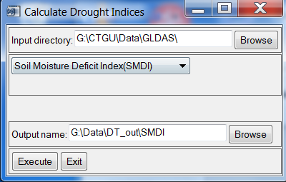
Figure 1:Calculate SMDI
This IDL application offers a set of functions to calculate drought indices for precipitation and soil moisture time series. These functions are:
- Calculate Standardized Precipitation Index (SPI).
- Calculate Soil moisture Deficit Index (SMDI)
  - Calculate SMDI
SMDI is defined as:
SMDI_{j} = 0.5SMDI_{j -1} + SD_{j}/50
SMDI _{j} = SMDI at month j (current month)
SMDI _{j -1} = SMDI at month j-1 (previous month)

SD_{j} = monthly soil deficit at month j
SD_{j}= (SW_{j} – MSW_{j})/(MSW_{j} – minSW_{j}) *100 if SW_{j} <= MSW_{j}
SD_{j} = (SW_{j} – MSW_{j})/(maxSW_{j} – SW_{j}) *100 if SW_{j} > MSW_{j}

SW_{j} = actual monthly soil moisture at month j
MSWj= long-term monthly median available soil water at month j
maxSW_{j}= long-term monthly maximum available soil water at month j
minSW_{j} = long-term monthly minimum available soil water at month j
SMDI₁ = SD₁/50 for initial month

Specify the inputs as indicted in Figure 1
After these step, you will see a new map list (named for example SMDI)

1.2) Calculate SPI
SPI is calculated based on the algorithm developed by (McKee, Doesken et al. 1993).
A probability density function is fitted over a frequency distribution of precipitation for a certain time scale. The found probability function is then transformed into a standard normal distribution. Because of the nature of the algorithm for time scales larger than one month the first month (e.g. time scale – 1) in the time series will be undefined. The SPI will be calculated for each of the time scales.

Calculate SPI using CMORPH precipitation time series
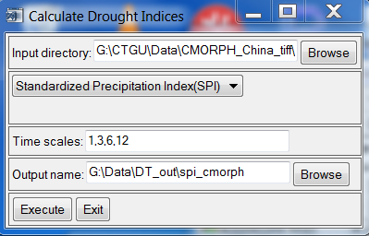
Figure2:Calculate SPI using CMORPH

Calculate SPI using GPCP precipitation time series
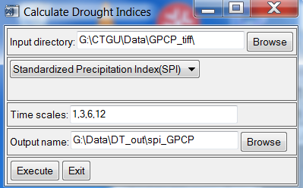
Figure3:Calculate SPI using GPCP

Start ILWIS
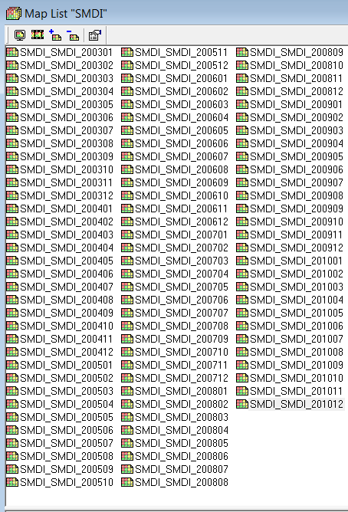
Figure4:SMDI maplist
Start ILWIS and navigate to the folder (e.g. D:\data\DT_out) where contains the ILWIS maps created before. Always use this folder as your working directory for the exercise.

2.1) Open the calculated drought indices (e.g. SMDI maplist ) , a window with all the SMDI bands contained in this map list will be opened. As an example, the output looks like in Figure 5. Note that the map list contains 96 images (one image per month, the SMDI from 2003 to 2010).

Display one image file and move the cursor over the image and check the coordinates displayed at the bottom of the display window.

Assign georeference coordinates
Right click on this map list file. Select the properties and change the georeference to “CHINA” for SMDI, “gpcp” for GPCP based SPI for each of the time scales (e.g. SPI_GPCP01, SPI_GPCP03, SPI_GPCP06, SPI_GPCP012), CMORPH_China_mask2 for CMORPH based SPI for each of the time scales (e.g. SPI_cmorph01, SPI_cmorph03, SPI_cmorph06, SPI_cmorph12)
Display the images again and move the cursor over the image and check the coordinates displayed at the bottom of the display window.

Display the time series e.g SMDI maplist as animation
- Double click SMDI maplist to open the maplist window
- Click Open As Animation button (see the red circle in Fig. 4)
- Click on Run (See the red circles in Figure below), animation management option will appear, leave the settings as they are and click on “Start” tool starts the animation (See the red circles in Figure below).
- 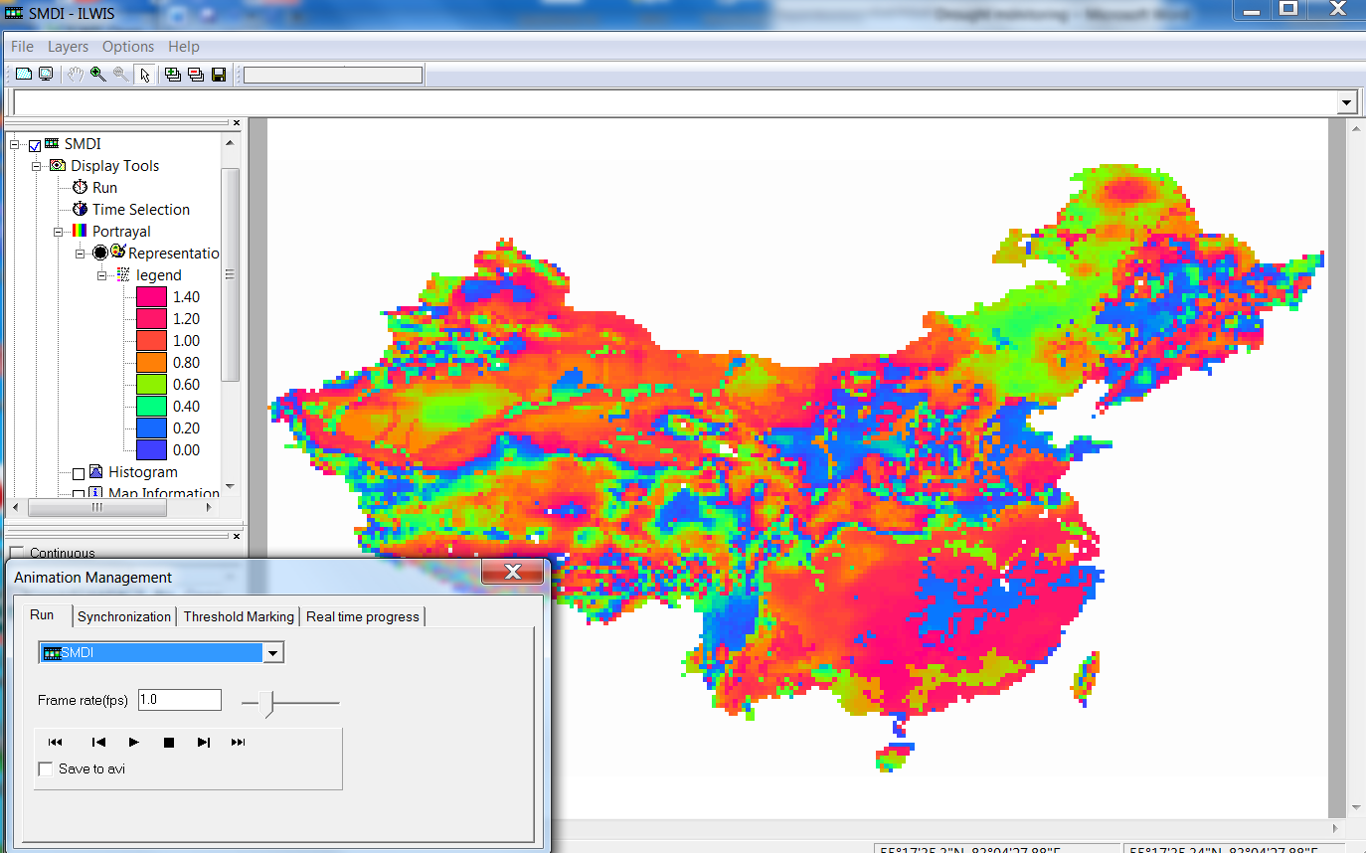

3) Classify SMDI

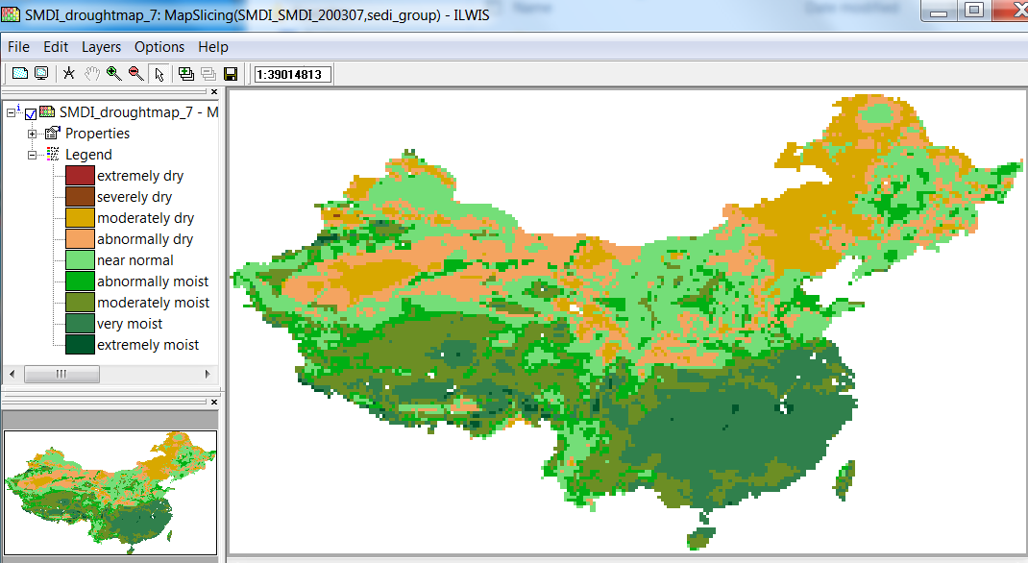
Figure6:Classified SMDI

SMDI | Class
-3 and less | Extremely dry
-3 – -2 | Severely dry
-2 – -1 | Moderately dry
-1 – -0.5 | abnormally dry
-0.5 – 0.5 | near normal
0.5 – 1 | abnormally moist
1 – 2 | Moderately moist
2 – 3 | very moist
3 and above | extremely moist

Here we classify the SMDI according to the above table using the Slicing function. Slicing classifies the values of a raster map. Ranges of values of the input map are grouped together into one output class. A domain Group should be created beforehand; it lists the upper boundaries of the groups and the group names.

- Create a domain go to File > Create > Domain

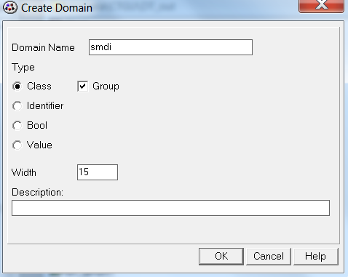

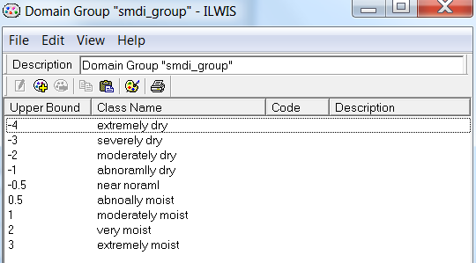

- Go to Operations > Raster operations > Maplist Calculation

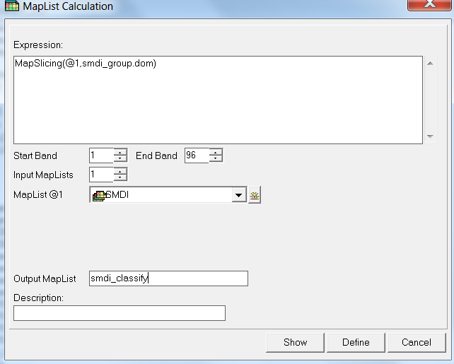

3.1) Display time series and observe the spatial temporal patterns of the classified SMDI (using ILWIS 372 version )
  - Identify the driest and wettest locations/periods

3.2) Plot the temporal behavior
- Right click on the map list SMDI, select Statistics menu > MapList Graph. MapList Graph window will appear (see Fig below). Click mouse over the regions of interest and observe the spatial and temporal variations of SMDI.

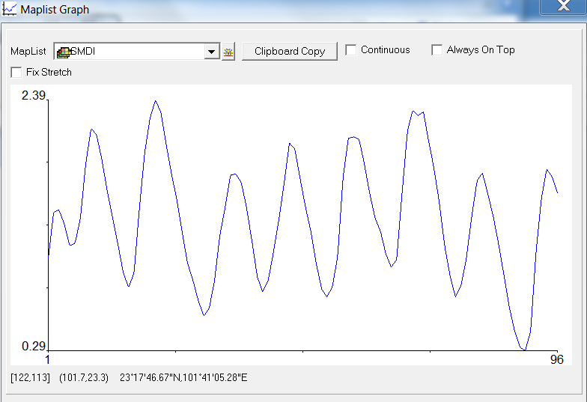

- Classify SPI

SPI | Class
-1.6 and less | Extremely dry
-1.6 – -1.3 | Severely dry
-1.3 – -0.8 | Moderately dry
-0.8 – -0.5 | abnormally dry
-0.5 – 0.5 | near normal
0.5 – 0.8 | abnormally moist
0.8 – 1.3 | Moderately moist
1.3 – 1.6 | very moist
2 and above | extremely moist

- Create a domain for classifying SPI images
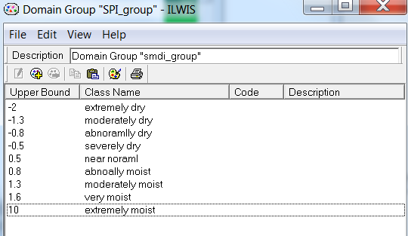

- Classify SPI for each of the time scales

- Display time series and observe the spatial temporal patterns of the classified SPI for each of the time scales (using ILWIS 372 version)
  - Identify the driest and wettest locations/periods

- Plot the temporal behavior
Note that long lasted negative rainfall anomaly leads to severe drought, short-term shortage of precipitation does not necessarily to result in drought.

5) Monthly evapotranspiration anomaly
Low evapotranspiration values are indicators of plant moisture stress. Actual ET anomaly is a good indicator for monitoring the agriculture conditions (growing-season conditions) and early warning of drought.

ET anomaly is defined as:
ET(anomaly)_{j} = ET _{j} – ET _{j} (mean) (1)
j = a specific month at the time series
ET _{j} = actual monthly ET at a specific month j and year
ET _{j} (mean) = mean long-term monthly value of actual ET for a specific month

a) Calculate the long-term mean monthly evapotranspiration (ET)
  - Run script sebs_monthly_maplist to create 12 image lists (one image list for each month of time series ET)
  - After these steps, you will see 12 new map lists. There will be one image list for each month of ET (named for example et_m1, et_m2…et_m12)
  - Run script sebs_longterm_monthly_mean to calculate the monthly long-term mean ET
b) Calculate monthly ET anomaly: Go to Operations > Raster Operations > MapList calculation, type the expression and use the settings as shown in Fig. 9 below to calculate the ET anomaly.

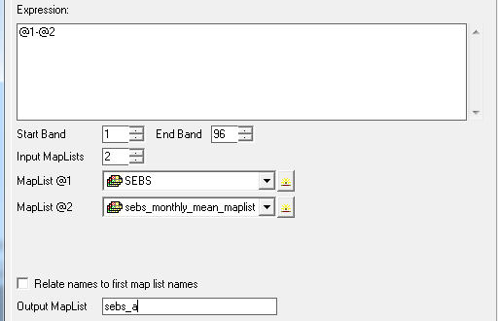

c) Identify the locations with extremely low ET anomaly to understand the drought locations

6): Assess and compare the different drought indices

- Open as Animation to:
  - observe the spatial and temporal variations of SMDI,SPI, and ETDI in different regions of China;
  - Determine the spatial extent of drought;
  - Identify the driest and wettest areas from the different drought index products.

- Use Cross section graph to:

- Plot time series drought indices;
- Compare two/more different drought indices for two specific regions of your choice (in south-west/north/north-east China, e.g. Chongqing, Chengdu, Inner Mongolia, and North Plain).

In this activity, you can use ILWIS 3.8 version Cross section function to compare temporal behavior for the different areas/pixels of the drought indices:
- Display an image, right click on the Display Tools in the left panel of the display window and select the Cross Section.
- Add the map list in the “Add data source” window that appears.
- Click on the area of interest, you will be able to see the temporal behavior of the selected area/pixel in the Cross section graph window.
- To compare the temporal variations in different area/pixel, Press Control key and click on the area/pixel of interest. Observe the temporal variations in different area in the Cross section graph window.
- 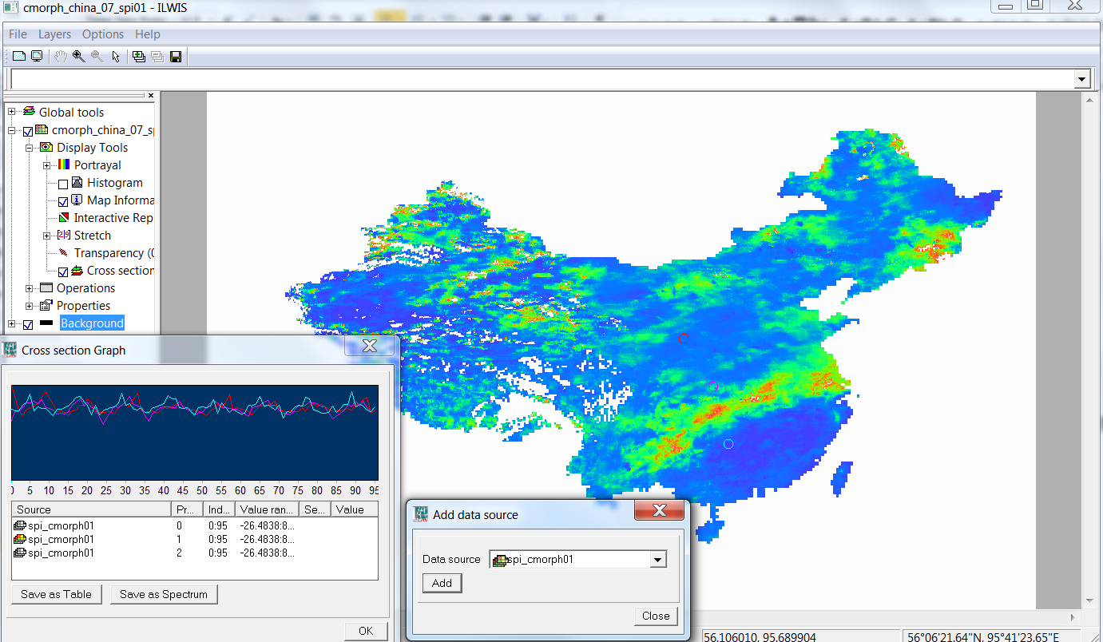

- For the students who like to do more
  - Copy all information in to an Excel file
- Plot the drought indices
- Plot the linear trend and correlate between the different drought indices
- Calculate drought class maps

