Forest height inversion and PCT extraction: step by step

- Set the environment

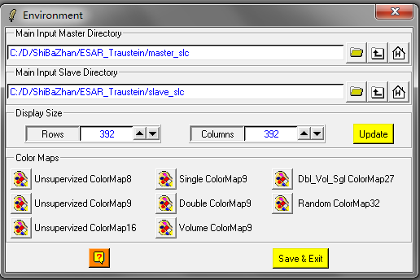
- Flat earth phase removal
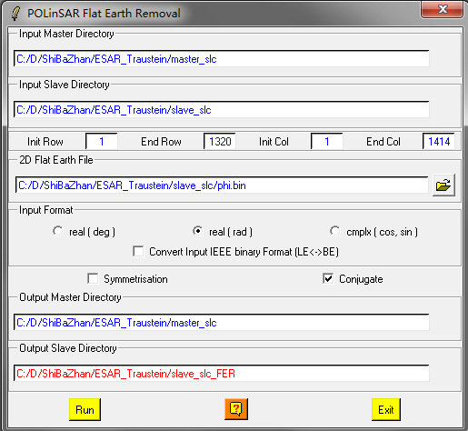

- Multi-look to generate the [T6] matrix of size 220*707
Speckle filtering
Main menuconvert
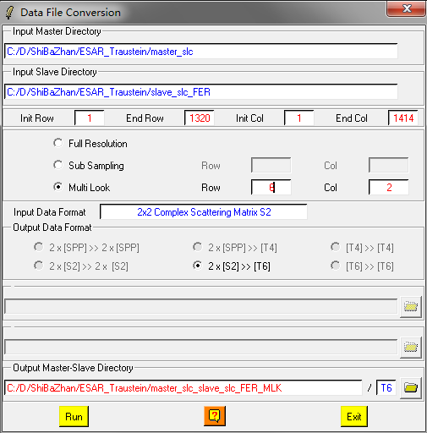

- Speck filtering
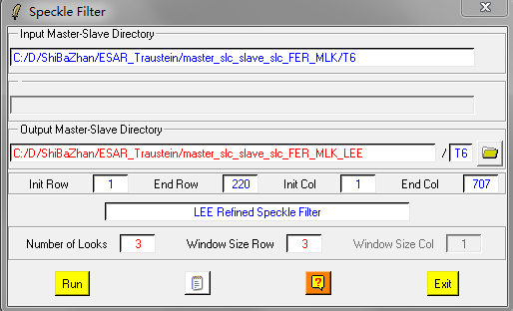

Check your [T6] matrix, the pauli-RGB image of master:
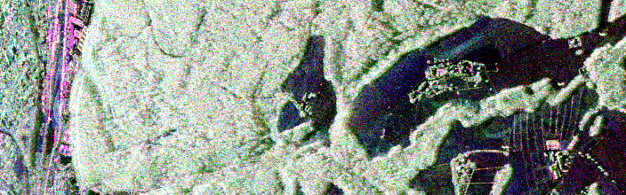
Mater image in Pauli-RGB

Run: main menuprocesscorrelation coefficients
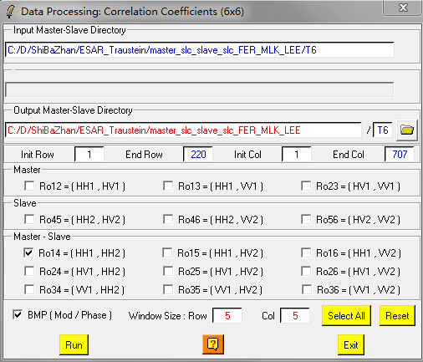
You should get the following phase image of the HH1-HH2
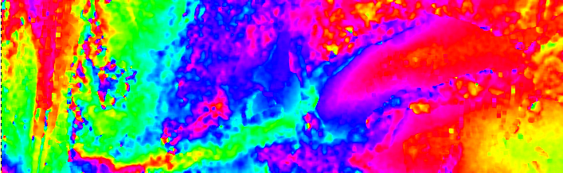

- Complex coherence estimation
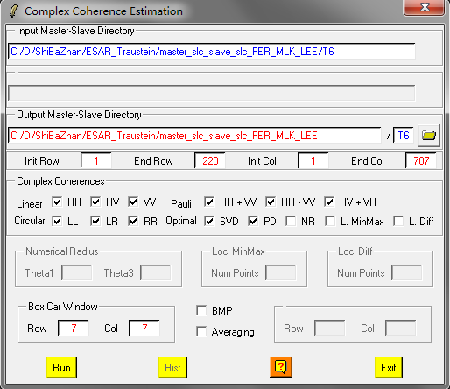
- Height estimation from inversion procedures
All the functions assuming we know the coherence whose InSAR phase is located to the top of the forest canopy, and the coherence whose InSAR phase is located at the ground surface under the canopy. So you have many choices to do the inversion. Here, we just choose HV, and HH-VV as the two coherences desired. You can try the other combination of coherences by yourself.
Here, we only demonstrate the Ground Phase Estimation and RVoG Inversion Procedure, you can try the other inversion method by yourself.
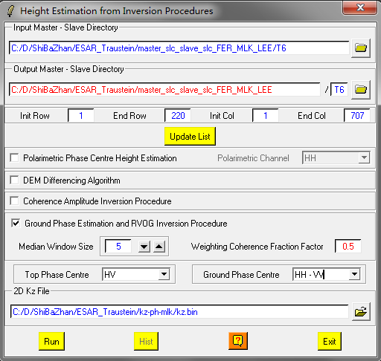

- PCT
- Run PCT parameters extraction
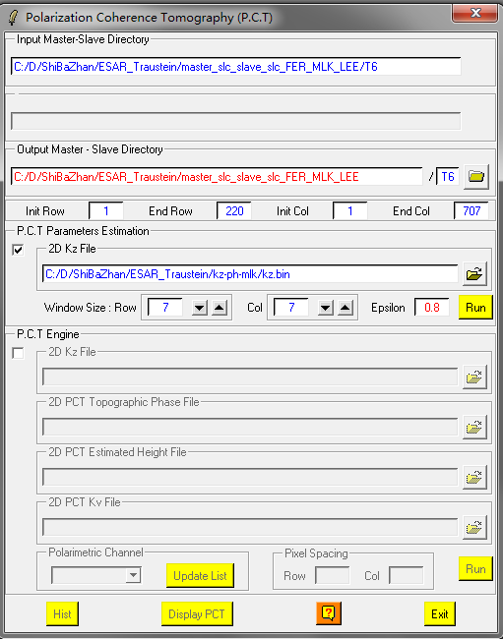

- Run the PCT engine to get the PCT profile
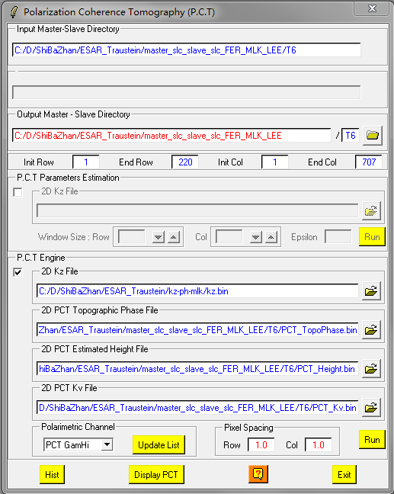

You can use the “Display PCT” button to check the PCT profiles.

