Description of the PolInSAR data set
In the directory named “ESAR_Traunstein”, we have the following four sub-directory and with this readme.docx file:
All the dataset is one pair of PolinSAR data (DLR E-SAR system, TreeSAR project.). The master S matrix data is in “master_slc” directory; and the slave S matrix is in “slave_slc”. You should note the size of the PolSAR image is of 1320 rows * 1414 columns. Near range is to the left of the image. Figure 1 shows the mater image in pauli-RGB combination.
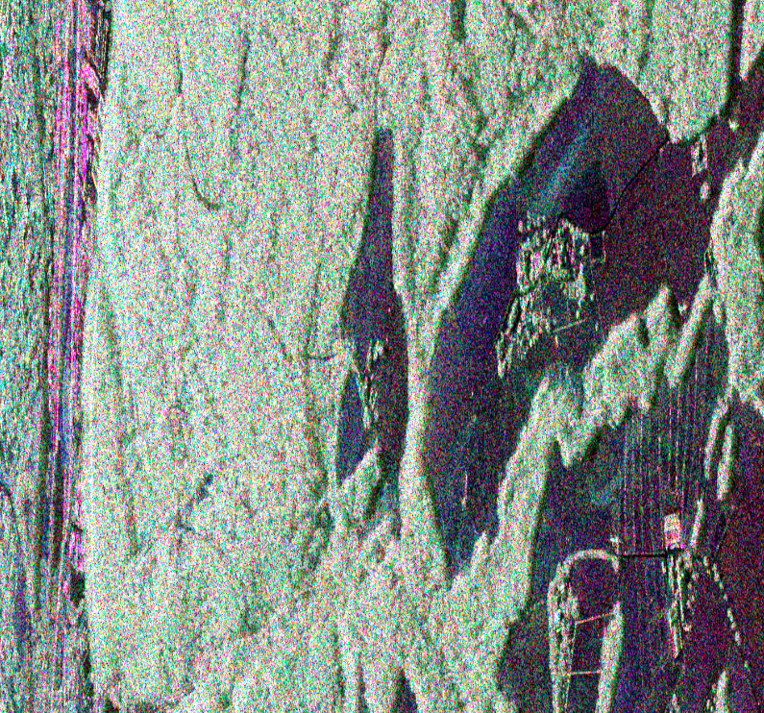
Figure 1. The pauli-RGB image of the mater data of the PolInSAR data set (Traunstein test site)

In the directory “kz-ph-mlk”, you can find the effective wave number file: kz.bin and the flat earth InSAR phase file: ph.bin, they are all in multi-look slant range geometry, the size of them is 220 line (rows)*707 pixels (columns).

So the multi-looks window size from [S2] matrix to [T3] should be 6 look in azimuth lines * 2 looks in range pixels. Figure 2 shows the kz.bin in ENVI, the left is the kz image, the right plane shows one horizontal line profile, we can see the kz changes from height value to low value from near range (left) to far range. Figure 3 is the flat earth InSAR phase, it changes from –pi to pi.
Figure 2 the kz image
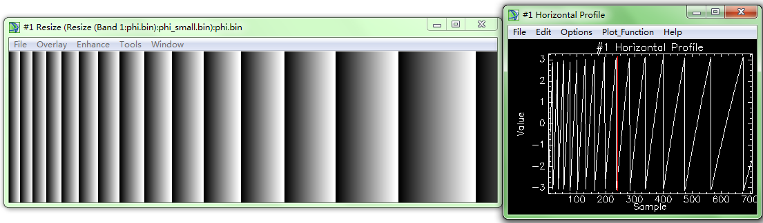
Figure 3 the flat earth phase image (warped phase)

In the “groundtrue” directory, we have two files, one is above ground biomass (AGB), another is forest height (FH). Both of them contents 8 forest stand level polygons, the value of the polygon equals the AGB or FH of this forest stand. Figure 4 shows the AGB image, the profile to the right shows the 8 forest stands, their AGB ranges from low biomass to high biomass. Figure 5 is the forest height image.
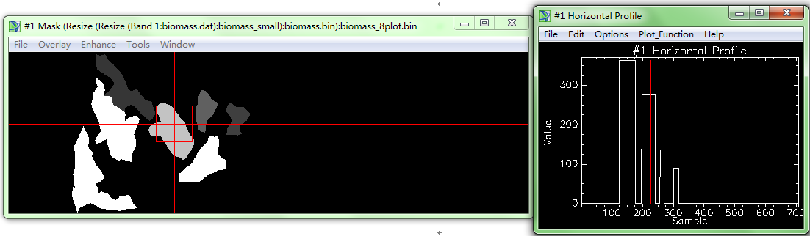
Figure 4 Forest AGB of the 8 forest stands
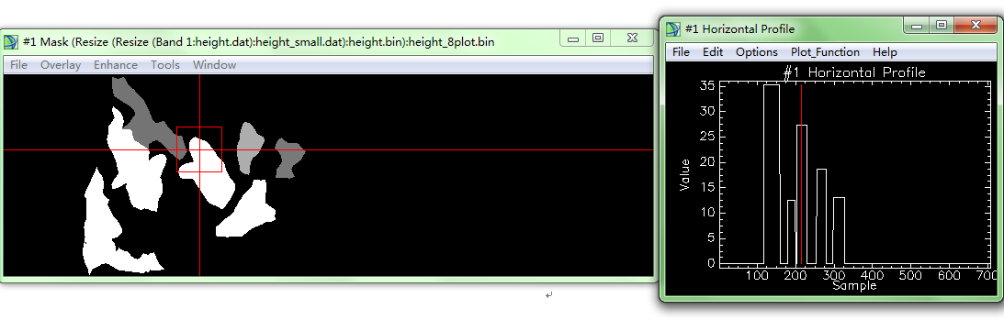
Figure 5. Forest heights of the 8 forest stands

Tutorial for forest height and biomass extraction

- Set the environment

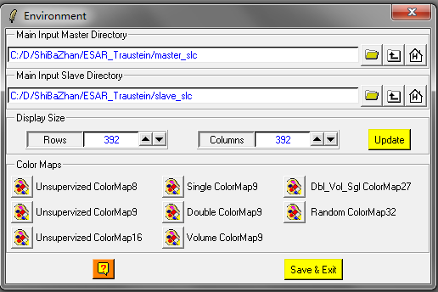
- Flat earth phase removal
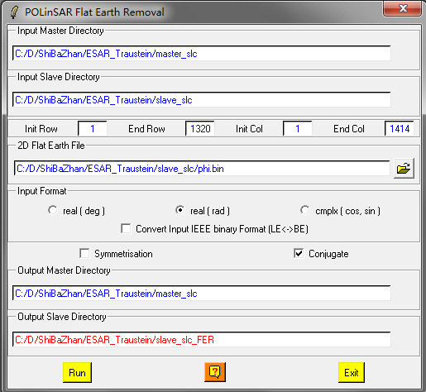

- Multi-look to generate the [T6] matrix of size 220*707
Speckle filtering
Main menuconvert
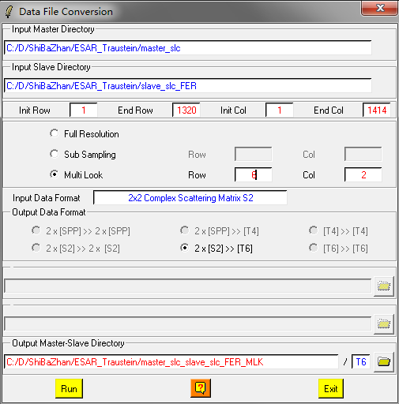

- Speck filtering
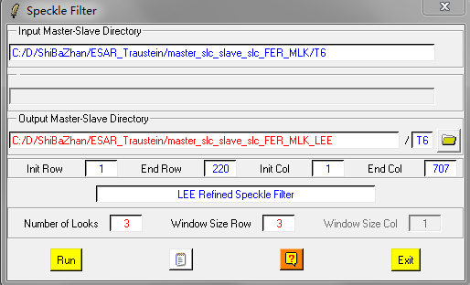

Check your [T6] matrix, the pauli-RGB image of master:
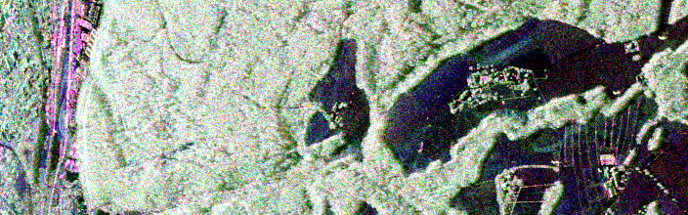
Mater image in Pauli-RGB

Run: main menuprocesscorrelation coefficients
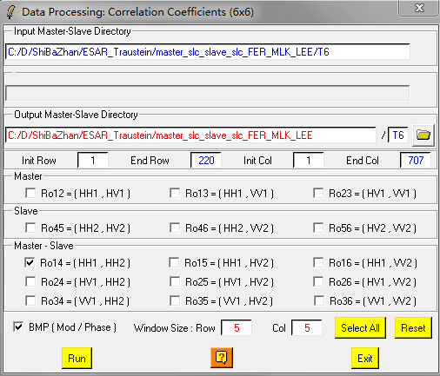
You should get the following phase image of the HH1-HH2
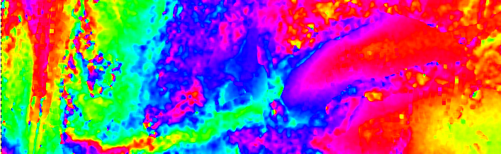

- Complex coherence estimation
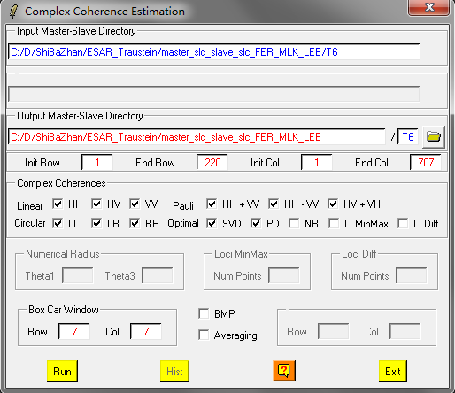
- Height estimation from inversion procedures
All the functions assuming we know the coherence whose InSAR phase is located to the top of the forest canopy, and the coherence whose InSAR phase is located at the ground surface under the canopy. So you have many choices to do the inversion. Here, we just choose HV, and HH-VV as the two coherences desired. You can try the other combination of coherences by yourself.
Here, we only demonstrate the Ground Phase Estimation and RVoG Inversion Procedure, you can try the other inversion method by yourself.
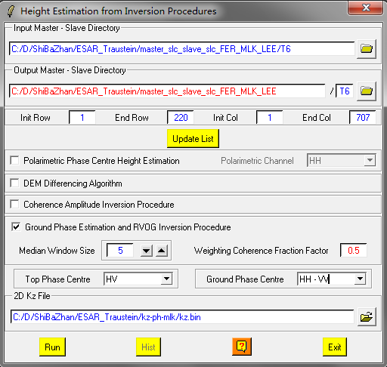

- PCT
- Run PCT parameters extraction
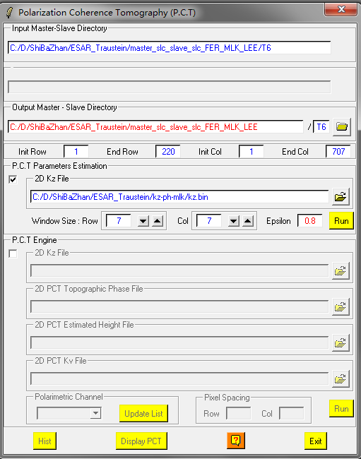

- Run the PCT engine to get the PCT profile
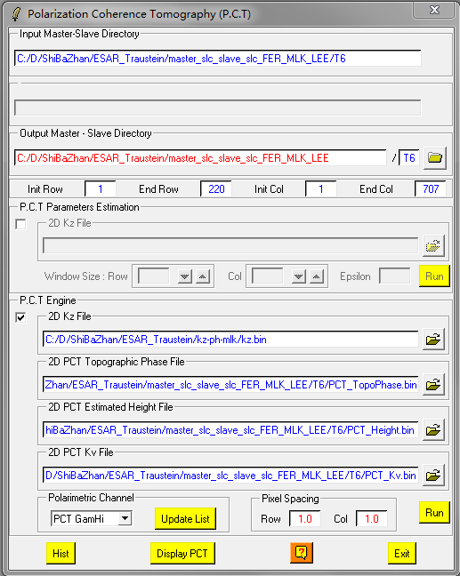

You can use the “Display PCT” button to check the PCT profiles.

