Installing OpenDroneMap on Windows
29-09-2023
Bas Retsios, WRS, ITC

Introduction
OpenDroneMap (ODM) is free and open source software for drone image processing. This document describes one of the methods to install WebODM. WebODM is the web-based version of ODM, whereby the ODM application is installed as a web-service on the computer, and interaction with the application goes through a web-browser (Edge, Chrome, Firefox). The advantage of this is that after getting some experience, WebODM can be installed on a central high-performance computer, and shared by multiple users. However in this document we focus on installing the entire WebODM suite on a personal computer or laptop.
This document is based on the official installation instructions that are available at the WebODM github page: https://github.com/OpenDroneMap/WebODM/. You can always revert to the official instructions if there is any issue with the description in this document.
For more information, and for ODM usage instructions, you can visit the main page of the OpenDroneMap project is https://opendronemap.org
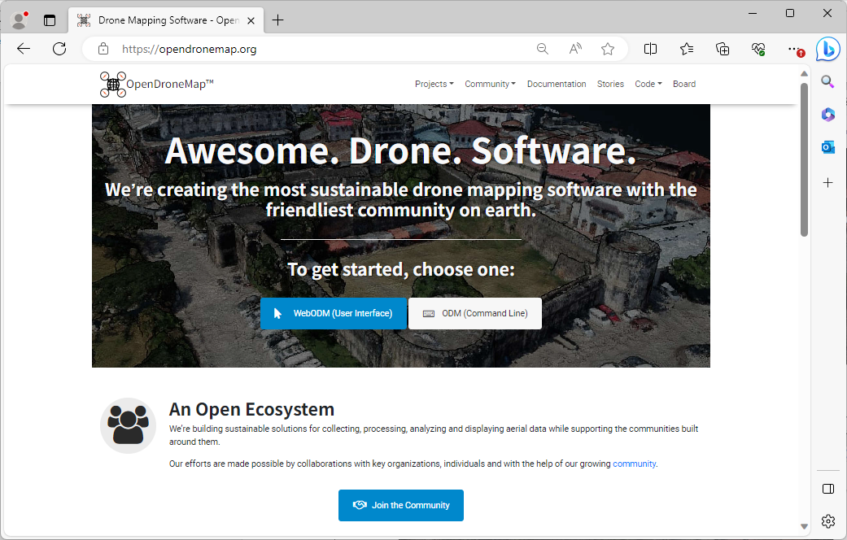
At the OpenDroneMap project page, navigation to the github page can be done by clicking the button labeled “WebODM (User Interface)”, then in the next page “Download”, and then “Go to GitHub” under “Manual Install”.
Installation of WebODM on Windows-based computers requires 3 steps:
- Installation of Linux on Windows
- Installation of Docker Desktop for Windows, using Linux as a backend
- Installation and configuration of the WebODM docker image
Depending on the speed of your internet, performing the installation as described in this document, should take approximately 30 minutes.

Install Linux on Windows
Since Windows 10, Microsoft has offered a method to integrate Linux with Windows. This is called WSL2 (Windows Subsystem for Linux, version 2).
Optionally you can deviate from this and use e.g. a method involving installation of VirtualBox. However the instructions here focus on WSL2, which is easier.
On freshly installed computers with Windows 10 or Windows 11, WSL2 is not installed.
To start the installation, open a Command Prompt with “Administrator” rights, as follows:
In the start / search, type cmd
The “start” menu will look like the screenshot. On the right side, look for the option “Run as administrator”, and click it.
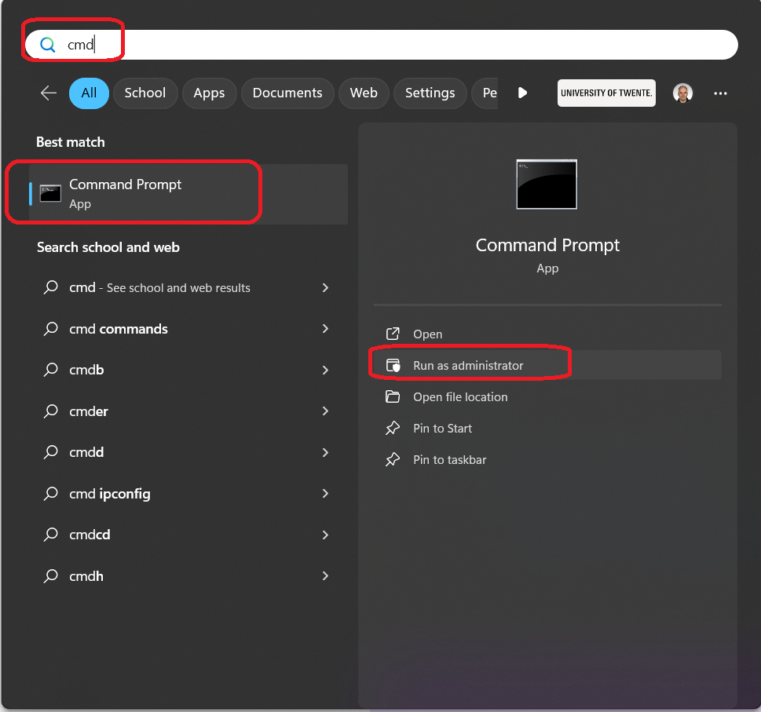
At this moment you will be prompted with the question “Do you want to allow this app to make changes to your device?”, with the app described as “Windows Command Processor”.
Click Yes to proceed.
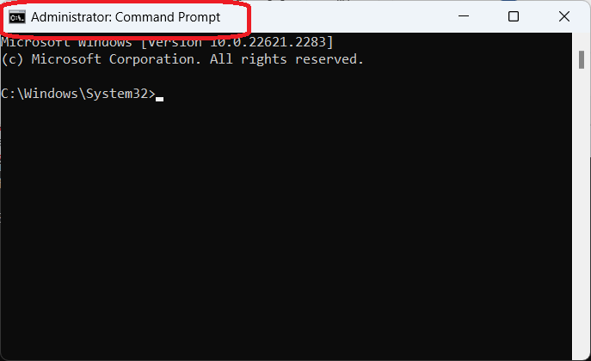
Confirm that the title of the command prompt window is “Administrator: Command Prompt”. If it is not, exit it, and repeat the instructions to start it again.
In the Command Prompt window, type the following command, and press ENTER.
wsl --install
The installation of WSL2 will start. During installation, you will be prompted with the question “Do you want to allow this app to make changes to your device?”, with the app described as “Host Process for Windows Services”.
Click Yes to proceed.
Note that (at the time of writing of this document), automatically Ubuntu 22.04 is installed. This is the long-term-support version of April 2022. There is no reason to deviate from this choice. WebODM works well with Ubuntu 22.04. The next long-term-support Ubuntu version will be 24.04 (April 2024).

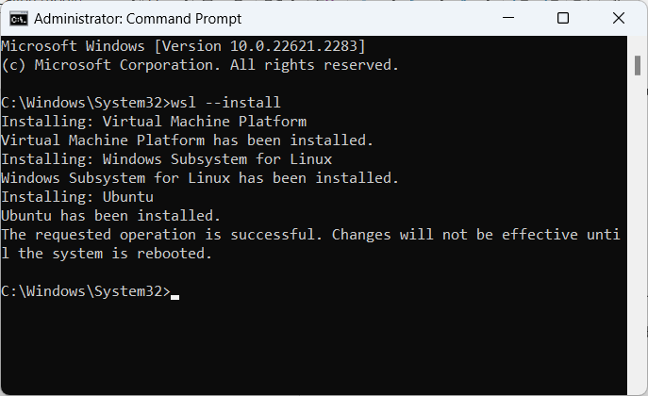
Restart the computer for the changes to take effect.
After reboot, you will be asked to create a new account on Linux/Ubuntu:
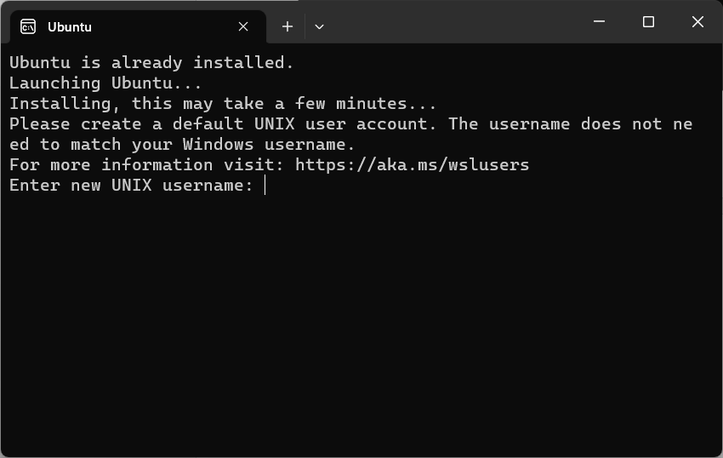
At the prompt “Enter new UNIX username”, type an account name that you would like to use for logging in to Linux/Ubuntu under WSL2.
E.g. odm
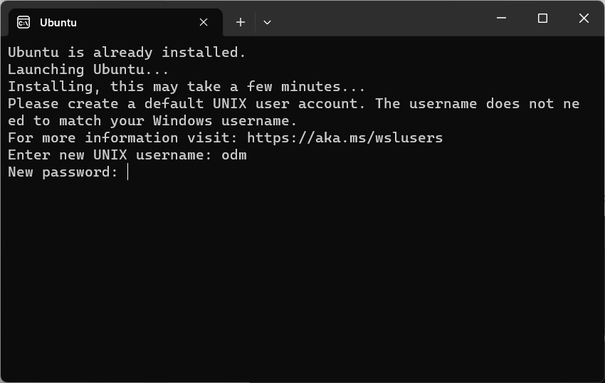
Then type a password that you would like to use. E.g. odmodm
Re-type the same password to confirm it.
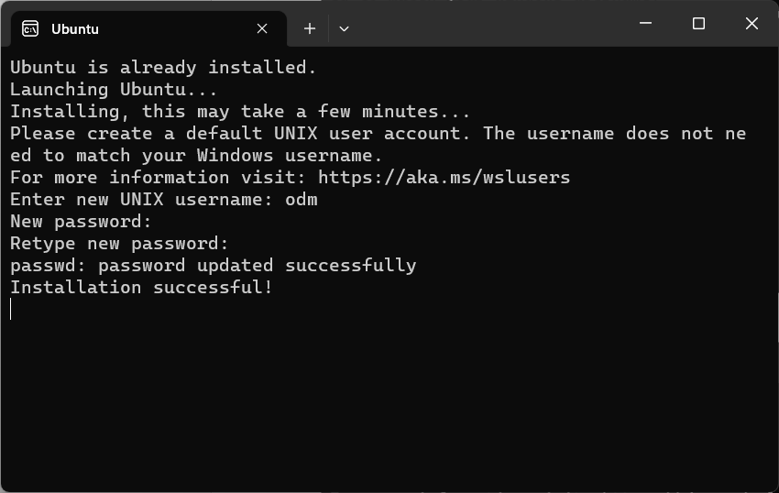
The installation of WSL2 is now complete. You can close the Ubuntu prompt.

Install Docker Desktop
Click the following link to go to the Docker Desktop on Windows installation page.
https://hub.docker.com/editions/community/docker-ce-desktop-windows
Click the “Docker Desktop for Windows” button to download the “Docker Desktop installer.exe” file.
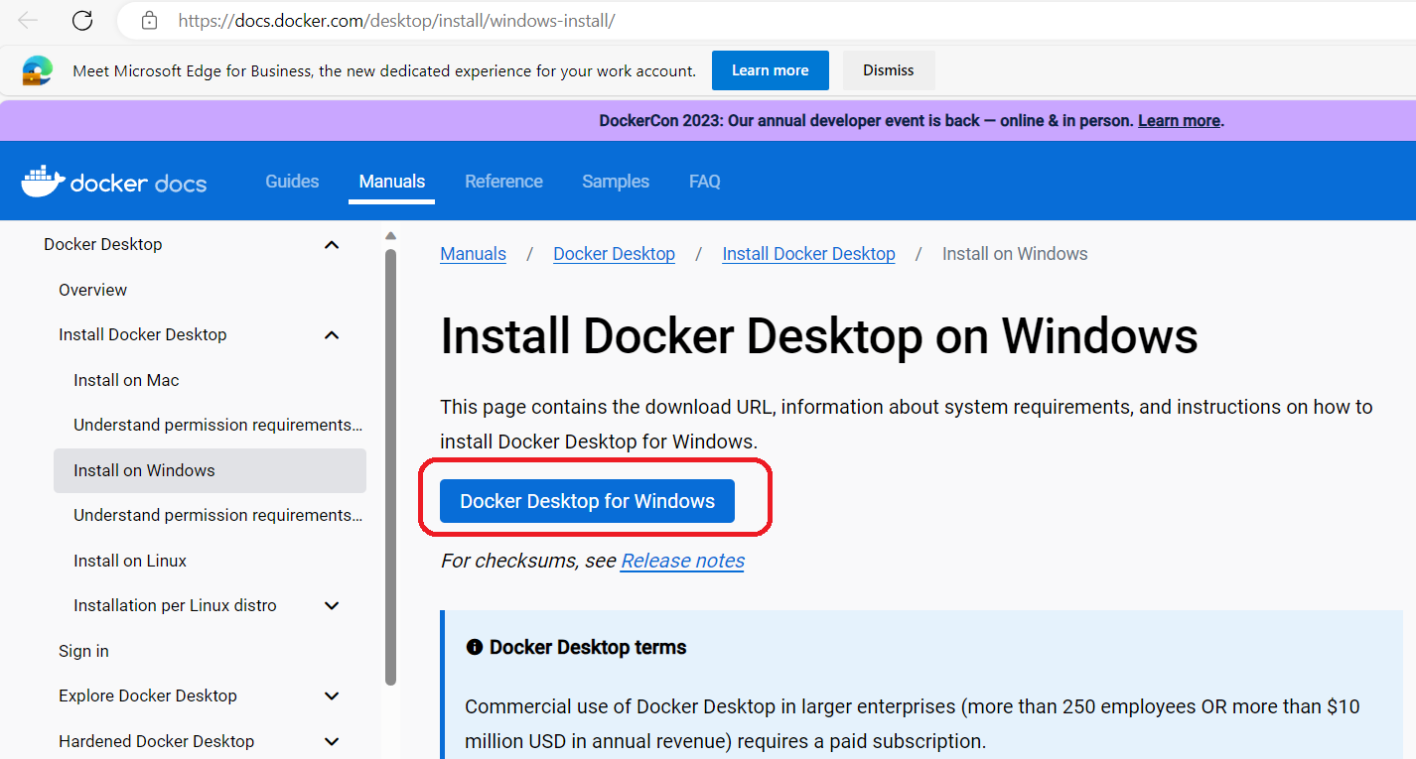
Depending on the browser that you are using, there will be some way to see the download progress, and then the file will likely be stored in your Downloads folder.
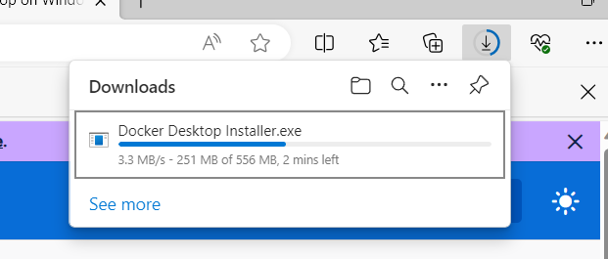
When finished downloading, click the downloaded file “Docker Desktop Installer.exe” to execute it.
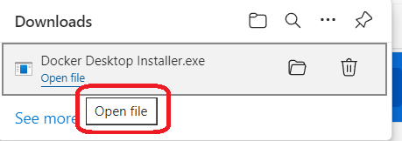
You will be prompted with the question “Do you want to allow this app to make changes to your device?”, with the app described as “Docker Desktop installer”.
Click Yes to proceed.
Then the installation will start. On the first page, click OK to continue.
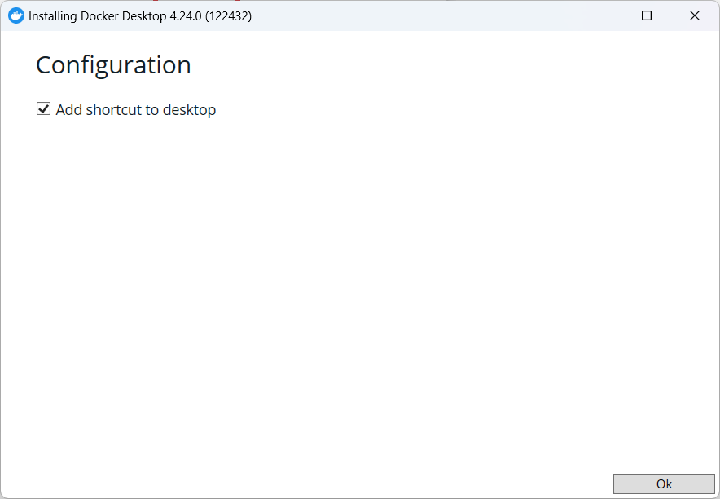
The next page looks as follows:
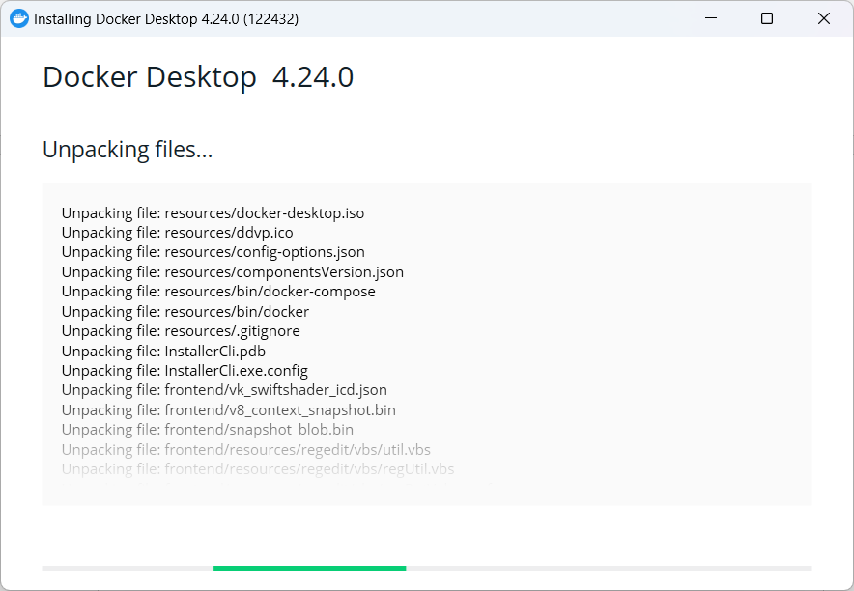
When finished, you will be prompted to restart the computer.
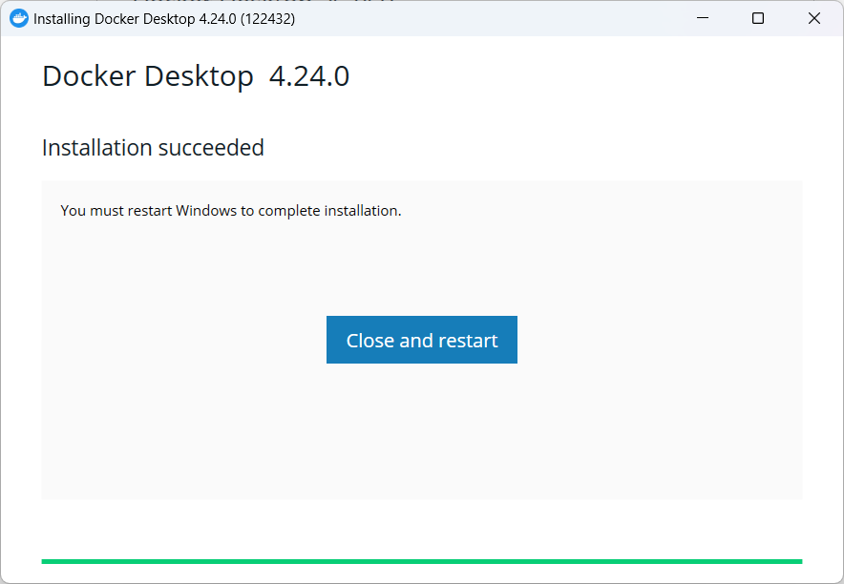
Click the “Close and restart" button to restart the computer.
After the restart, you will be prompted with the Docker Subscription Service Agreement.
You may read the documentation to check what you are agreeing with. When done, click “Accept” to continue.
At the next page, click “Continue without signing in”.
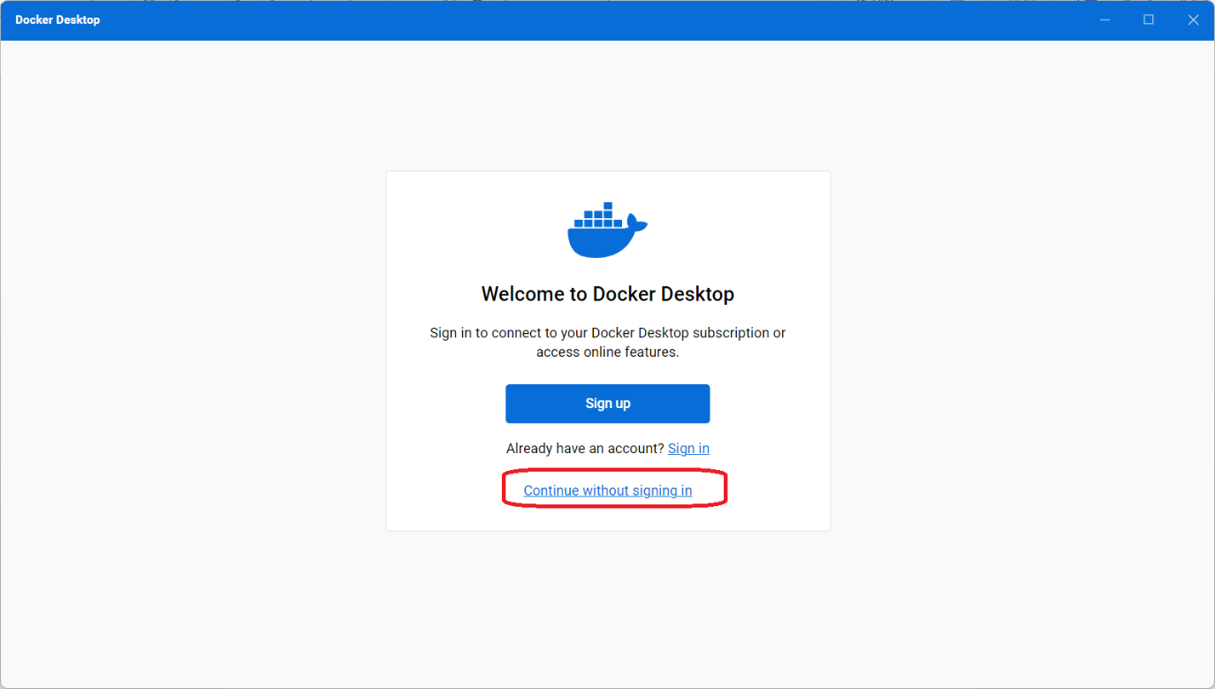
Then you may optionally select the role that most applies to you and the use of Docker, and click Continue (you may also click Skip).
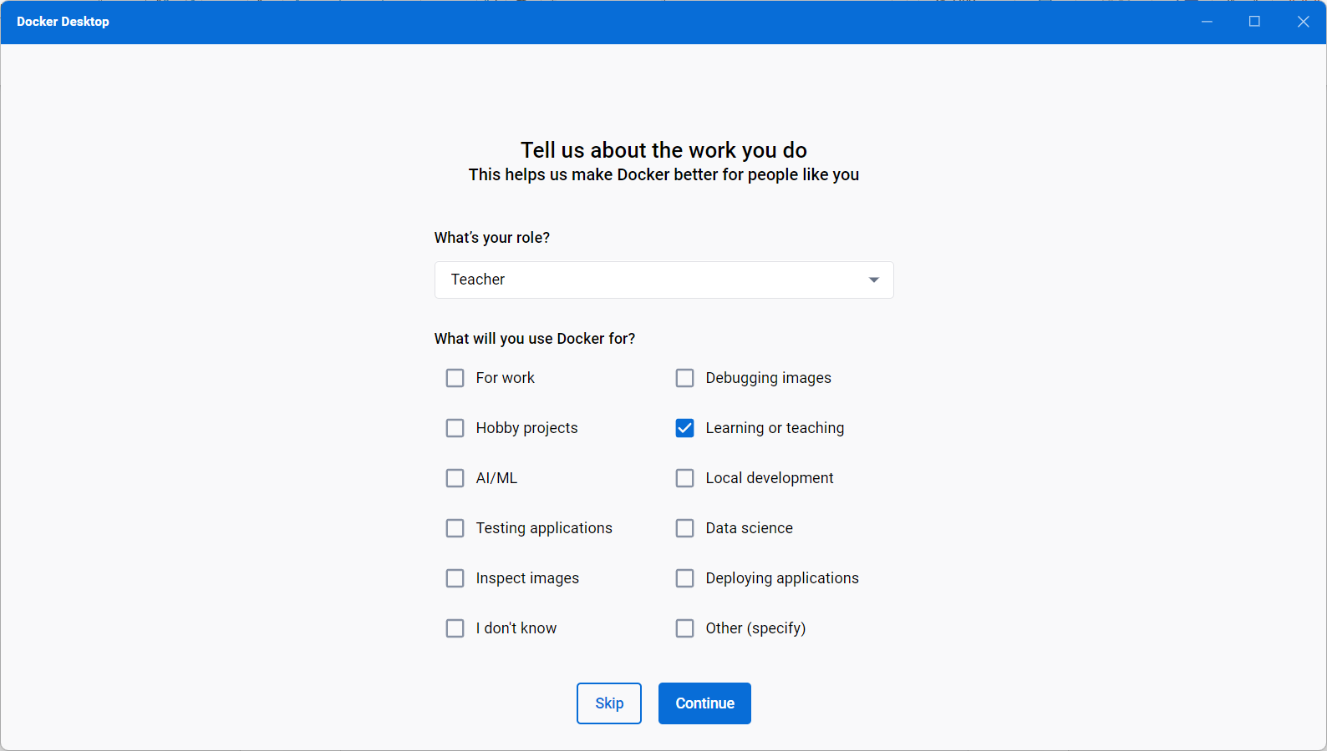
Docker is now successfully installed.
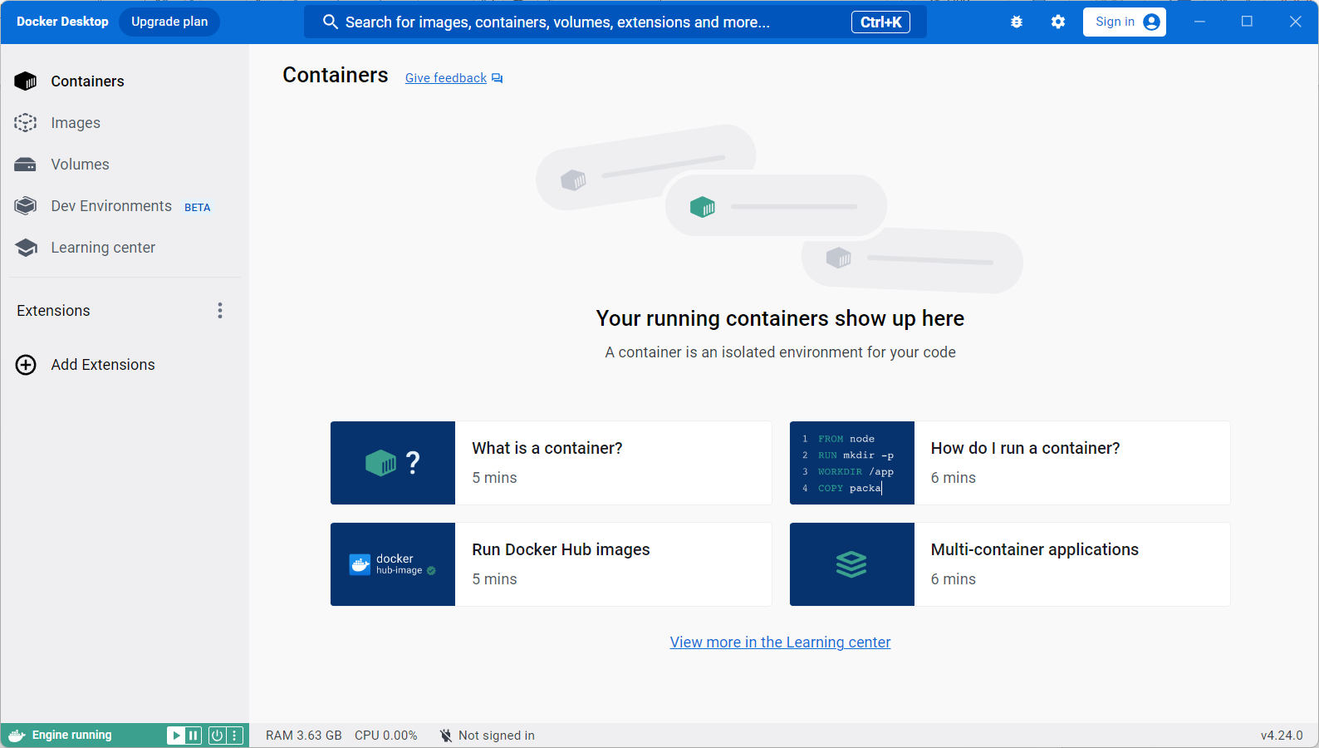
You can close the “Docker Desktop” window.

Install WebODM
Start the Windows Subsystem for Linux app. In the start/search, type linux or wsl to find it.
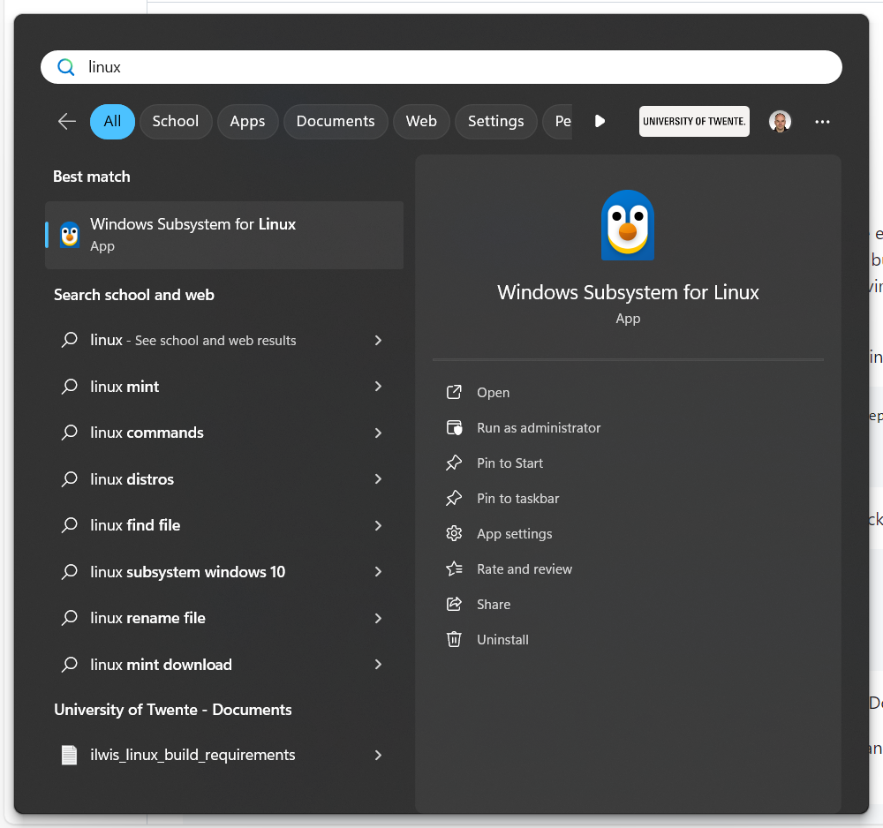
The Linux command prompt will start.
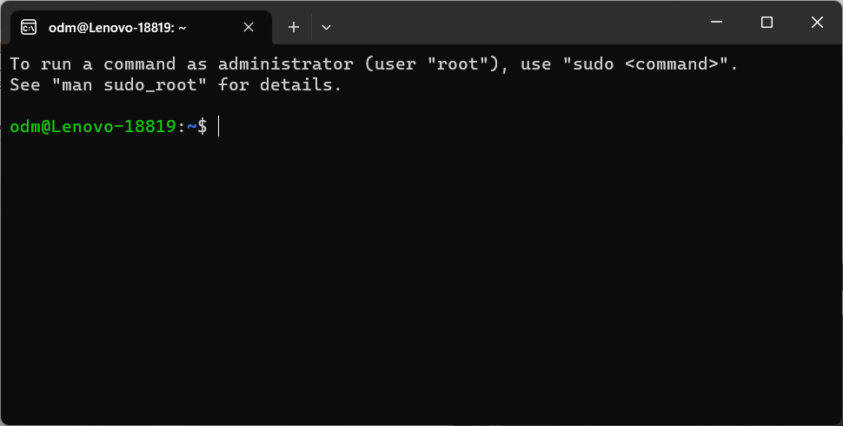
Copy/paste (or type) the following command in the linux terminal.
git clone https://github.com/OpenDroneMap/WebODM --config core.autocrlf=input --depth 1
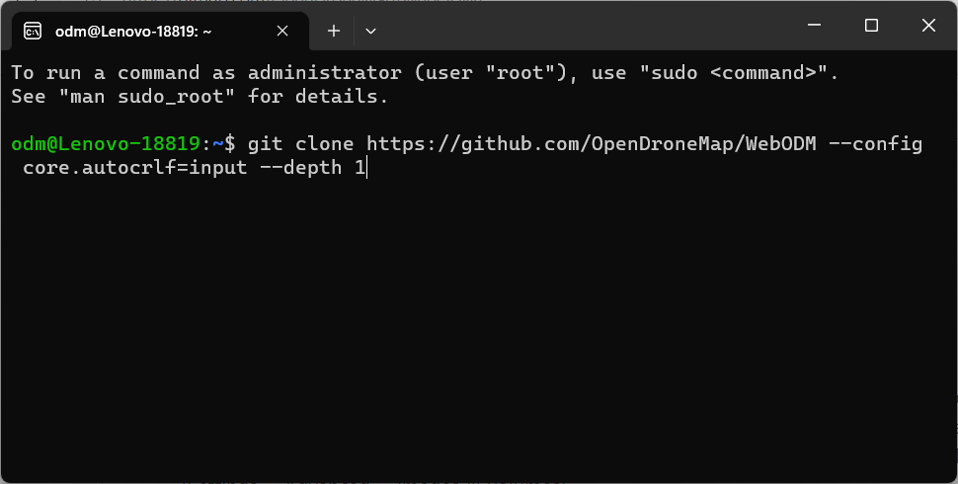
Press ENTER to execute the command.
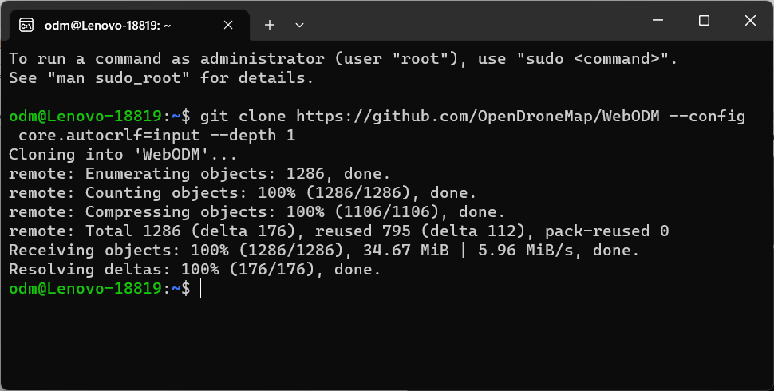
This downloads the WebODM installation script and its components from github.com .
When done, type the following two commands in the Linux command line to start the installation.
cd WebODM
./webodm.sh start
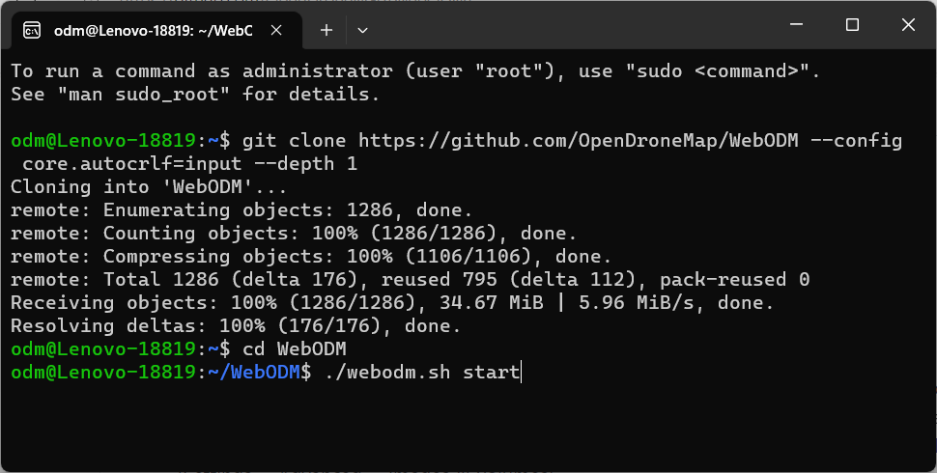
The so-called docker images for WebODM will be downloaded (“Pulled”) from the internet.
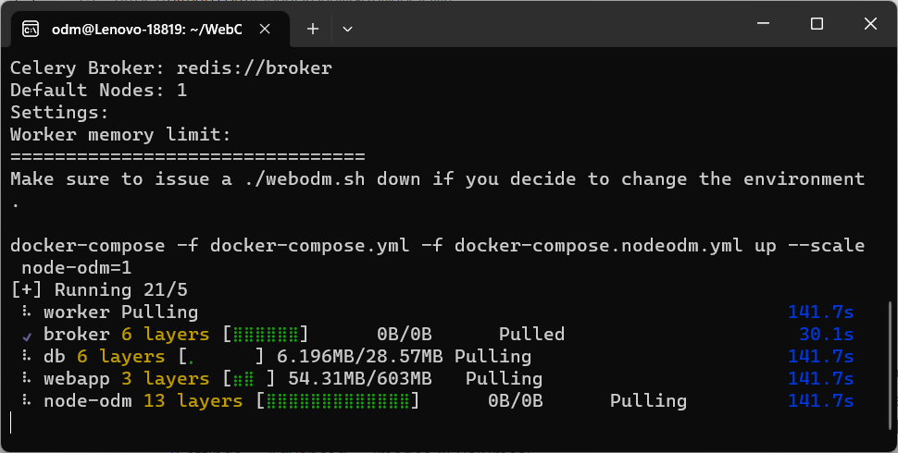
When asked, click the “Allow access” button to allow the “Docker Desktop Backend” through the Windows Defender Firewall:
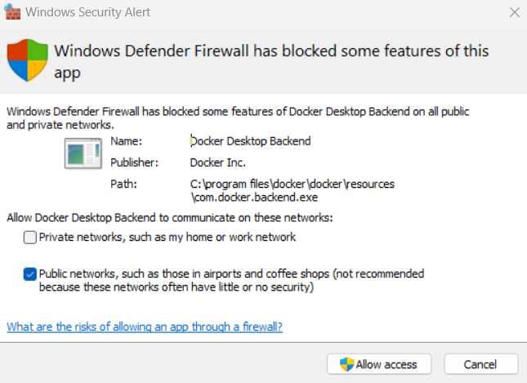
WebODM will start after the download is complete.
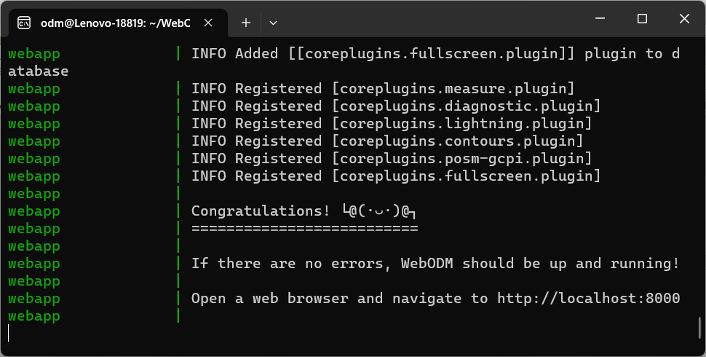
WebODM starts a web-server on the computer, serving the WebODM pages.
Use your browser to navigate to http://localhost:8000 to open the main WebODM page.
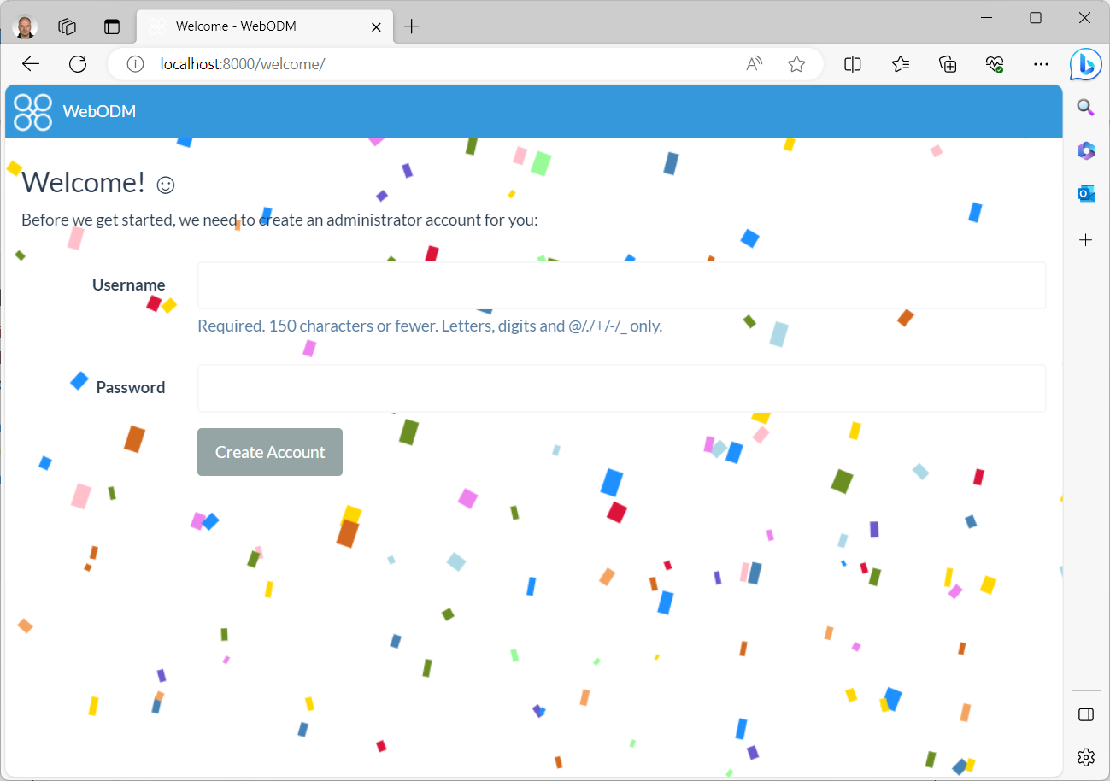
The first time you need to choose a new username and password (e.g. odm, odmodm). Click Create Account to create the user.
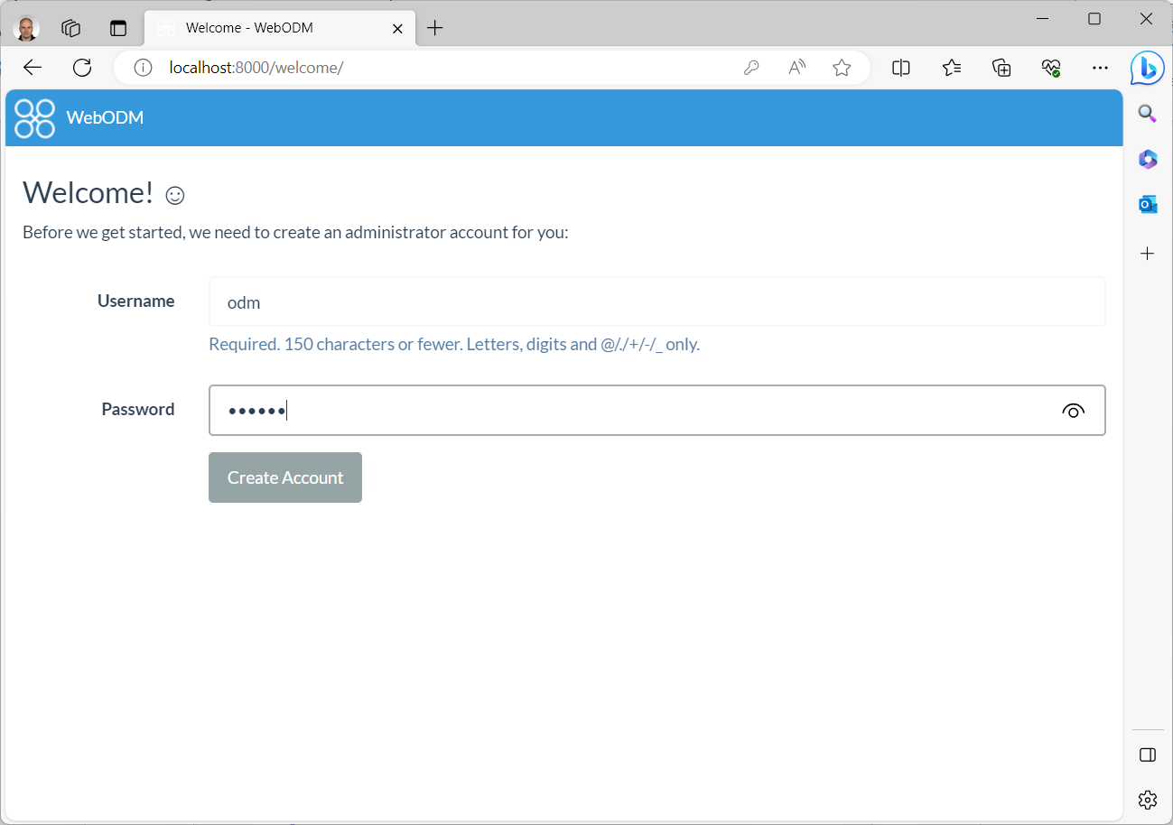
You are now connected to the WebODM application page. You can start working with WebODM.
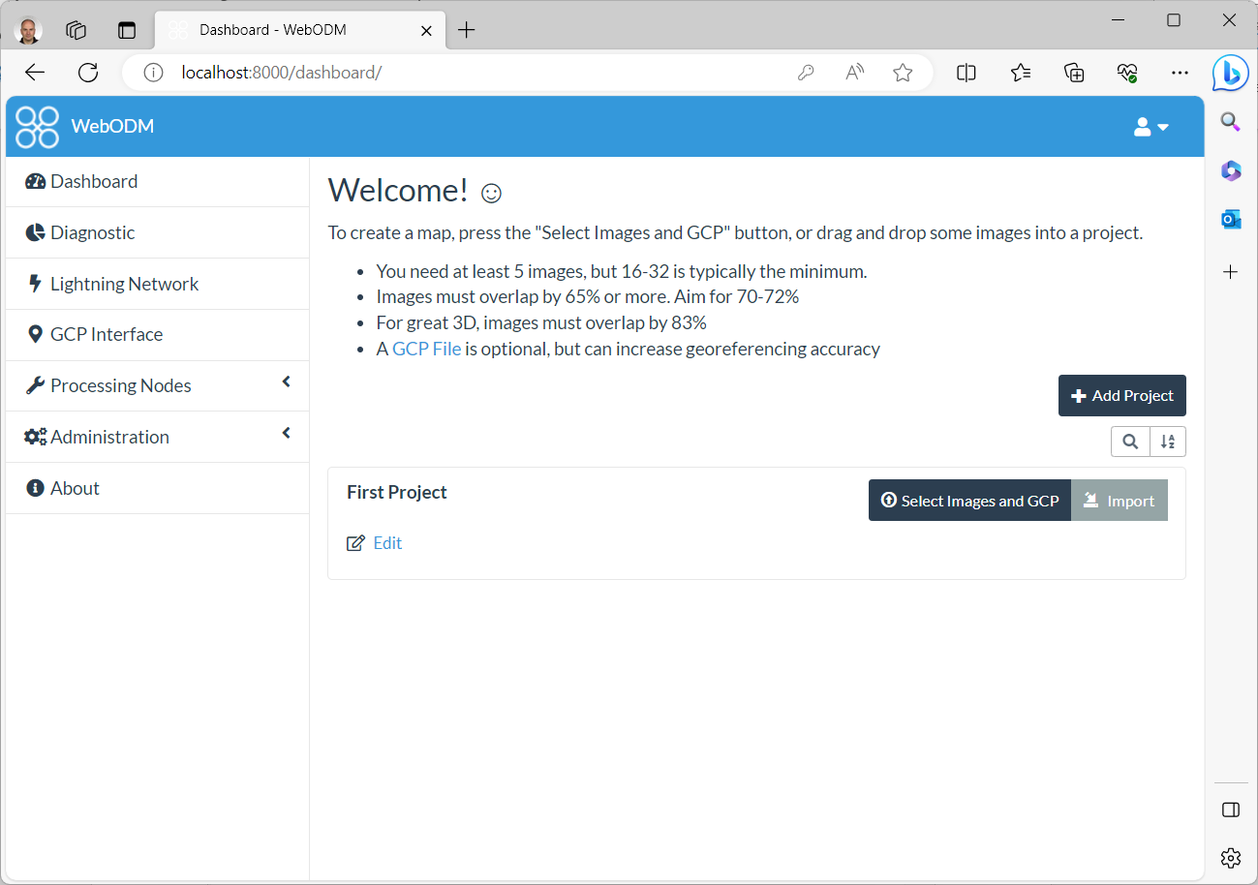
In Docker Desktop you can also confirm that WebODM is up-and-running:
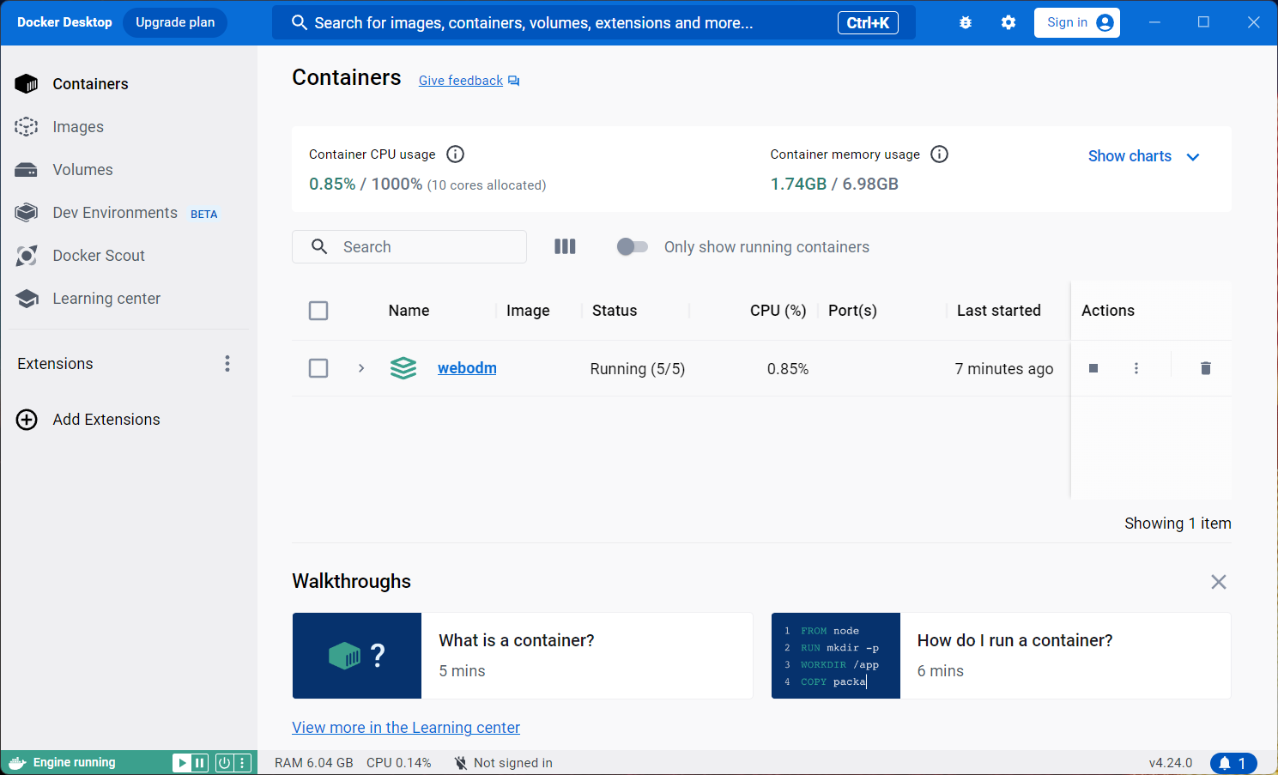
You can close the Docker Desktop window and the WebODM Dashboard page at any time. You can also shutdown the computer at any time.

Starting WebODM
The next time you start the computer (after a shutdown or restart), you must start the WebODM docker containers manually if you wish to use WebODM. To do so, double-click Docker Desktop in order to start the webodm image.
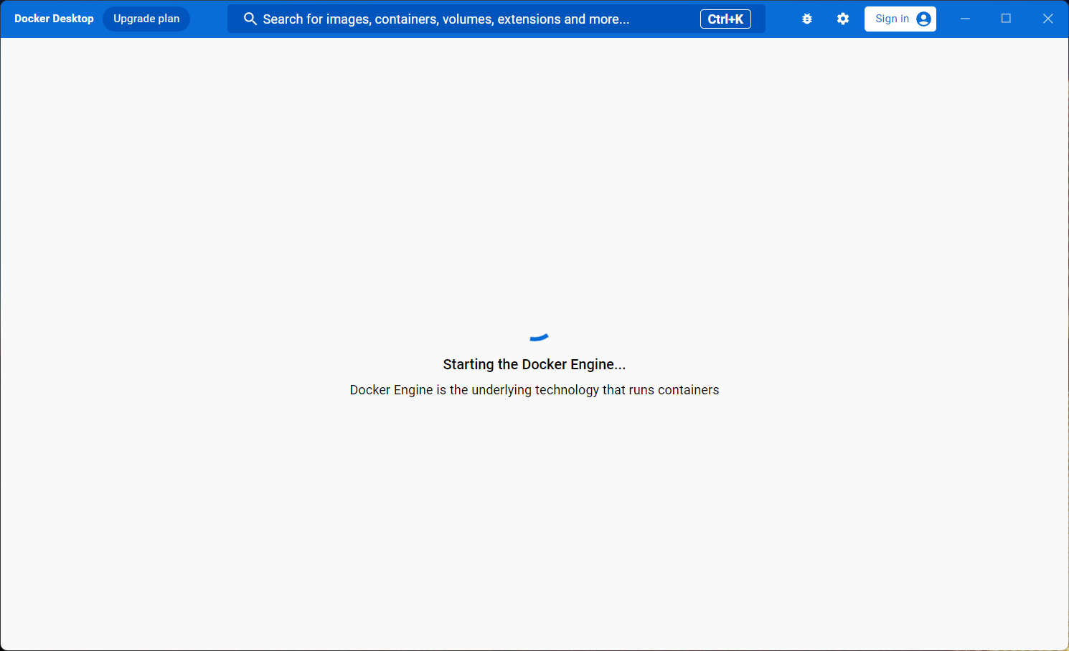
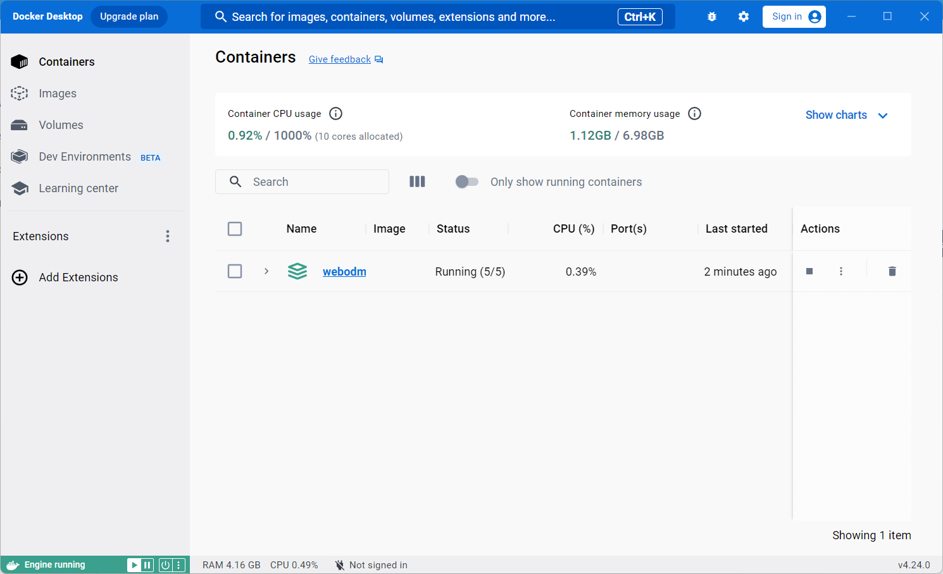
Like before, use your browser to navigate to http://localhost:8000 to open the WebODM application page.

