Date:20/06/2019
Ref.:??????
Version Nº:0001

Ethiopian Education Network to Support Agricultural Transformation (EENSAT)

Course Title: Establish, update and maintain EENSAT LMS
Lesson No: 01, Windows Setup

 | Name | Responsibility
Prepared by | Ivan Oliveira | e-Learning Specialist at University of Twente, ITC
Reviewed by | ???? | ???

Windows Setup

Ivan Oliveira, 20/06/2019

OpenCourseWare

Contents
1 Introduction 2
1.1 Overall learning objectives 2
2 Prerequisites 2
3 Best practices 2
4 Clean the computer (optional step) 2
4.1 Instructions 3
5 Setting up a new Windows computer 8
5.1 Instructions 8
6 Adjusting the power 14
6.1 Instructions: 14
7 Adjusting time configurations 18
7.1 Instructions: 18
8 Windows Update 20
8.1 Instructions on updating the system: 20
8.2 Instructions on configuring the updates: 21
9 Concluding remarks 25

Introduction
This document will walk you through basic windows configurations that you might need to check before you start actually setting up web services.

Prerequisites
- Have a Computer available to perform the tasks on.
- Active internet connection (preferably via cable, not wireless)
- Have Windows 10 installed on the computer.
- Basic computer skills (Windows)
- Have no other software besides the necessary for the webserver installed in the system (look at the next chapter for clarification and solution)

Best practices
This computer will be a production webserver. This means that we should avoid using it for anything other than its task of serving webpages. Any other task or any software installed alongside the webserver can interfere with the performance of the machine. Please follow the best practices below to ensure the system continues to work properly:
- Do not install software in the server unless specified in the guides.
- Do not install Anti-Virus or Anti-Malware software (Windows 10 has its own built-in security).
- Document any change you make to the computer.
- Write down or save digitally any password used during the guides and store this information safely whether it’s digital or physical.
- Do not use the computer for any other task rather than serving Moodle (do not browse websites, configure personal emails, etc).

Clean the computer (optional step)
Before we do anything to the computer it’s important to confirm that it was not used for anything else before.
When we are serving websites from a computer in a production environment, we do not want to have any other software installed or running on the same system. Unnecessary software will slow down the computer, take hard-drive space, take memory and even worse: might interact with your server software.
The tutorial on cleaning the computer can be skipped in case you are sure that the computer has a clean Windows install already.

Instructions
IMPORTANT: Before you start this process, please make sure you understand that this will delete all files and all user information in the computer with no chance to recover it. If your computer has been used before and you have saved files to it in the past, please save all the files to another location (an external hard drive or USB stick) before continuing.
Click on the Windows (Start Menu) button, and then on the cog (Settings) icon
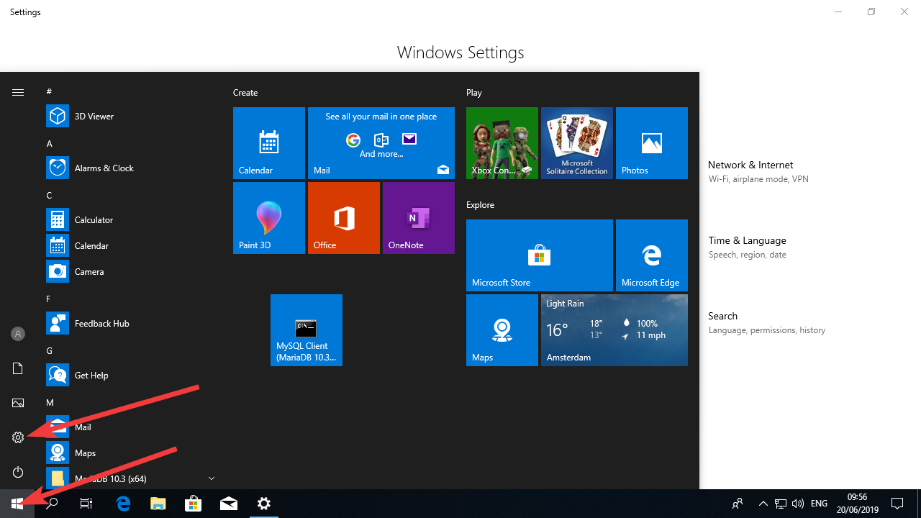
Click on “Update and Security”
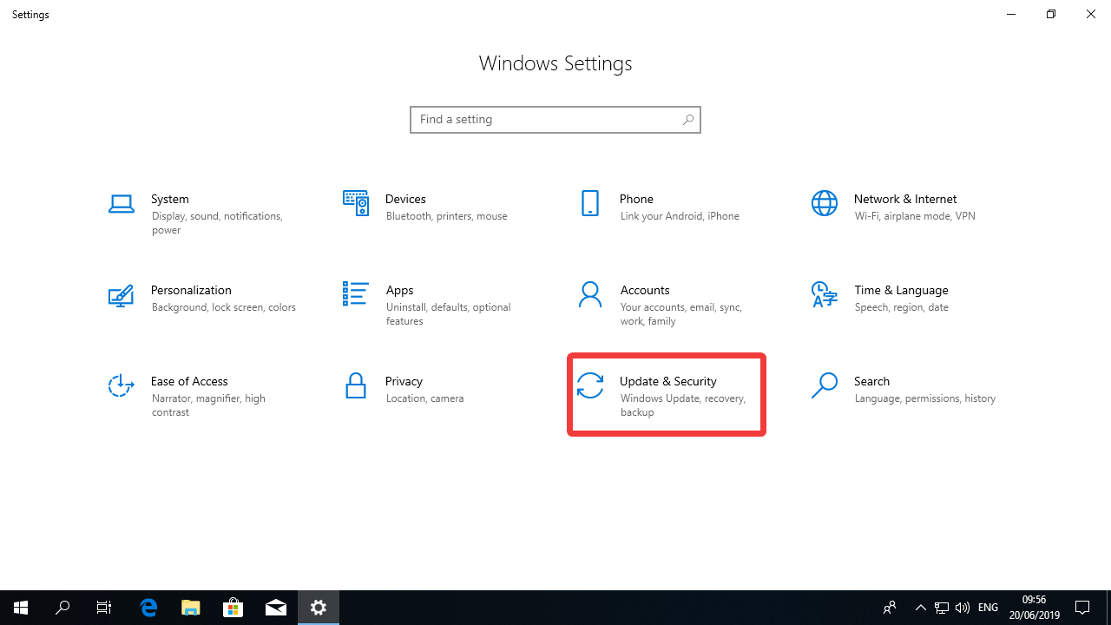
Select “Recovery” on the menu on the right.
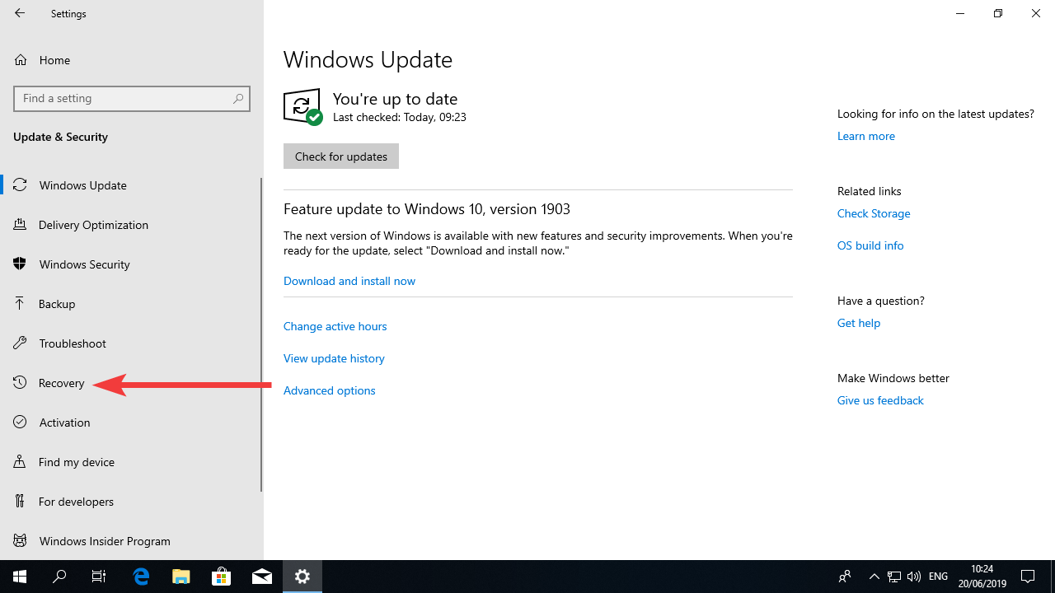
Under “Reset this PC”, click “Get Started”
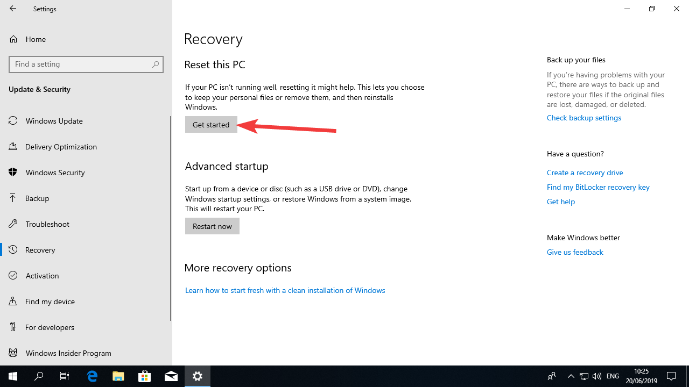

Click “Remove everything”.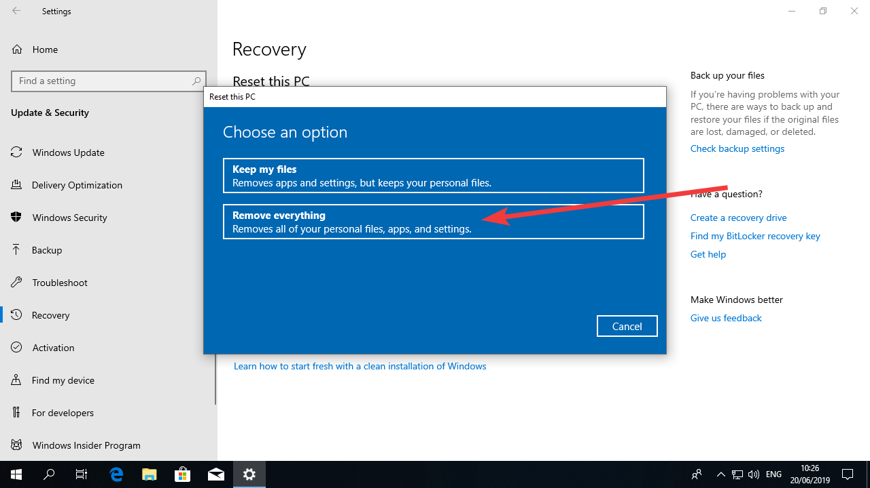
Select “Just remove my files”
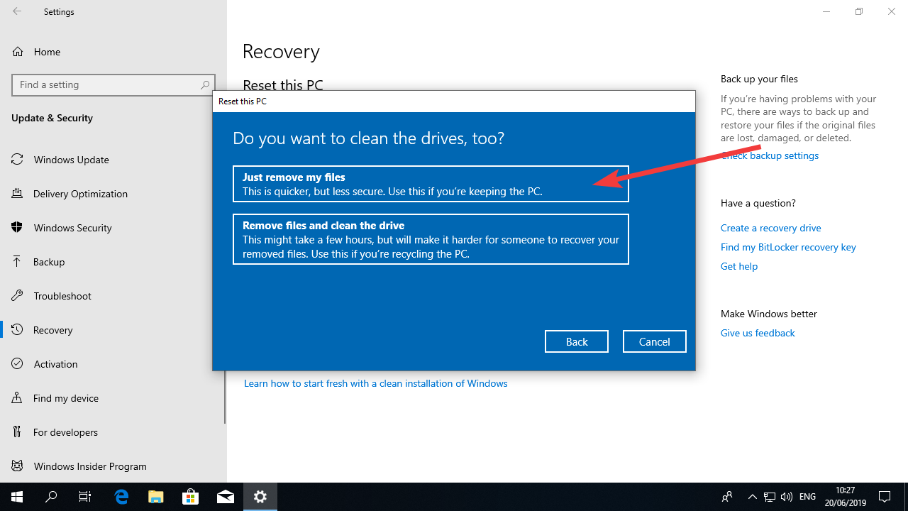

Click in “Reset”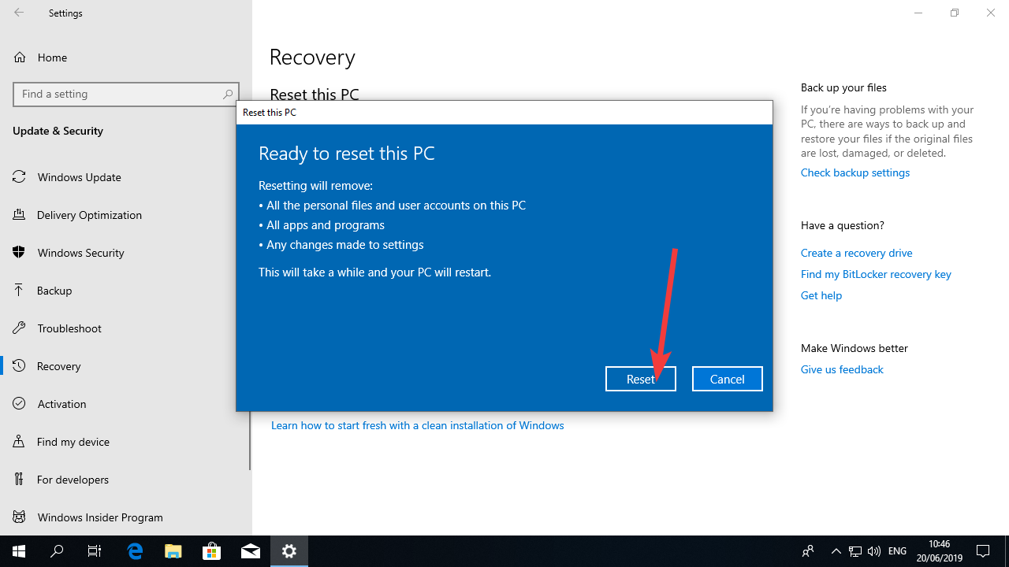
After that the computer should perform a number of tasks automatically and restart.
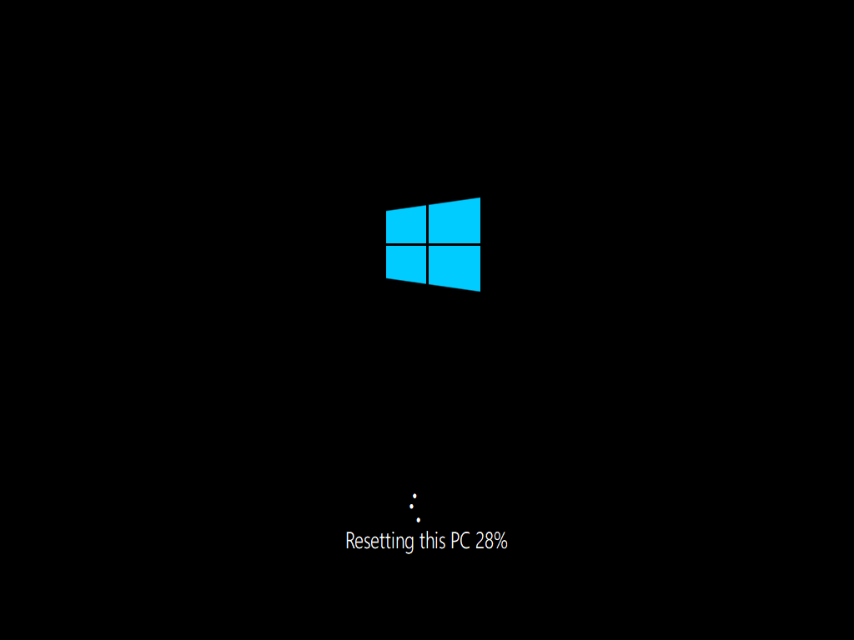
Once the PC is reset, you will need to configure it as a new PC (create a username and password, configure locale, date, time, etc. Please follow the instructions below to perform this task.

Setting up a new Windows computer
For the first time you turn on a new computer or after a factory reset, you will have to go through the installation procedure. Unfortunately, this procedure can change with the release of a new version of Windows. This part of the guide can get out of date by the time you apply it.

Instructions
Select you region. In the example I selected Netherlands, but as you are located in Ethiopia, please select Ethiopia. And then click on “Yes”.
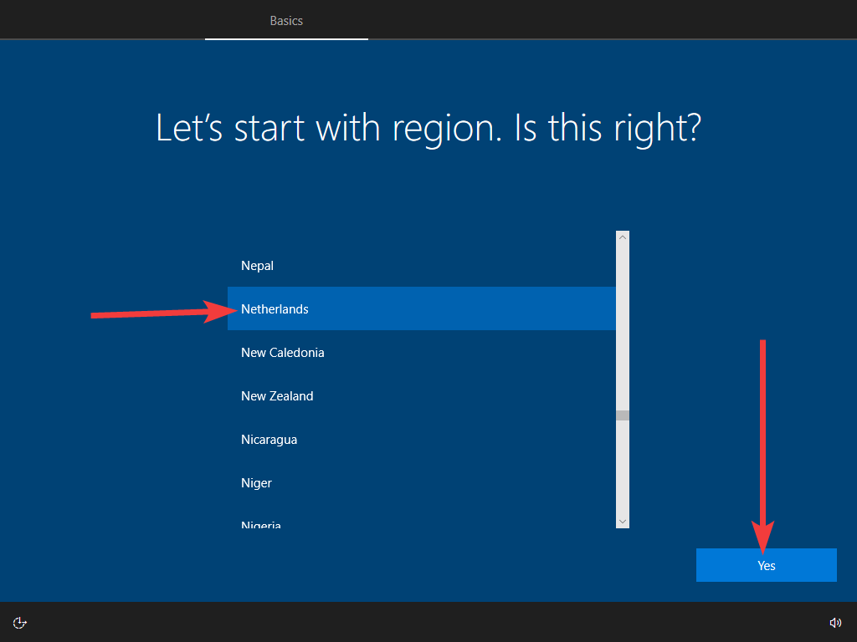
Select the type of keyboard connected to the computer. In my case, this is a “United States – International” keyboard. Select the one you use and click “Yes”.
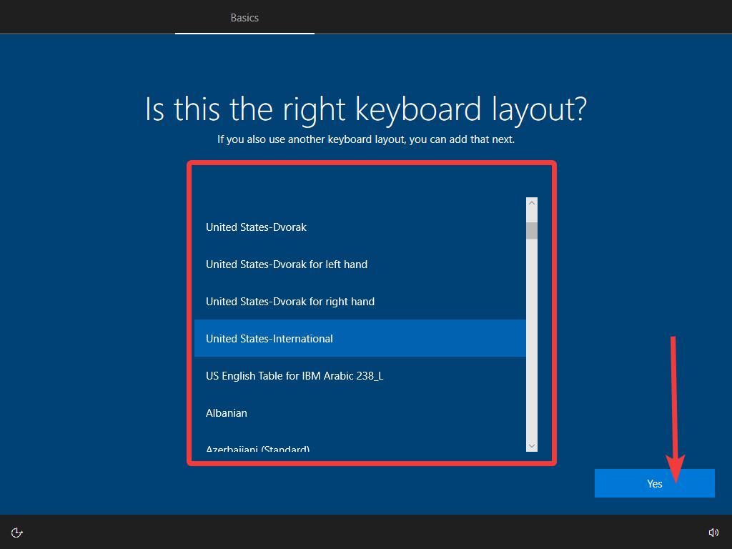
If windows asks you if you want to add a new keyboard, click “No”.
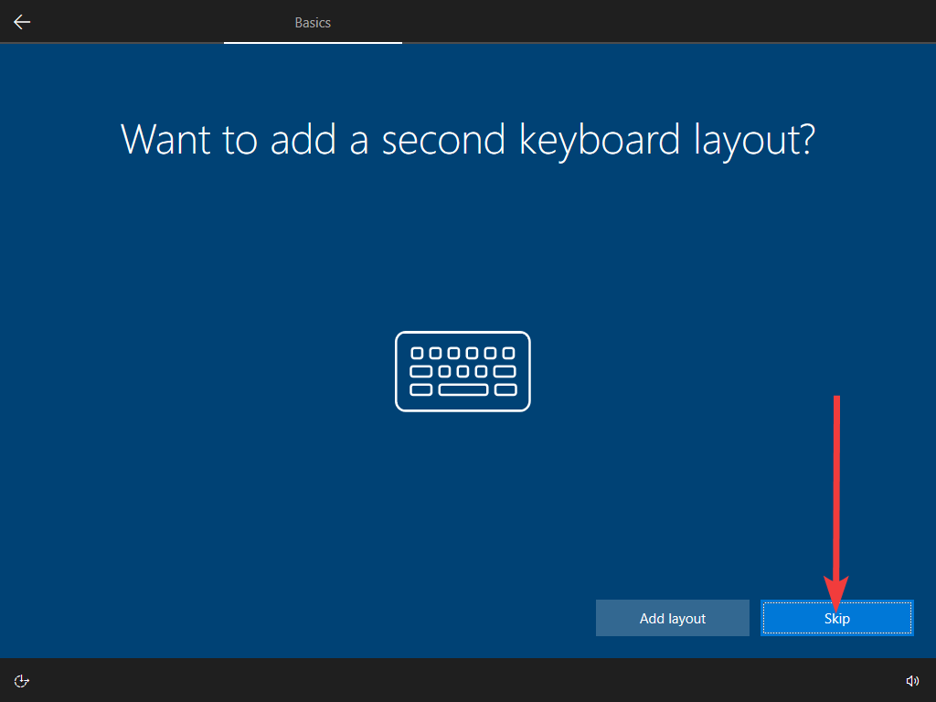
Click “Accept” in the License Agreement page.
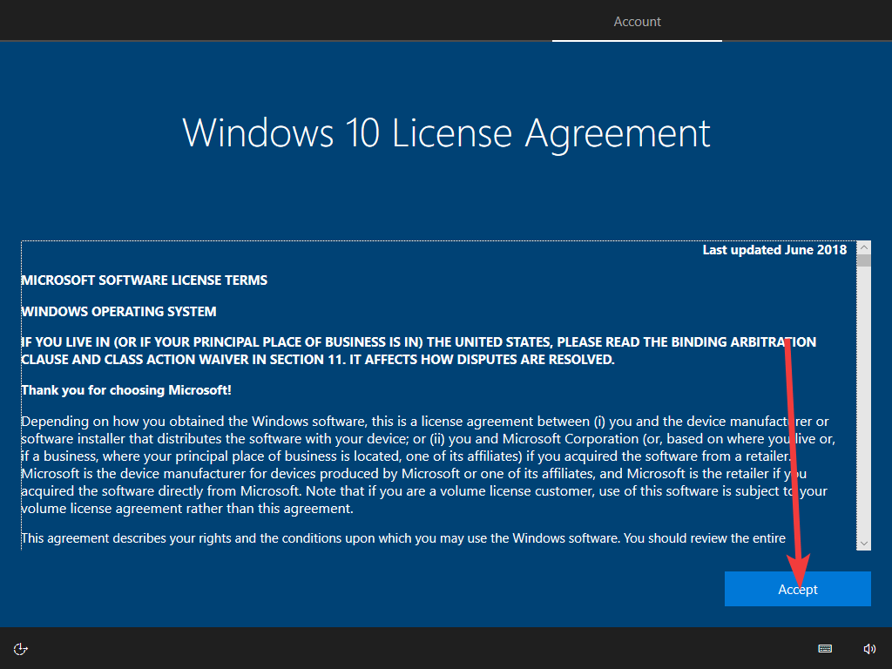
Now it’s time to create an account. We are not going to use a “Microsoft account” so you must click in “Offline account”.
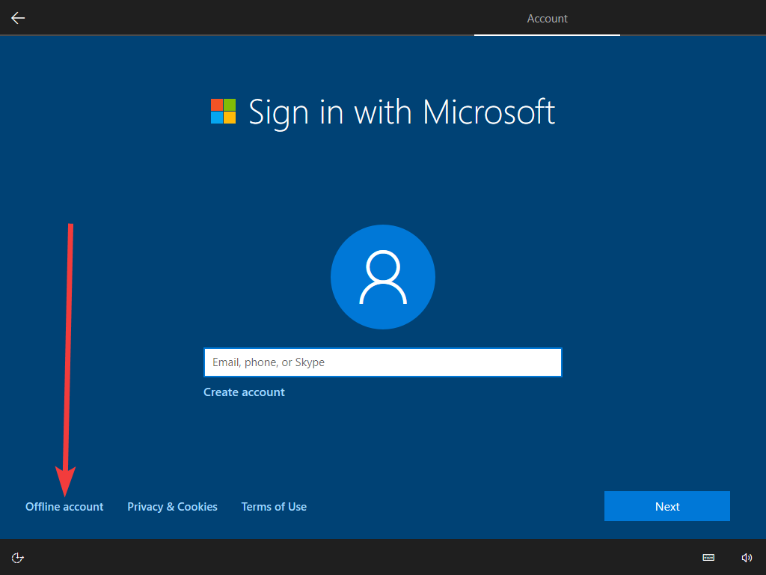

Create a username. The username in the example is eensat-itc, this should be eensat-bdu, eensat-mu or eensat-aau depending, of course, on your location. Click “Next”.
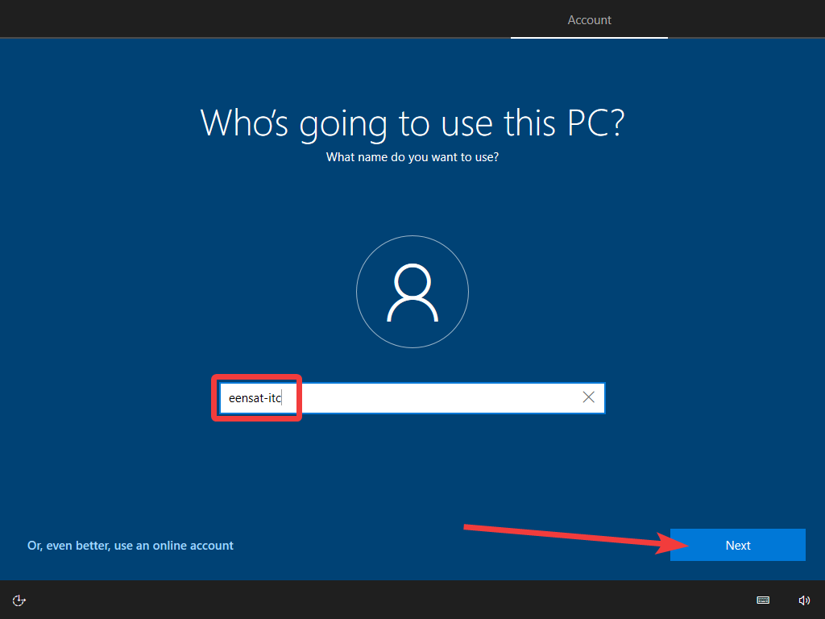

Now is time to create a password. This is important so please pay extra attention to this step.
- You can choose a password that makes sense to you. Don’t mind about using strange characters like “!” or “#”. Just use letters and numbers and make it 10 characters or longer.
- Write the password down on a sheet of paper.
- You will be asked to select questions and provide answers to these questions in the next screens. Please write down these questions and the answers you provided in the same paper.
- Once you’re done. Put this paper in an envelope and store it somewhere safe (and don’t forget where you stored it).
- Also email all the usernames and passwords you use to the e-learning specialist at ITC for safeguard.
Type in your password and click Next.
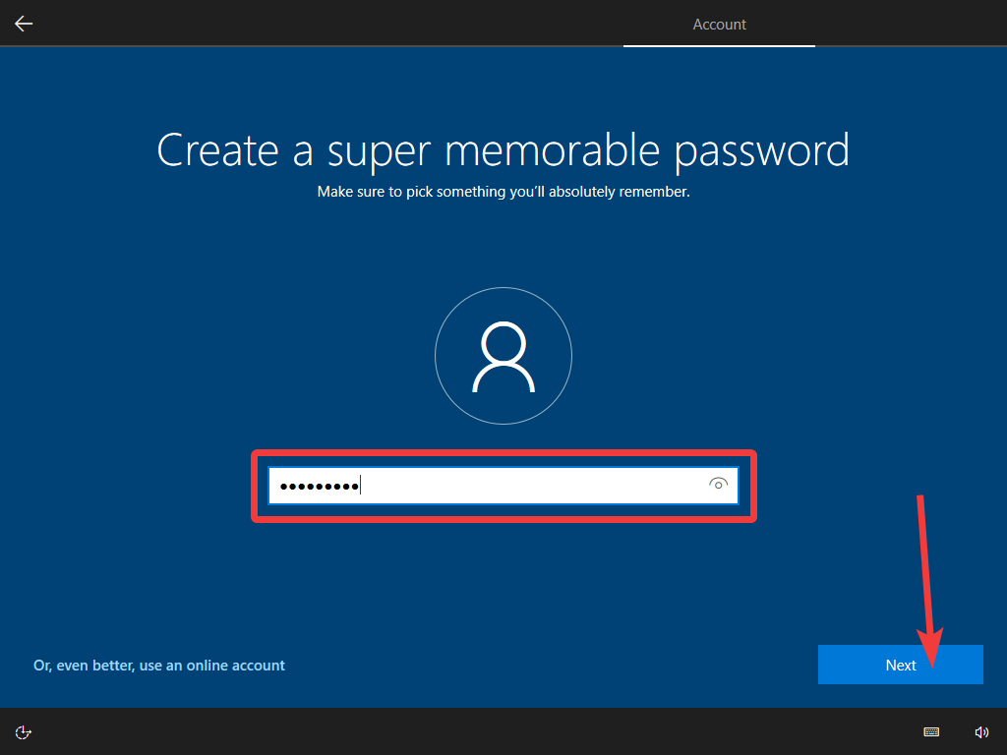

Type the password again to confirm.
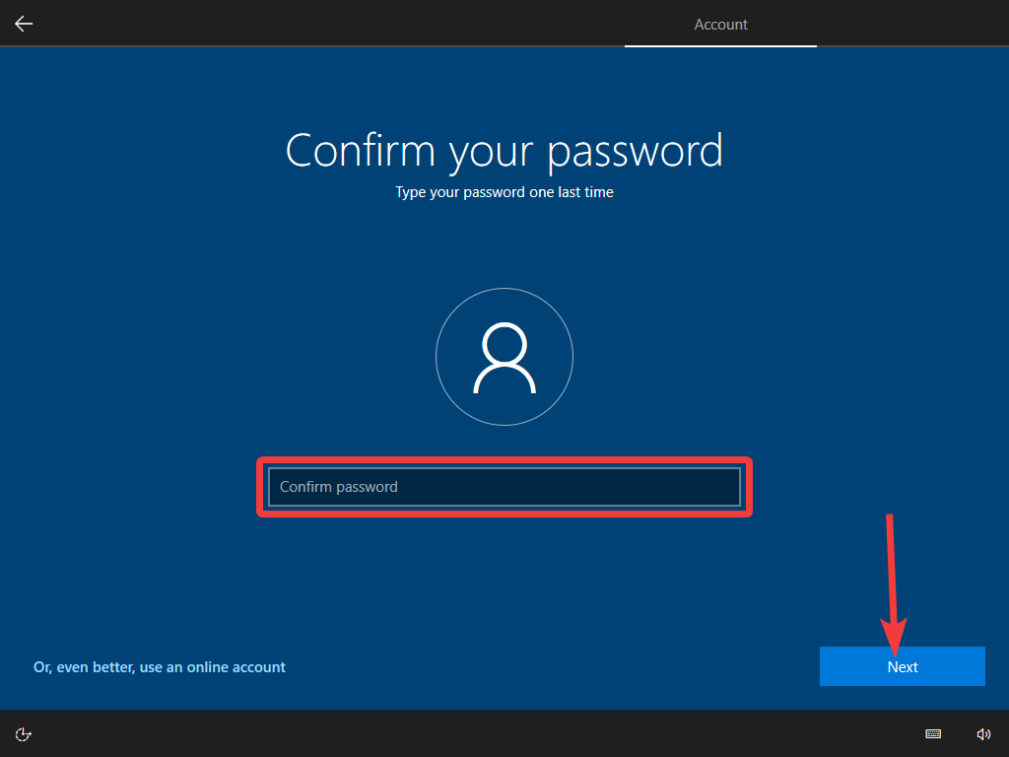
Windows will ask you to select a question and provide an answer. Don’t forget to write down all the questions and answers in your paper. You will be asked to do this 3 times.
Select the question, provide an answer and click Next.
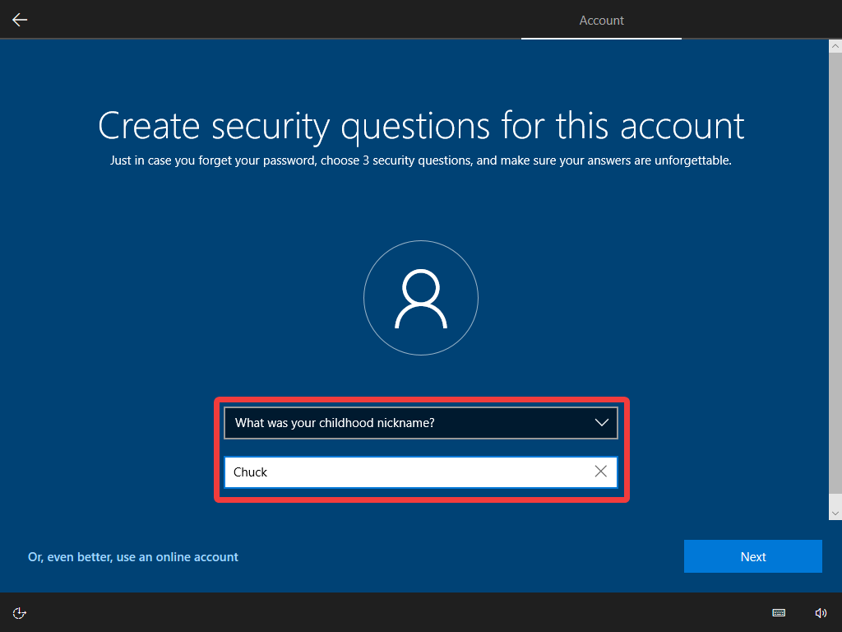
After setting up the security questions, you will be presented with a number with a number of screens with different questions about enabling windows features.
These features are focused on desktop use, not server use and will use computer resources unnecessarily.
At the moment of writing this document, the questions (and answers) are as you see below, but this changes frequently. If you find different questions than I present you here, try to answer the one which seems to respect the privacy of the user the most.
The questions and answers:
- Do more across devices with activity history?
-> Click NO
- Do more with your voice?
-> Click “Don’t use online speech recognition” click “Accept”
- Let Microsoft and apps use your location?
-> Click “No” and click “Accept”
- Find my device?
-> Select “No” and click “Accept”
- Send diagnostic data to Microsoft?
-> Select “Basic” and click “Accept”
- Improve inking and typing?
-> Select “No” and click “Accept”
- Get tailored experiences with diagnostic data
-> Select “No” and click “Accept”
- Let apps use advertising ID?
-> Select “No” and click “Accept”
After going through these questions, the system will finish configuring and will display the windows desktop.

Adjusting the power
Windows has power optimizations to reduce power usage in a computer to save energy. This is very useful for a desktop computer and specially for a notebook running on a battery, but our server will be running a webserver software and a database. This kind of application can be badly influenced by these power optimizations which will make the server respond slower.
The two most important to us are the CPU speed and the hard drive sleep.
The CPU (Central Processing Unit) in a computer can consume a lot of energy. Windows will slow down the CPU when it is not being fully used to save energy. This means that anytime the database needs to be accessed after a period of inactivity, the CPU will initially be in a low power mode, and the first requests of the database will be slower as well.
Windows will also “spin-down” or turn off the hard drives after a period of inactivity. In that case, once a user tries to access our server, before the system sends a message back, it has to actually turn the hard drives back on, which can take from 2 to 5 seconds depending on the hard drive model.
The instructions that follows go through the power configuration to avoid both problems.

Instructions:
Start up your Windows computer. On the desktop screen, click on the Start menu (Windows Icon) and then settings (cog icon).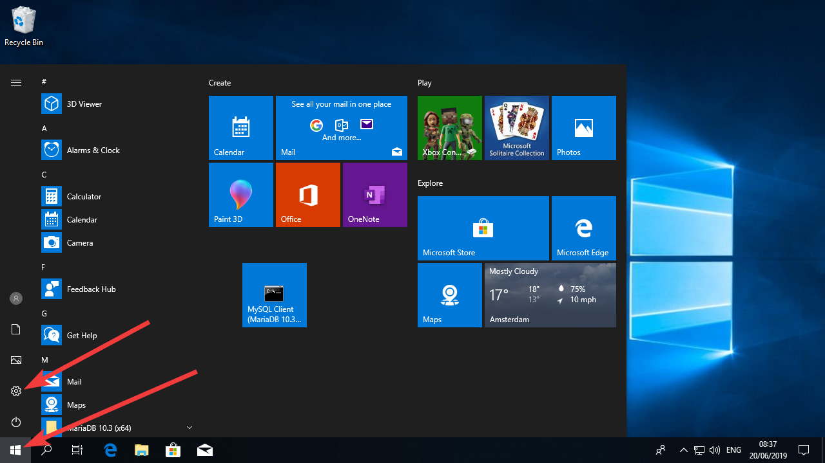

Click in System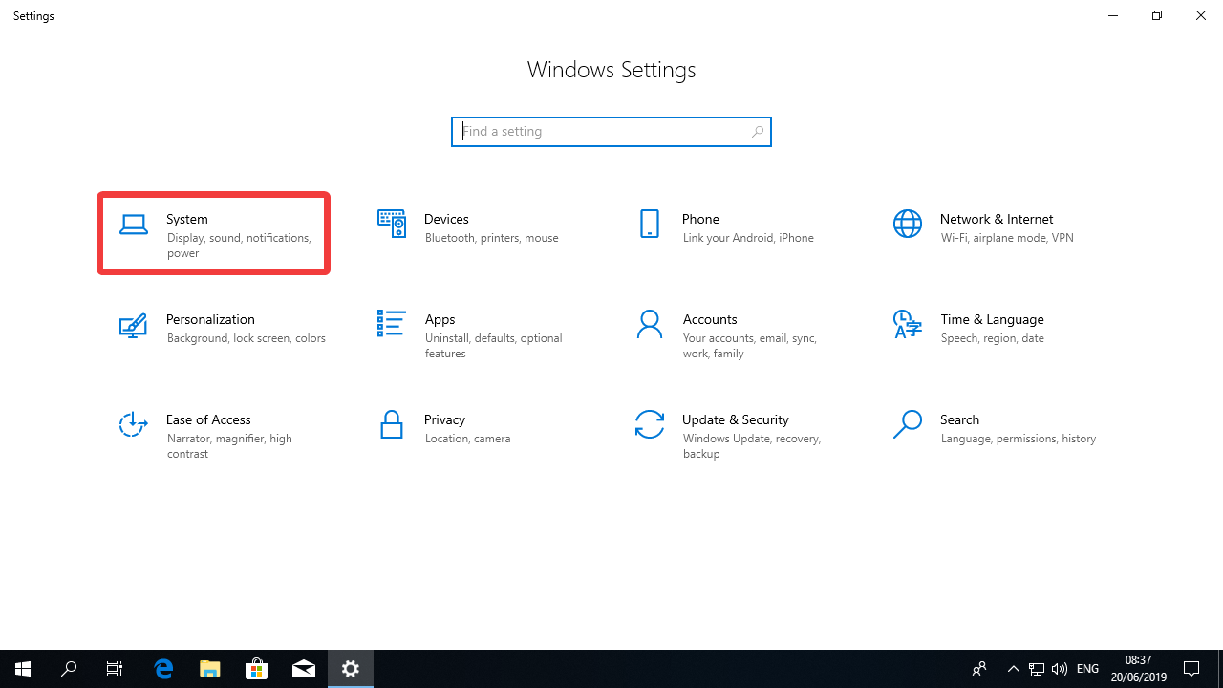
Click in “Power & Sleep” on the left menu and then click in “Additional power settings”
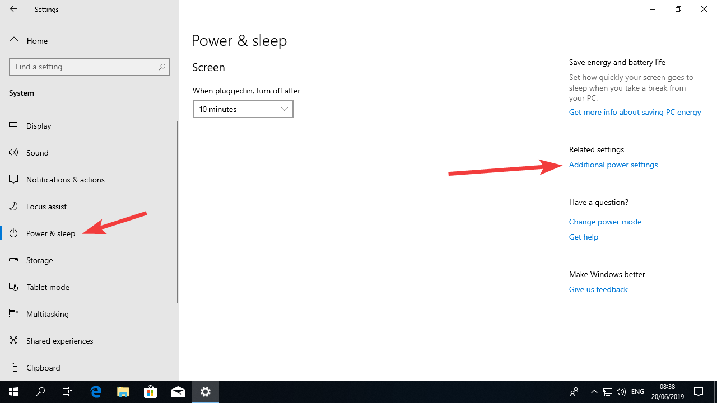

Click on the arrow on the right to open the “additional plans”. Select “High performance” by clicking the radio button and then click in Change plan settings.
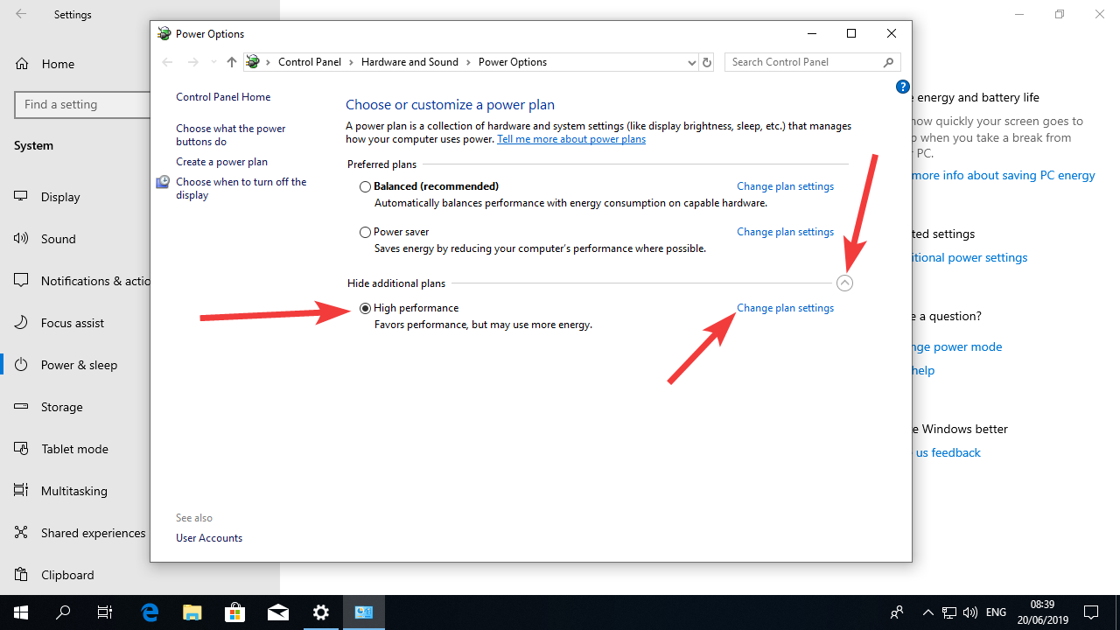

Click in “Change advanced power settings”
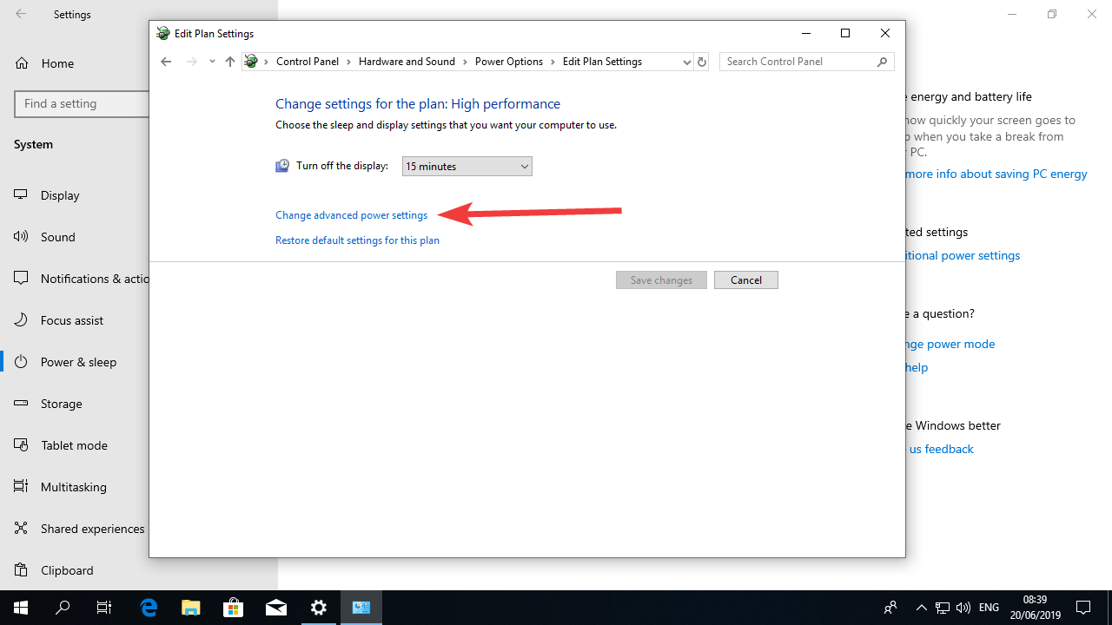

Now click set the “Turn off hard disk after” setting to 0 (zero) so the hard drives on the computer never shut down to save energy. Change the “USB Settings” to disabled.
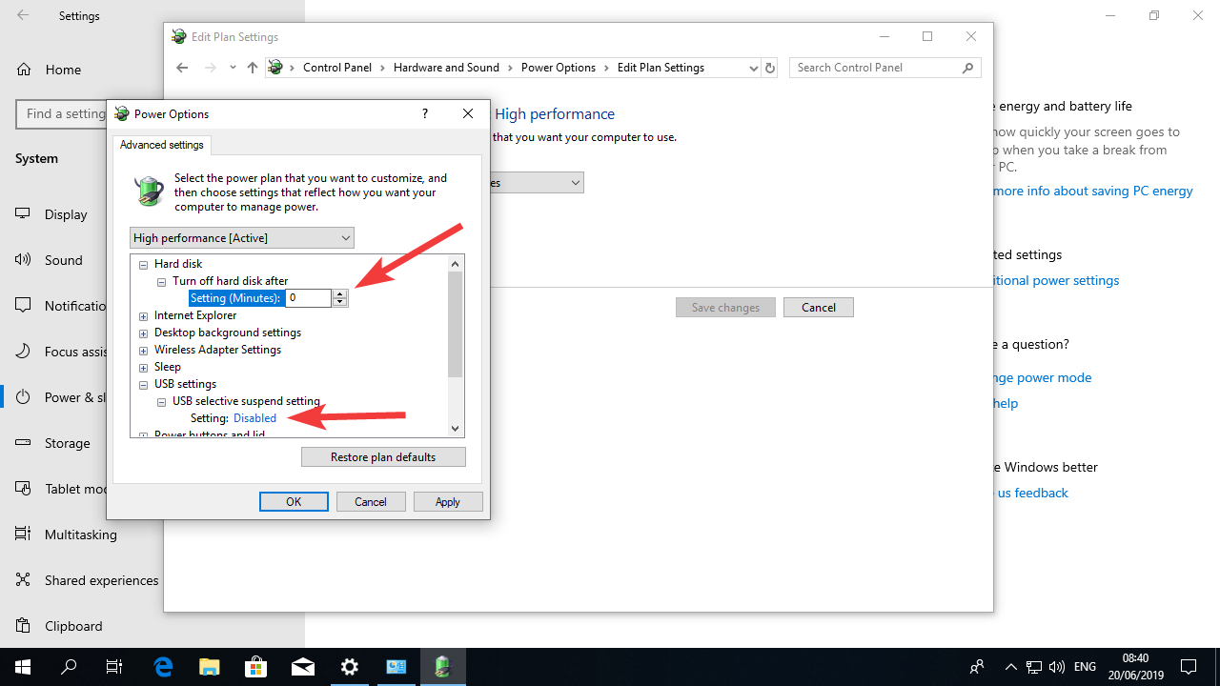

Now click on the “Apply button” click the OK button and close all the windows.
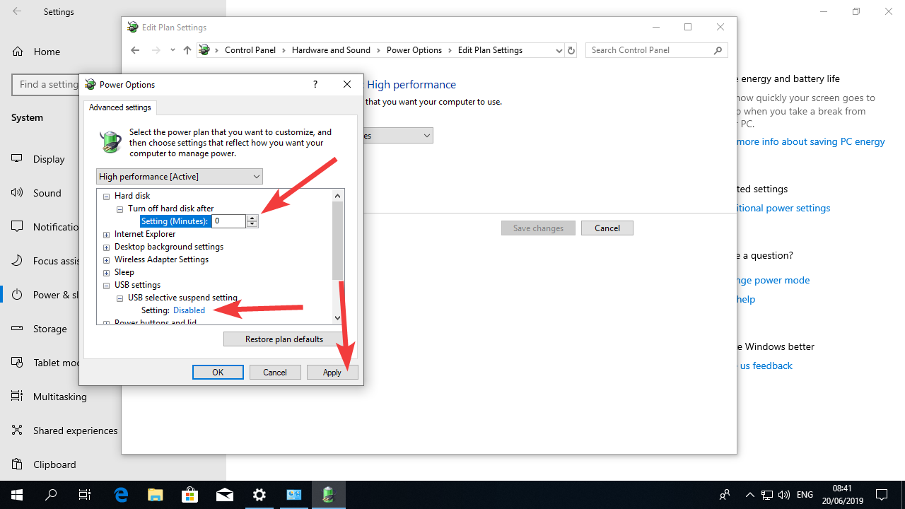

Now your power configurations will not interfere with the server.

Adjusting time configurations
The PHP runtime the database and Moodle rely on the date and time configurations in Windows to properly manage things. It’s very important to configure date, time and location correctly to make sure that these different parts of our server will work accordingly.
The following instructions will guide you through some simple configurations to make sure your date and time configurations are correct.

Instructions:
In the Settings menu in Windows, click in “Time & Language”
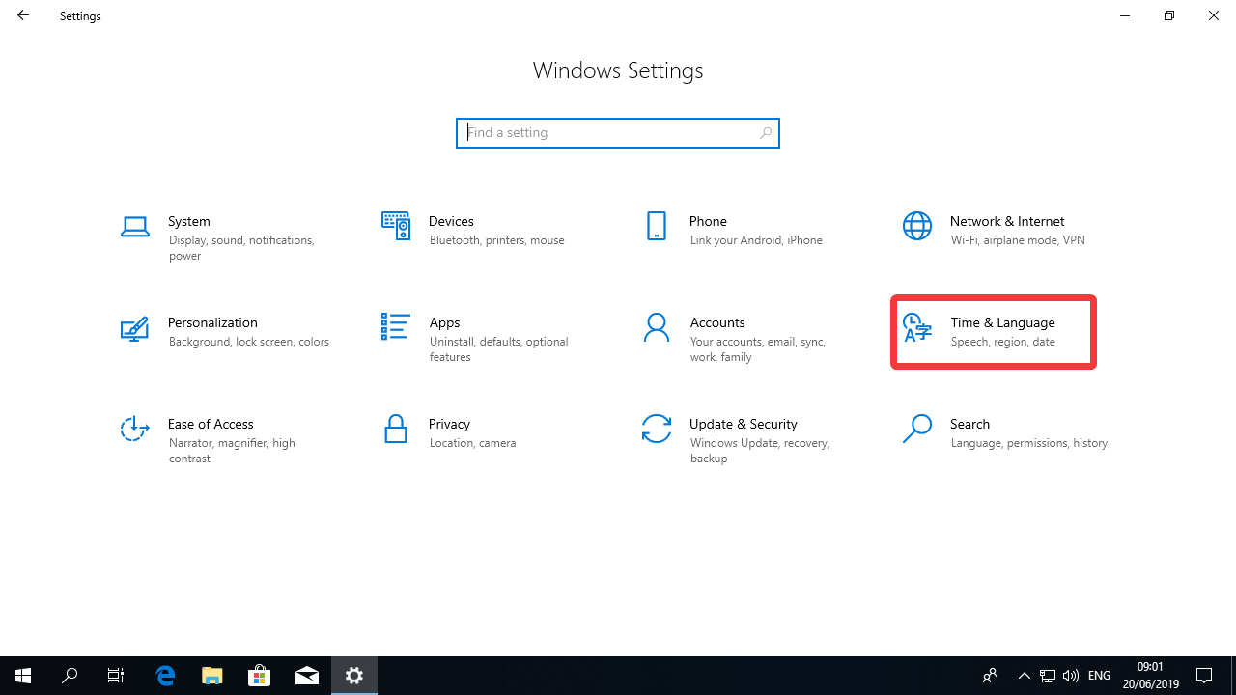

- Make sure that “Set time automatically” is on (this will periodically synchronize the clock to an atomic clock for precision)
- Turn off “Set time zone automatically”
- Make sure you are in the correct time zone
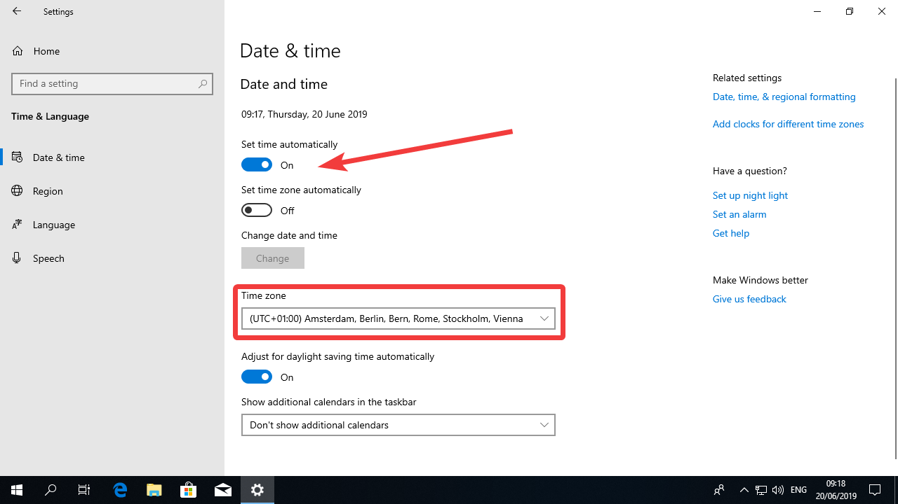

Windows Update
Part of the initial set-up is to make sure out Windows system is up to date. We must ensure that we have the last security updates and virus definitions installed and we can also make it so that Windows will update itself when necessary with minimal impact to server uptime.

Instructions on updating the system:
In the Windows Settings menu, click : Update and Security
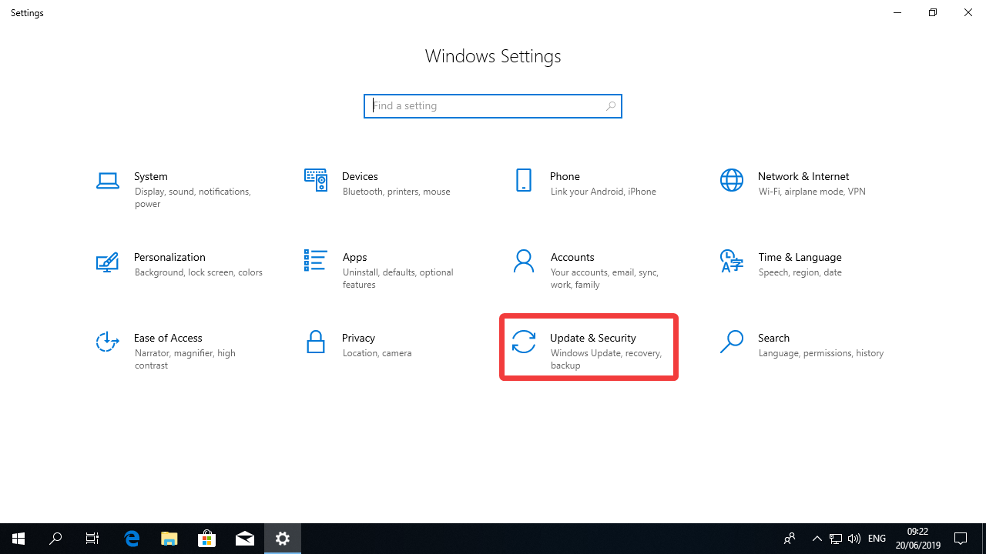

Click the button “Check for updates”
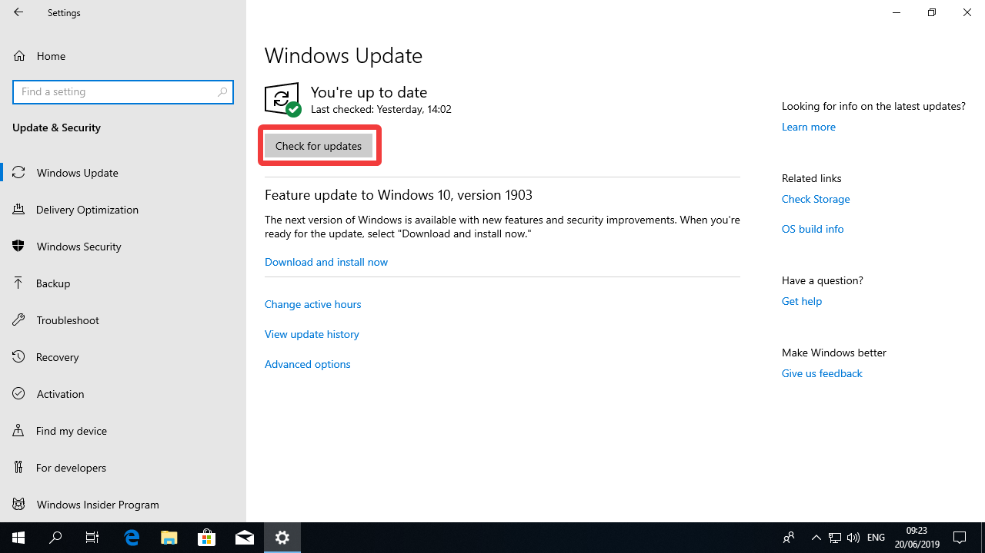

Windows will check for the updates, this might take a few minutes.
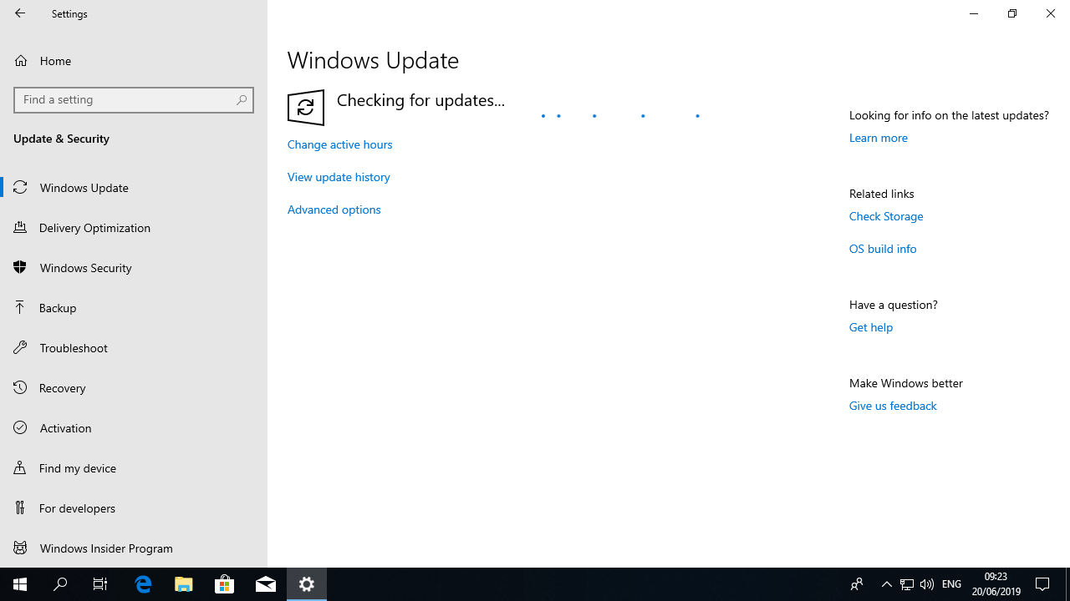

Once you’re done updating you should see the “You’re up to date” message.

Instructions on configuring the updates:

Still in the update menu, click “Change active hours”
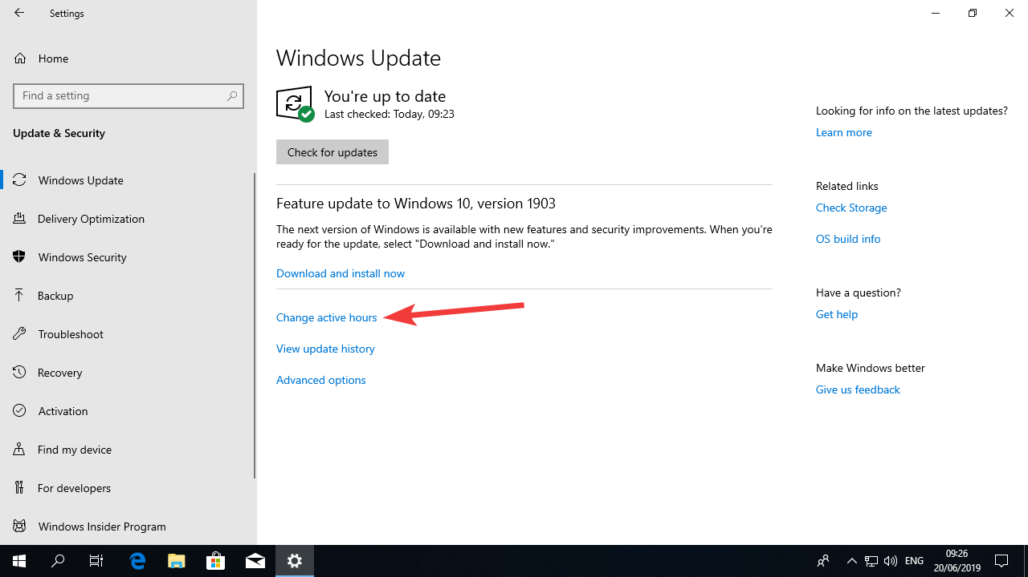

Active hours are the time when you do not want Windows to update itself. If you expect that most of your students will be accessing Moodle between 7 in the morning and midnight, you should do that (as in the example below). The maximum length of active hours you can set is 18 hours.
Once you set that option, Windows will only update the computer automatically outside of these hours.
Select the start and end time of your choice, or just use the time proposed here and click “Save”
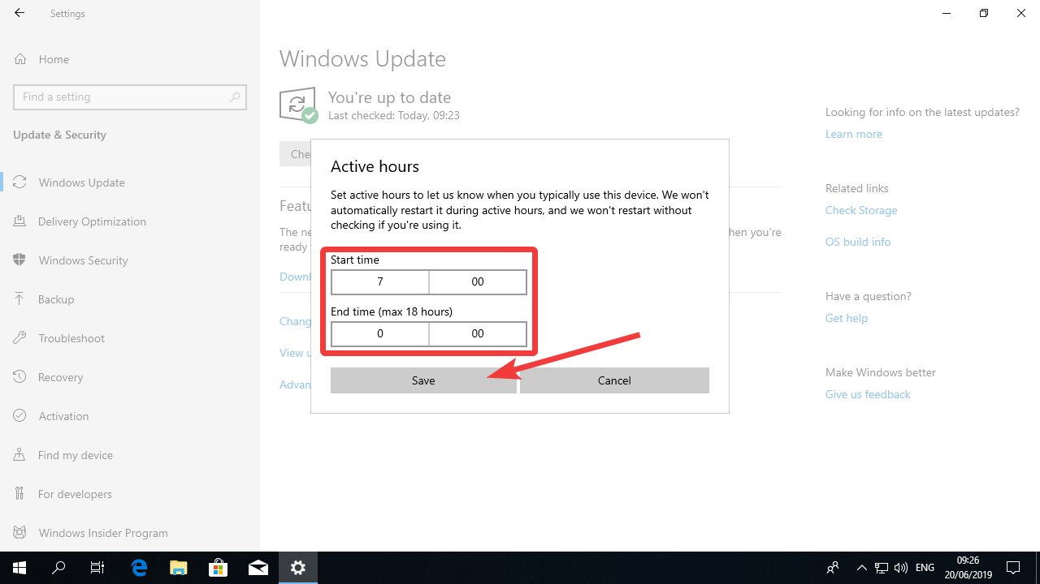

Now click in “Advanced options”
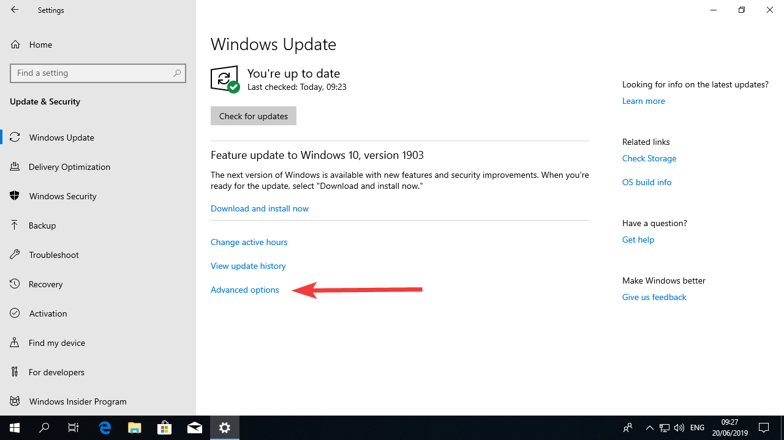

Turn on the option “Give me updates for other Microsoft products…” and then click “Delivery optimization”.
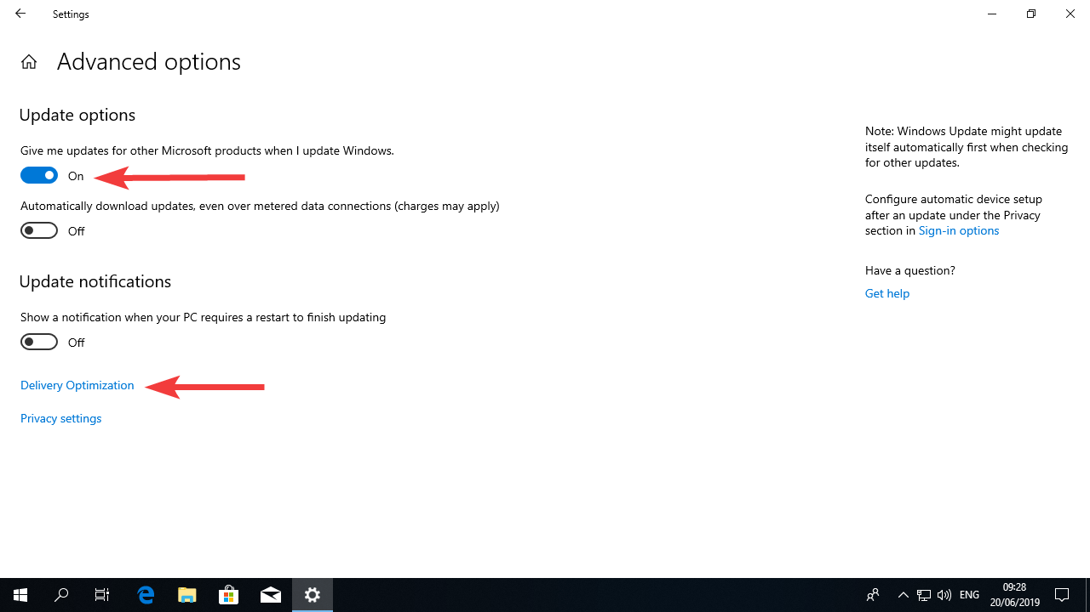

Delivery optimization is used by Microsoft to reduce traffic in their servers and to accelerate the download of Updates. This is useful for desktop and notebook computers, but it’s a bad thing for servers as it will user resources of the server.
Simply turn off the setting “Allow downloads from other PCs”
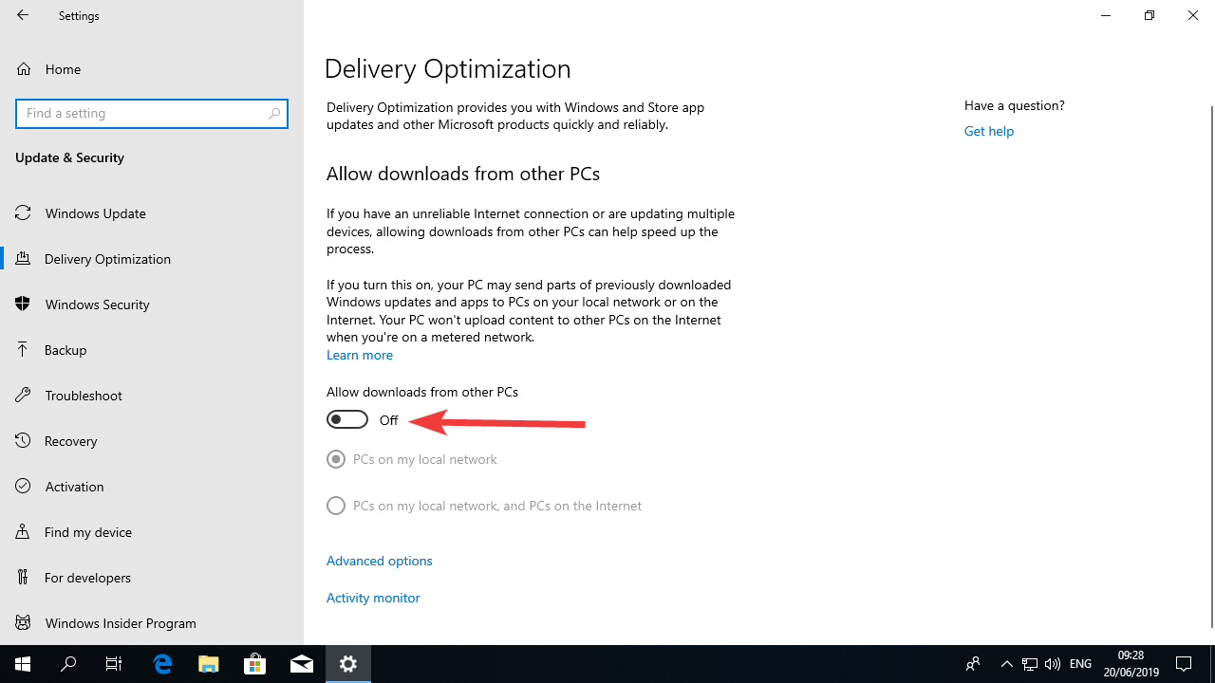

Concluding remarks
After going through all these steps, you will have a computer ready for the installation of the webserver software.

