Date:20/06/2019
Ref.:??????
Version Nº:0001

Ethiopian Education Network to Support Agricultural Transformation (EENSAT)

Course Title: Establish, update and maintain EENSAT LMS
Lesson No: 02, Install webserver and PHP

 | Name | Responsibility
Prepared by | Ivan Oliveira | e-Learning Specialist at University of Twente, ITC
Reviewed by | ???? | ???

Webserver and PHP installation

Ivan Oliveira, 20/06/2019

OpenCourseWare

Contents
1 Introduction 2
2 Prerequisites 2
3 Install the Web Platform Installer, IIS and PHP 2
3.1 Instructions 2
4 Configure PHP 12
4.1 Instructions 13
5 Install MariaDB 17
5.1 Install MariaDB 17
5.2 Configure MariaDB 25
5.3 Create a new Database for Moodle 31
6 Concluding remarks 37

Introduction
The Moodle software depends on three main software components on a server. These components are:
- HTTP server: this is the software that facilitates the communication between the user’s browser and the software (Moodle) in the system.
- PHP interpreter: Moodle is written in the PHP scripting language. Scripting means that its files are “human readable” and for a computer to run such a language, this human-readable code needs to be converted into computer code. The interpreter will do that.
- Database server: All data created by Moodle, like user information, logs, user interaction, etc needs to be stored somewhere in an organized way. The Database takes care of that.
In this guide you will learn to install and configure both the HTTP server and the PHP interpreter using Microsoft’s own “Web Platform Installer” to which we will refer sometimes as WPI.
Then you will Install and configure the database server and create a database for moodle

Prerequisites
- Configure windows using the instructions from the previous document.
- Active internet connection (preferably via cable, not wireless)
- Basic computer skills (Windows)

Install the Web Platform Installer, IIS and PHP
The Web Platform Installer is a tool to install web server related software directly from Microsoft’s servers. It makes the job of installing and updating software easier.

Instructions
Open your browser and go to https://www.microsoft.com/web/downloads/platform.aspx or just search the internet for “web platform installer”. This should be the first link.
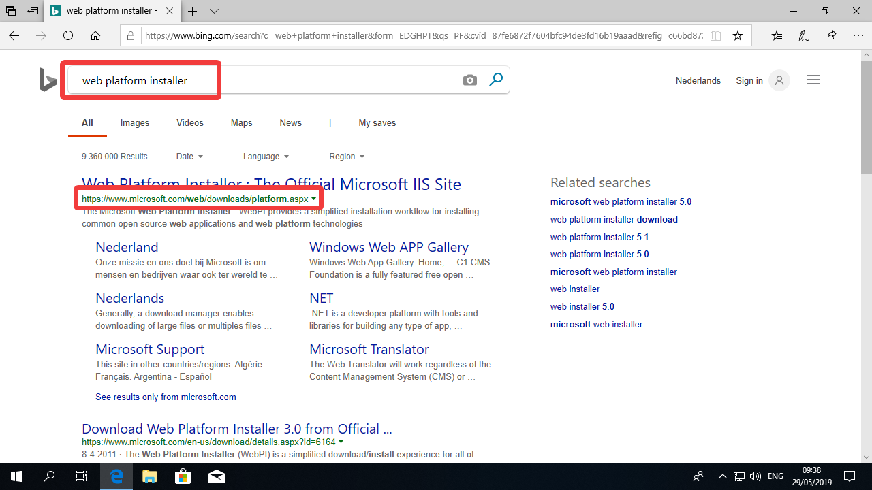
Once in the WIP webpage, click “Install this extension”
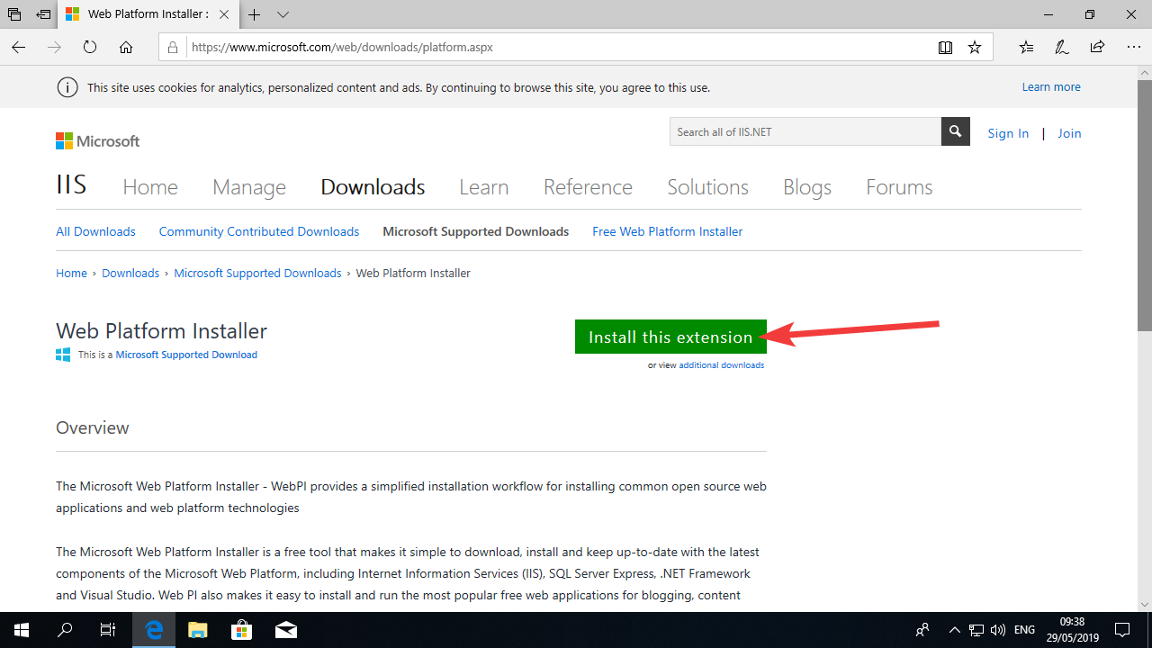
For this example I am using Microsoft Edge as my browser. You can use other if you want but then the messages in the browser might differ.
Select Run in the Dialog:
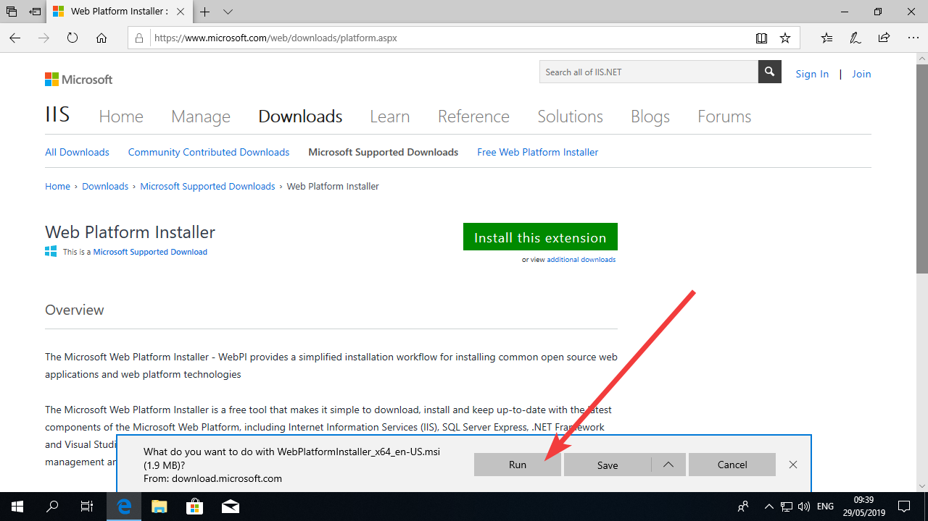
Once the software starts, click “I accept…” and click “Install”
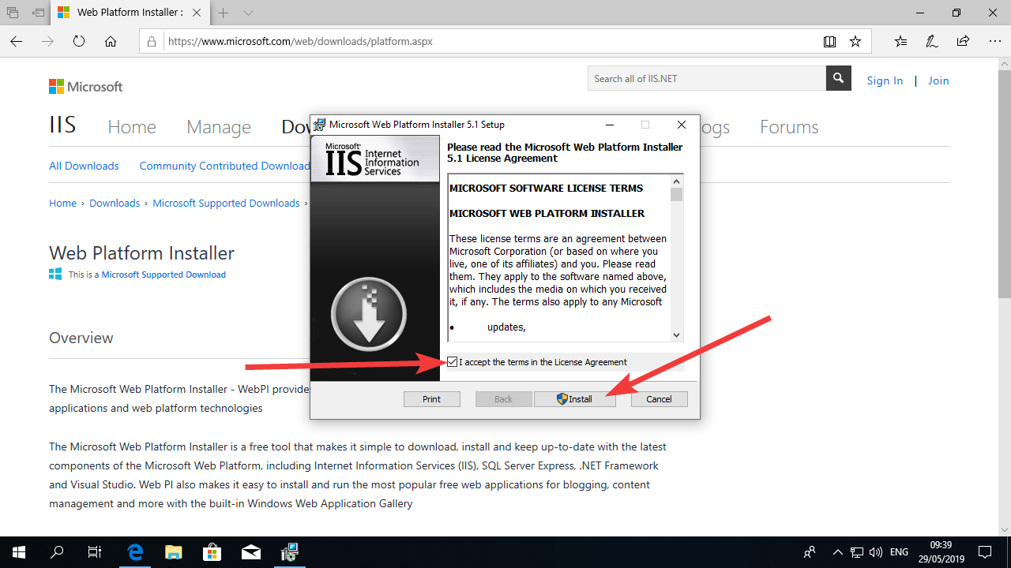
You will be presented with a UAC (User Account Control) window. This window will always appear when a software requires administrator access to the system. We will see this window often during the guides.
Click “Yes”.
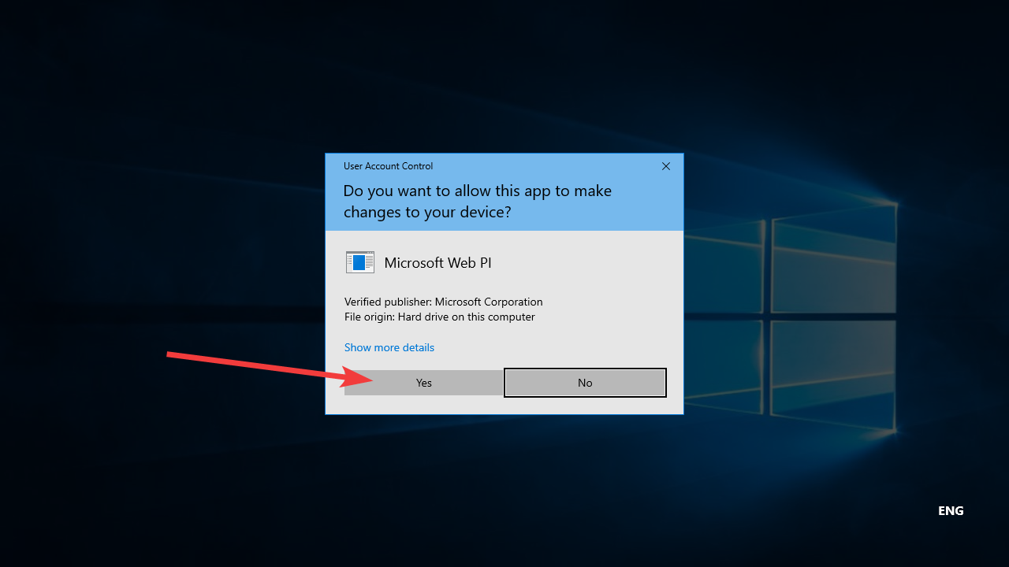
Once the Installer is done, click “Finish”.
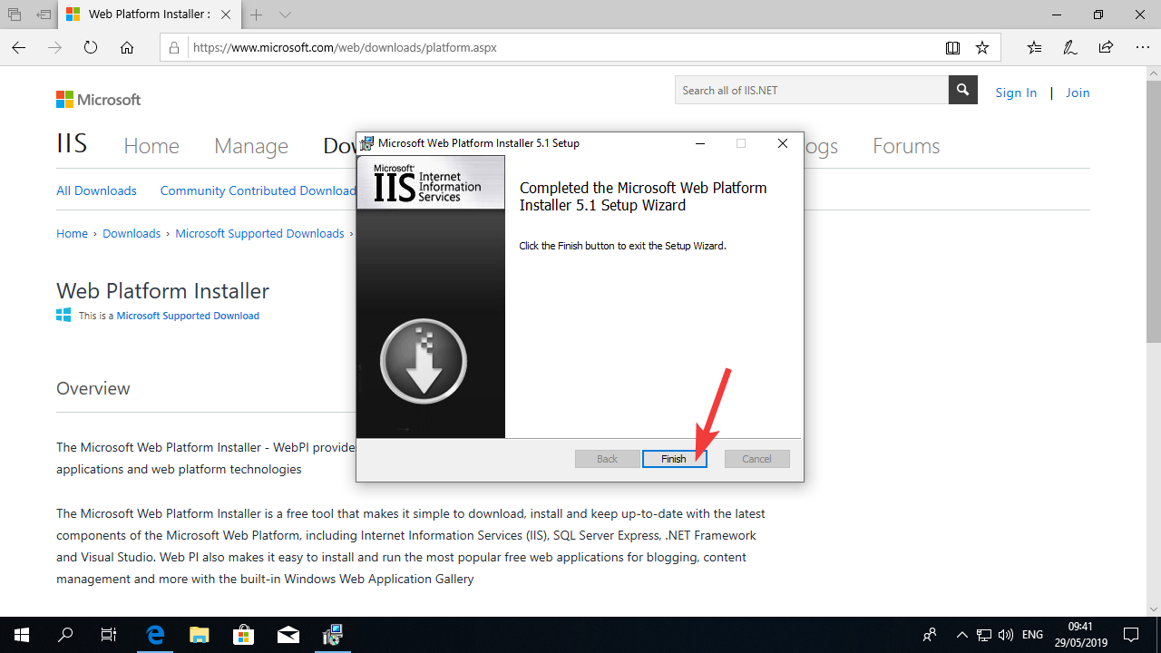
Now open the Start Menu and find the Web Platform Installer icon. Click on the icon.
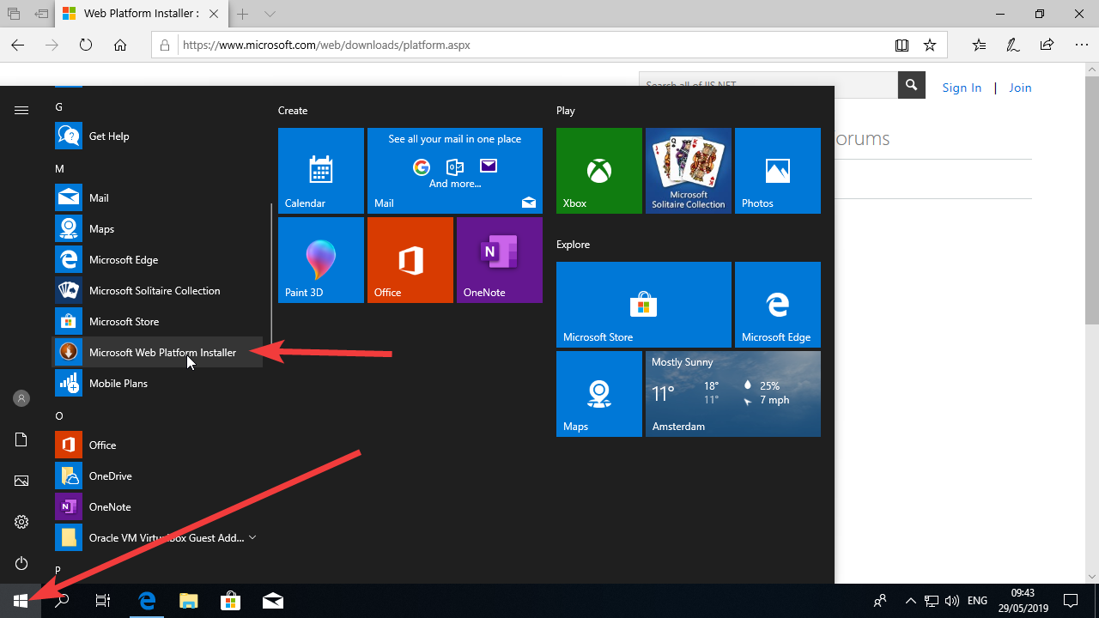
One more time UAC will display the confirmation window. Click “Yes”.
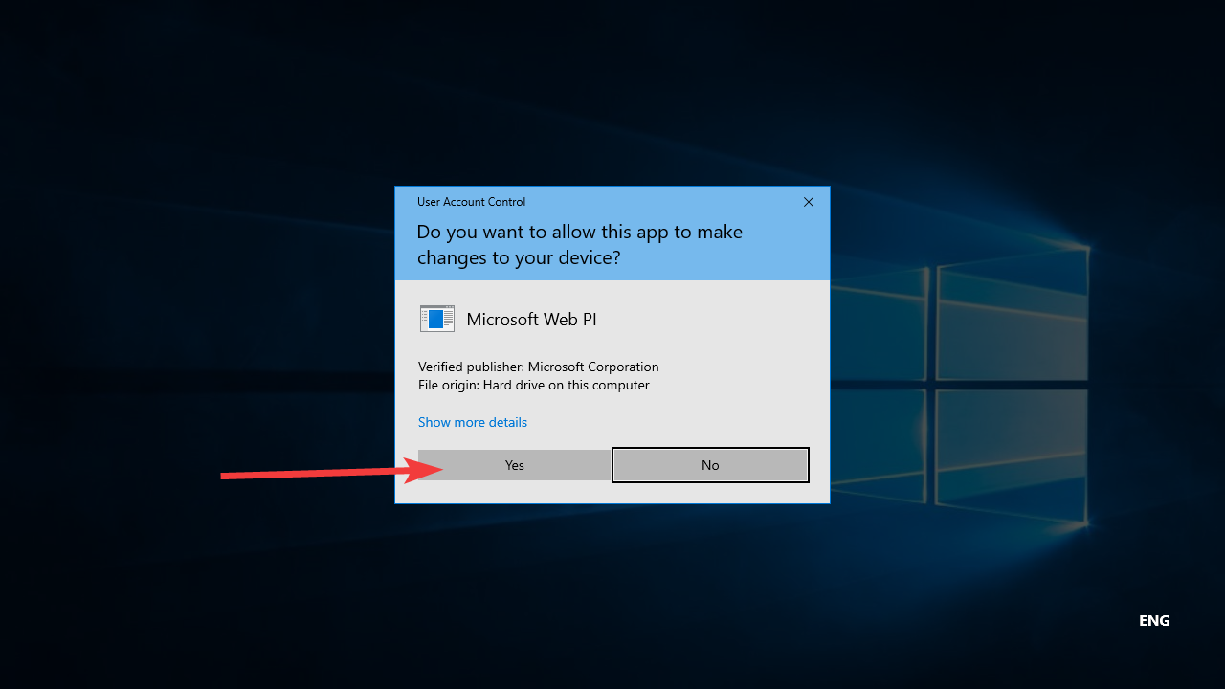

On the WIP interface, type “php” in the search box and press enter on your keyboard.
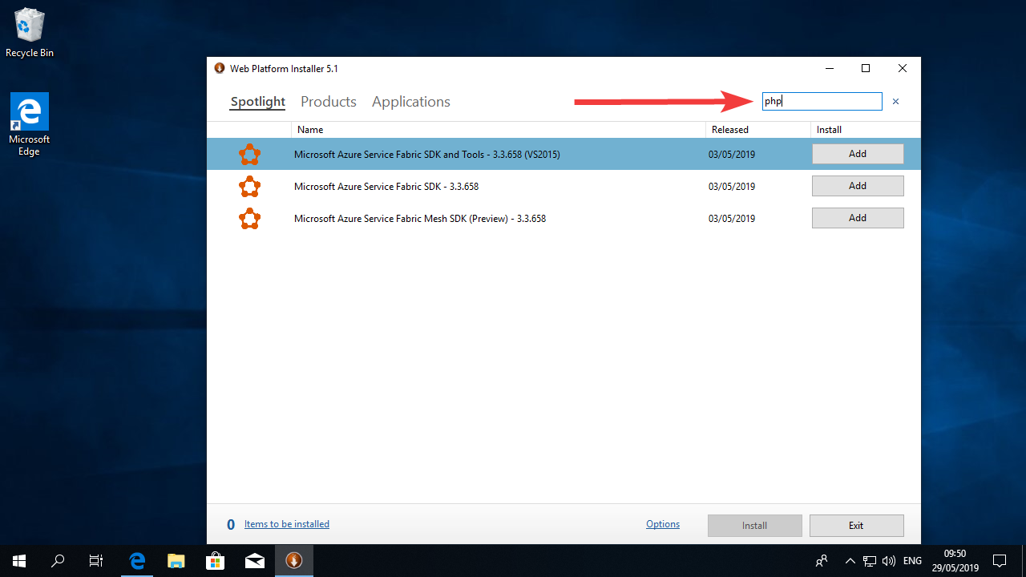
You will be presented a long list of option. Look for the latest version of the PHP package. It should be called PHP 7.3.1 (x64). It is important that you choose the latest version (if you find one with a larger number you can choose it (e.g.: 7.4.1) but make sure you select the option marked with “x64” because Moodle prefers the 64 bit PHP.
Click the Add button beside your selection.
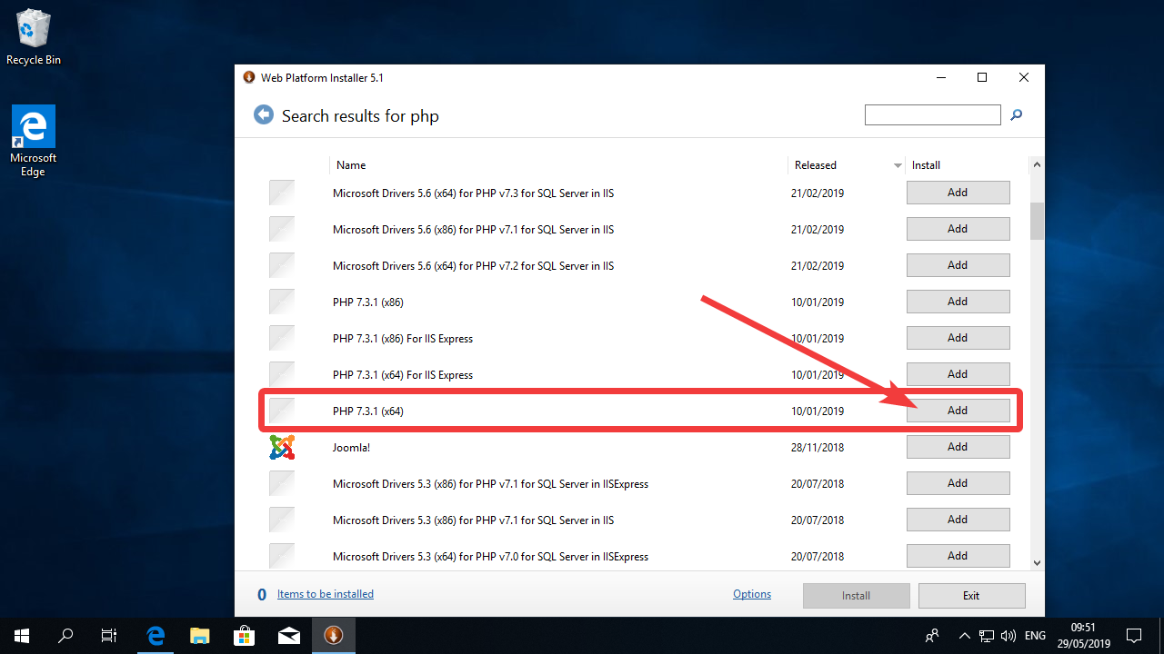
Now click on Options.
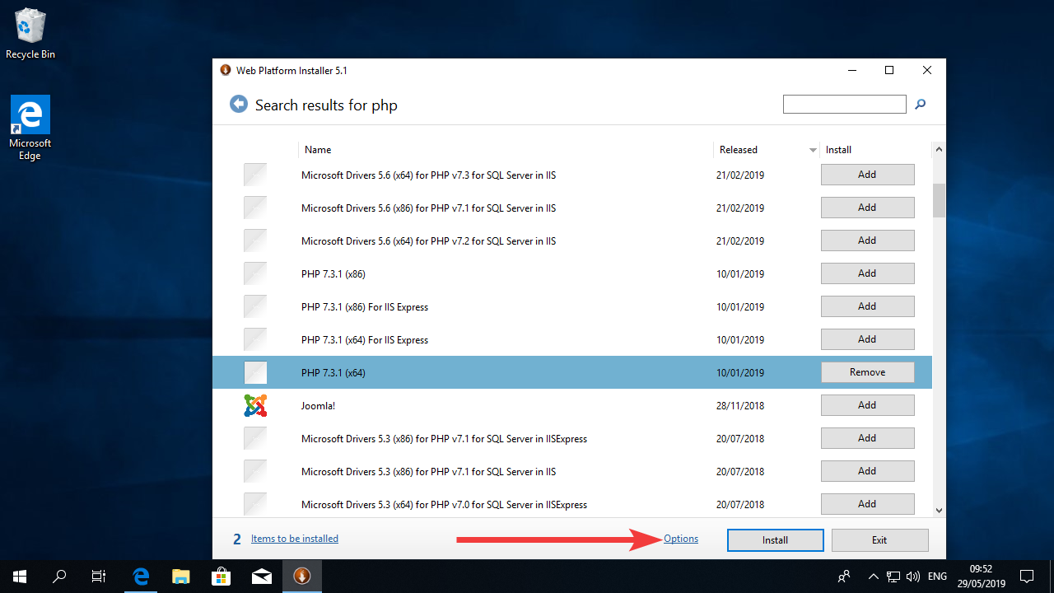
Un-select the box with the text “Yes, I am willing…” and under “Which Web Server would you like to use” select “IIS”. Then click OK.
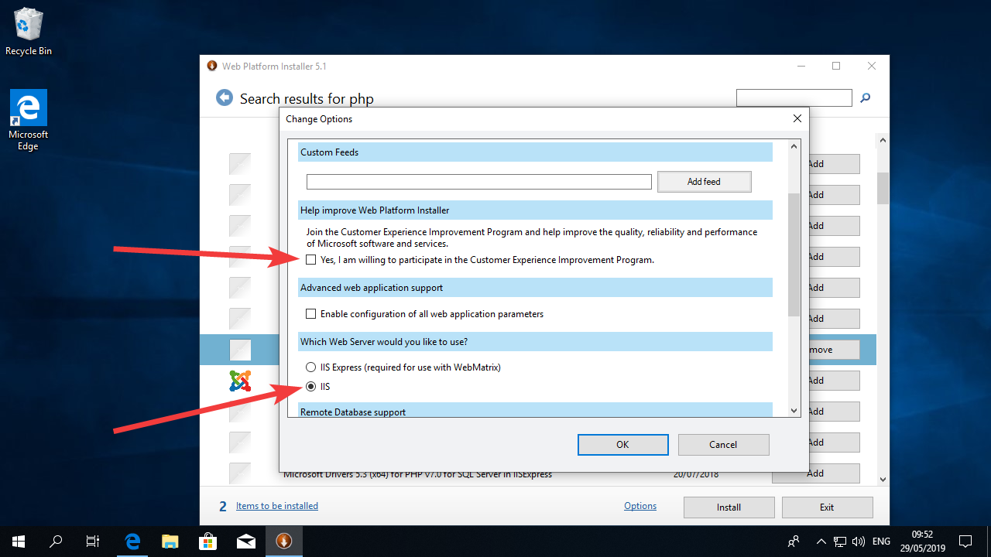
Now click on the Install button.
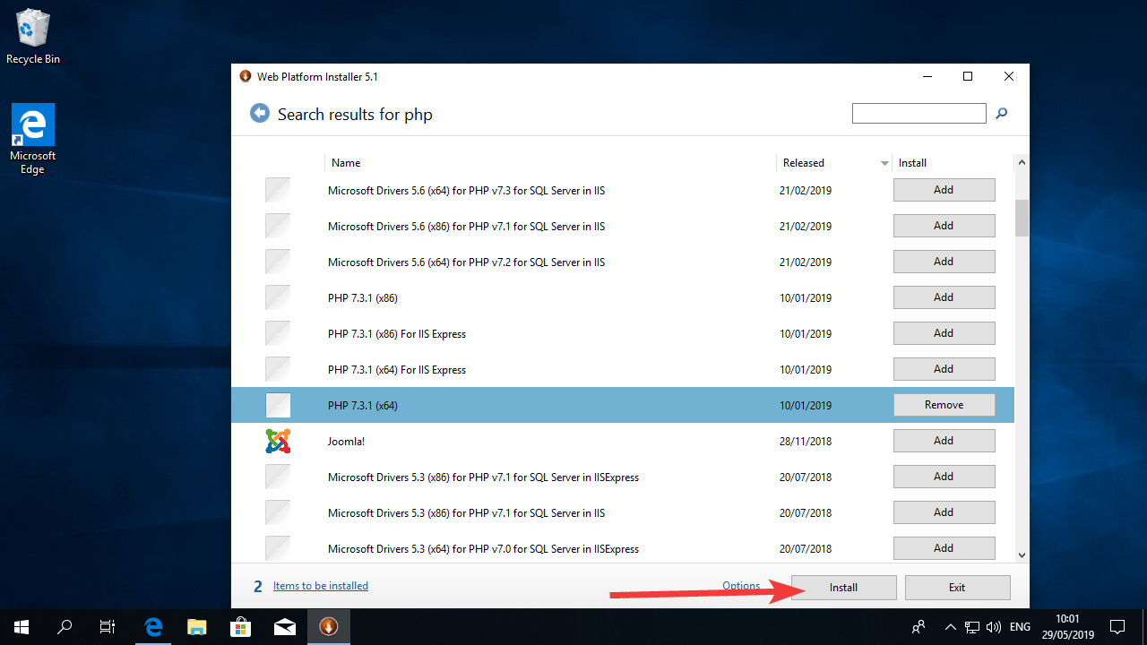
Click in “I Accept” in the next window.
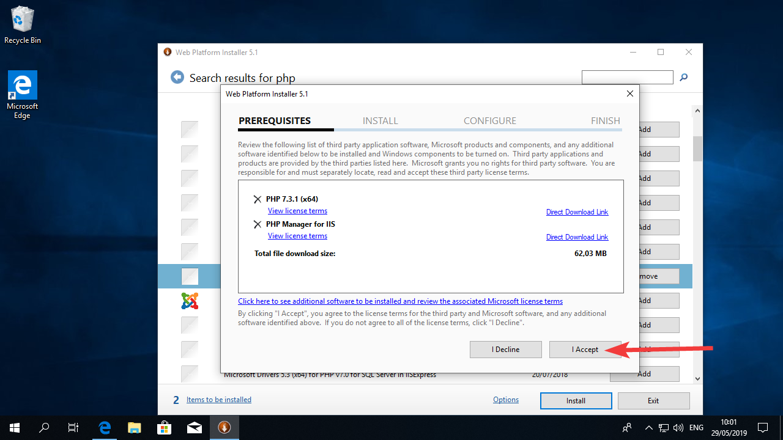
Now wait for WPI to install the software (this will take a few minutes, you can go have a coffee)
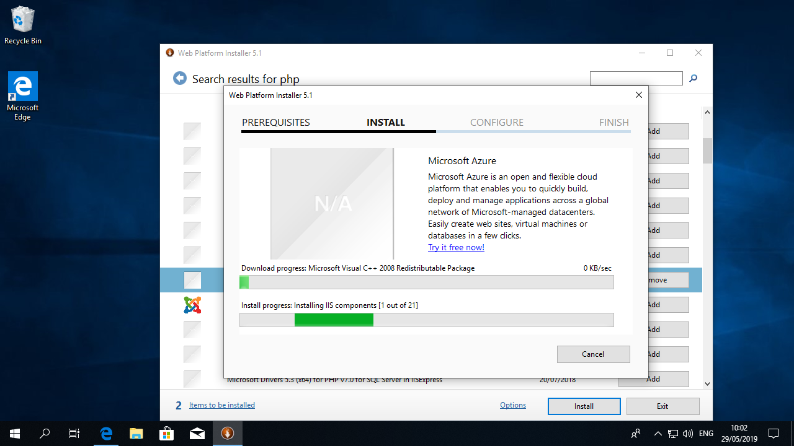
It’s likely that after the installation WPI will require you to re-boot the computer. Click Yes in the window.
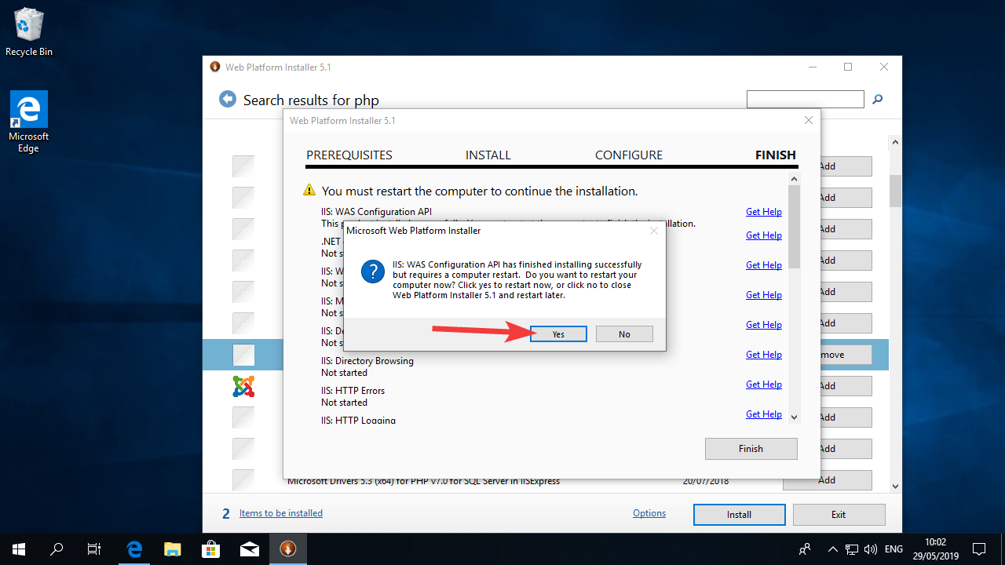
After booting, you will see the UAC window one more time. Click “Yes”.
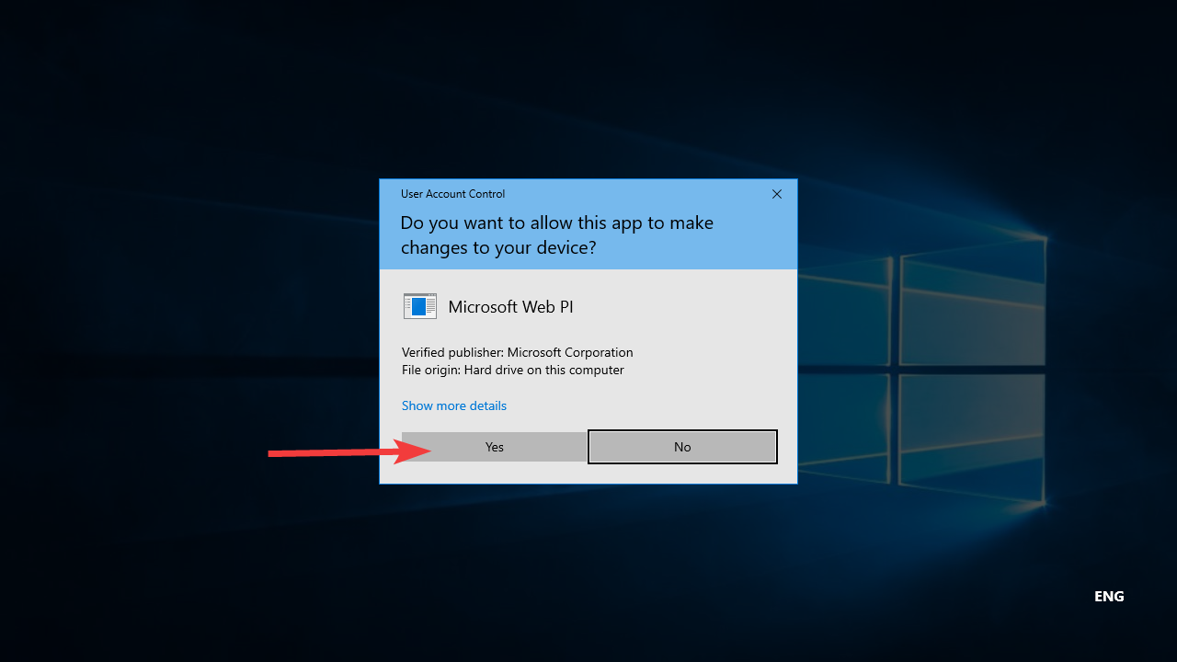
After WIP is finished installing the software you might receive the error below. You can ignore the problem and click “Finish”
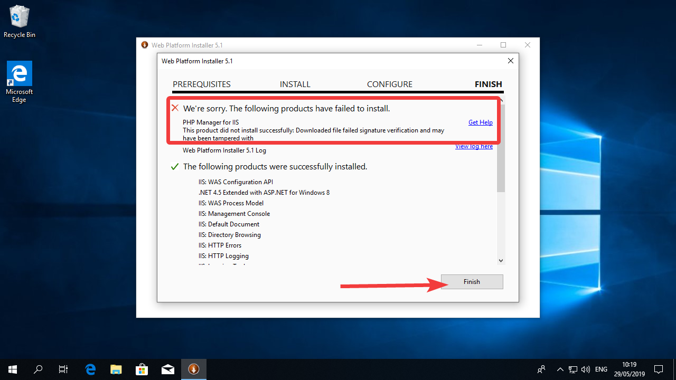
And next, click on Exit.
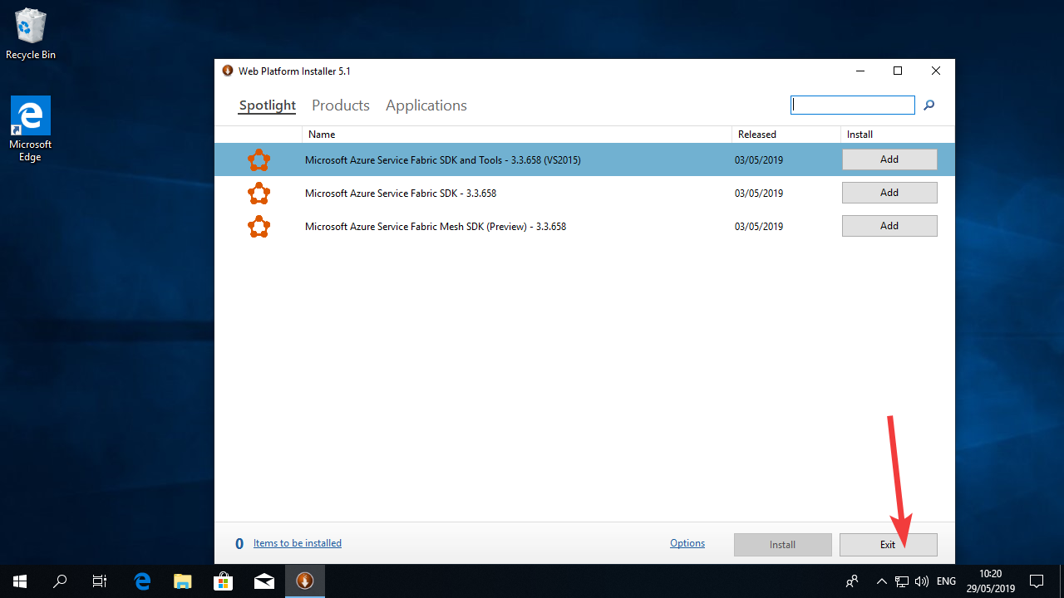
If you want to check if your webserver is working, you can open the browser and visit the address: http://127.0.0.1 or http://localhost/ there you should see the screen below:
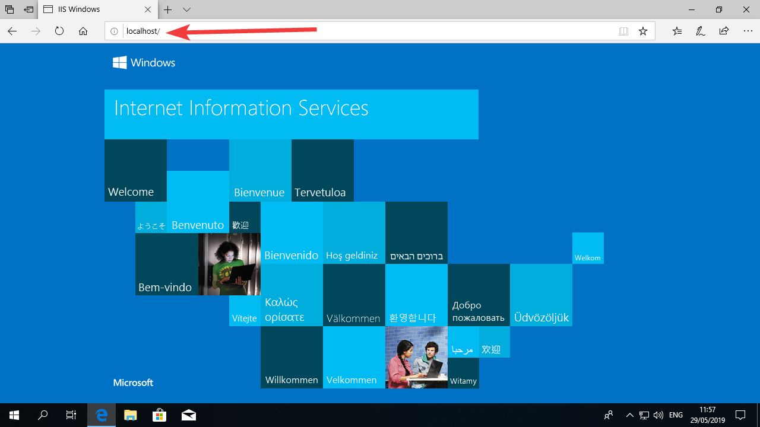

Configure PHP
For Moodle to be run smoothly we need to make sure that all the PHP settings are configured according to its requirements. This will be done by changing configurations on a text file.

Instructions
Click on the “Start Menu” icon and search for notepad (just start typing notepad after clicking on the start menu icon). Click with the right button of your mouse on the notepad icon and select “run as administrator”
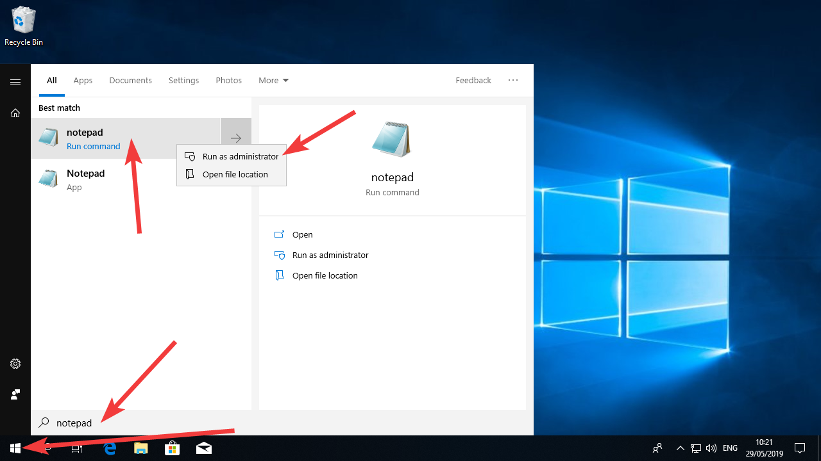
Since running as administrator gives extra privileges to notepad, you will see the UAC window. Click “Yes”.
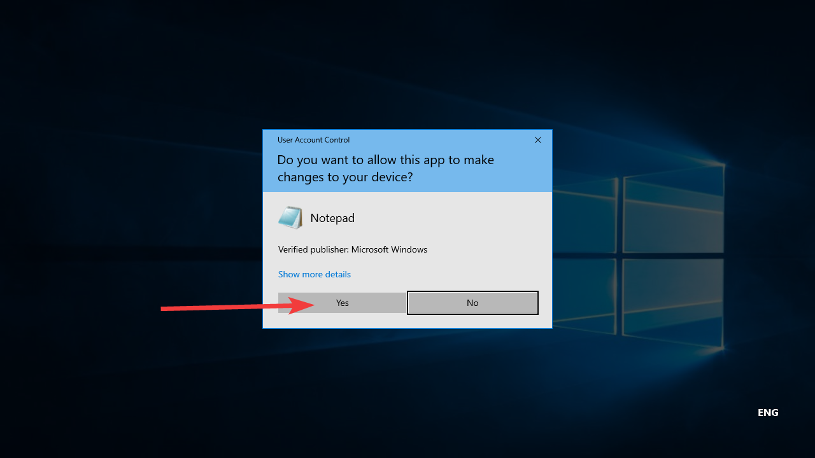
Now, on the notepad window, click “File” and then “Open”
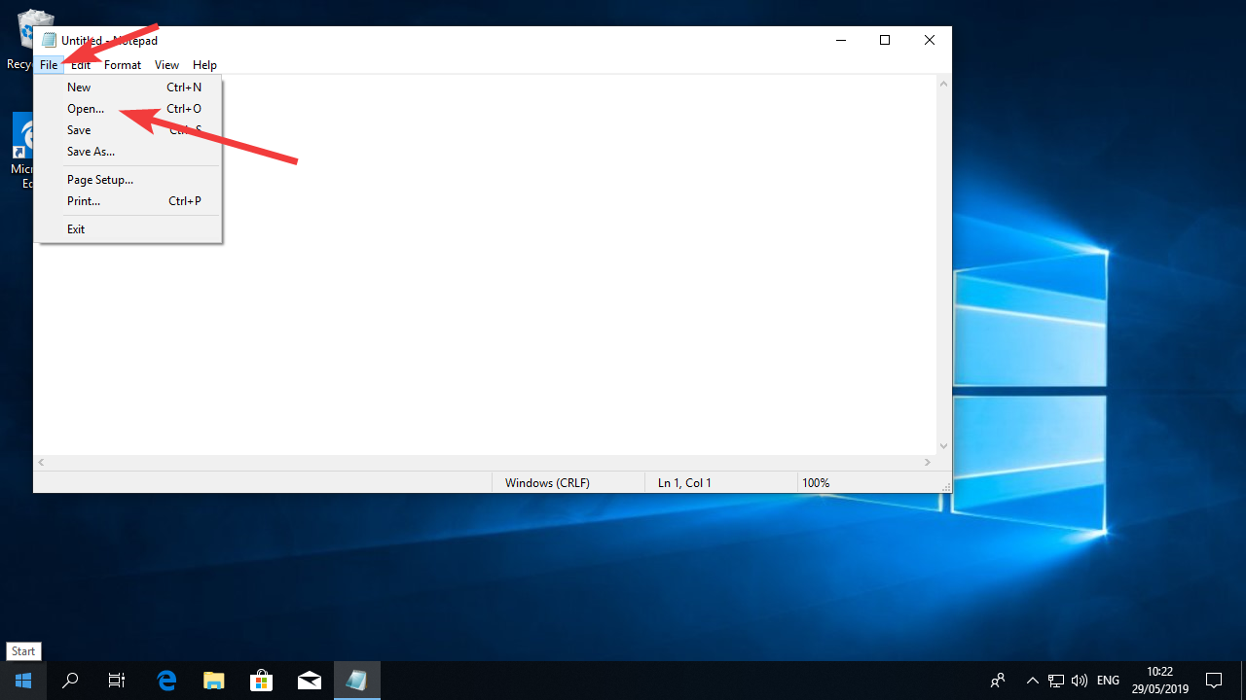
Now browse to C:\Program Files\PHP\v7.3 (or later version in case you’ve chosen it in the previous step).
Select “All files” instead of “Text Documents” in the dropdown menu.
Select “UTF-8” for Encoding
Double click the “php” file with the cog icon (on the right side it should read “Configuration settings”) to open the file.
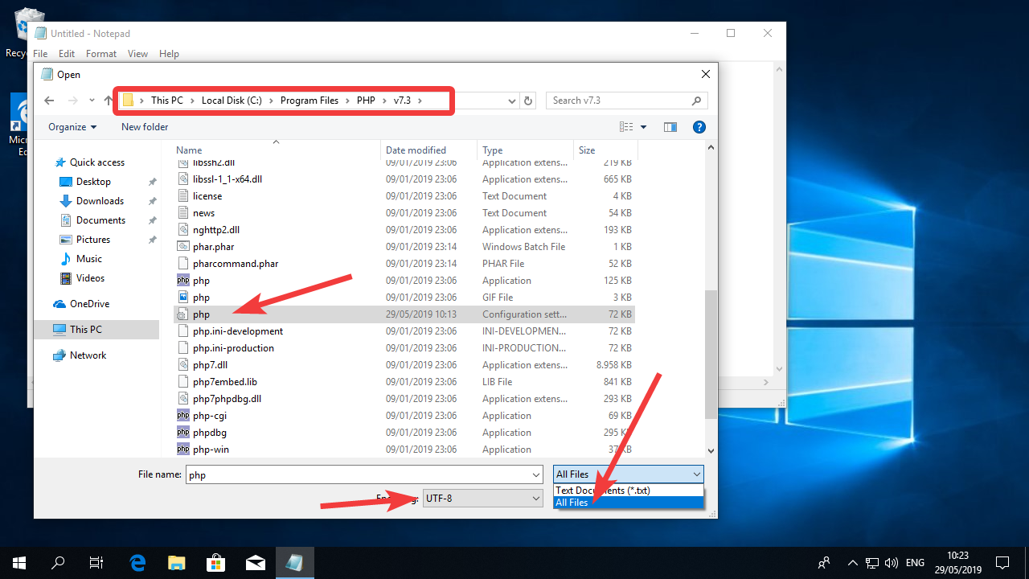

Go all the way down to the end of the text and add the three lines below:
extension=php_intl.dll
extension=php_fileinfo.dll
zend_extension=php_opcache.dll
Make sure you either copy and paste the text or double check that the text is typed precisely or you might encounter errors later.
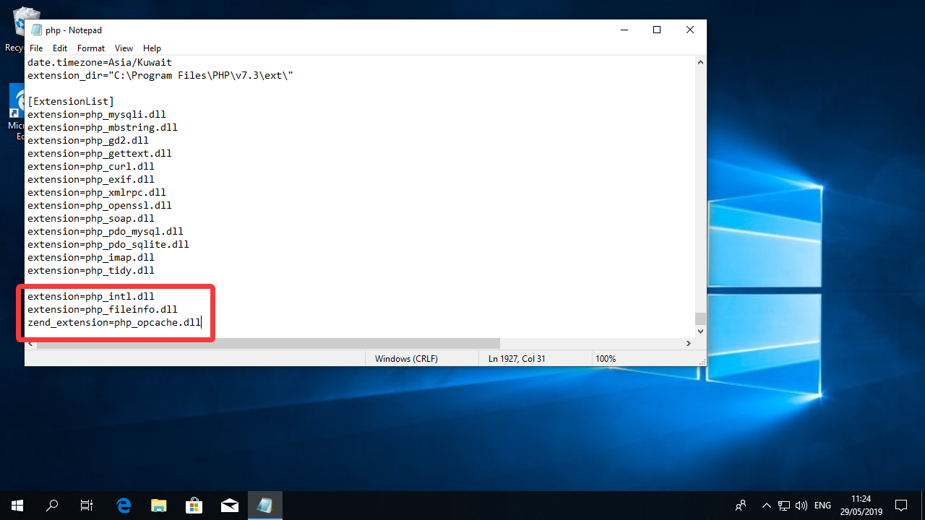

Now click on “Edit” and then “Find…”
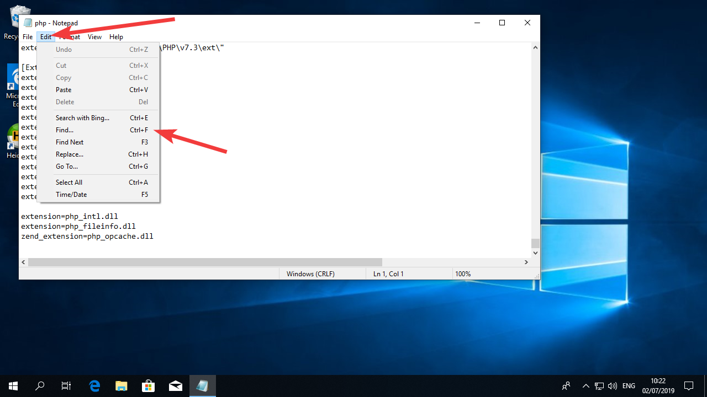

Type in “post_max_size” and click “Find Next”.
(If you can’t find it, change the direction from “Down” to “Up”)
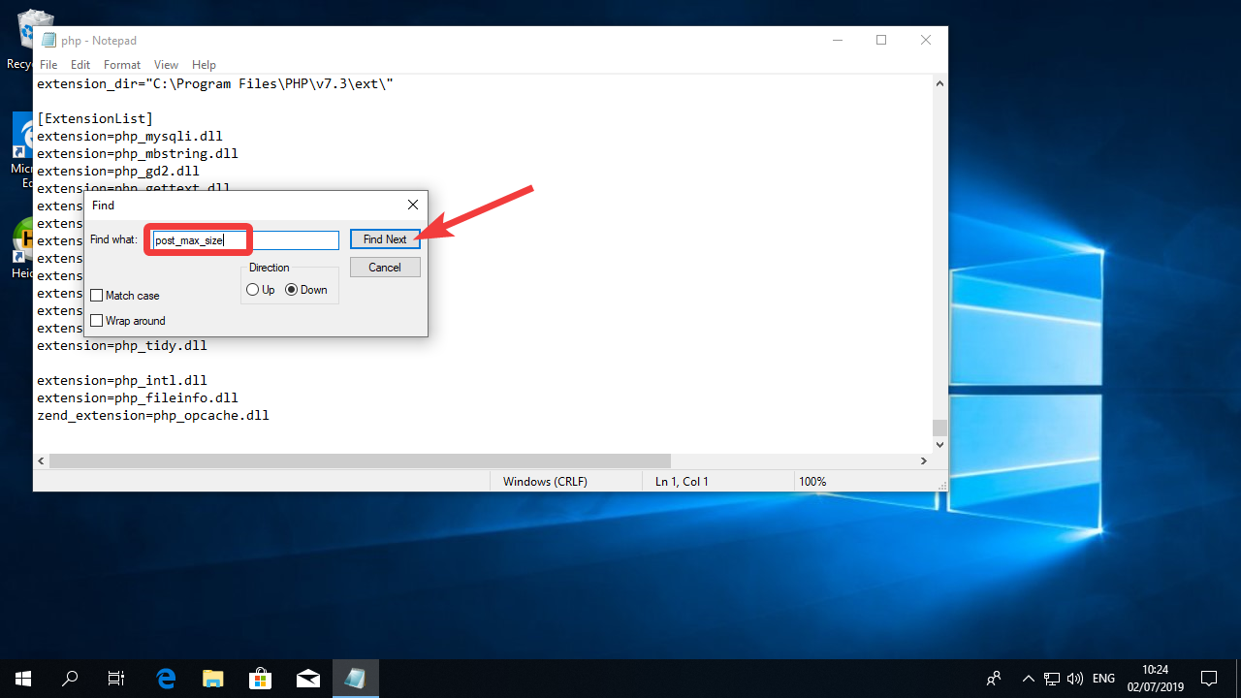

Notepad will show you the line saying “post_max_size = 8M”
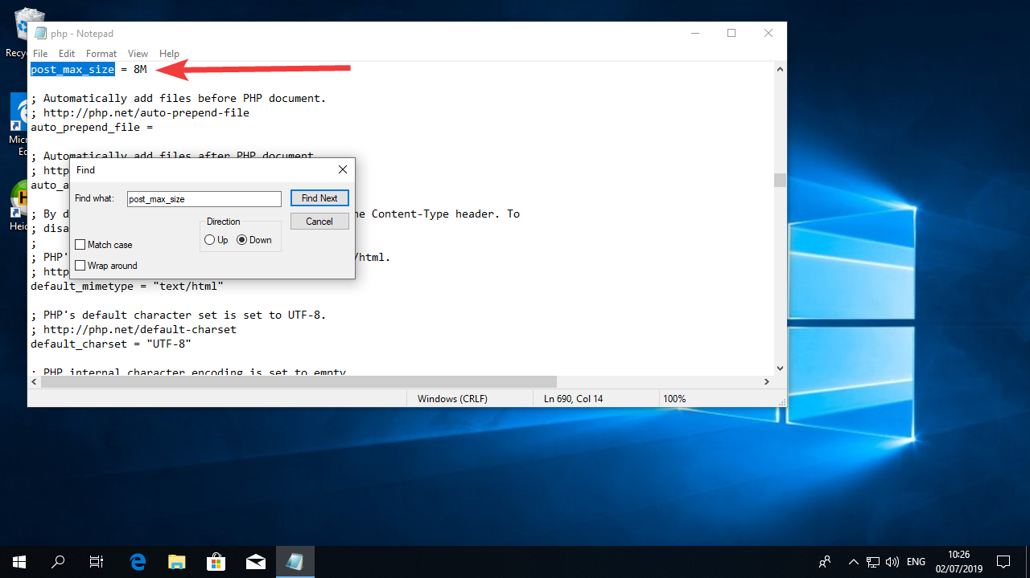

Change the text to “post_max_size = 1G”
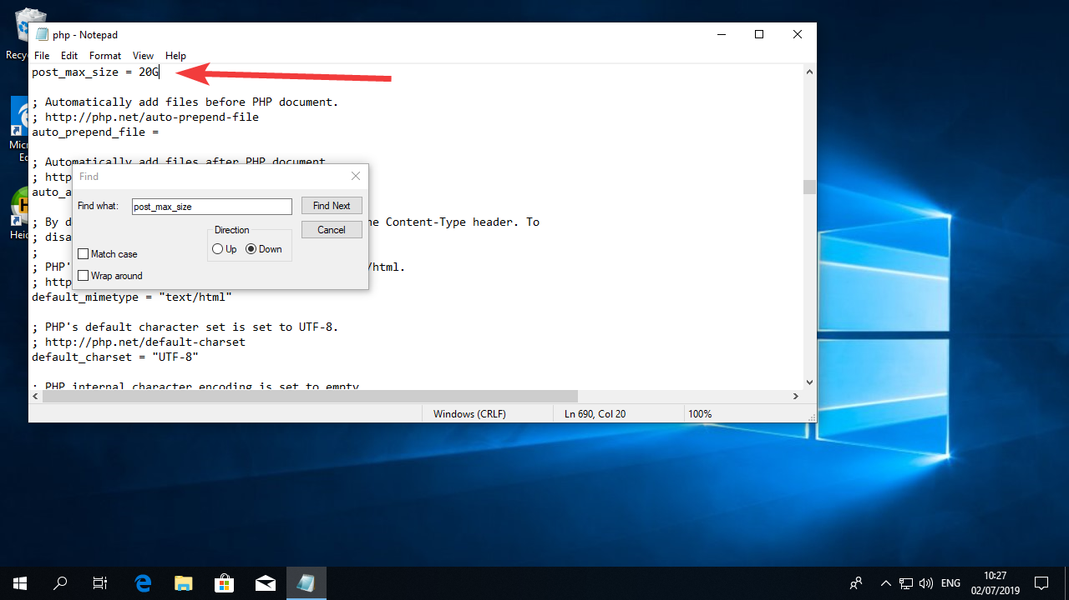

Now perform a search again using the term “upload_max_filesize”
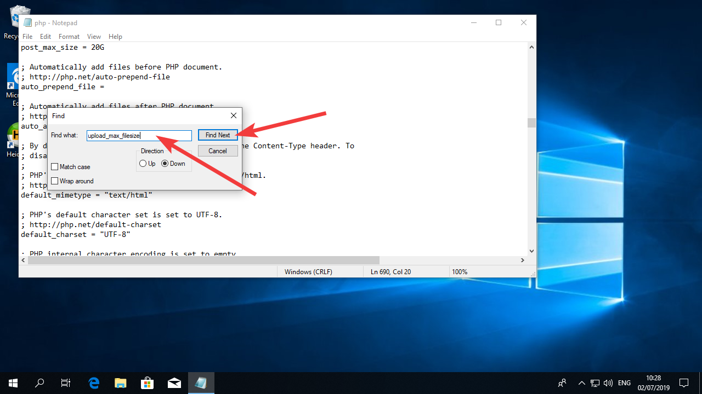

Change the value to “upload_max_filesize = 1G”
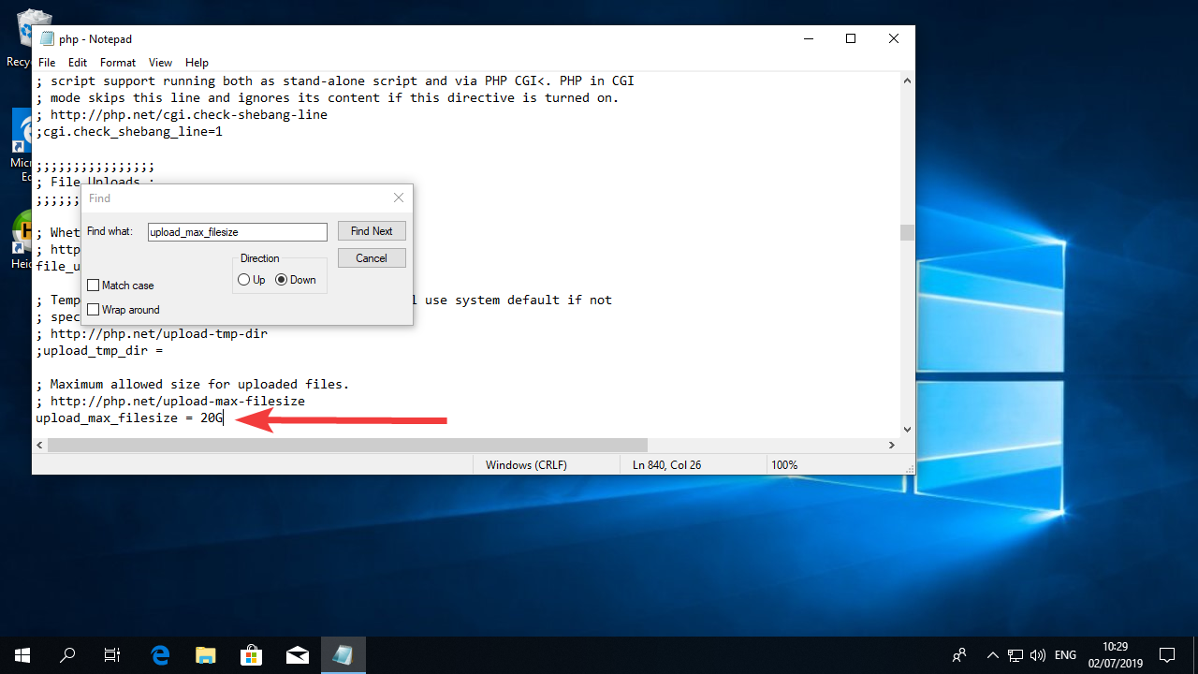

Now search for “max_execution_time” and change the value to “max_execution_time = 600”
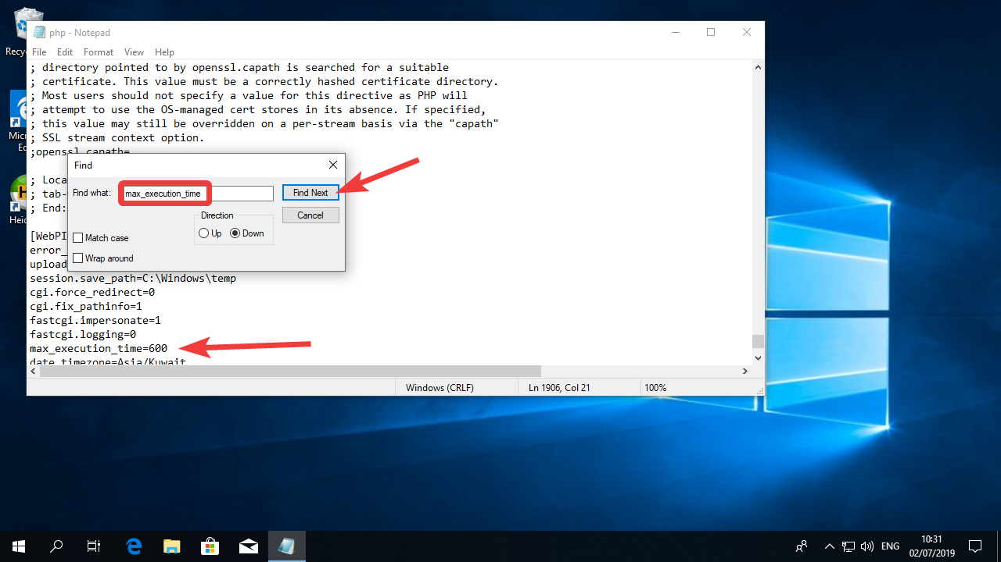

Now click on “File” and then in “Save”
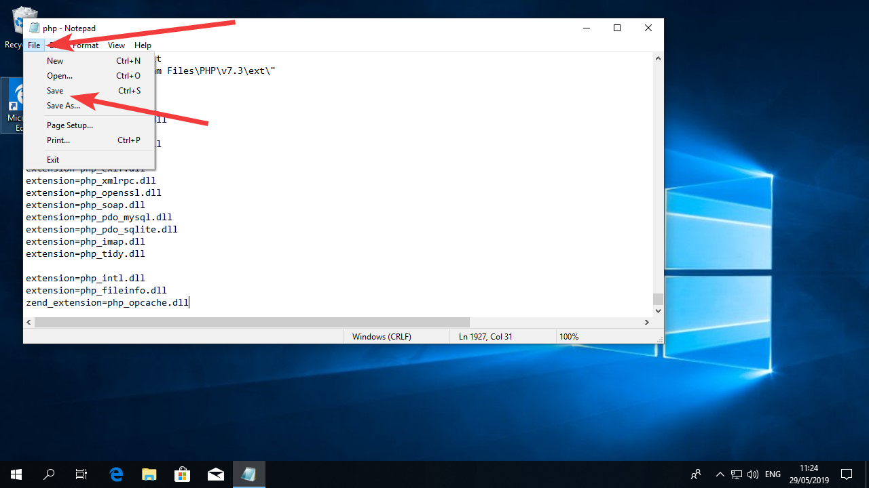

Then on “File” and “Exit”
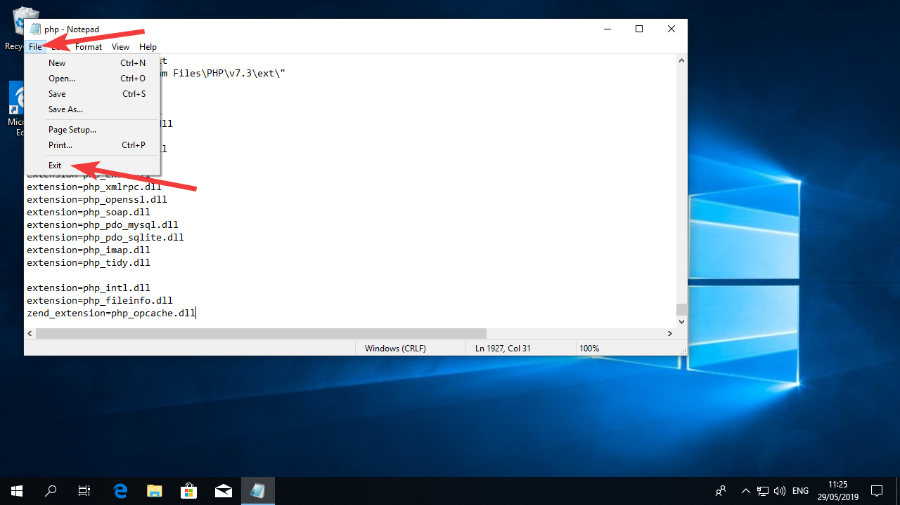
The PHP interpreter is now configured to be used with Moodle.
You must now reboot the computer.

Install MariaDB
For the Database server in our system we will use MariaDB. This is a “fork” of the MySQL database with virtually the same functionalities but has a more open license.

Install MariaDB
Click on the “Start Menu”
Open your web browser and go to https://downloads.mariadb.org/ or search the internet for “MariaDB download for windows”. This should be the first link.
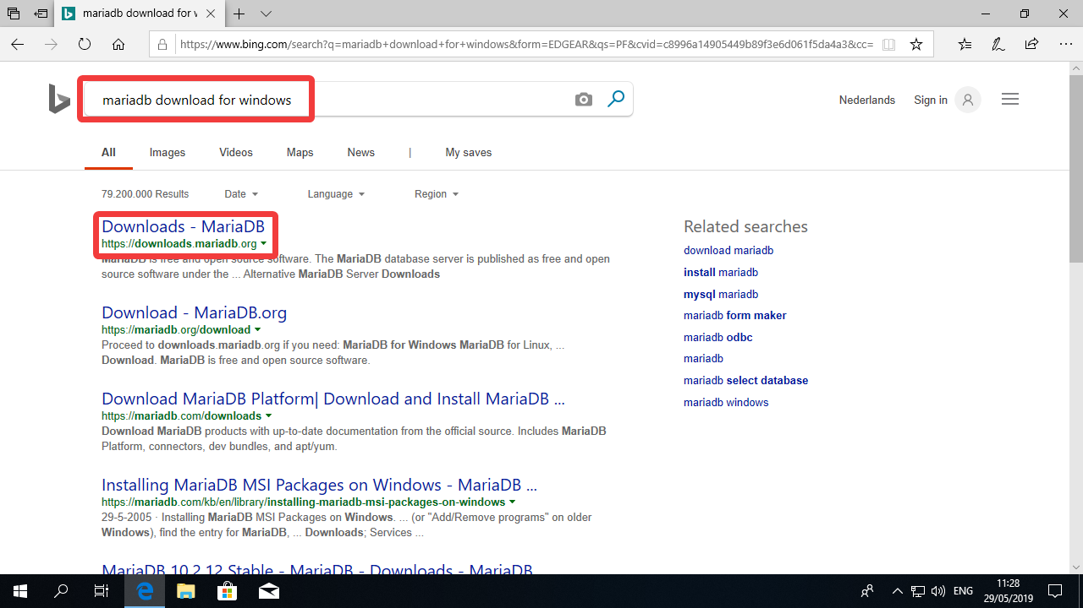
The link will take you straight to the last stable release. Click “Download XX.X.X Stable now” (it might be a newer version than you see in the screenshot below).
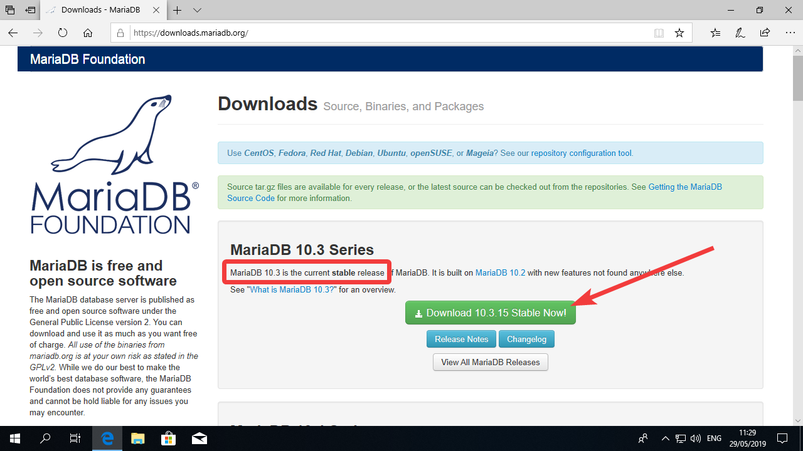
You will see a page with many links. Search for the file that ends with “…winx64.msi”. That means that this is a 64 bit version with a installer (which will make our lives easier). Click on the filename to download it.
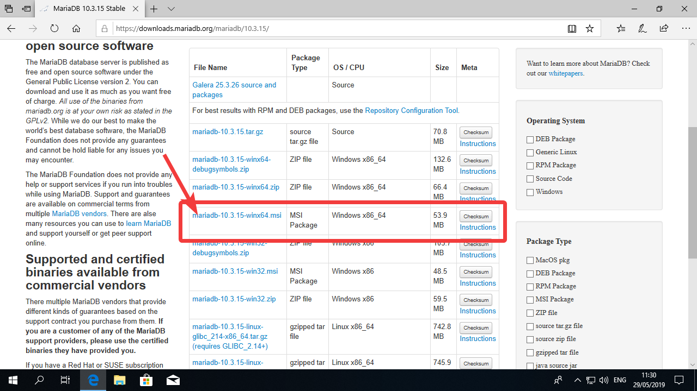
Click Run.
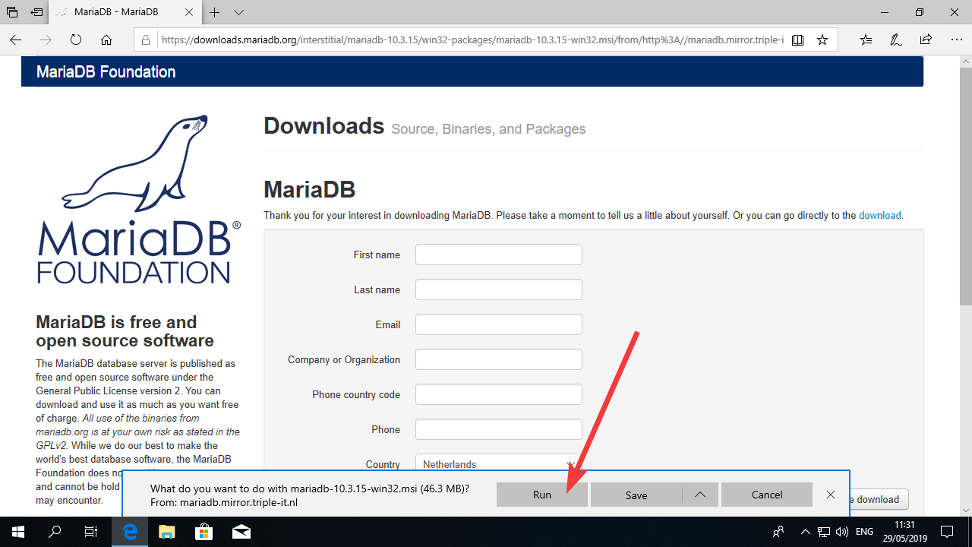

Once the installer is running, click “Next”
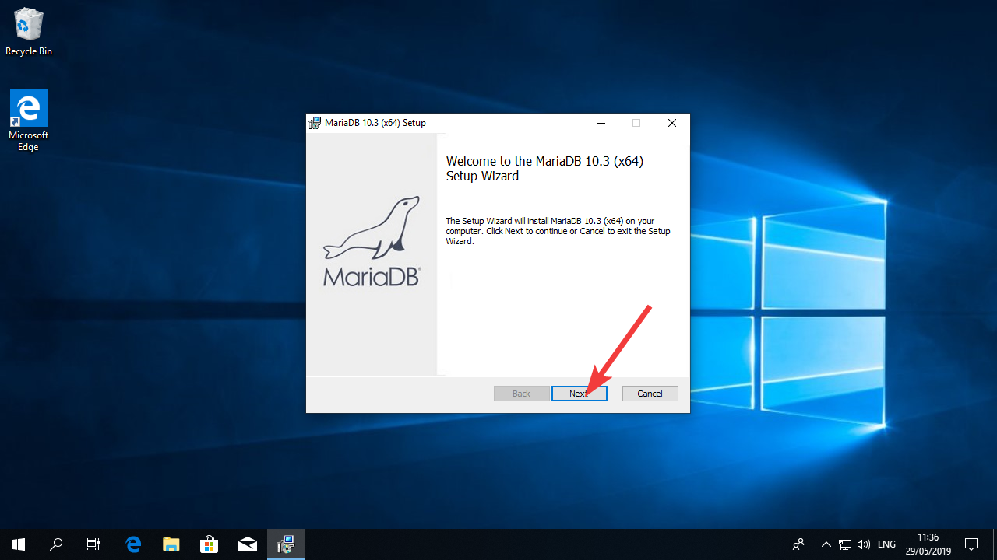

Check “I accept…” and then click “Next”
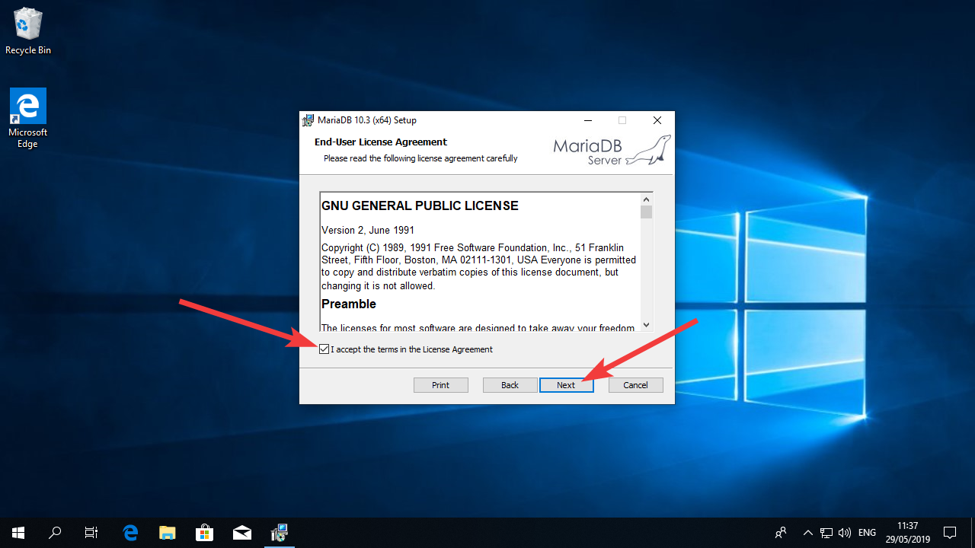

Click “Next” in the following window.
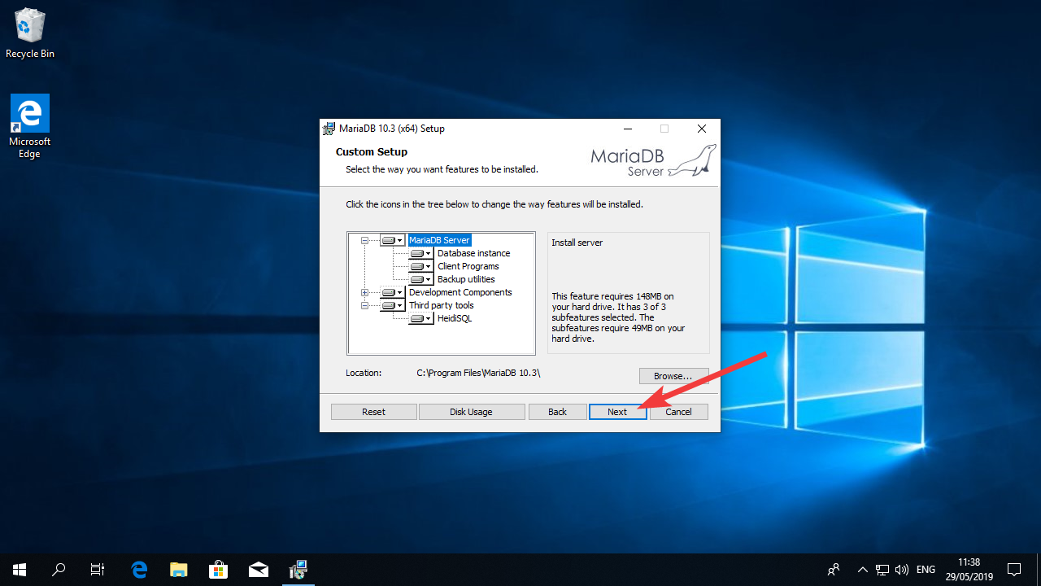

Now it’s time to create the root password. Root is the user with full privileges so it’s very important to create the password for this user and write it down. If you performed the tasks in the previous document you already have a sheet of paper with the password to your computer. You can write the password you chose for your database there. Make sure it’s 10 characters long or longer and contains only letters and numbers.
Once you typed your password twice, uncheck the “Enable access from remote machines…” checkbox and check “Use UTF-8 as default…” checkbox. Then click next.
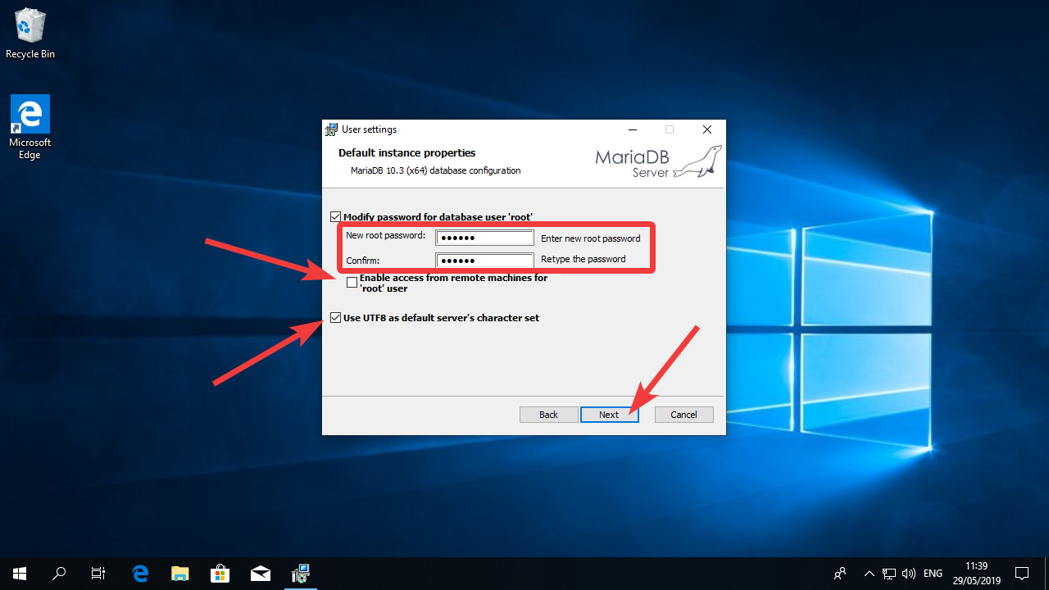
Make sure the configurations on the next screen are the same that you see in the following picture and click “Next”
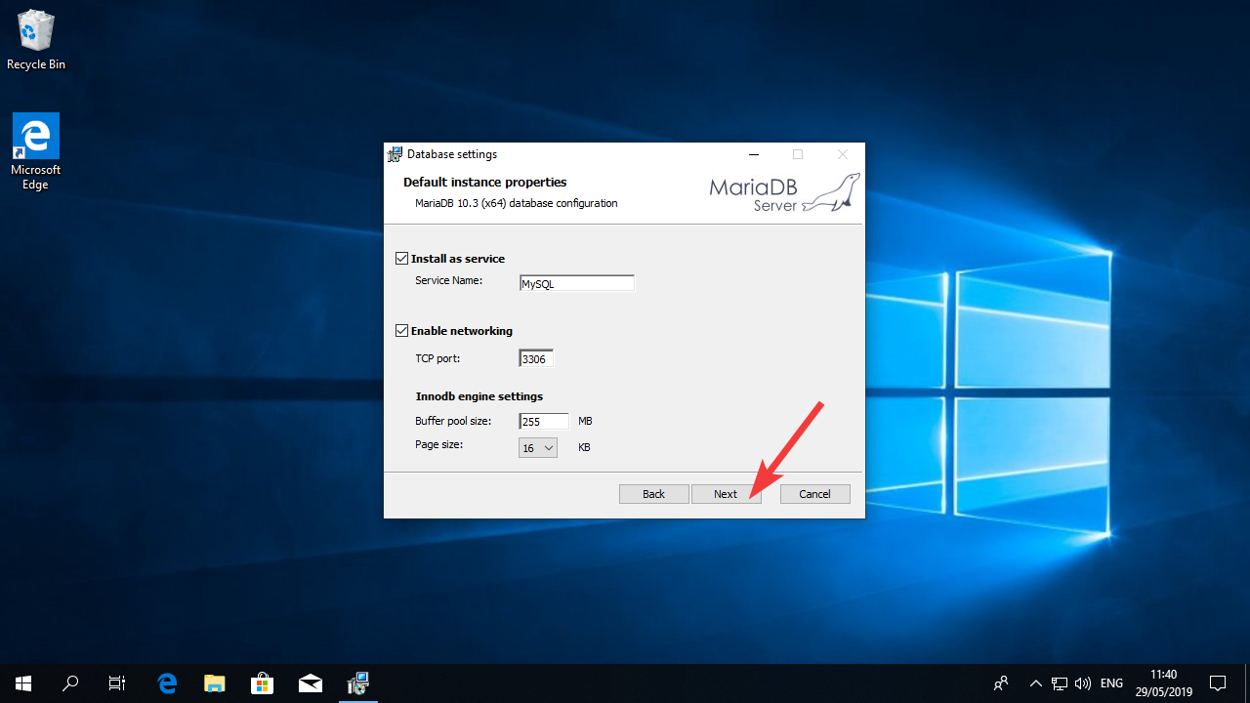
Uncheck the “Enable feedback…” checkbox and click “Next”
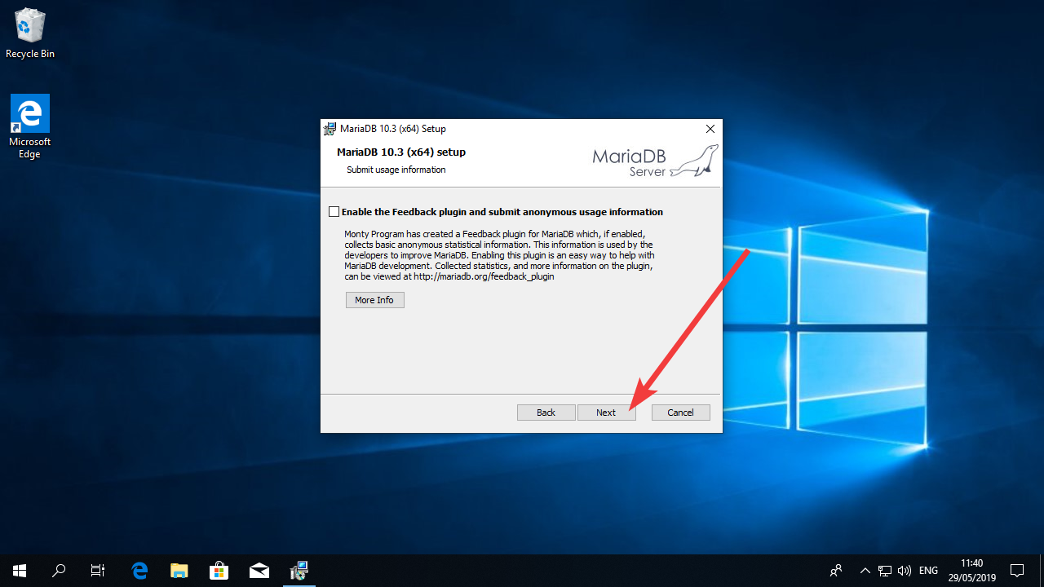

Click Install
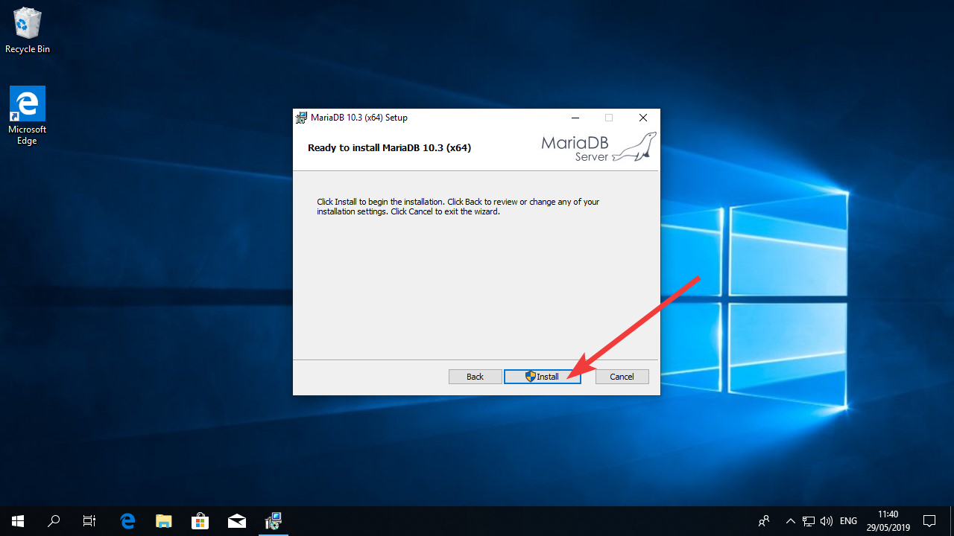

Click “Yes” on the UAC window.
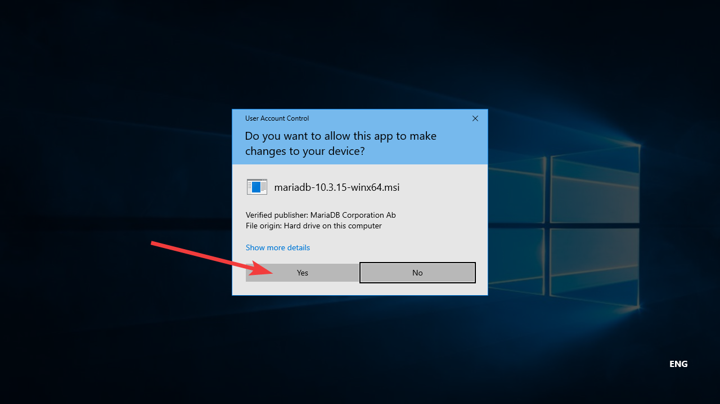

Wait for the installation to complete.
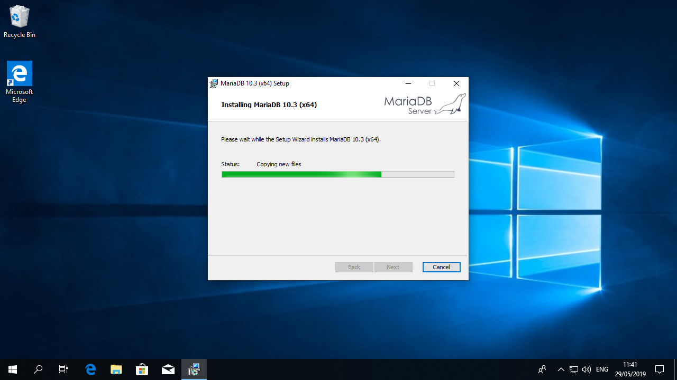

Once the installation is complete, click in “Finish”

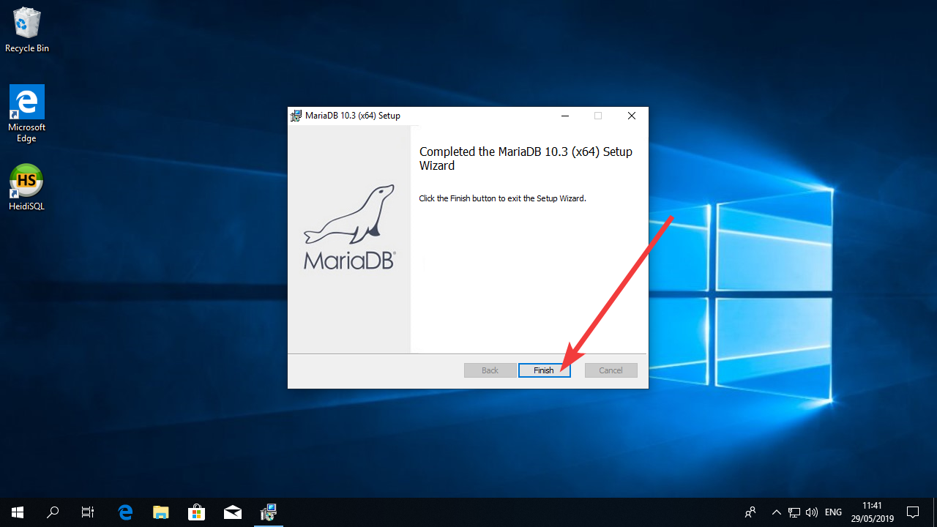
That’s it, MariaDB is installed. Now you can go ahead and configure it to be used with Moodle.

Configure MariaDB

Click on the “Start Menu”, search for “notepad”, right click the icon and click on “Run as Administrator”

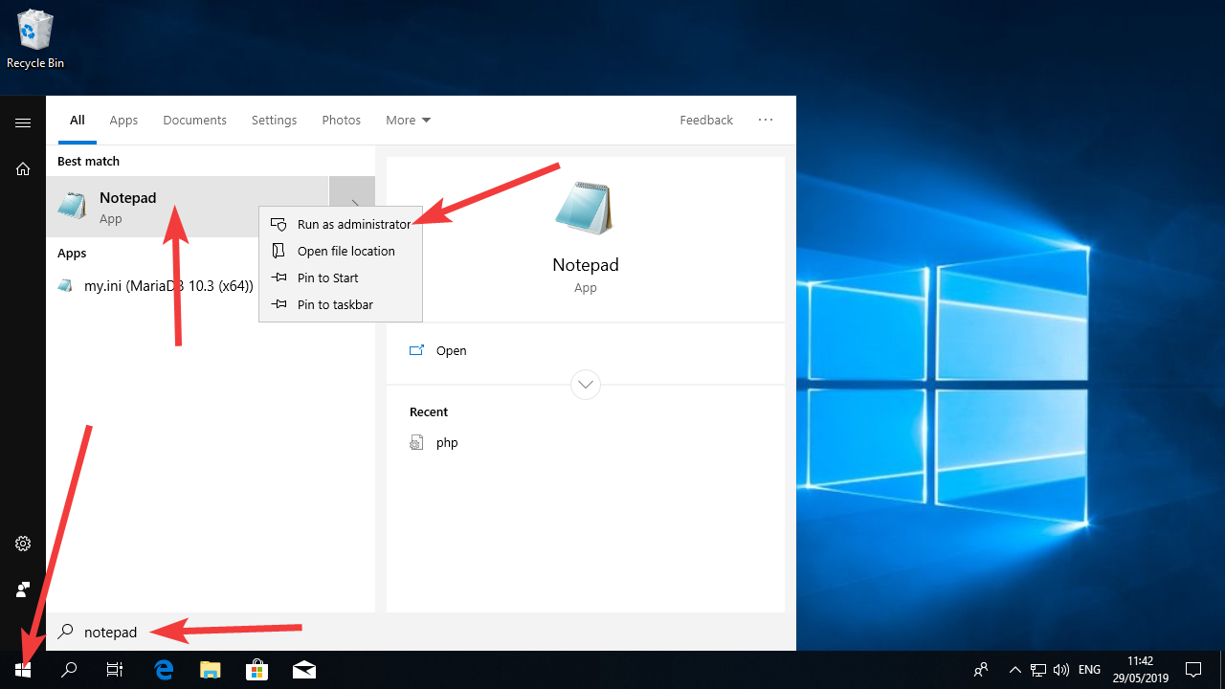
Click “Yes” on the UAC window.
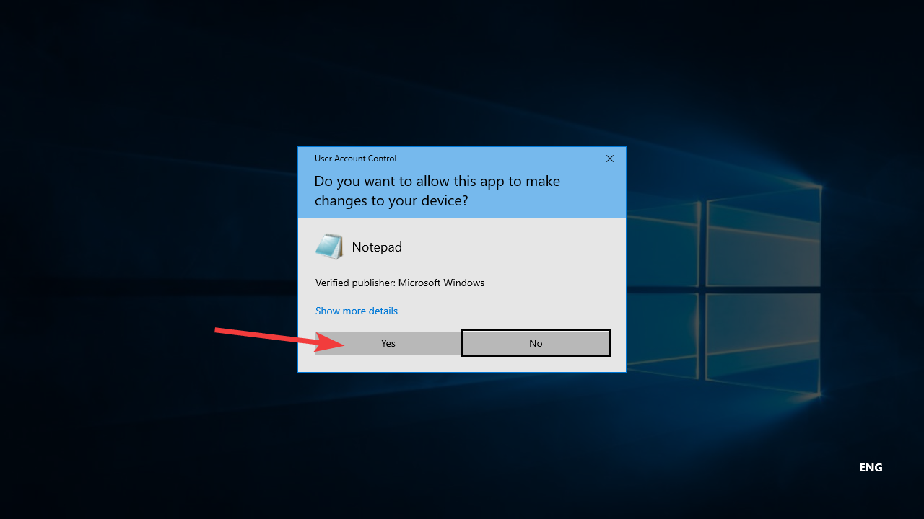
Click in “File” and then “Open”
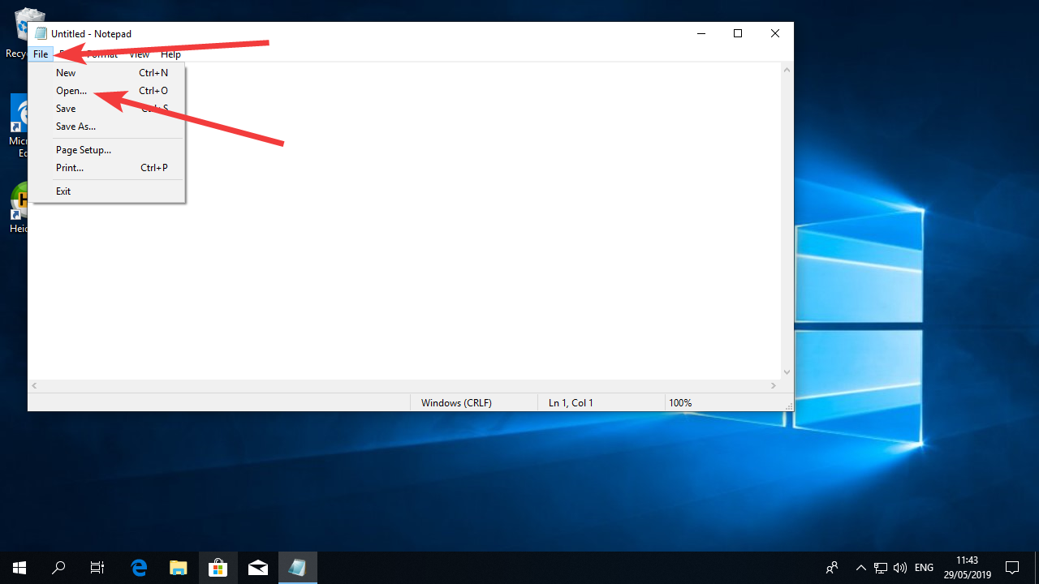
Navigate to c:\Program Files\MariaDB 10.3\data (the number 10.4 might be different depending on the version you installed)
Select “All files” in the dropdown menu.
Where you see “UTF-8” in the image below, change to ANSI
Select the file “my” where you can see a cog in the icon and “Configuration settings” on the right.
Click Open.
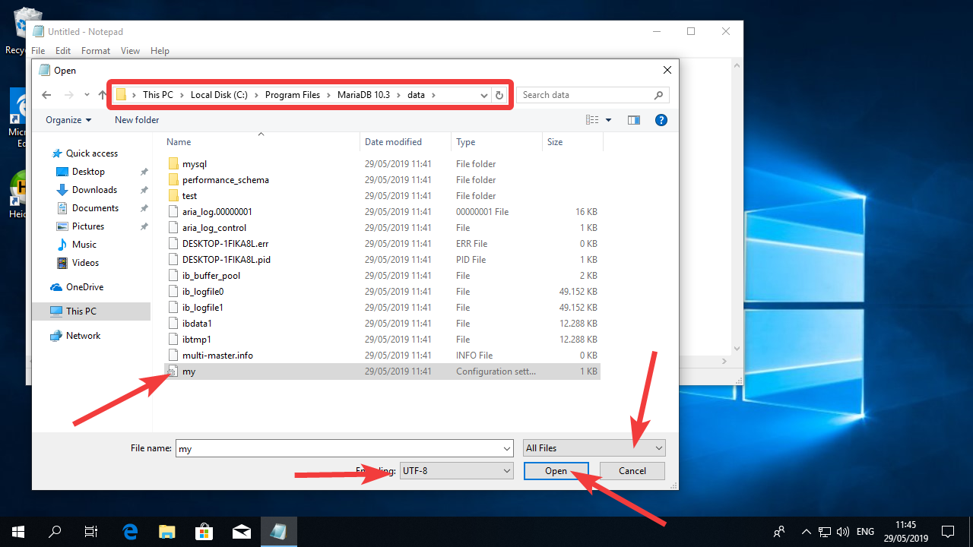
The image below shows the typical configuration.
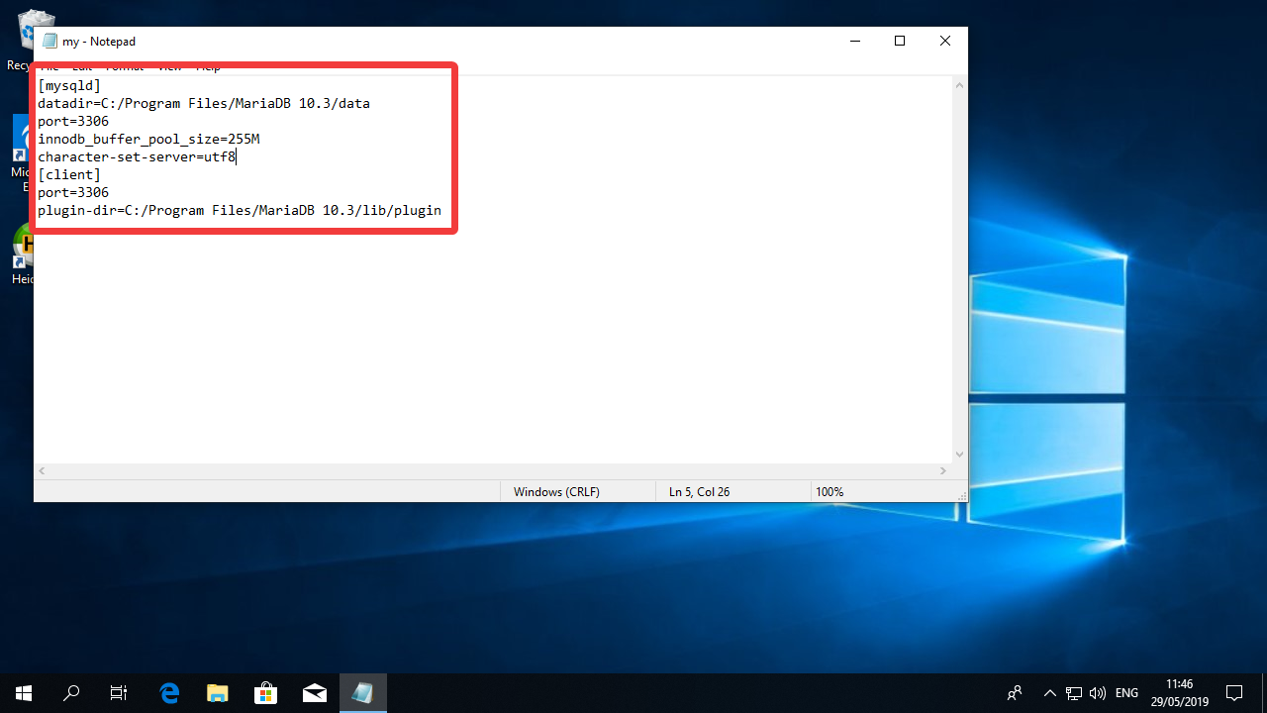
You can copy the text below and replace the original:
[mysqld]
datadir=C:/Program Files/MariaDB 10.3/data
port=3306
innodb_buffer_pool_size=1012M
innodb_file_format = Barracuda
innodb_file_per_table = 1
innodb_large_prefix = 1
character-set-server = utf8mb4
collation-server = utf8mb4_unicode_ci
skip-character-set-client-handshake
[client]
port=3306
plugin-dir=C:/Program Files/MariaDB 10.3/lib/plugin
default-character-set = utf8mb4
[mysql]
default-character-set = utf8mb4
Your file should look exactly like the one below. Also note that the paths in the file should match the paths in your computer. It’s likely that MariaDB will be installed in a different folder rather than “MariaDB 10.3” like in the text above. Please adjust accordingly.

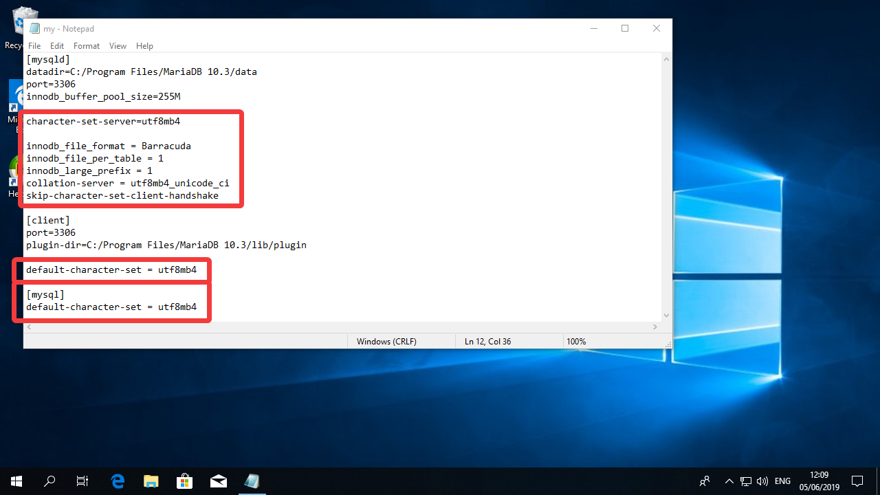

Click on File and Save
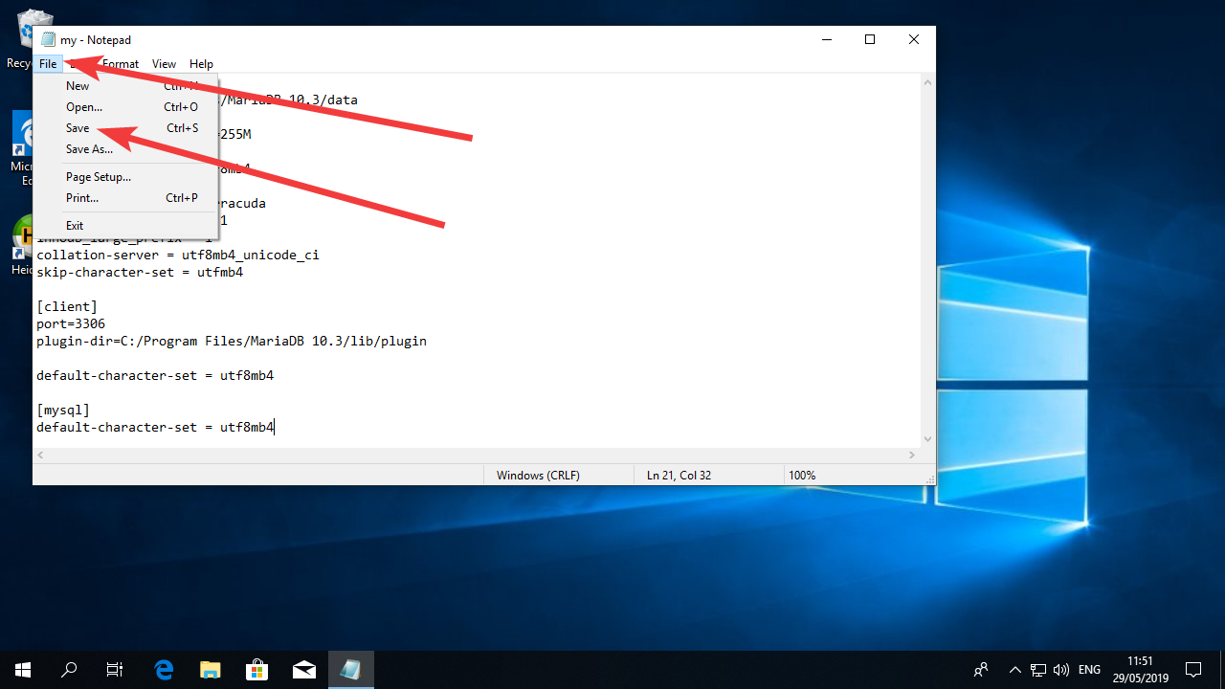
And then in File and Exit
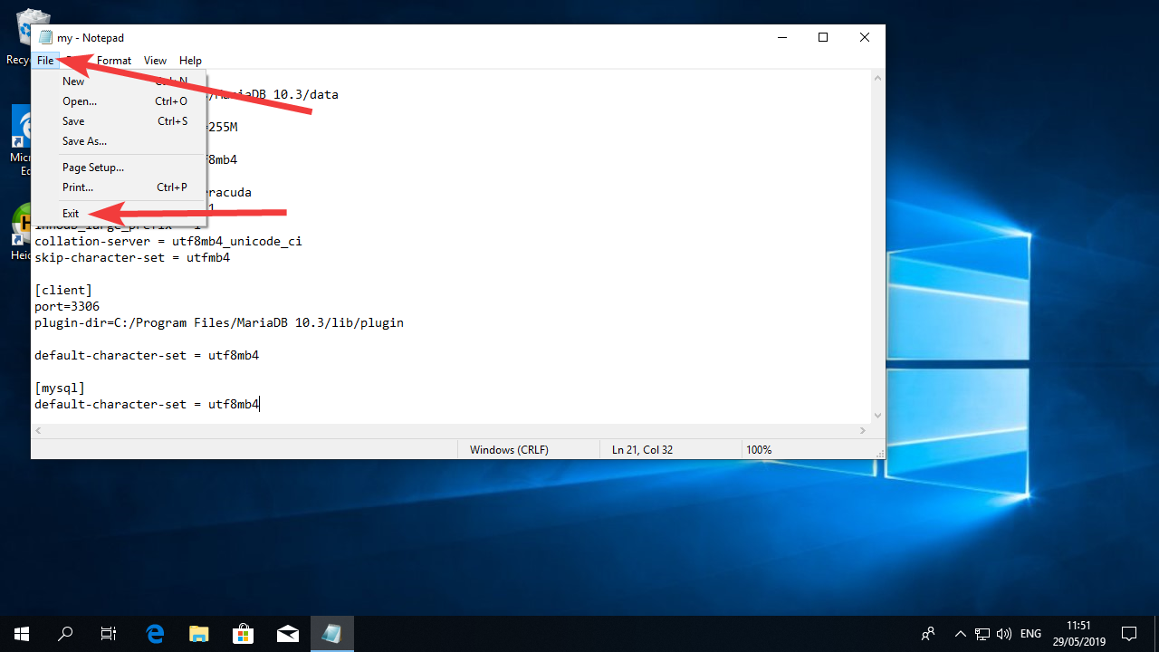
Now you can click on the Start Menu and the power icon. Then select restart.
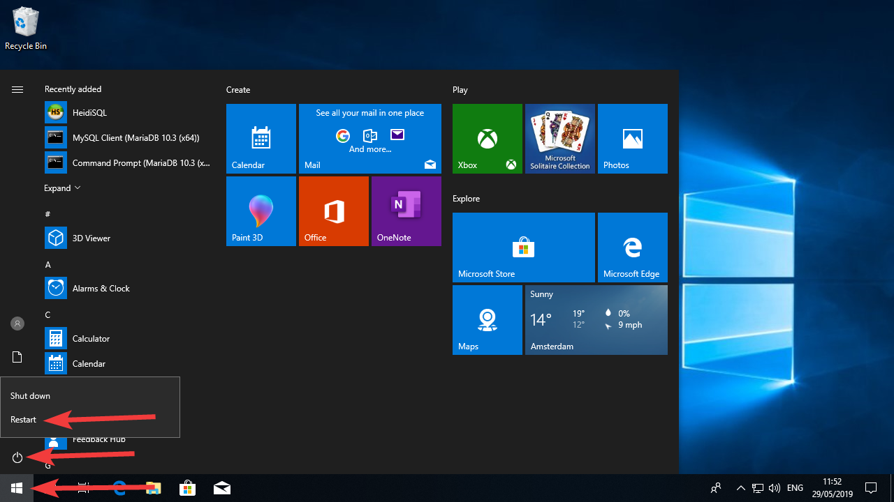

Your database is now installed and running every time you restart your computer.

Create a new Database for Moodle

Click on the “Start Menu”, search for “MySQL”. You should see a software called “MySQL Client (MariaDB 10.x (x64)”. Click on it.
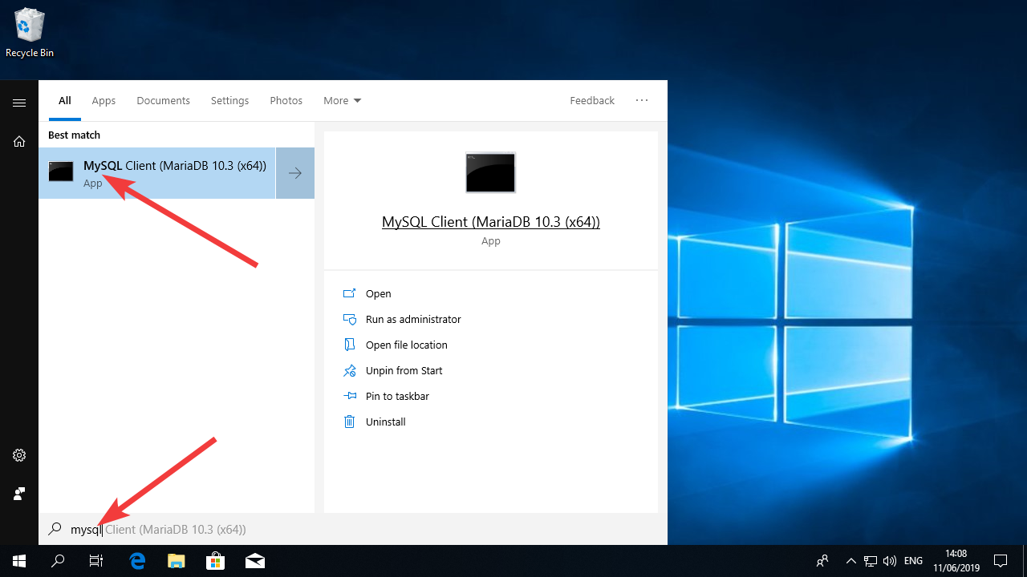
Enter the password you set for the root access of the Database in the previous chapter.
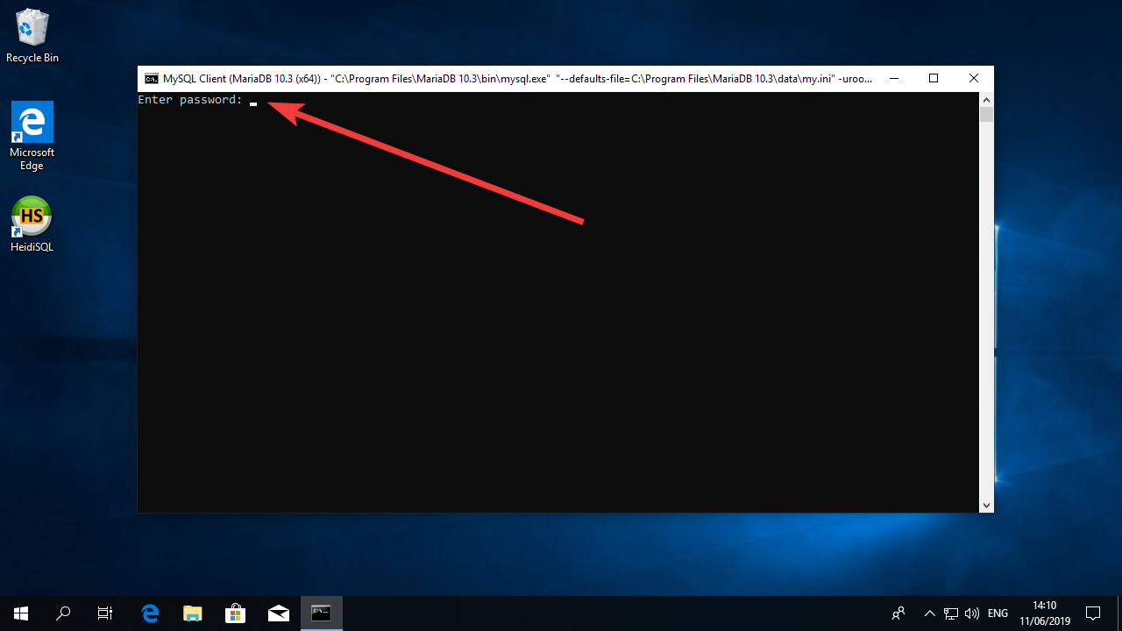
If you typed the correct password, you should see the screen below.
In this software (we call it a terminal) you will be typing MySQL commands. Those are commands meant to communicate and change the database. Remember that all commands end with a semicolon “;” which is the character MySQL understands as the end of a line.
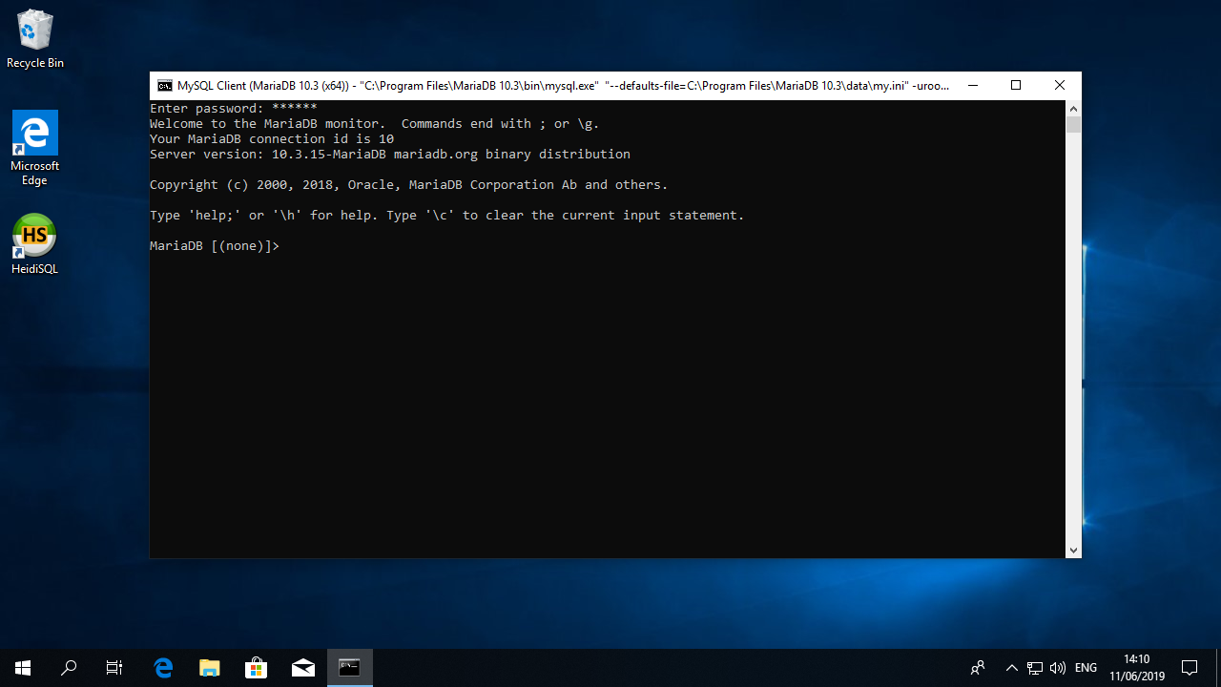
Now type:
SHOW DATABASES;
And press enter. (don’t forget the semicolon at the end of the command)
You should see a result similar to the one below:
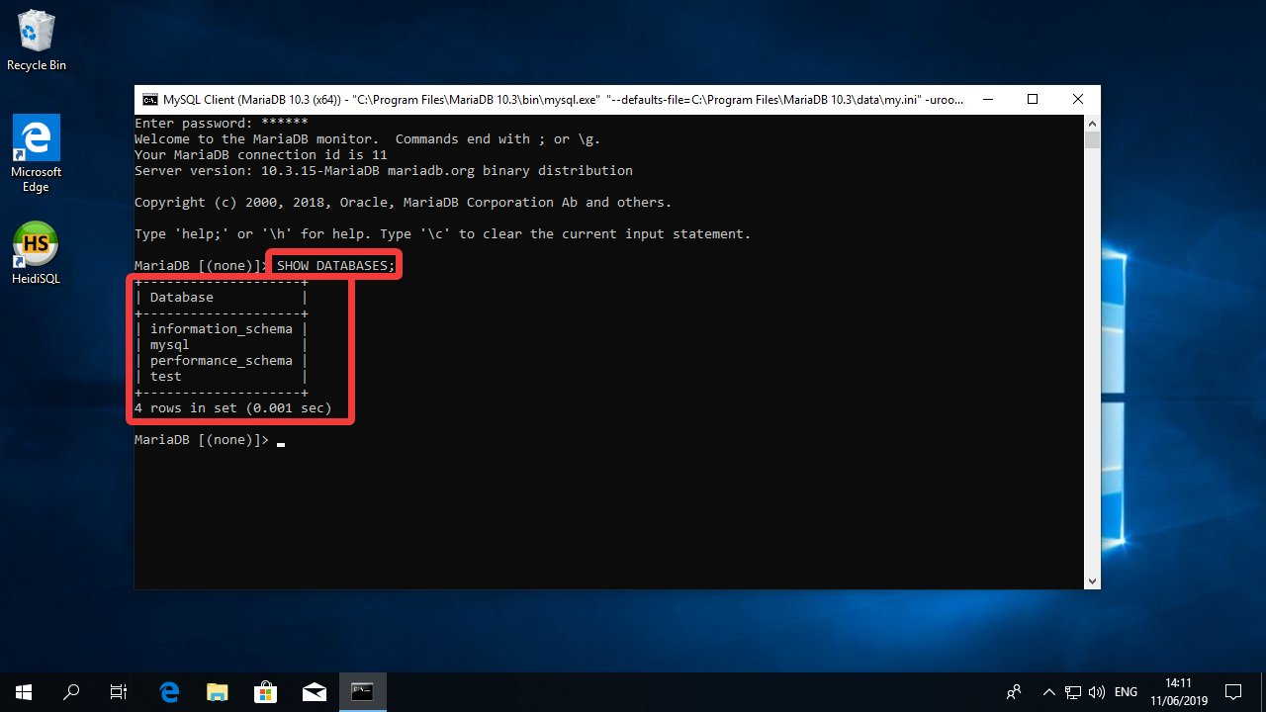
Now let’s create the database, type:
CREATE DATABASE moodle DEFAULT CHARACTER SET utf8mb4 COLLATE utf8mb4_unicode_ci;
And press Enter. One more time, the software should return the message “Query OK, 1 row affected”

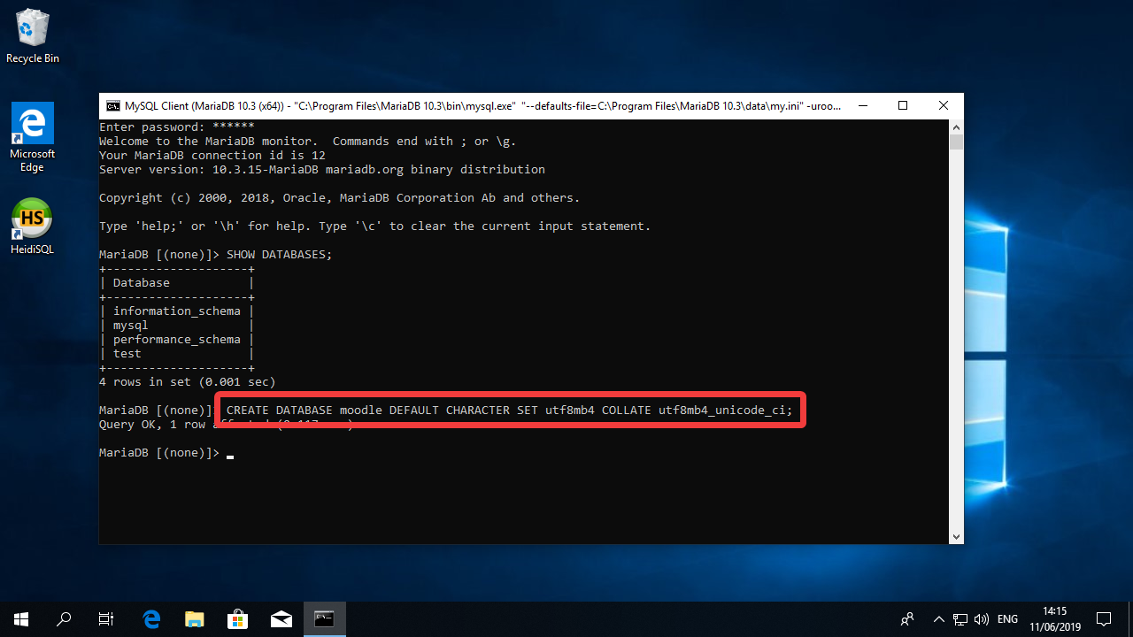

Now let’s create a new user called “moodleuser” and grant it access to the database using the code below
GRANT SELECT,INSERT,UPDATE,DELETE,CREATE,CREATE TEMPORARY TABLES,DROP,INDEX,ALTER ON moodle.* TO moodleuser@localhost IDENTIFIED BY 'yourpassword';
Please notice the part in red in the comment above. That will be the password that Moodle will use to communicate to the Database. It is very important that you create a strong password for the database.
You can think of a strong password yourself, or you can use the website https://passwordsgenerator.net/ to generate a random password.
Navigate to the website, uncheck “Include Symbols” and click in “Generate Password”.
Your password will appear in the “Your New Password” field.
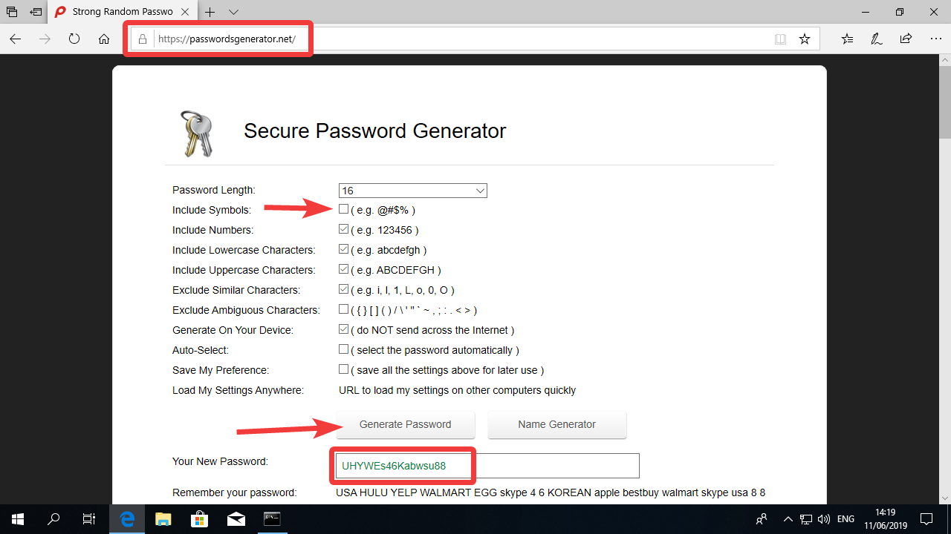
Copy this password to the clipboard by selecting and pressing CTRL-C or by selecting it, clicking on the text with the right mouse button and clicking in “copy”.
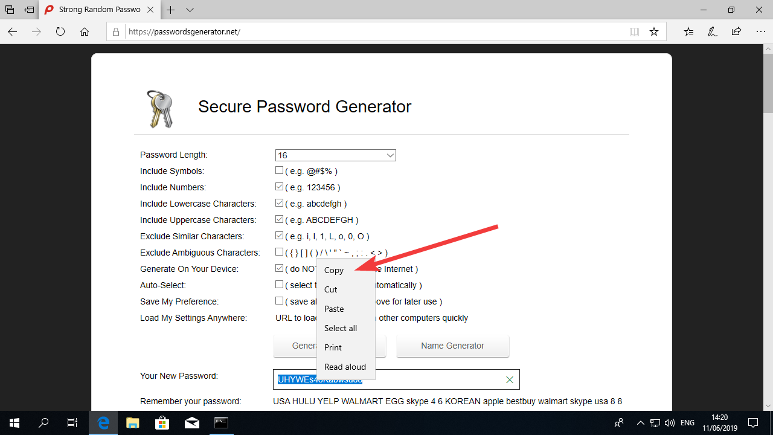
Now enter the command above changing the word “your password” to the password you created.
Note that the password is still enclosed between Apostrophes -> ‘
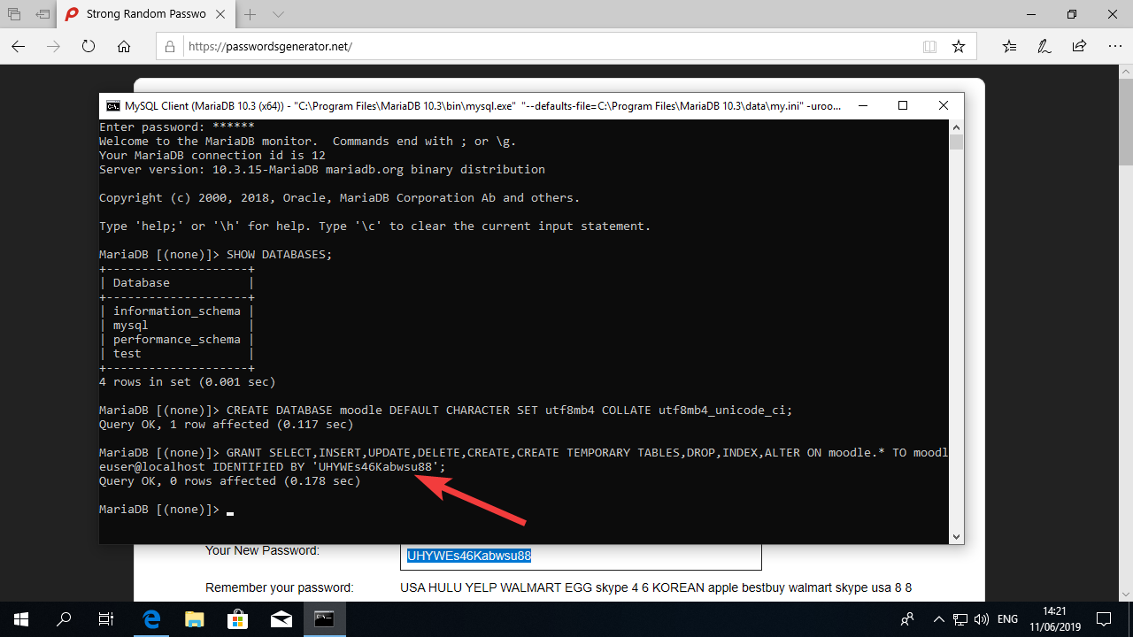
Once you press enter on your keyboard, you will see the message “Query OK, 0 rows affected.”
You can now type quit and press enter.
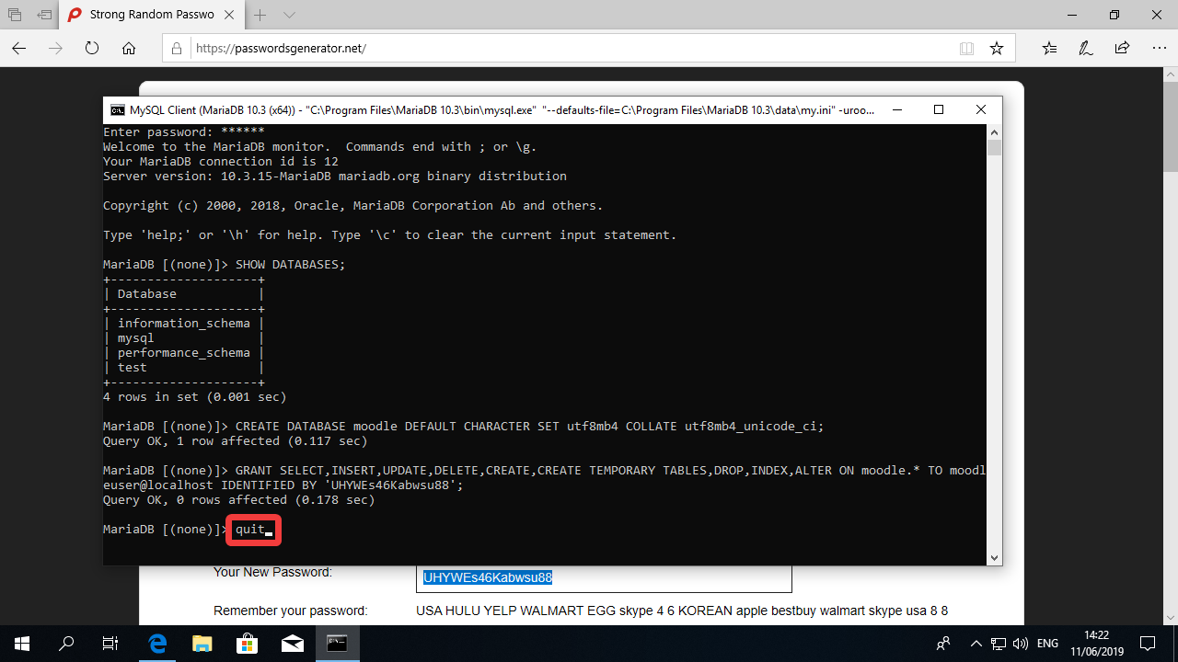

Concluding remarks
It is very important that you write down the Database password or copy it to a text file using the notepad or other text tool. You will need it in the next guide.

