Date:20/06/2019
Ref.:??????
Version Nº:0001

Ethiopian Education Network to Support Agricultural Transformation (EENSAT)

Course Title: Establish, update and maintain EENSAT LMS
Lesson No: 01, Windows Setup

 | Name | Responsibility
Prepared by | Ivan Oliveira | e-Learning Specialist at University of Twente, ITC
Reviewed by | ???? | ???

Moodle Download and Install

Ivan Oliveira, 20/06/2019

OpenCourseWare

Contents
1 Introduction 2
2 Prerequisites 2
3 Best practices 2
4 Downloading Moodle 3
5 Configuring Moodle 15
6 Configuring an email in Moodle 22
7 Changing the web address for Moodle 31
8 Concluding remarks 32

Introduction
This document will walk you through basic windows configurations that you might need to check before you start actually setting up web services.

Prerequisites
- Have a Windows computer with:
  - IIS installed, configured and running.
  - 64-bit PHP installed, configured and running.
  - 64-bit MariaDB installed, configured and running.
  - A database in MariaDB configured according to the Moodle specifications.
- Hardware:
  - Physical network connection to the internet.

Best practices
This computer will be a production webserver. This means that we should avoid using it for anything other than its task of serving webpages. Any other task or any software installed alongside the webserver can interfere with the performance of the machine. Please follow the best practices below to ensure the system continues to work properly:
- Do not install software in the server unless specified in the guides.
- Do not install Anti-Virus or Anti-Malware software (Windows 10 has its own built-in security).
- Document any change you make to the computer.
- Write down or save digitally any password used during the guides and store this information safely whether it’s digital or physical.
- Do not use the computer for any other task rather than serving Moodle (do not browse websites, configure personal emails, etc).

Downloading Moodle
Open your browser and go to https://download.moodle.org or search the internet for “download moodle” like in the image below.
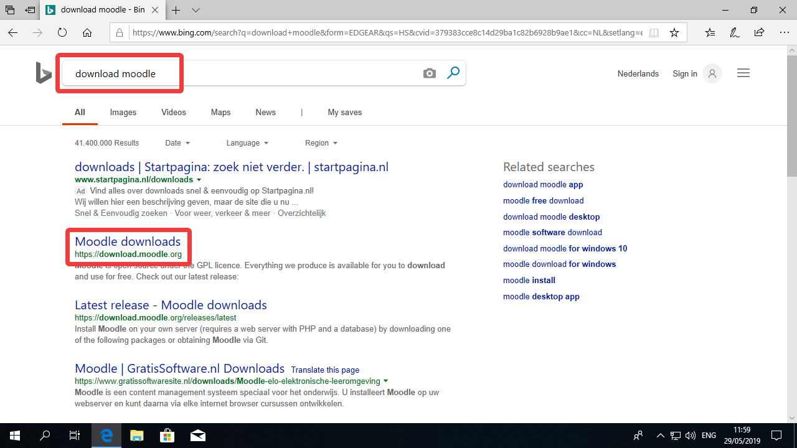

At the download website, click the link in the page to go to the download links.
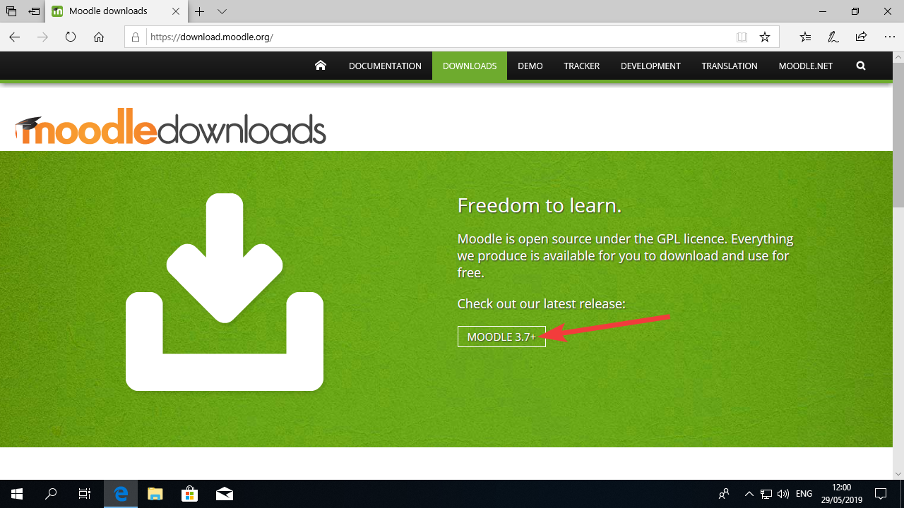

Now You should look for the line with that says STABLE (like in the picture below) and click in button “Download ZIP”.
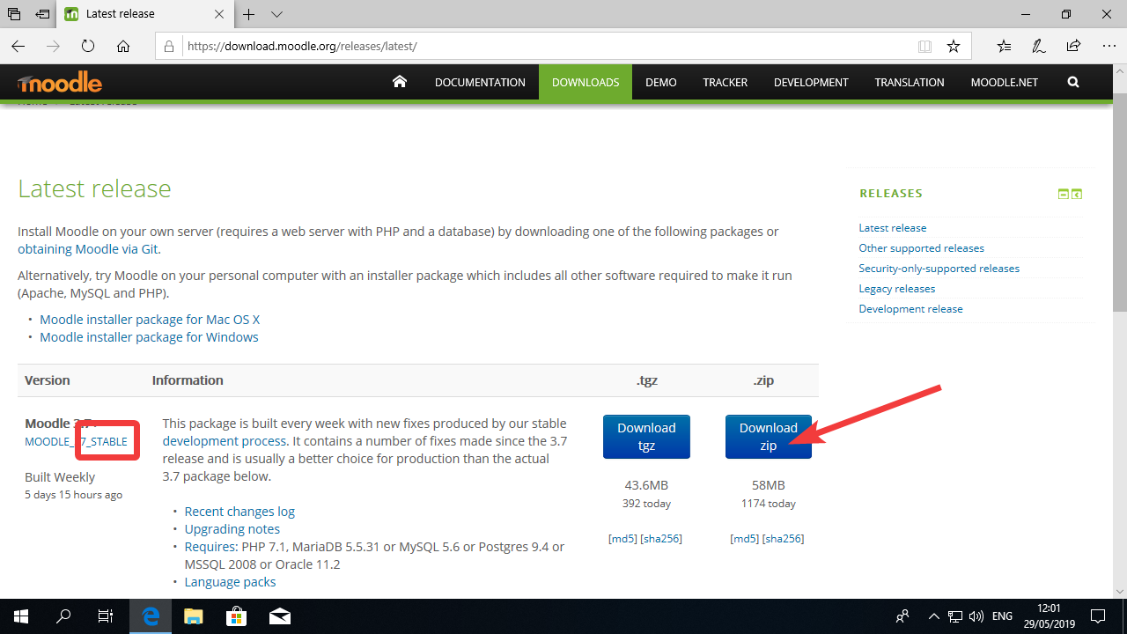

You will be presented with a dialog asking you what do you want to do with the file. You can click in Save.
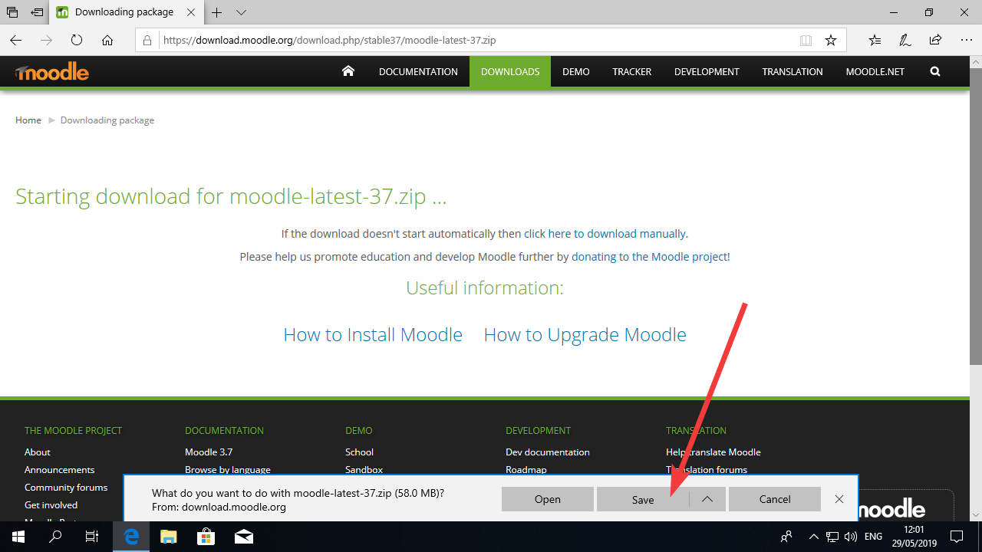

Once the download is finished, you should click in “View Downloads” or navigate using Windows Explorer to the Downloads folder in the computer.
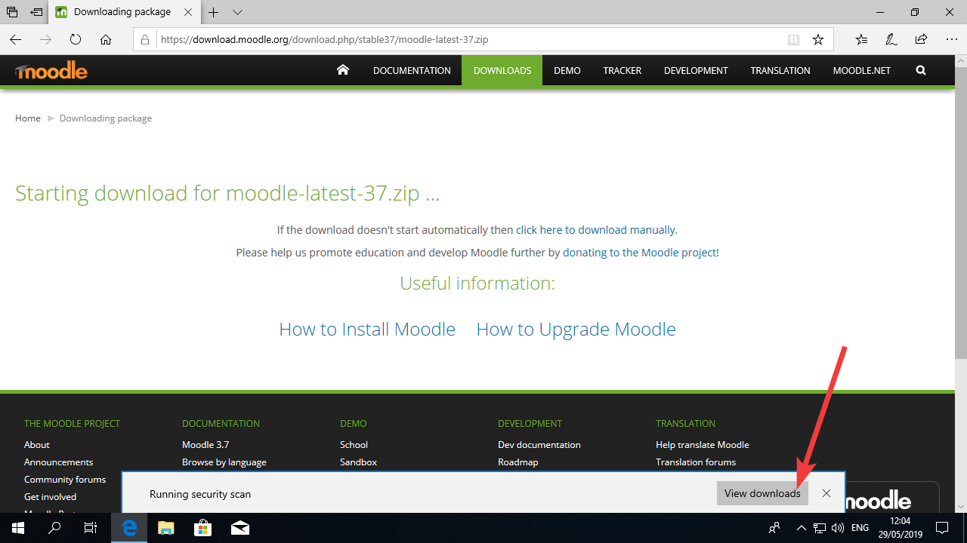

In the downloads folder, you will see a file with moodle in it.
Double click this file.
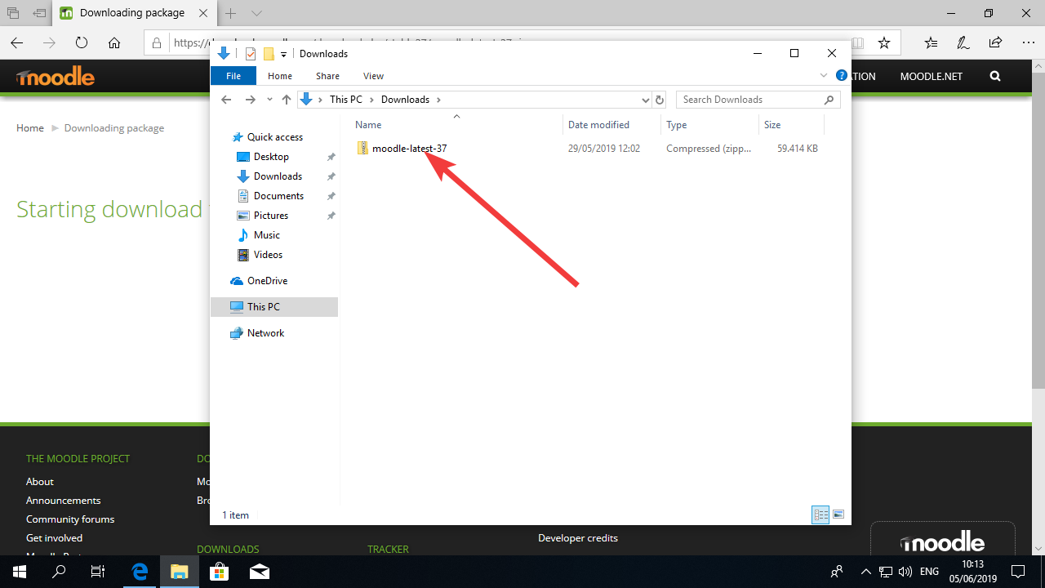

Enter the “moodle” folder by double clicking it.
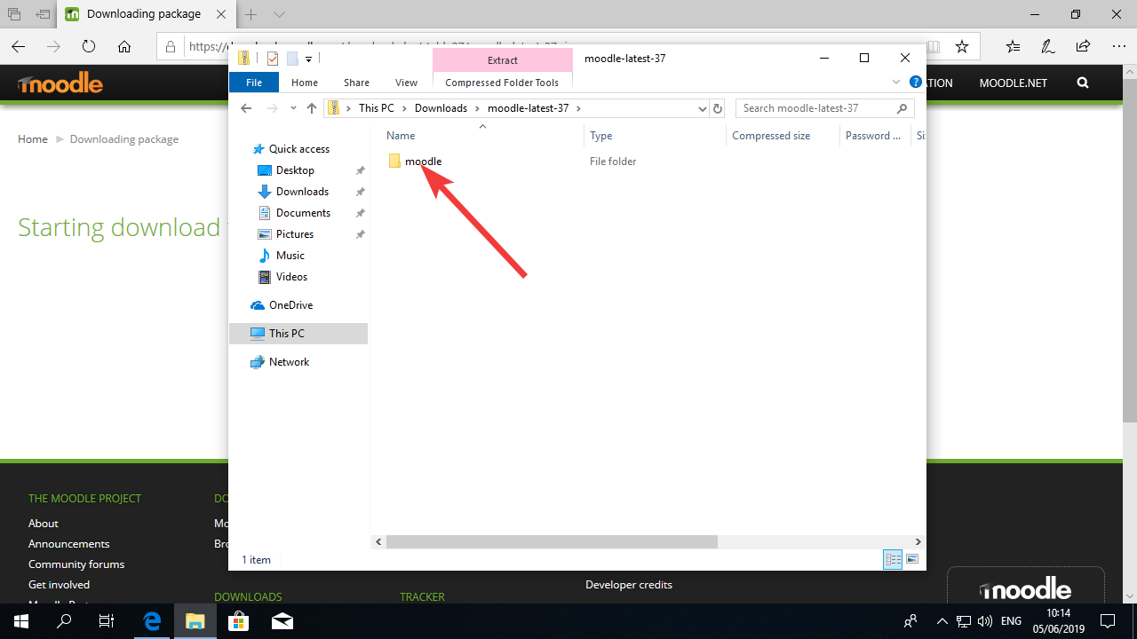

Select all the files with the shortcut “CTRL-A” on your keyboard. Then copy the files to the clipboard either by pressing “CTRL-C” on the keyboard or by right clicking in the blue area and clicking in copy.
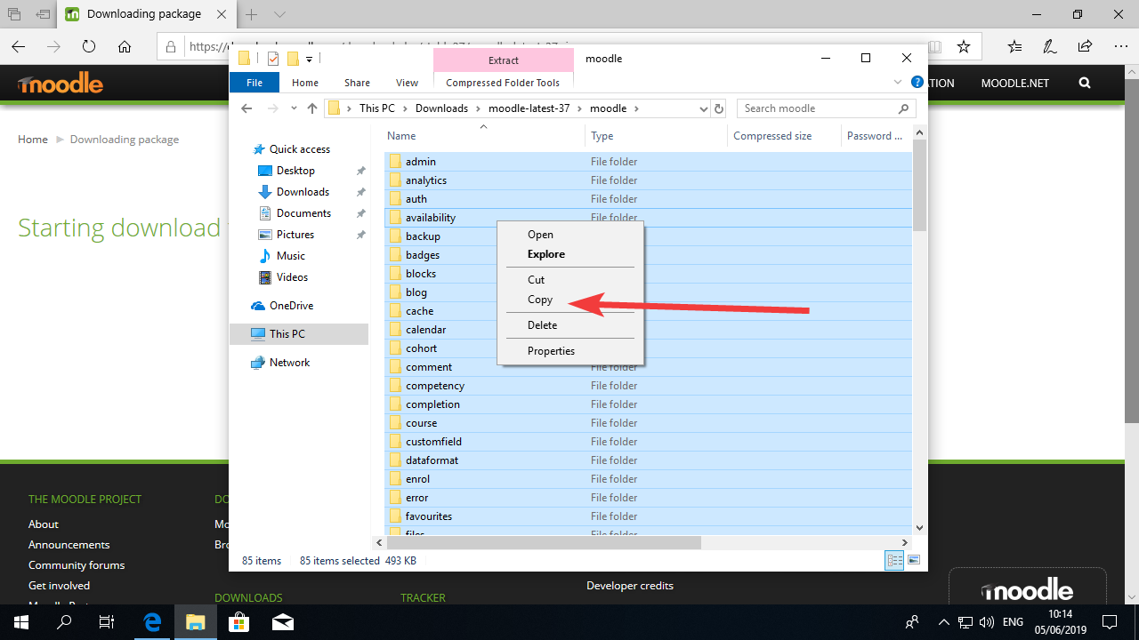

Now you can open a new Windows Explorer window (you can do that by pressing the Windows button and “e” on your keyboard).
Navigate to c:\inetpub\wwwroot This is where your website is.
You can select the two files names “iisstart” and delete them.
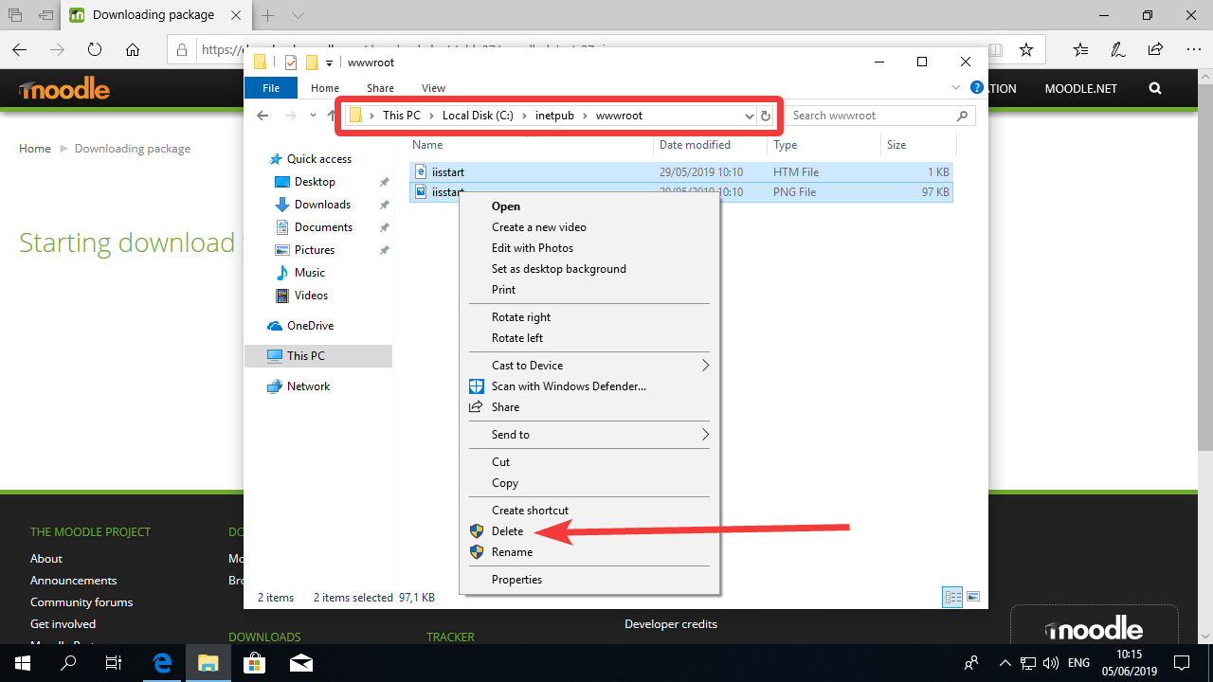

Right-click on the empty space in the folder and select paste (or alternatively, just use the “CTRL-V” shortcut).
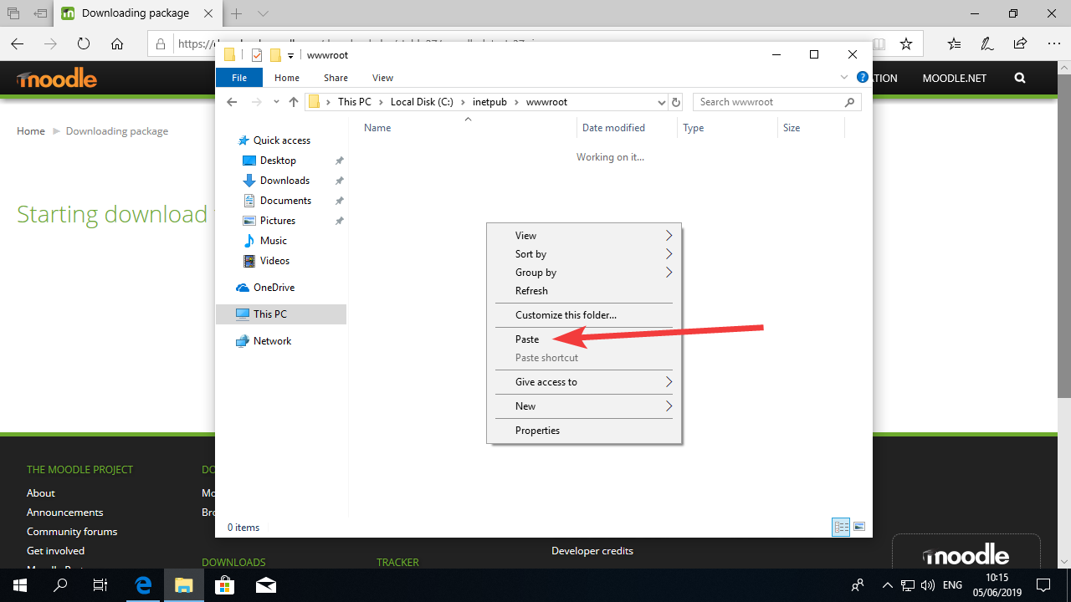

You will be asked to grant administrative access to the folder. You can check the box where it says “do it for all current items” and then click “Continue”.
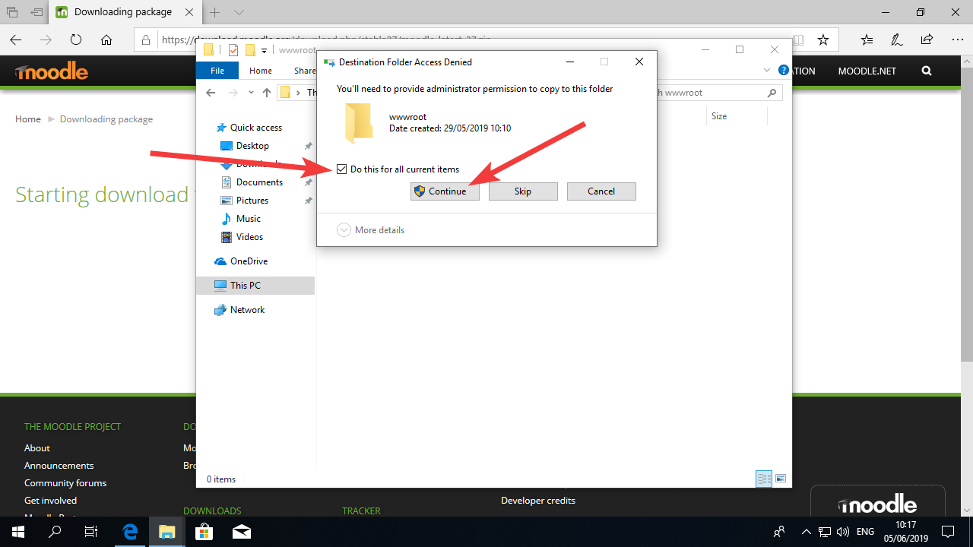

This should take a few minutes, so maybe it’s a good time to go get yourself a coffee!
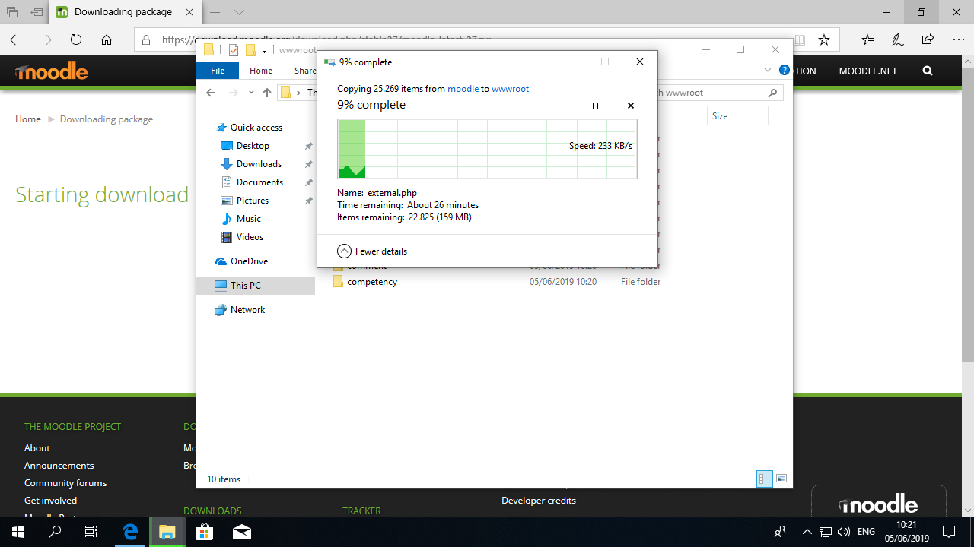

Once the copy is finished, you will see all the files necessary to run Moodle inside that folder.
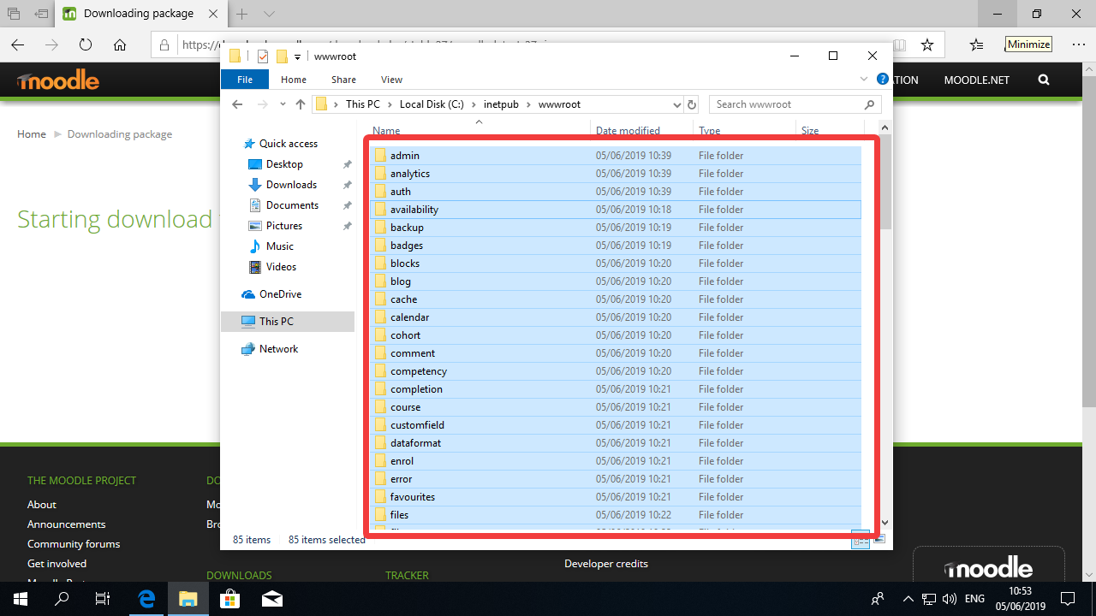

Now it’s time to create Moodle’s “data” folder. This is the folder where Moodle will store any file that users upload to the system.
Right-click on the empty space in the c:\inetpub folder. Select New -> Folder.
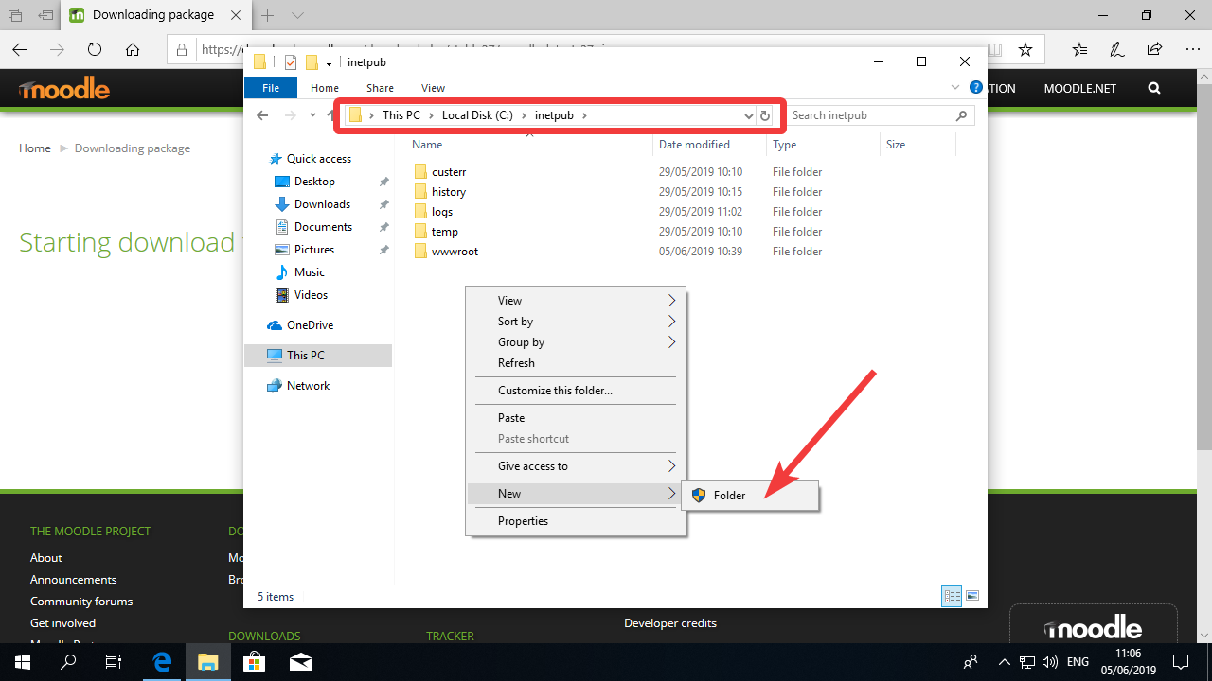

This will create a new folder and give you the chance to give it a name. Type “moodledata”.
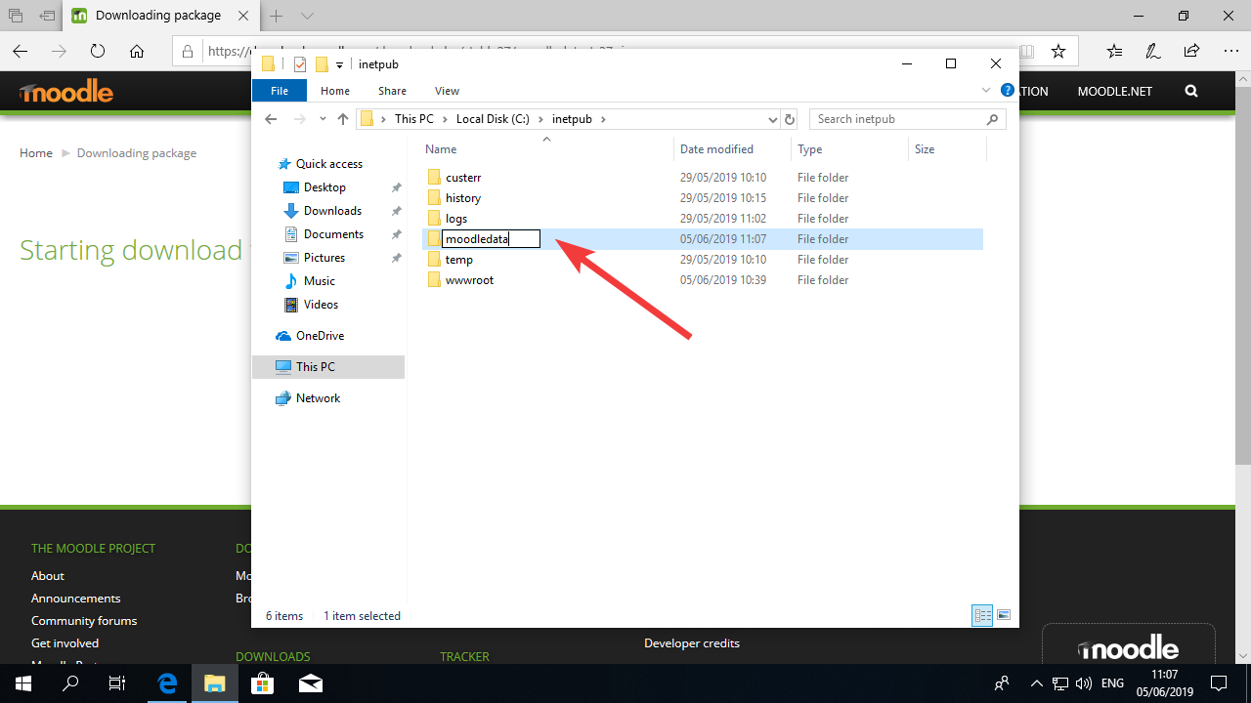

Now it’s time to change the permissions to the folder. That means we are going to authorize programs (in this case Moodle) to write to that folder, or else it will be unable to write to files.
Right-click on the moodledata folder, select “Properties”.
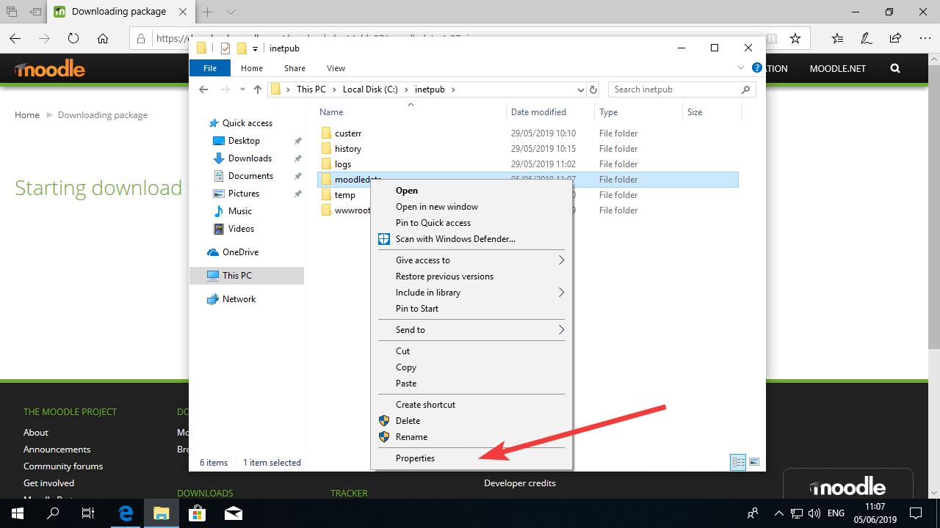

Click on the “Security” tab, select the line where it says “Users” and click the button “Edit”.
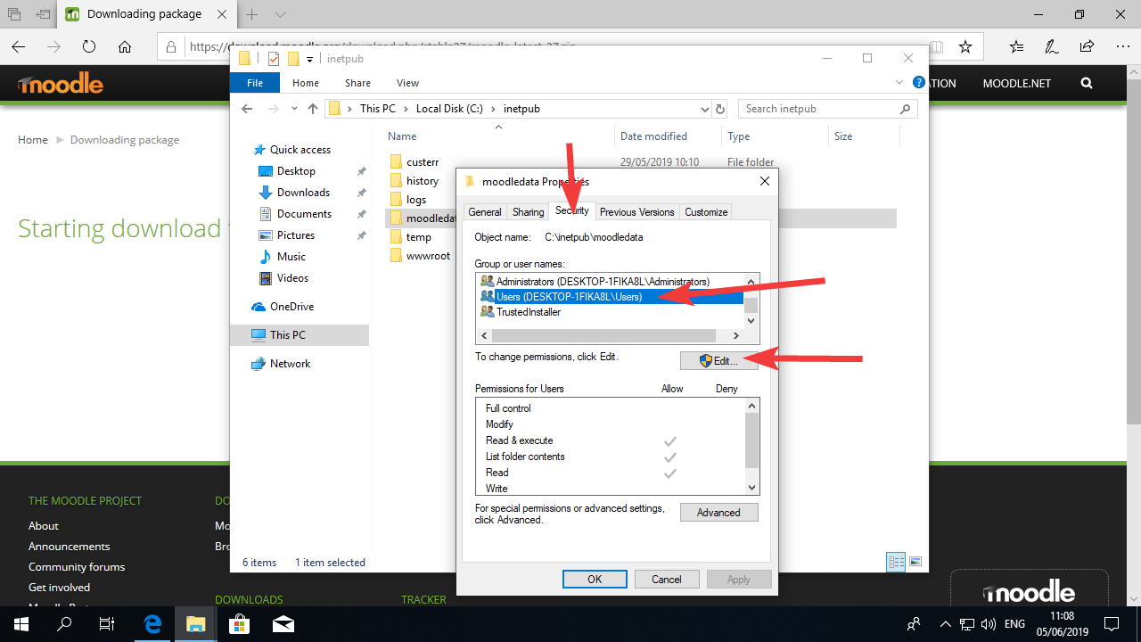

Now select “use4rs” again, and mark the checkboxes where it says “Modify” and “Write” link in the picture below. Then press OK.
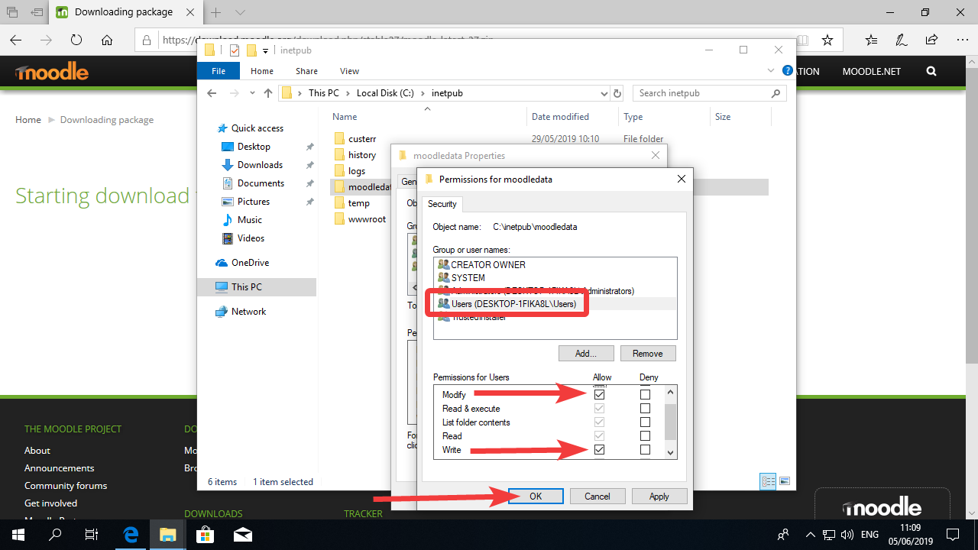

You’ll be sent back to the previous window where you can see that “Users” can modify and write to that folder.
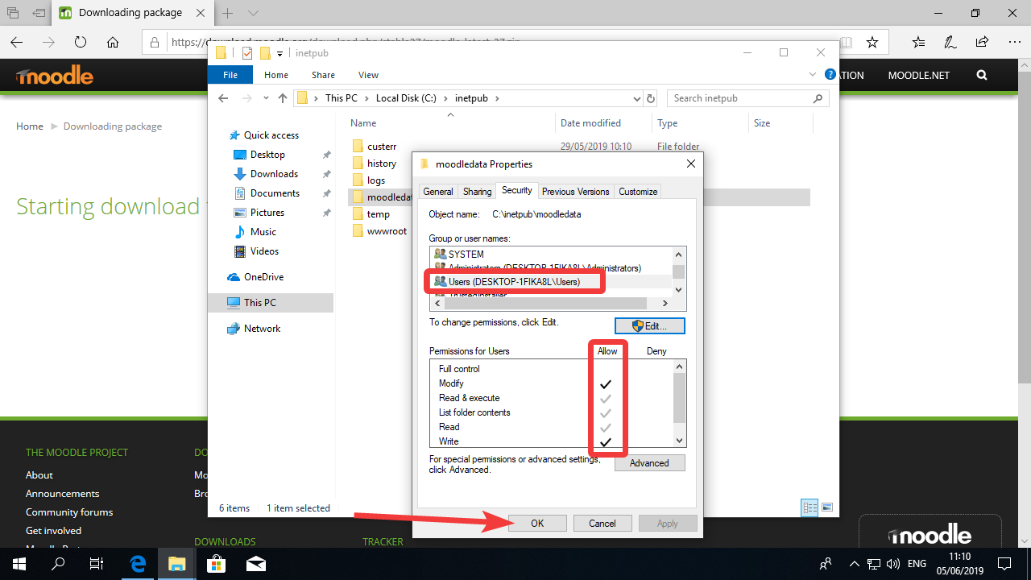

Now let’s do the same to the wwwroot folder.
Right-click the wwroot folder and select Properties.
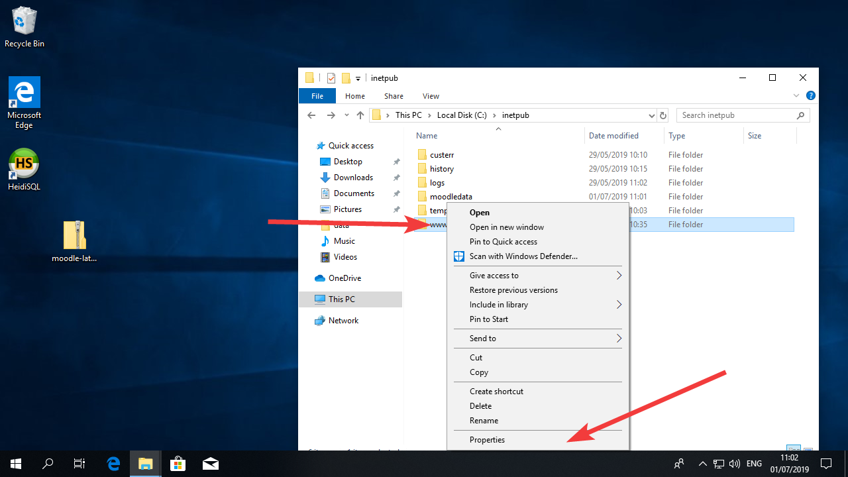

Click in the Security tab in the top of the window and then Edit
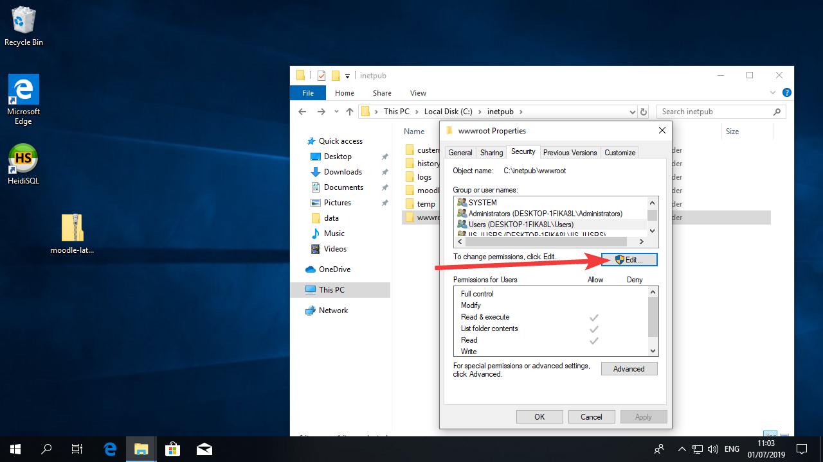

Now in select “Users” and mark the “modify” and “Write” checkboxes. Then press OK.
This configuration allows Moodle to change it’s own files, which makes configuration easier, but also allows for auto-updates and installation of plugins if necessary.
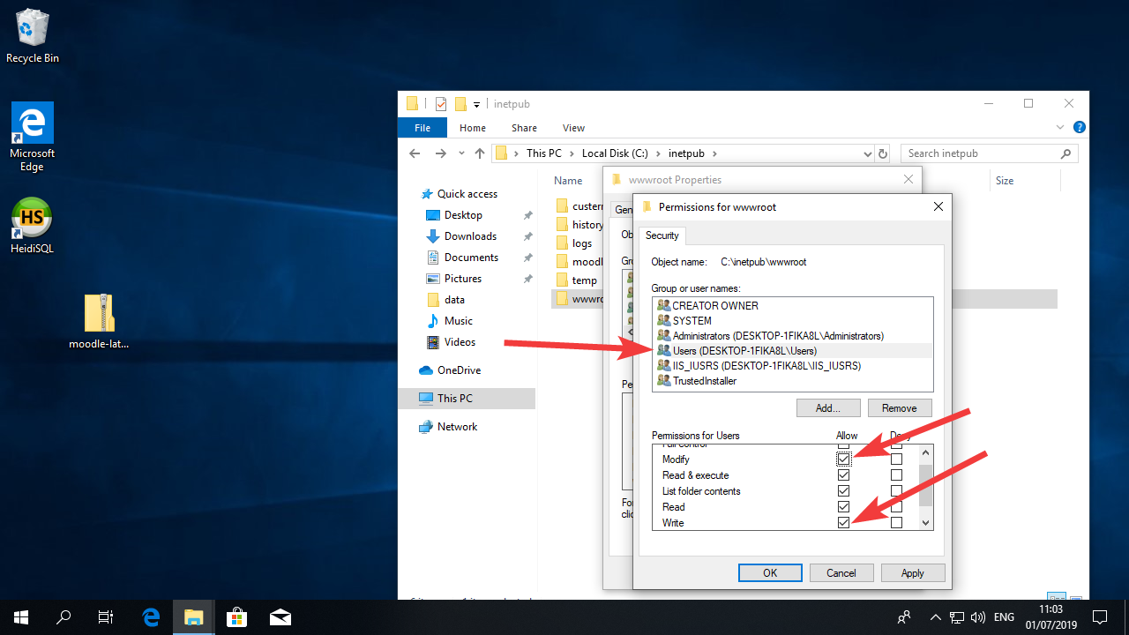
After that press the OK button, and then press it again in the next window.

Configuring Moodle
Now that our webserver is running and the Moodle files are on the right folder and with the right priviledges, let’s run Moodle!
To do that, open your browser and go to http://localhost or http://127.0.0.1 both addresses direct the browser to the local machine. Alternatively, if you already have a URL directed to that machine, you can use that.
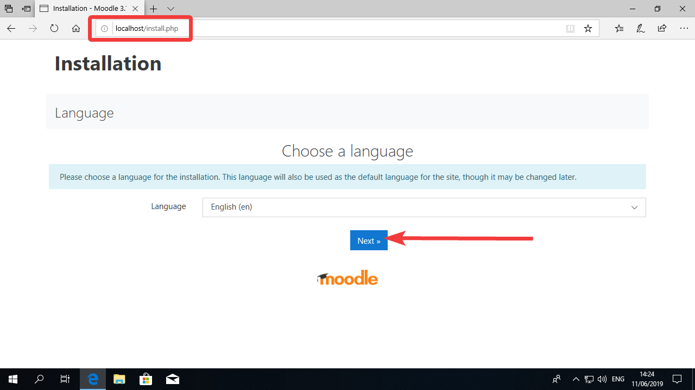

Check that the configuration is similar to the image below.
For my configuration, I’m accessing using the http://localhost address, so that is what Moodle identified.
The moodle directory is C:\inetpub\wwwroot and the data directory is c:\inetpub\moodledata
If you see something wrong, please correct it.
Press “Next” to to go the next step.
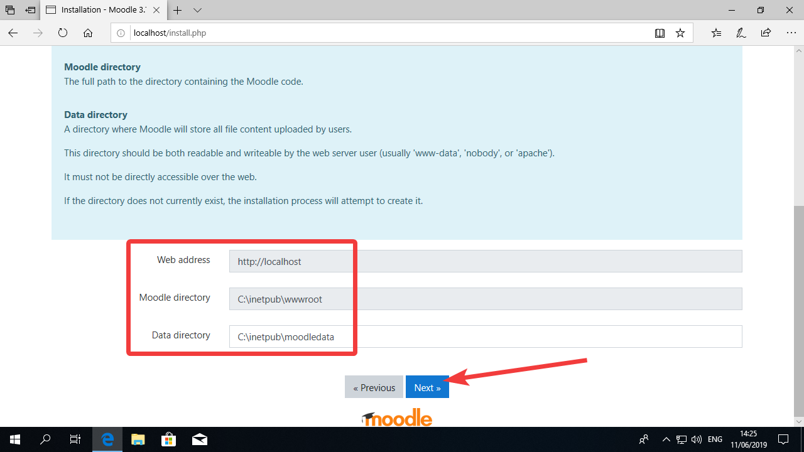

Select MariaDB as the database and click Next.
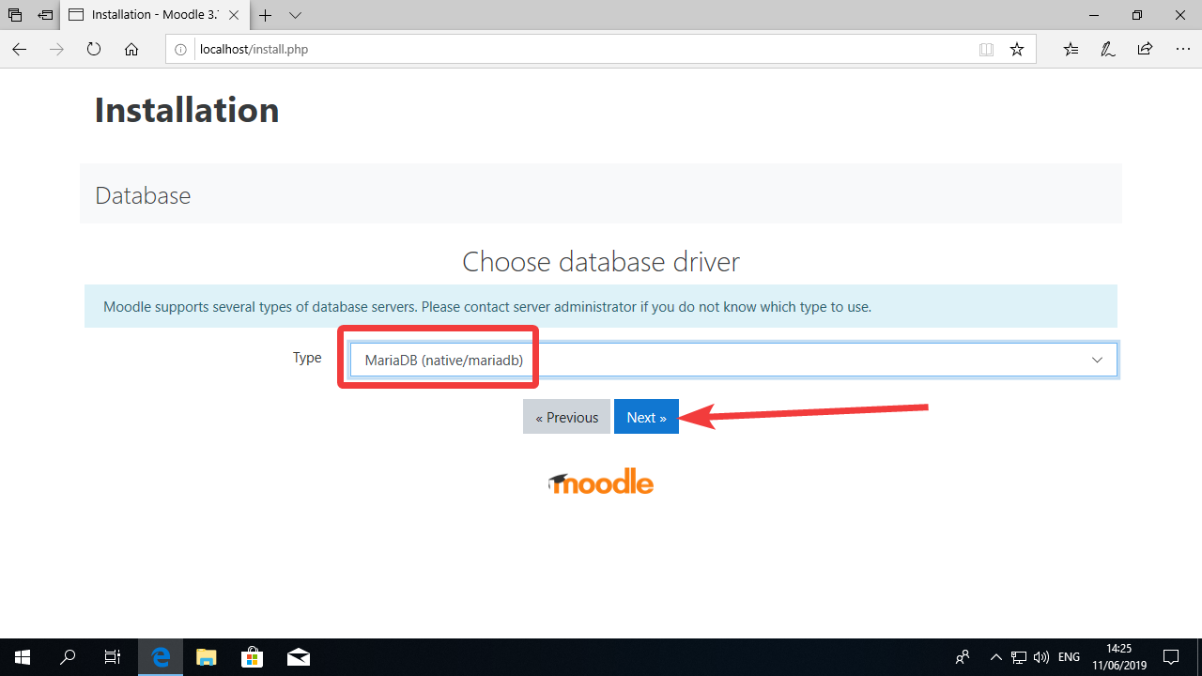

Make sure that your database configuration is the same as in the image below.
For “Database password” enter the password you set up for your database.
Click Next to go to the next screen.
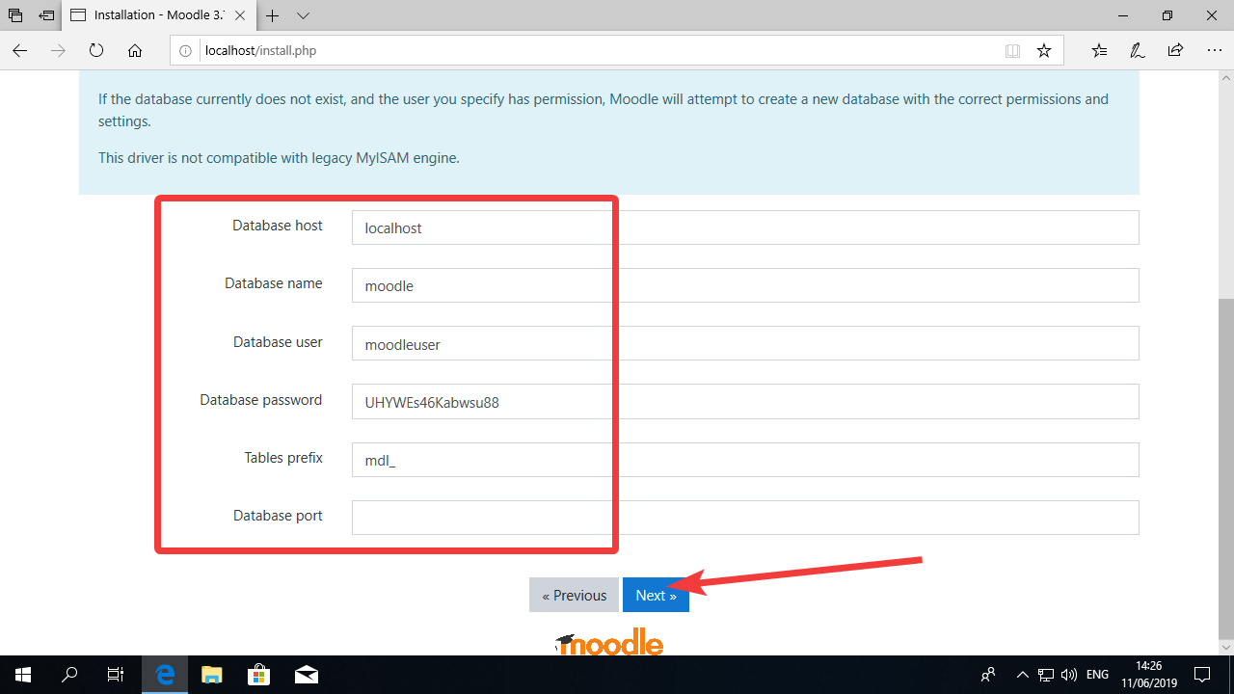

You should now see the screen below. Click “Continue”.
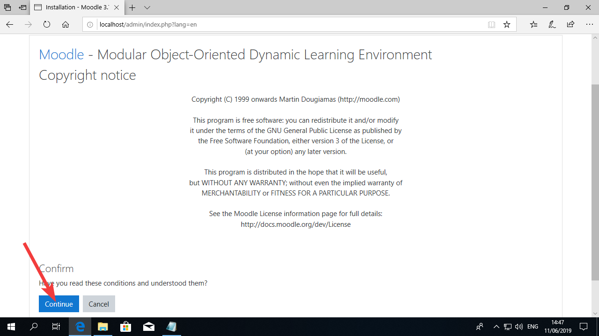

The next screen shows all the dependencies and modules that Moodle needs for running correctly.
As you can see in the image below, there is a yellow warning saying the website is not being accessed as https. This is not a problem for the moment but it is something we will try to fix later.
All the other lines should have a green “OK” on the right like in the picture below.
Press “Continue”.
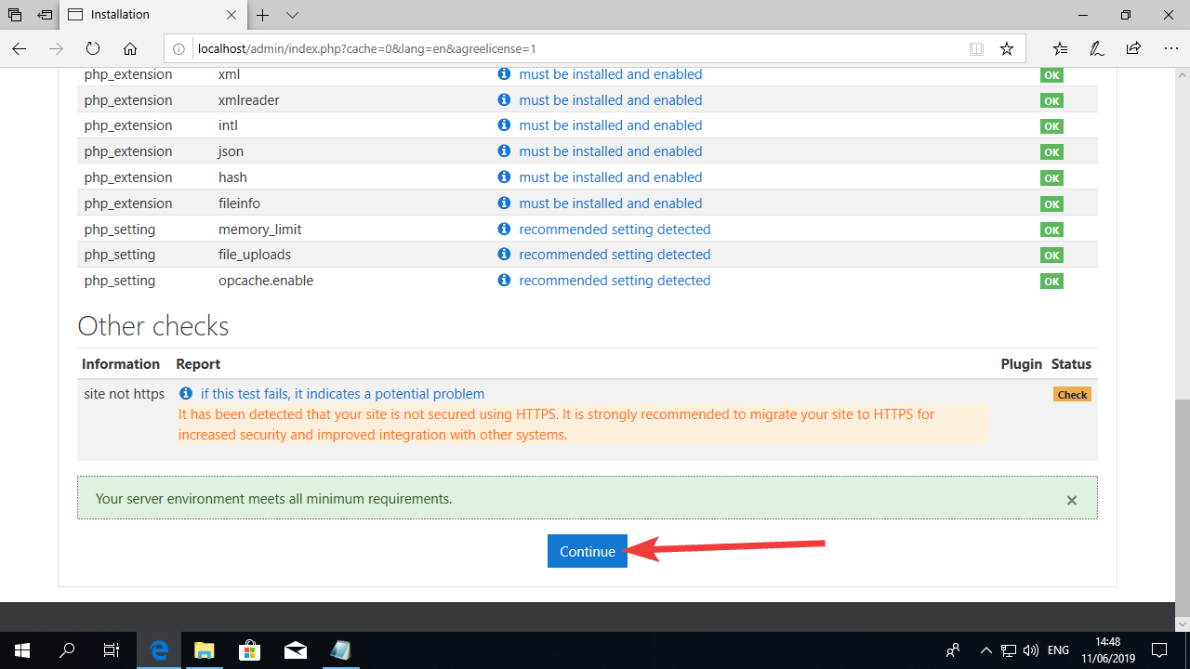

Now it’s time to create your administrator account.
The default Username for the administrator account is admin. You can leave it like this.
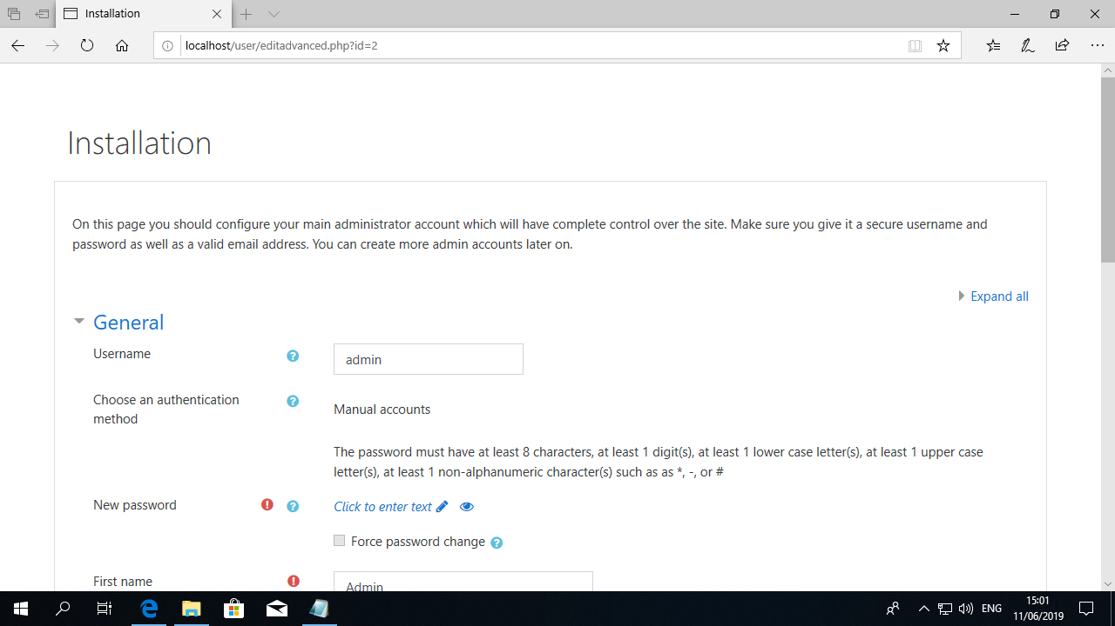

For the Password, add a personal password, as this is your own admin password.
Later on you can add more people to Moodle and also give them administrator rights.
Add your email as well and, If you want, change the “First name” and “Surname” fields.
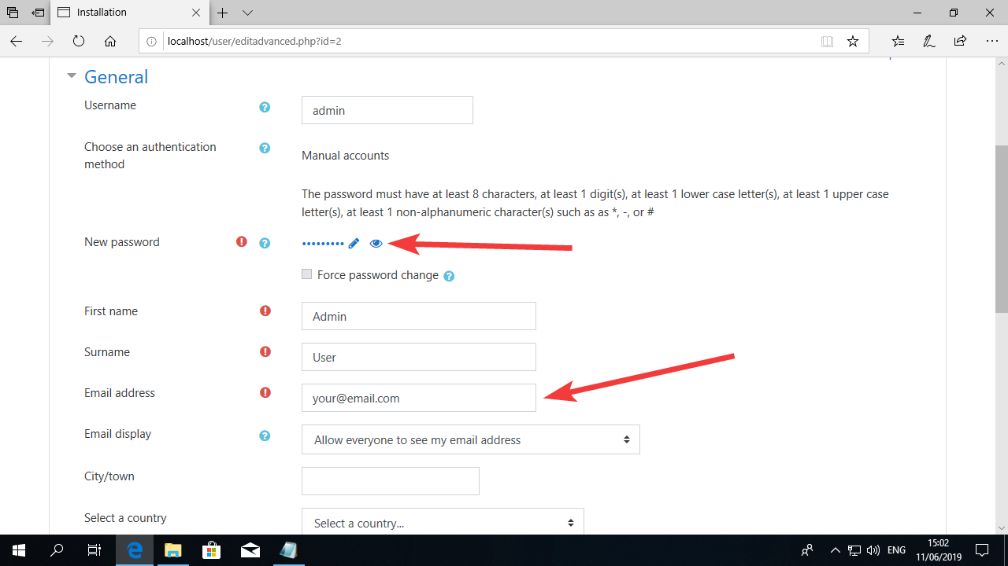

Now change your City, Country and Timezone. This will make Moodle display the time correctly.
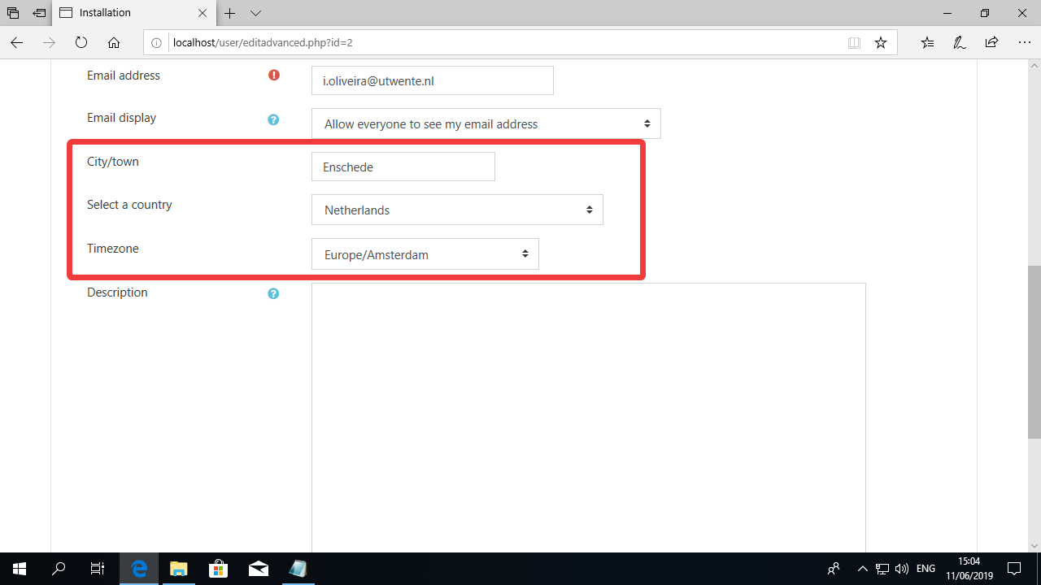

Now roll the page down and press “Update Profile”
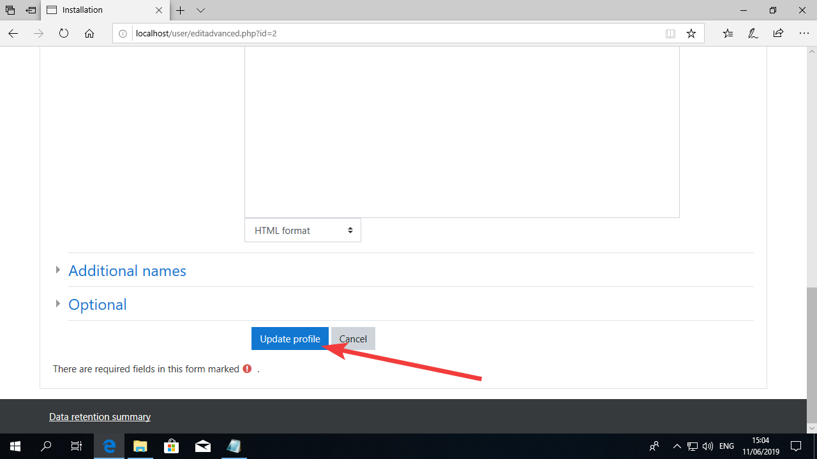

Now for the name of the website add:
Full site name: EENSAT Learning Management System Mirror at ‘your university’
For Short name: EENSAT LMS @ “Your University”
It should look like the image below:
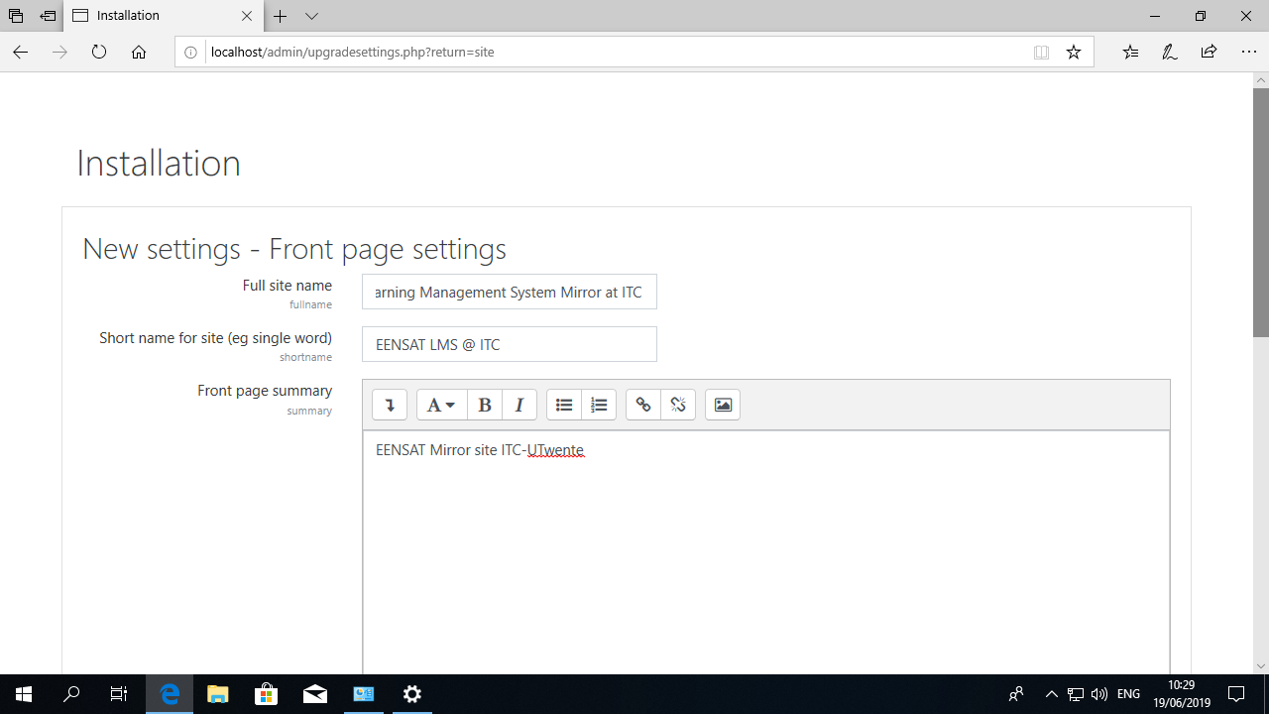

Now adjust the settings for Location (select your own location), Disable Self Registration, set-up an email for your Moodle.to send emails from.
If you did not receive an email account to use in your Moodle installation, please provide one from your own University.
In the example, I’m adding a Gmail account eensat.itc@utwente.nl
Then click “Save Changes”.
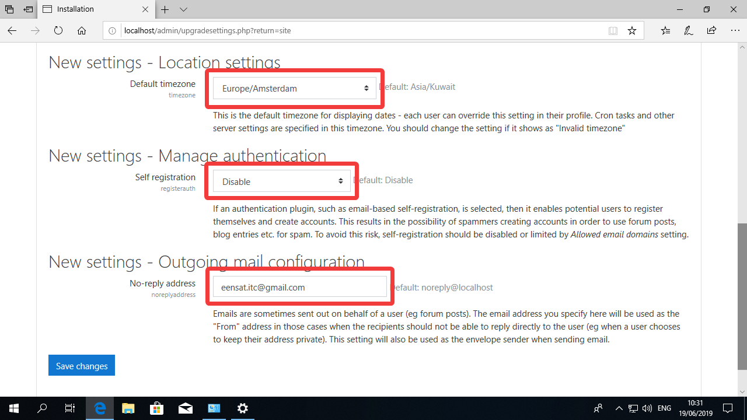

Now you are in Moodle!
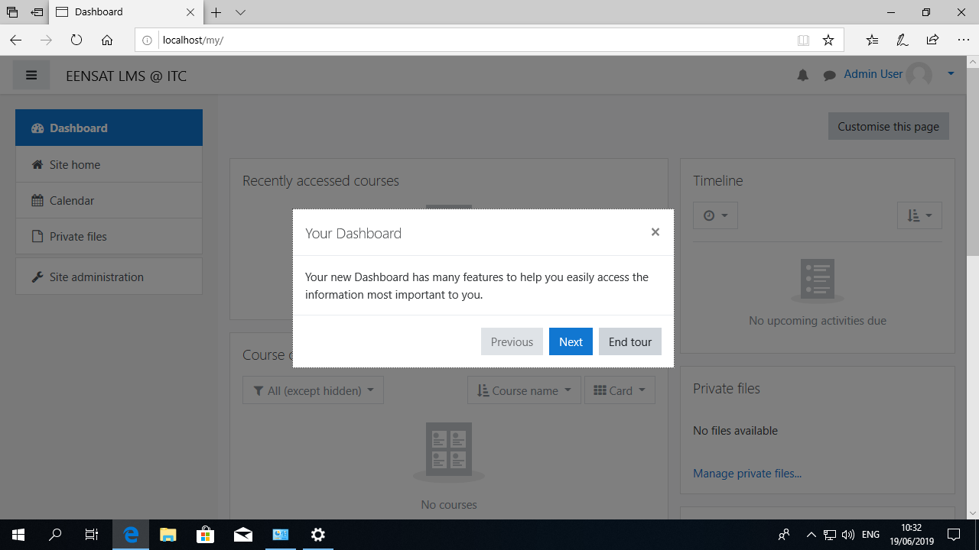

Configuring an email in Moodle
Now that your Moodle installation is running, let’s change the email configuration so that our users can receive updates from the Moodle platform and can reset their passwords when needed.
First go to the Site Administrator link.
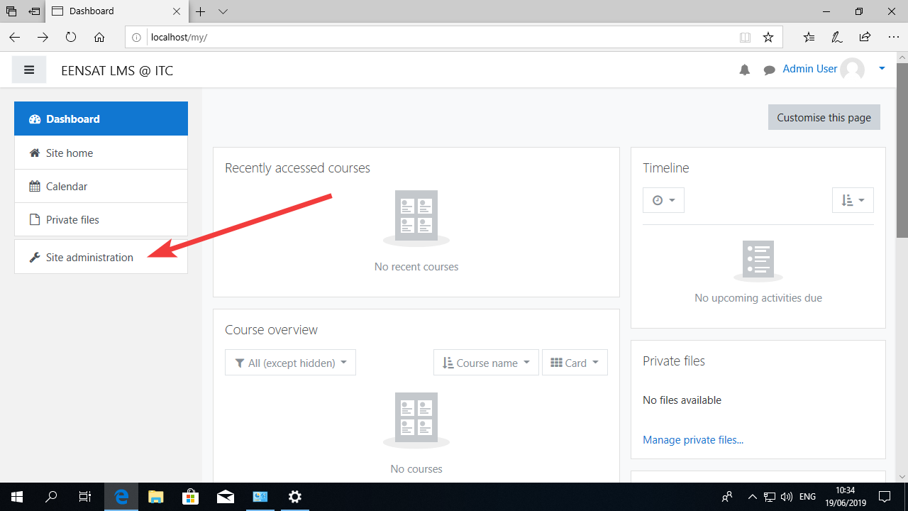

Now click on the tab “Server”
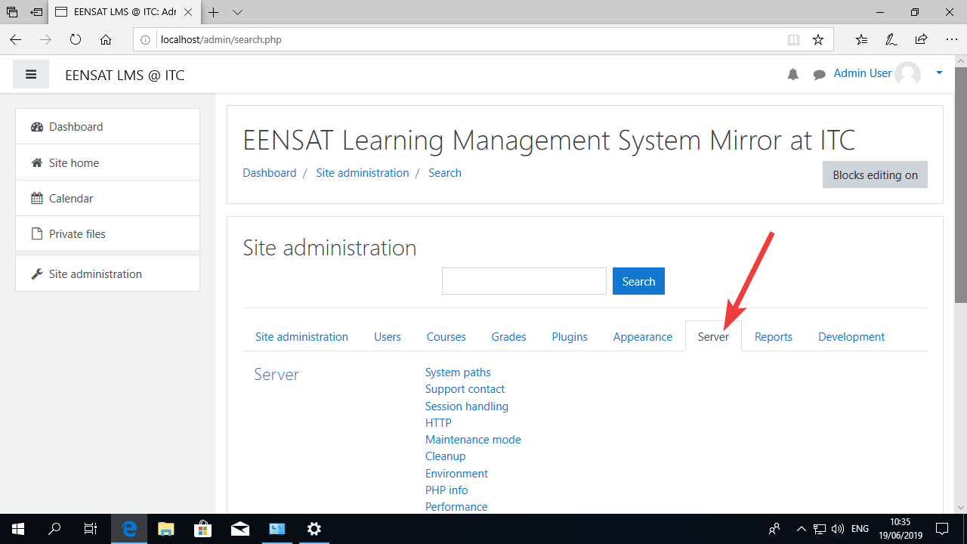

And click in “Outgoing mail configuration”.
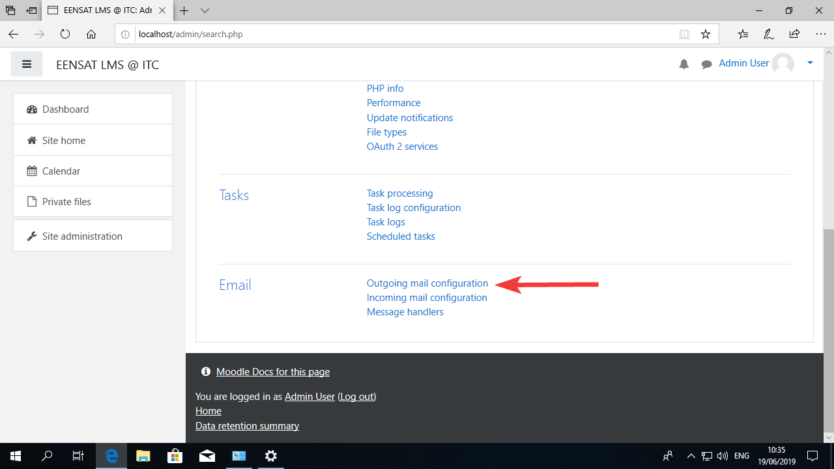

This is the page where you can set up you email.
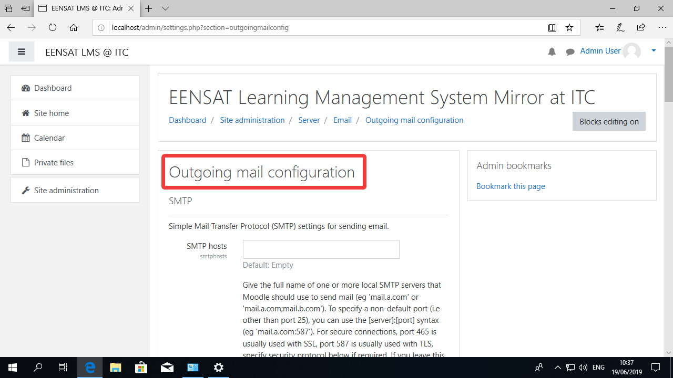

For this guide, we will see how to set up a Gmail account for use with Moodle.
Create a new Gmail account and login. In your Gmail page click the configuration icon and then in Settings like in the picture below:
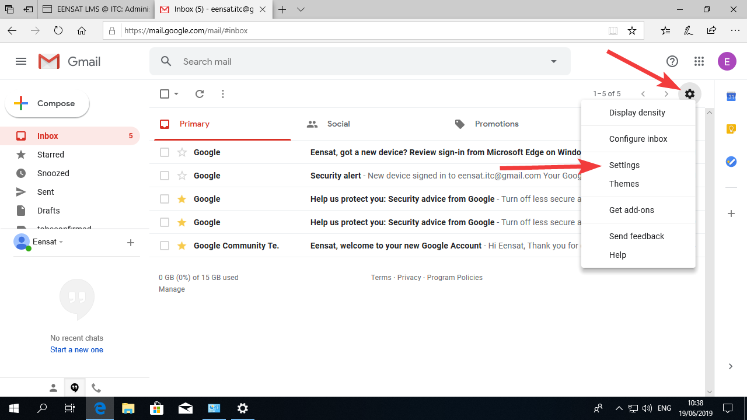

Go to “Forwarding and POP/IMAP
Select “Enable IMAP”
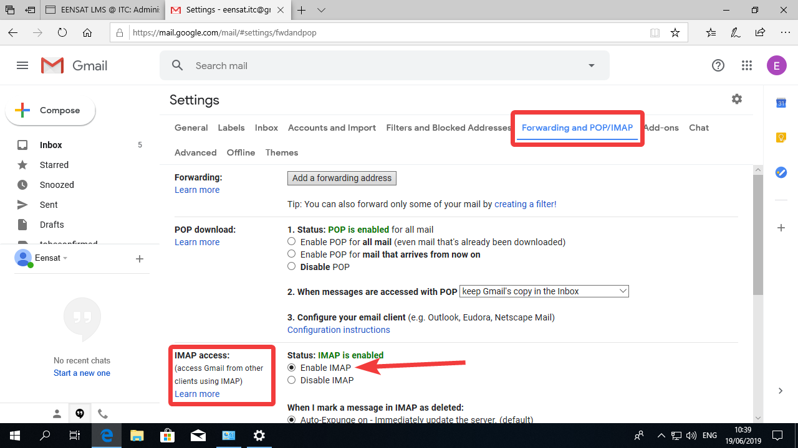

In your email configuration in Moodle, add the SMTP host as smtp.google.com:465
And in “SMTP Security” choose “SSL”
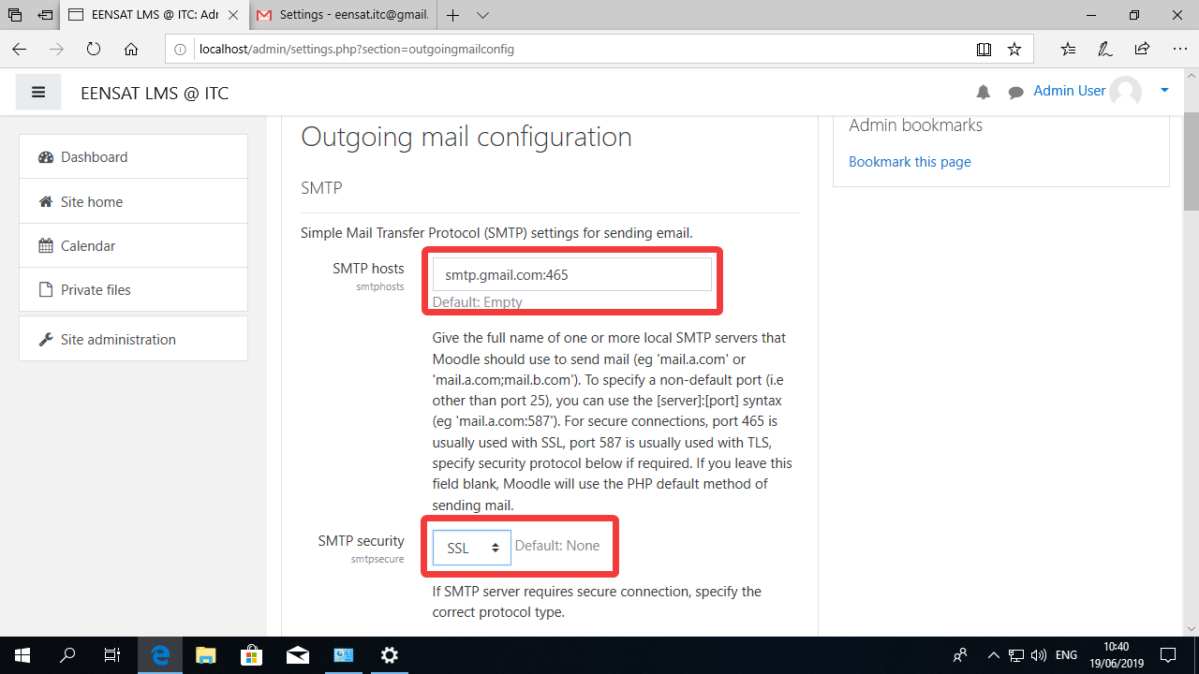

Roll down for more options.
In “SMTP Auth Type”, choose LOGIN
In “username”, add the Gmail email address.
In “password”, the password provided.
“SMTP Session limit” should be set to 1.
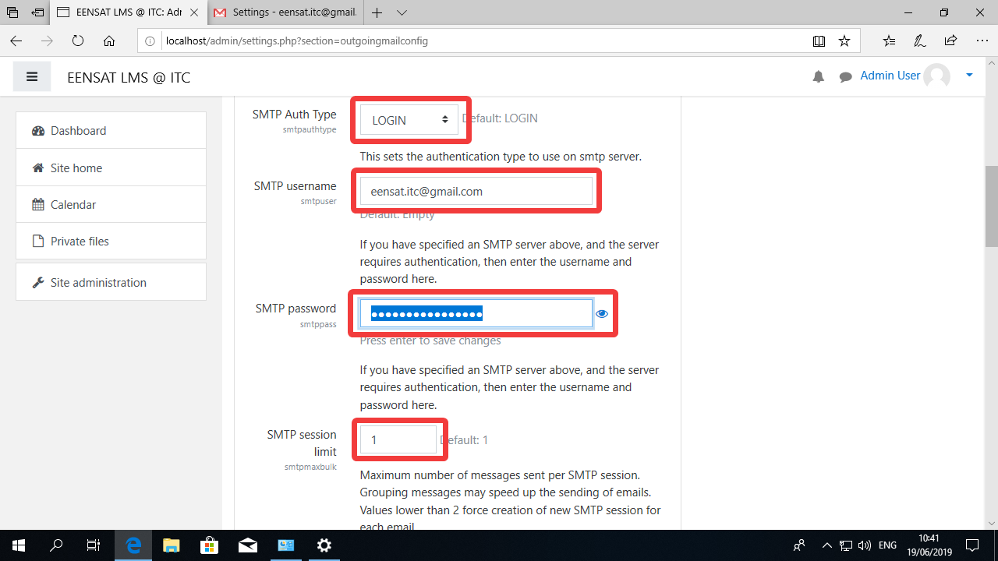

The “No-reply address” can be the same email.
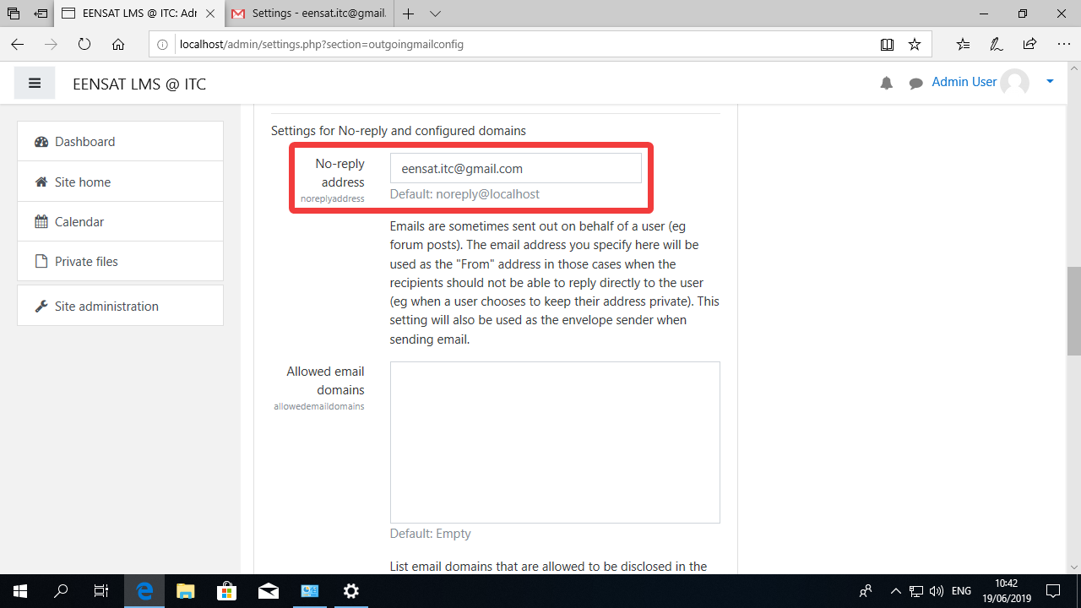

Now click in “Save Changes”.
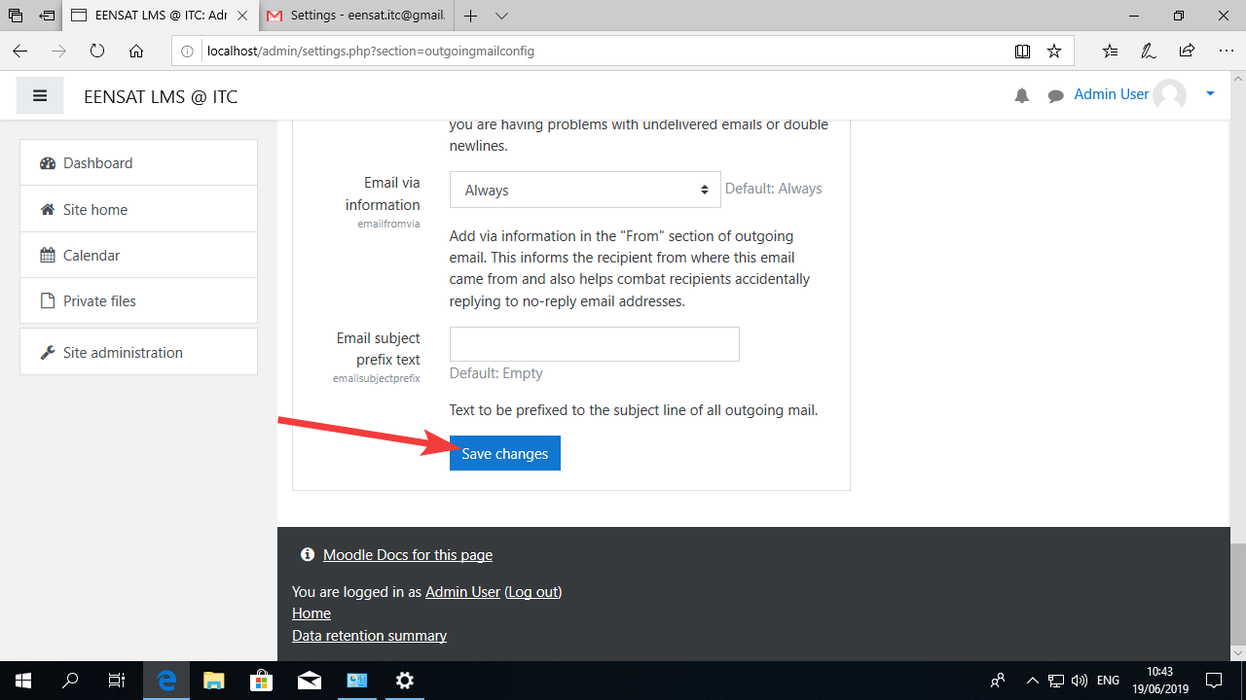

You should see a message saying that the changes were saved:
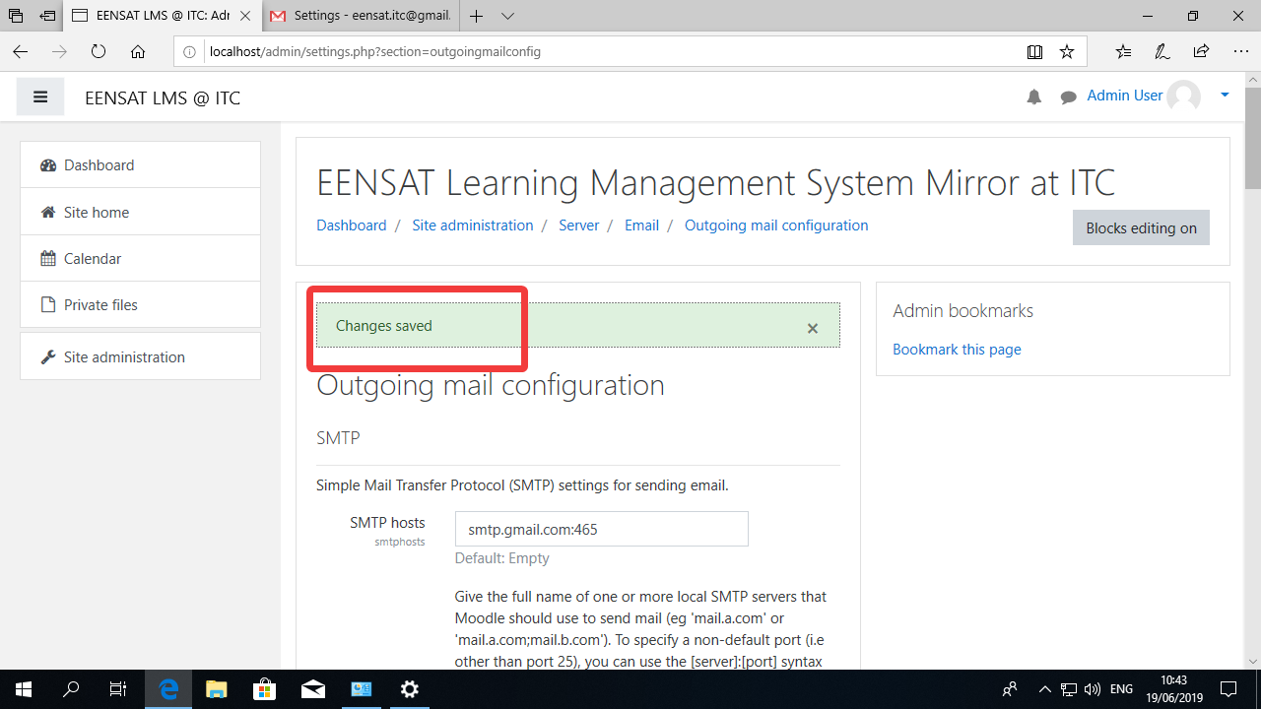

Now roll down and click in “Test outgoing mail configuration”.
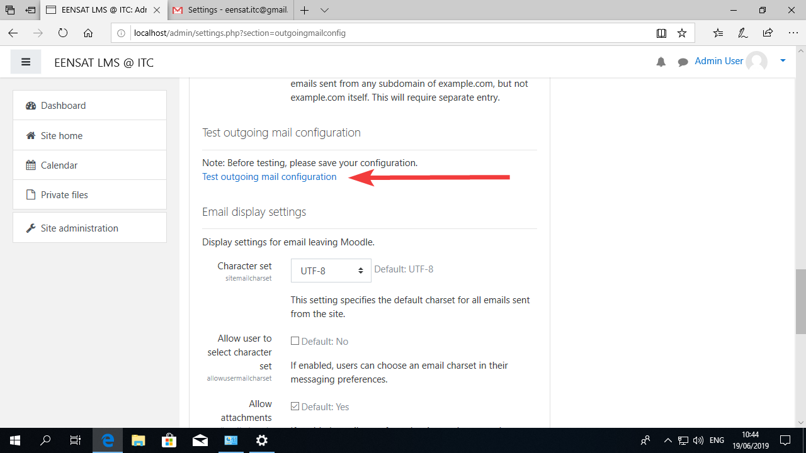

Add your own personal email to the box and click in “Send a test message”.
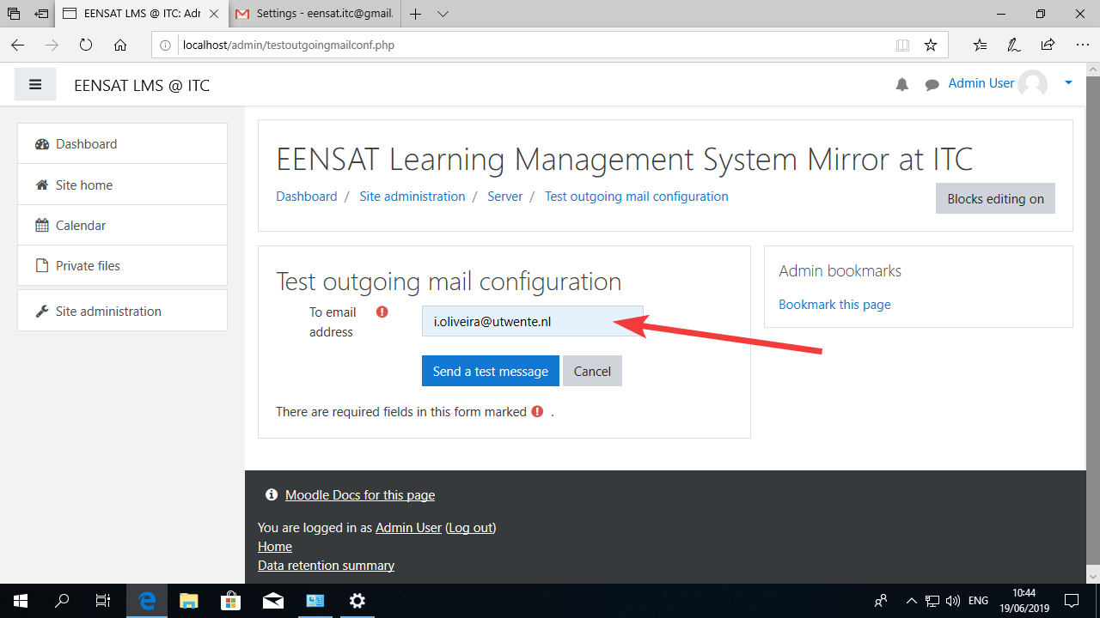

In the screen below you can see that the message was sent without problems.
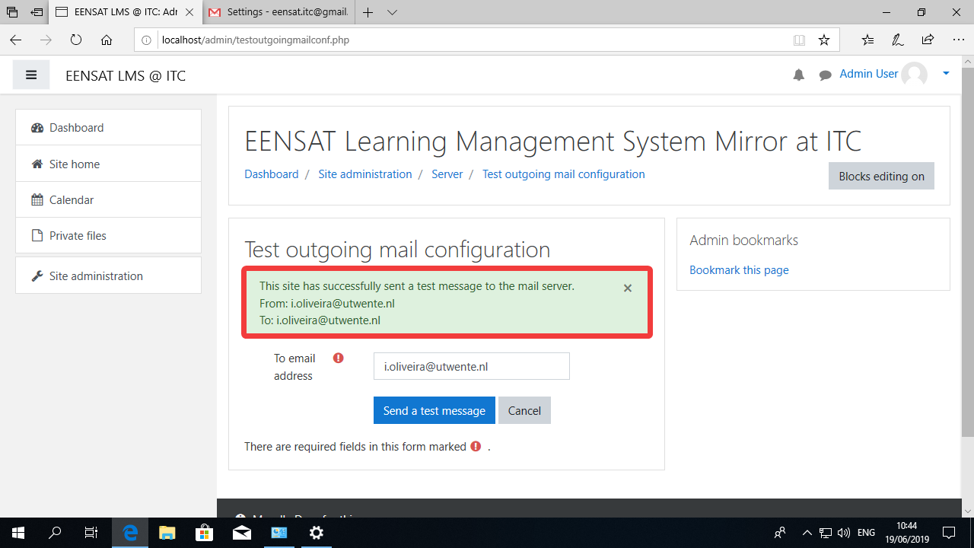

In the Gmail account, I can navigate to the “Sent” folder and check the message I just sent.
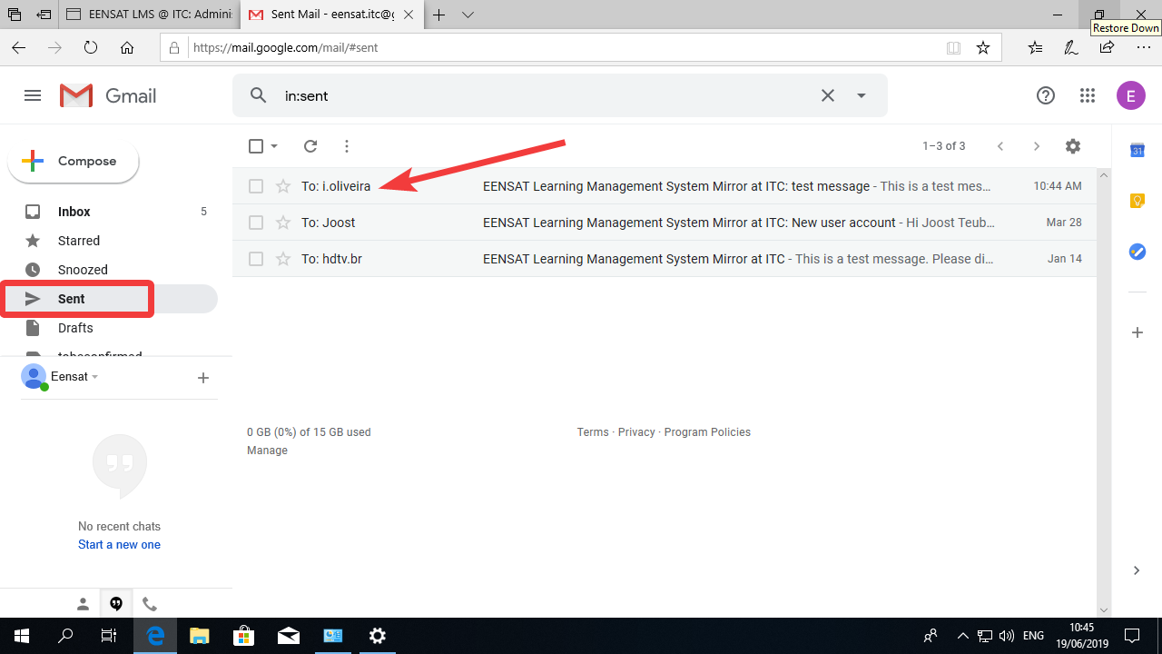

If I click on the message I can read it there.
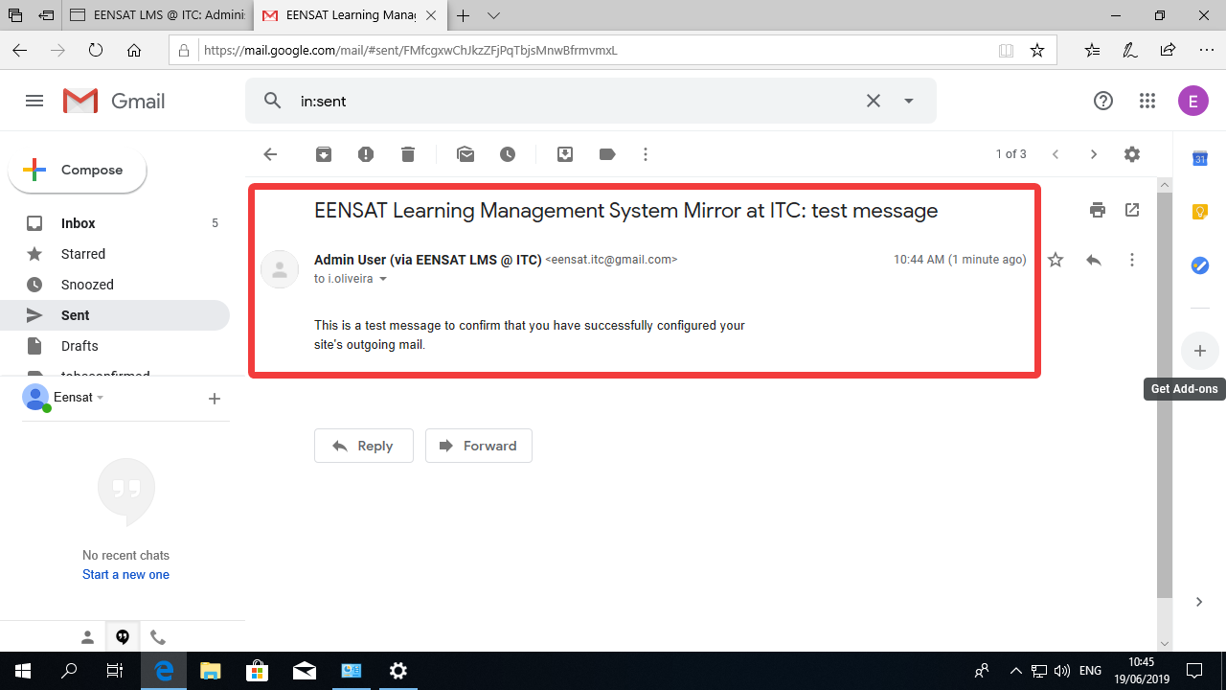

In my personal email I can see that I received the same message:
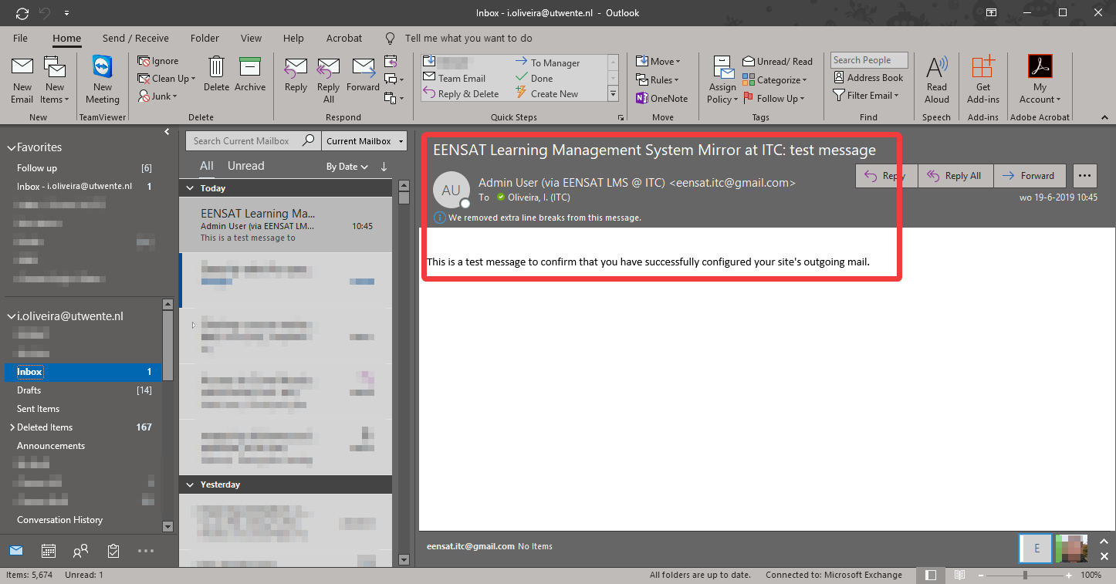

Changing the web address for Moodle
If you set up Moodle from http://localserver or http://127.0.0.1 you will have to later on change the URL configuration manually.
To do that you must open Notepad, then click “File” and “Open:”
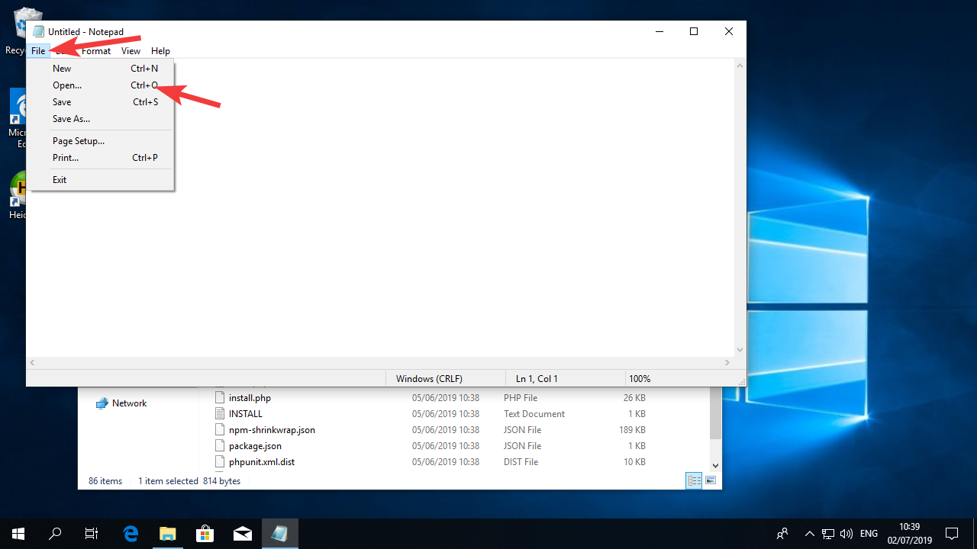

Go to c:\inetpub\wwwroot, select “All files”, Select “UTF-8” for encoding, and double click “ the file config.php
In that file, change the line that reads:
$CFG->wwwroot = 'http://localhost';
to
$CFG->wwwroot = 'http://yoururl';
Of course, replacing “yoururl” with your own URL.
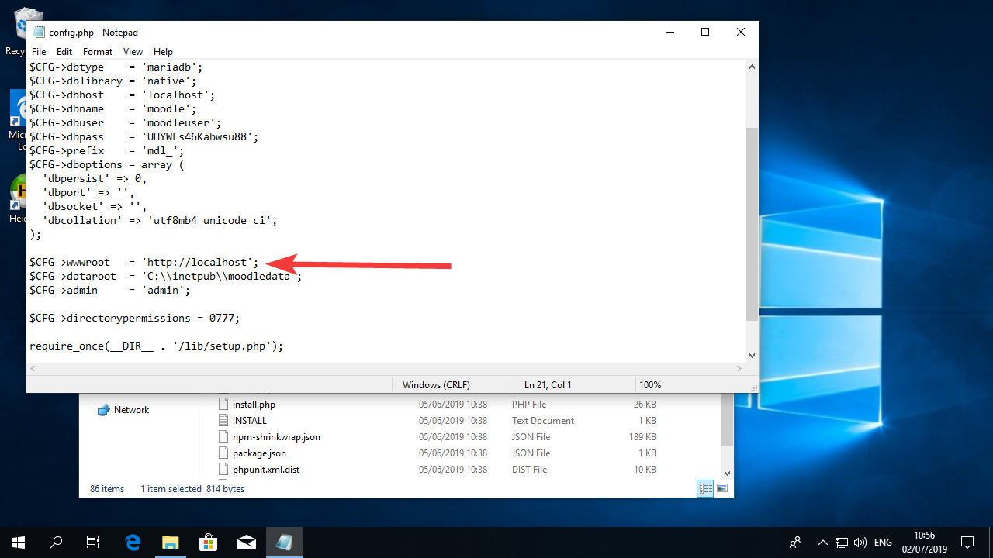

Once you save the file, Moodle will be configured to use this URL as the access route.

Extra note on the web address configuration.
It might be sometimes necessary to access Moodle from multiple different addresses.
If you need to do that, you should change the config.php file and change the address line to this:
$CFG->wwwroot = 'http://'.$_SERVER["HTTP_HOST"];
Please be cautious with this setting as it should only be used for testing and while configuring. Moodle might malfunction if you leave this on and yo should in no way us this in a production environment.

Concluding remarks
You should have now a fully functioning Moodle installation with access from the Internet.
You should notice that at the moment the server does not have encryption, so any data travelling between the server ad the end user is not safe. Moodle works better using encryption so you should follow the guide about installing TLS/SSL to make sure your server safer.

