ILWIS Exercise Landslide hazard Zonation

by P.K. Champatiray

Introduction
In this exercise landslide hazard zonation will be attempted using nine parameters such as:

Theme | Raster file name
Lithology: | litho
Landuse: | luf
Drainage zone: | drzone
Road zone: | rdzone
Lineament: | lin3zone
Slope amount: | sl10
Slope aspect: | aspmap
NDVI: | ndvi
Mass wasting map: | p25fard
Landslide map: | slide

Brief description about the data layers
Lithology map is prepared frpm Rupke’s map and the vector file is rasterise at 10m resolution.

The landuse map is prepared from topomap, aerial photo, satellite image and field investigation.

Drainage map is prepared from topomap (53 F/10) and all drainages are given a buffer.

Road map is prepared from topomap and PAN data, and is given buffer distance as the influence zone.

Lineament map is prepared from aerial photo, satellite image and field verification.

Slope amount and aspect map is prepared from the relief data taken from Survey of India topomap.

NDVI map is prepared from satellite images (TM data).

Mass wasting potential map is prepared from principal component 2 and 5 above a threshold value (user defined) and on slopes > 15 deg to eliminate flat areas.

Landslide map shows mainly active slides, which are mapped from satellite images, aerial photo, topographical map and field investigation.

All the raster maps may be displayed and contents may be checked by clicking over the image or by checking the respective map domain.

Now, landslide hazard zonation will be attempted using information value.

Prior probability = nslide / nmap
Information value = log((nslclass / nclass) / Pr. prob.)

nmap = total number of pixels in the map
nslide = total number of landslide pixels
nclass = number of pixels in each class
nslclass = number of pixels with landslides in a class

Now for to calculate information value for each class of the thematic maps, each thematic map is crossed with landslide map.

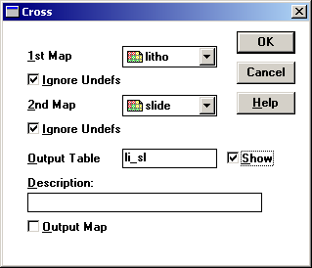

Create only cross table; an output map is not required. Now open the output table. What did you see, try to make sense out of this.

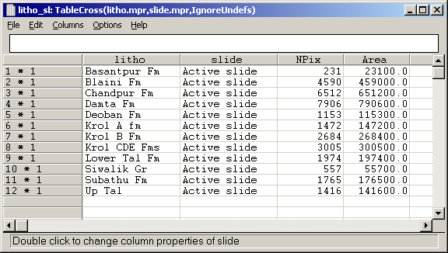

Now in the above table npix column represents the overlapping of a particular class in the thematic map and active landslide and this is nslclass as per the information value equation.

Now in order to determine the number of pixels each class contains in a thematic map, histogram is calculated, the histogram table looks like:

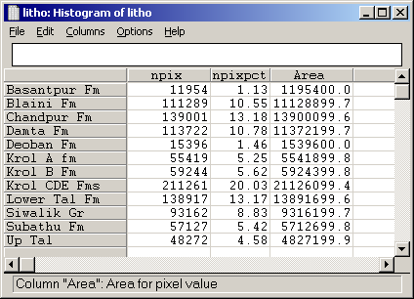

Npix indicates number of pixel in each class, according to above formula it is nclass
Now we know the source for nclass and nslclass, which are to be imported to a new attribute file of the map Litho.

For creating a new attribute table, right click on the map Litho, and then select property, click on attribute check box and click for the new, take the default file name, and say OK.

Now the new attribute table opens with only one column, i.e. domain with all rock types. Now for brining Nclass from histogram file, go to

Column
Join column

Then join column window appears, and select the column as shown:

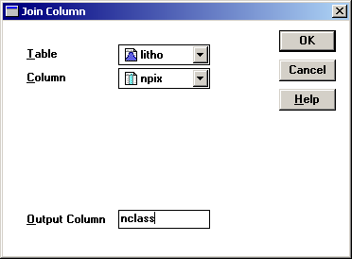

Similarly for brining nlsclass from cross table, again go to column, join column and make entries as shown:

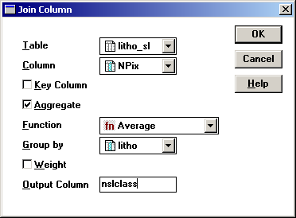

Note that in the join column, the average function does not do any thing, as there is only one entry against each lithological category for the active slide.

Now we have brought successfully two columns in the attribute file, litho.

The prior probability can be calculated as the ratio of

No. of landslide pixels/ total no. of pixels in the study area, this can be obtained directly from the histogram file of slide map.

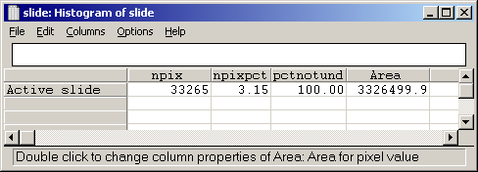

Here npixpct directly gives the prior probability i.e 0.0315

Now again go back to the attribute file for map litho, and calculate a new column as:

Inf= log((nslclass/nclass)/ 0.0315)

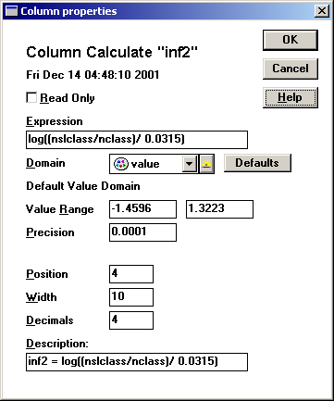

Accept all default values, but think for a while their significance, particularly value range and precision.

Now your attribute table should look like this:

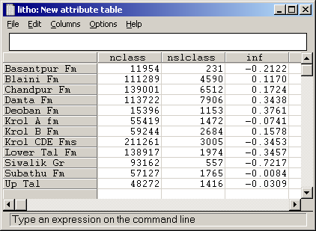

Look at the information value column, what is the significance of the negative and positive numbers?

Now we will create an attribute map for info column:

Wlitho = litho.litho.inf

Display the map wlitho and around the values. You may observe that all the map classes are replaced by respective information value.

Now for other parameter maps, follow similar steps and creat the following weight maps:

wluf
wdrzone
wrdzone
wlin3zone
wsl10
waspmap
wndvi
wp25fard

Check the information value in each attribute table and try to make sense of the significance.

Now having made all information value maps, we can integrate them as:

Wf= wdrzone+wlin3z+wlitho+wluf+wndvi+wp25fard+wrdzone+wsl10+waspmap

Display the map wf and check the final integrated values.

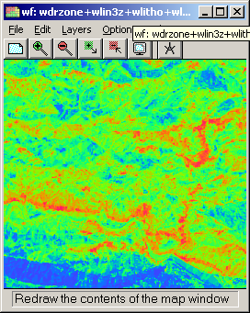

You can also check for the values in the histogram table and decide about ranges for density slicing.

Now classify the resultant map by density slicing (map name: lshazard) and make hazard classes as shown:

Very high
High
Moderate
Low
Very low

So, congratulation, you have created the hazard map, which you will be cross checking on Saturday during filed visit.

