Session 3.C Task 3-A Answers
Hazard analysis of cyclone flooding in Bangladesh
Part A: Analysis of historic cyclone events

Displaying the entire coast of Bangladesh, and data points of cyclone landfall from a table. Please note that the geomorphological legend is also given

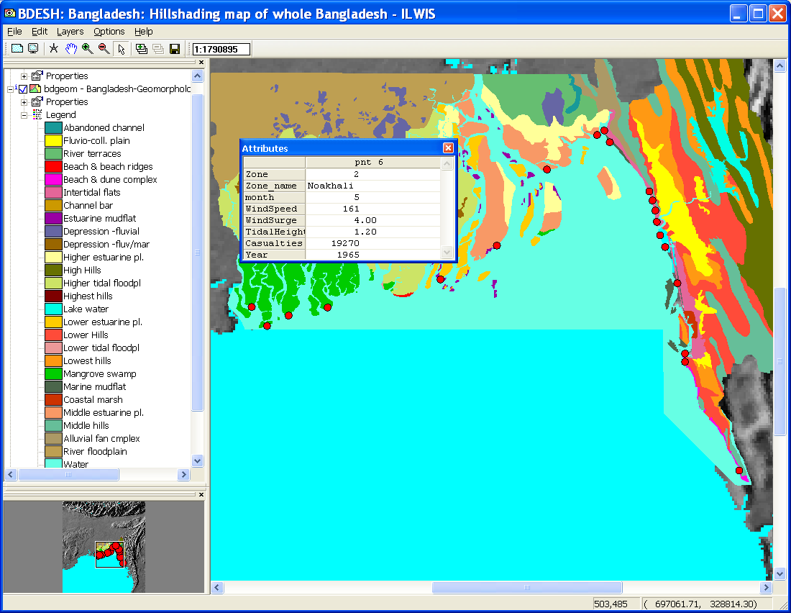
Examples of tables on the historic cyclone events

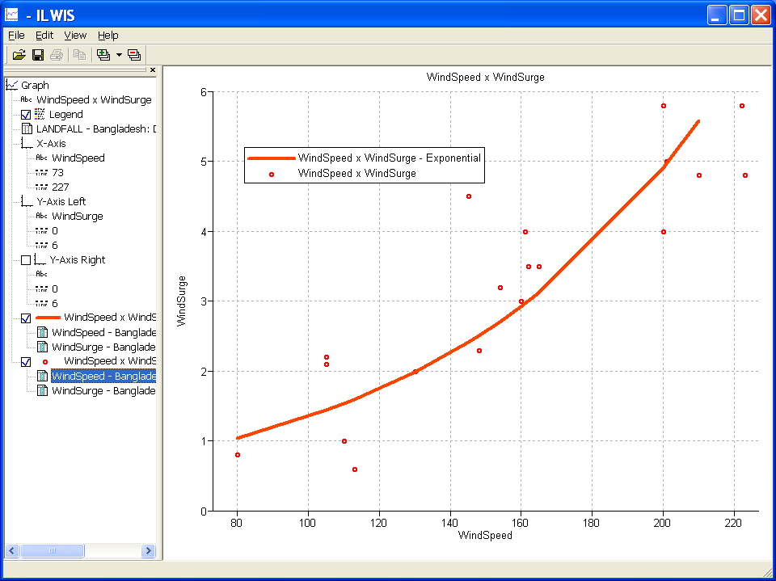
- Wind speed and wind surge for whole zone of Bangladesh. Graph exponential :

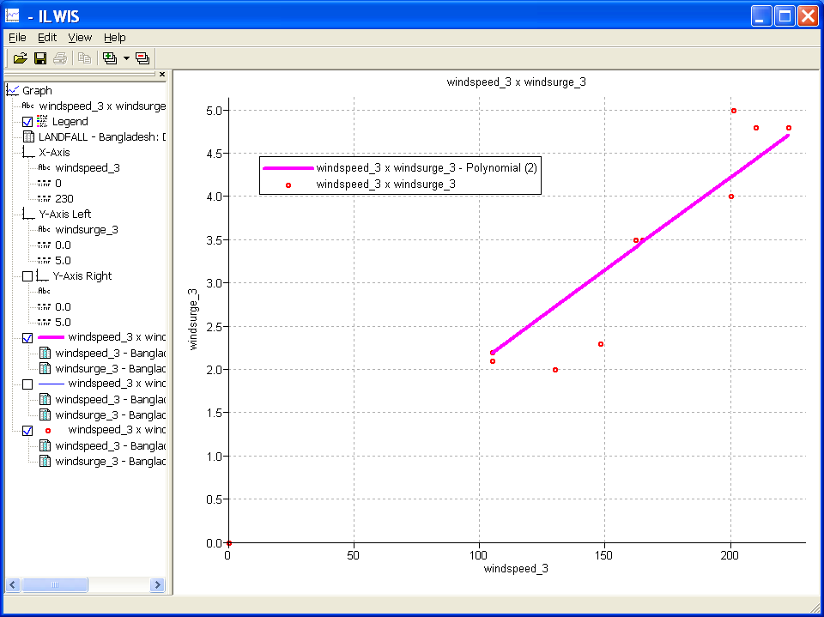
- Wind speed and wind surge from only zone 3. Graph polynomial:

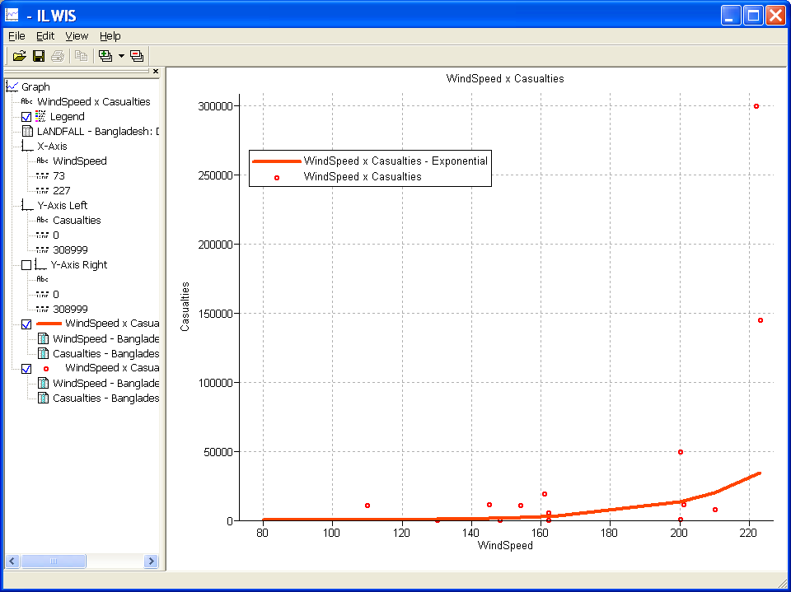
- Wind speed and casualties for whole of Bangladesh:

