Session 3.C Task 8
Analysis of coastal areas vulnerable to Enhanced Sea Level Rise
Example from Java, Indonesia
Expected time: 1 hour
Data: Data file: Session 3.C Task 8 : Java-Bali_SRTMData.Zip
Objectives: After this exercise you will be able to:
- Display an SRTM elevation model with a color representation
- Change the color representation for values between 0 and 1
- Calculate the pixel size of SRTM
- Calculate the surface areas vulnerable to Enhanced Sea Level

1. Introduction
Indonesia is a country with many islands and therefore highly vulnerable to Enhanced Sea Level Rise (ESLR). The freely available Shuttle Radar Elevation Data (SRTM) is an excellent source for the impact analysis of ESLR on coastal areas at medium scale. As an exercise example we only use the island of Java and Bali.
The procedure is as follows: First the areas between 0 and 1 meter are displayed in red by changing of the color representation. After this the total surface area between 0 and 1 meter elevation will be calculated by analyzing the histogram of the SRTM.

Figure 1: SRTM Elevation model & drainage lines- Central Java, Indonesia

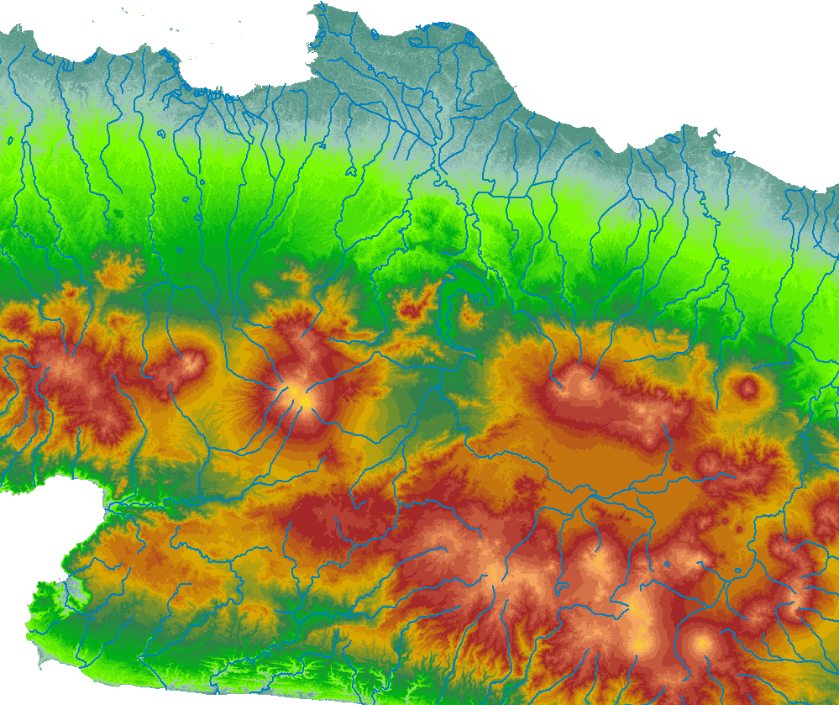

2. Exploring the input data
In the data catalog you see the icons of the available input data for this exercise. This includes a SRTM elevation model of the islands Java and Bali and a color representation of the elevations to be used in combination with the SRTM data.
The SRTM elevation map has been downloaded from:

The Drainage lines are downloaded from the Maproom of the Digital Chart of the world:
http://www.maproom.psu.edu/dcw/
The coordinate system used is in degrees: latitude / Longitude.

Name | Type | Meaning
Java_Bali_SRTM | Raster map | Digital Elevation Model of the islands Java and Bali, Indonesia. Source: Shuttle Radar Topographic Mission (SRTM)
IndDrainage | Segment map | Drainage lines of the islands Java and Bali
Java_Bali_SRTM | Representation | Color representation of the elevations to be used in combination with SRTM data
Java_SRTM | Georeference & Coordinate system | Georeference of the SRTM data and coordinate system in Latitude / Longitude (degrees)

3. Analyzing the SRTM data of Java and Bali
Display of the SRTM elevation model with the representation and drainage lines

- Display the raster map Java_Bali_SRTM with the Representation Java-Bali_SRTM. This is an SRTM elevation map in meters of Java and Bali
- Mouse-click to see the elevations in meters. Zoom in at different places.
- Add the Drainage map IndDrainage as an extra data layer. To do so, select: Layers > Add Layer….
Select from the Add Data Layer dialog box the segment map: IndDrainage. Type 1 for the boundary width in the Display Options dialog box. Click OK.
You will see that the drainage lines do not follow at all places very well
The lower places of the terrain, such as valleys in between the volcanoes.
At other places they cross the coastline. This is due to inaccuracies of
Both the SRTM elevation model and position of the drainage lines.
- Zoom-in to different places along the coast
- Select: Properties of the raster map Java_Bali_SRTM. As you will see is the Pixel Size: 3 Arc Seconds. This is the original pixel size of this global dataset. If you open the Georeference Java-Bali you will see however that the pixel size is 0.001 m. This is of course not correct; the reason of this error is that ILWIS by default is using meters in stead of Arc Seconds. To calculate surface areas we preferably use correct values in meters.

Question1
What is the pixel size of the SRTM elevation model in meters?
Hint: use for the calculation of the circumference of the earth the radius value near the equator. You can find this value in meters by double-clicking the Java_SRTM coordinate system (value a).

Give answer of Question 1

Pixel size of SRTM …………………….. meter

4. Display & calculating areas vulnerable to Enhanced Sea level Rise

To display the areas that will be affected by a future sea level rise of for instance 1 meter we can adjust the map representation. To analyze the areas that will be affected by a future sea level rise you create a histogram of the SRTM elevation map. After this you multiply the pixel size (answer Question 1) with the number of pixels present between 0 and 1 meter elevation.

- Open the Map Representation: Java-Bali_SRTM. Now the Representation window opens.
In the left of the window elevation values are given (0, 5 10, 50, 100, 200, 400, 800 200 and 3500) and the colors of the elevations in between these values in a stretched mode.
- To change the 5 m. into 1 m. and to also change the color to red, you do the following: Select: Edit > Insert Limit… Fill in Value: 1 and select Color: Red. After this select: OK
- To give also the 0 m. elevations a Red color you double mouse-click the color bar next to 0 m. to open the Edit Limit window. Select: Red as a color. After this select: OK.
- Change the stretch option between the values 1 - 0 and 5 – 1 into: upper. Leave all the other colors in stretch mode !
- Save the Representation value: File > Save Copy As… Use a new filename: Java_Bali_SRTM_SLR 1m
- Display the map Java-Bali_SRTM with the new representation. If you zoom in, you will see that the elevation map is not very accurate in details. Try another display with a stretch between the limits 0 -3.
- To calculate the surface area between 0 and 1 m. elevation you first create a histogram by selecting: Operations> Statistics > Histogram. Select the map: Java-Bali_SRTM and after this select: Show
- Multiply the number of pixels with values 0 and 1 with the pixel size (answer Question 1). Fill in the answer for Question 2

Give answer of Question 2

Surface area in km² of elevations between 0 and 1 meter: ……………………km²

