*Session 3.C Task 12 ANSWERS*

Monitoring the change of the Solo River delta , East Java, Indonesia

with multi-temporal satellite images & historic topographical map

**Expected time:** 1.5 hour

**Data:** Data file: 3**C Task 12 : MonitoringSoloDelta**

After this exercise you will be able to:

**-** display multi-temporal and multi-resolution coastal images of a delta environment

- analyze processes leading to changes in surface area;

- quantify the changes of surface area using multi-temporal satellite data and an old topographical map;

- display the results in a graph.

**3. Display and analysis of the individual satellite images**

**Display of the satellite images of the Solo River delta next to each other.**

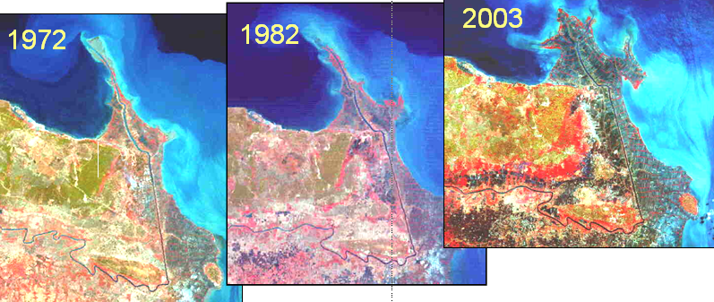

***Question 1.***

**Which five or six terrain classes do you recognize? Give them a name:**

1. **Fluvial-marine: delta plain**
2. **Structural-denudational: upland area**
3. **Marine: coastal plain**
4. **Fluvial: Natural levee**
5. **Fluvial: Backswamp area**
6. **Denudational: Transition zone between upland area and fluvial plain**
7. **Volcanic-denudational : Lower volcanic footslope.**

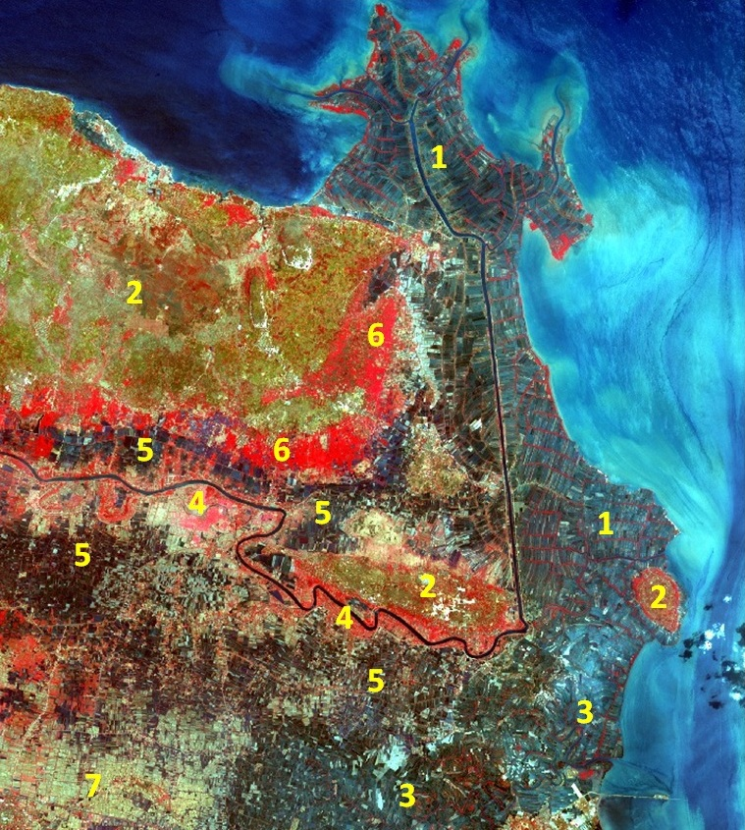

**4. Change analysis of the Solo River delta**

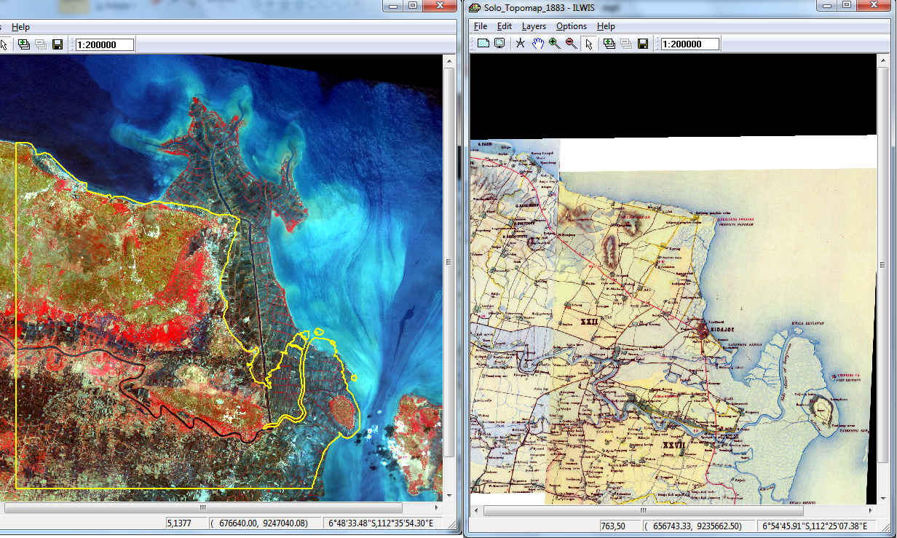**Analyze the change of the Solo River delta using the data from different years.**

***Question 2.***

Which trends do you see in respect to the delta development?

* **Development of the delta in the North and the East due to the construction of the canal.**
* **Development of several delta lobes**
* **Old delta and river in the East (near Tandjung island) not active anymore**

***Question 3.***

Calculate the surface area of the land for each year from which we have the data

|  |  |
| --- | --- |
| **Year** | **Surface area (km2)** |
| 1883 | **414.7** |
| 1972 | **501.7** |
| 1982 | **493.4** |
| 2002 | **499.8** |
| 2003 | **501.1** |

Create a histogram from the segment file to find the surface area