Session 3.3.C Task 12

Monitoring the change of the Solo River delta , East Java, Indonesia
with multi-temporal satellite images & historic topographical map

Expected time: 1.5 hour
Data: Data file: Session 3-3-C Task 12 SoloDelta
After this exercise you will be able to:
- display multi-temporal and multi-resolution coastal images of a delta environment
- analyze processes leading to changes in surface area;
- quantify the changes of surface area using multi-temporal satellite data and an old topographical map;
- display the results in a graph.

1. Introduction
The Solo River delta in Indonesia is one of the largest on the island of Java, situated at the Northern coast. The delta can be characterized as a highly mud dominated and rapidly prograding single finder delta system. The east monsoon generated coastal currents and waves cause the mouth to be deflected eastward. The delta system consists of one major straight channel with pronounced natural levees and a few river outlets. The size of the drainage basin of the Solo River covers 16.000 km² and the total length of the river is 550 km.
The river flow regime is highly influenced by the monsoons. Most discharge takes place during the wet season (December – March). The mean annual discharge is 1350 m³/sec (max 4000 m³/sec – min. 80 m³ sec.). The suspended sediment concentrations may vary from > 5000 mg/l (wet season) to less than 50 mg/l in the dry season. Almost 95 % of the suspended matter has a grain size < 50 microns.

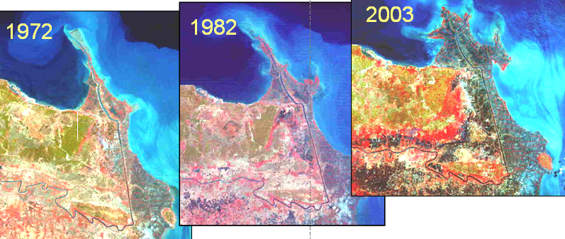
2. Exploring the input data
In the data catalog you see the icons of the available input data of this case study.

Name | Type | Meaning
Solo_Topomap_1883 | Raster | Scanned topographical map of 1883
Solo_MSS_1972 | Raster | Landsat MSS image. Acquisition date: 27-09-1972
Solo_MSS_1982 | Raster | Landsat MSS image. Acquisition date: 11-09-1982
Solo_ETM_2002 | Raster | Landsat ETM image. Acquisition date: 23-08-2002
Solo_Aster_2003 | Raster | Aster VNIR image. Acquisition date: 22-09-2003
Polygon maps of the coastline:
Solo_Coastline_1883 | Polygon | Digitized coastline from topographical map of 1883
Solo_Coastline_1972 | Polygon | Digitized coastline from Landsat MSS image of 1972
Solo_Coastline_1982 | - Polygon | Digitized coastline from Landsat MSS image of 1982
Solo_Coastline_2002 | - Polygon | Digitized coastline from Landsat ETM image of 2002
Solo_Coastline_2003 | - Polygon | Digitized coastline from Aster VNIR image of 2003

3. Display and analysis of the individual satellite images
Display of the satellite images of the Solo River delta.

- Display the satellite images in color composites. Do this in screen windows with the different images next to each other.
- Analyze the images; try to recognize the coastline, the rivers(s) etc. Analyze the differences in respect to land and water characteristics, suspended materials in the sea and river water.
- Answer Question 1.

Question 1.
Which five or six terrain classes do you recognize? Give them a name:

- ……………………………………………………………………………………..
- ……………………………………………………………………………………..
- ……………………………………………………………………………………...
- ……………………………………………………………………………………...
- ………………………………………………………………………………………
- ……………………………………………………………………………………….

Analysis of the individual satellite image bands

- Display all image bands of the Landsat MSS images of 1972 (or 1982) in screen windows next to each other (gray scale)
- Explore with the mouse the pixel values of the image in both the sea water and the land area
- Make a histogram of all the image bands
- Answer Question 2 a.
- Repeat for Landsat ETM and Aster VNIR
- Answer Questions 2 b and 2 c

Question 2 a.
Which image band of the Landsat MSS gives the best discrimination between the land and the sea water area? And what is the maximum DN value of the sea water?

Image band :………………………………Max DN value sea water:………………………………..
Question 2 b.
Which image band of the Landsat ETM gives the best discrimination between the land and the sea water area?

Image band :………………………………Max DN value sea water:………………………………..
Question 2 c.
Which image band of the Aster VNIR gives the best discrimination between the land and the sea water area?

Image band :………………………………Max DN value sea water:………………………………..

Extra task (OPTIONAL !!)

Creation of digital land-sea masks

- Create digital masks of the land and sea area using the Map Calculation capability of ILWIS. Use the maximum DN values of the sea water area (answers Question 2) . Give the land value 1 and the sea value 0
- Start with the Landsat ETM image
- Try to make also masks of the other satellite images

4. Change analysis of the Solo River delta
Analyze the change of the Solo River delta using the data from different years.
- Display a color composite of the most recent satellite image together with the 1883 topographical map in screen windows next to each other
- Answer Question 3 a
- Display the segment file of the 1883 coastline on top of the most recent satellite image
- Answer Question 3 b
- Calculate the surface area of the land for each year we have polygon maps available
- Answer Question 3 c

.

Question 3 a.
Where do we find the largest change of the delta in respect to surface area, river morphology, etc.?

…………………………………………………………………………………………………………………………………….
…………………………………………………………………………………………………………………………………….
…………………………………………………………………………………………………………………………………….
Question 3 b.
Which trends do you see in the development of the delta?

…………………………………………………………………………………………………………………………………….
…………………………………………………………………………………………………………………………………….
…………………………………………………………………………………………………………………………………….

Question 3 c.
Calculate the surface area of the land for each year from which we have the data

Year | Surface area (km2)
1883
1972
1982
2002
2003

