Flood hazard monitoring using multi- temporal SPOT-XS imagery
By:
B.H.P. Maathuis and C.J. van Westen
Department of Earth Resources Surveys,
International Institute for Aerospace Survey and Earth Sciences (ITC),
P.O. Box 6, 7500 AA Enschede, The Netherlands.
Tel: +31 53 4874 391/ 263, Fax: +31 53 4874336,
e-mail: MAATH@ITC.NL / WESTEN@ITC.NL
Summary
In this exercise you will use multi temporal satellite images to evaluate the flood problem in the confluence area of the Ganges and Jahmuna rivers in Bangladesh, Southwest of the capital of Dhaka. In this area river dynamics are impressive. Rivers change their course for kilometers within years.
You will evaluate the areas covered by water during three periods:
- During the dry season, using a SPOT image from 9-1-1987,
- During a moderately severe flood, using a SPOT image from 7-11-1987,
- During a severe flood, using a SPOT image from 10-10-1988.
Getting started
The data for this case study is available under the blackboard title “Ilwis data case study flood hazard Bangladesh”. To copy the data into your local pc proceed as follows: create a folder with the name “FloodMonitoringBangladesh”; download the zip file, and extract its contents to the folder previously created. If you have already installed the data on your hard-disk, you should start up ILWIS and change to the subdirectory where the data files for this exercise are stored.

- Double-click the ILWIS program icon in the ILWIS program group.
- Change the working drive and the working directory until you are in the directory where data are stored.

1.1 Introduction
Bangladesh probably is the most affected country by natural catastrophes, especially floods, in the world. Approximately 40 percent of the country is subjected to regular flooding. It contains more than 250 perennial rivers, of which 56 originate outside of the country, in Tibet, India, Bhutan and Nepal. Ninety percent of the river discharge from the main rivers, the Ganges, the Brahmaputra and the Meghna originates from other countries.
The primary cause of flooding in Bangladesh is directly or indirectly related to rainfall in the catchment areas of the three major river systems. The rainfall, together with snow-melt from the Himalayas generates enormous quantities of runoff to be discharged through Bangladesh into the Bay of Bengal.
Moderately strong semidiurnal tides are prevailing in the Bay of Bengal. Due to the extreme flat topography of the country (half the country lies below the eight meter contour line), the tidal influence reaches very far into the country. During the monsoon, recession of the floodwater is delayed due to the tidal effect. Cyclonic sea flooding occurs when due to the friction of the wind on the surface of the sea a storm surge moves inland.
From 1960-81 Bangladesh has suffered 63 disasters with the loss of 655.000 lives. Of these events, 37 were tropical cyclones, which killed 386.200 people. The last major floods were in 1987 and 1988 and a cyclone in 1990, killing about 140.000 inhabitants on the Bay of Bengal coast.
The evaluation of the flooding hazard is an international effort, as rainfall and river discharge monitoring in the entire catchment of the major rivers is required, as well as monitoring of sea levels and warning systems for tropical cyclones. For flood stage mapping and river dynamics determination, digital image processing and analysis of sequential SPOT images using GIS can be of large use. The study area covers the confluence of the rivers Meghan and Ganges, south east of the capital of Dhaka.
With the images from the three dates you can evaluate two things:
- Monitoring the extend of inundations,
- Monitoring river dynamics.
First a method has to be used for discriminating water surfaces from the other land cover types present in the images.
Selection of a single band in which water can be differentiated
All images are multi spectral SPOT-XS images, with a spatial resolution of 20 meters, consisting of three bands:
- Band 1: spectral resolution 0.5-0.6 µm: green portion of the visible spectrum.
- Band 2: spectral resolution 0.6-0.7 µm: red portion of the visible spectrum.
- Band 3: spectral resolution 0.8-0.9 µm: near infrared portion of the spectrum.
This method can be applied when individual bands are selected in which water has a specific reflectance that does not spectrally overlap with other cover classes. In this exercise SPOT XS imagery is used and the reflectance curves for some cover types are given in figure 2.1.
Figure 2.1: Reflectance curves for some cover types, and the spectral resolution of the three SPOT XS bands
Band ratio’s
Another method is the use of band ratios, which are combinations of the individual bands. This method has the advantage that if spectral reflectances of cover types in one band are similar, the ratio of two bands can be used to differentiate them.

Table 2.1: Relative reflectance for different land cover types for the 3 SPOT XS bands

Cover type | Band1 | Band3 | Band ratio 3/1
Water | Moderate | Low | Low-moderate
Clouds | High | High | Moderate
Shadow | Low | Low | Moderate
Vegetation | Moderate | High | Moderate-high
Bare soil | High | High | Moderate

The table shows that water has the same range of reflectance if compared to vegetation in band 1 and shadow in band 3. Using a band ratio water can be better separated. On the other hand clouds, shadow and bare soils are harder to distinguish. It therefore depends on the type of research which method to use.

1.2 Flood stage mapping
Before the band ratios are made, it is important to get a good idea of the individual images. First band 1 of the image from the moderate severe flood will be displayed.

- Display the image Mfl87_1w by double-clicking the map icon. Deselect the check box stretch in the Display Options dialog box. Click OK. The map will be displayed. Note the overall gray, or low contrast, throughout the whole image. You can find out the DN (digital number) value of each pixel by clicking on a pixel within the image.
- Close the map window.
- Double-click the histogram of the map Mfl87_1w. The histogram is shown in a table window. Observe the values in the table (scroll down to see the values). Display the histogram in a graph by selecting Options and Show Graph. Select Image value for the X-axis and Npix for the Y-axis in the Graph dialog box. Click OK, and again click OK in the Edit Graph window. Now the histogram is displayed as a line.

The horizontal axis of the histogram may be interpreted as if it is a gray scale, with 256 different shades of gray. A reflectance value of zero is displayed in black, a reflectance value of 255 is displayed in white, and all values in between in various shades of gray. The vertical axis shows how many pixels in the image have that value.
Notice that practically all pixels have a DN value between 20 and 50. Only the white spots in the image, which are actually clouds, may have higher DN values. That is why the image is mostly dark gray. To increase the contrast in the image, we will need to change the display so that all the colors of the palette are used, ranging from black to white.

- Close the graph window.
- Scroll down the table and write down the DN values for which the cumulative percentage (column Npcumpct ) = 1 and to 99. Close the table window.
- Double-click the raster map Mfl87_1w again, but now select the check box stretch in the Display Options dialog box, and enter the values you have just written down, as the minimum and maximum values. Click OK. The image is now displayed with much more variation in gray tone.
The easiest way to improve the visibility of an image is by using the option stretch. When this is used, the minimum value in the image is displayed with the lowest color in the gray representation (black) and the maximum is displayed with the highest color (white). If we use the stretch option in the display of the map, the actual image values are not changed. Only the way in which they are represented changes.
If we want to actually create a map with DN values between 0 and 255 we have to use a Stretch operation, which will produce another image. In ILWIS two possibilities exist for stretching an image: linear stretching, and histogram equalization. The most commonly used method is the linear stretch. The principle of linear stretching is shown in the figure below. IN represents the original image values; OUT the corresponding image values after stretching.

Figure 2.2: Principle of the linear stretching technique

- Close the map window.
- From the Operations menu in the Main window, select Image Processing, Stretch. The Stretch dialog box is opened. Select the image Mfl87_1w as input map. Use the Linear Stretch option, and a percentage value of 1%. Enter Mfl87_1s as the output image, and click on Show and OK. After calculation the Display Options dialog box is opened. Click OK. The image is shown. It will look the same as the previously displayed image, except when you now click on the values in the map, you will see that they are really in the range of 0 to 255. See results
- From the File menu of the Main window, select Open Pixel Information. Drag-and-drop the maps Mfl87_1w and Mfl87_1s into the pixel information window. Move the mouse pointer over the image and observe the different values before and after stretching.
- Compare the histograms before and after stretching.
- Close the map window and the pixel information window.

Creating a false color composite
The first step is to evaluate the pixel values for different cover types. This will be done using a color composite from the moderate flood.

- From the Operations menu, select Visualization, Color Composite
Enter for the Name of red band: Ml87_3w
Enter for the Name of green band: Mfl87_2w
Enter for the Name of blue band: Mfl87_1w
Name of output image: Mfl87fcc.
Switch off 24 bits.
Select Linear Stretching and a percentage of 1.00 for all three input bands.
- Click Show and OK. After calculating the map the Display Options dialog box is opened. Click on OK. The false color composite is displayed. See results

In this image you can see more clearly the different land cover units. As you can see water is shown in blue green colors, vegetation in red colors, clouds and bare soils (e.g. sand bars) in white, and shadows in black. Now you will evaluate how these classes are shown in the three individual bands.

- Open the pixel information window and add the maps Mfl87_1w,. Mfl87_2w and Mfl87_3w to it. If you move the mouse pointer through the image you see the values of three input bands.
- Zoom in on certain parts of the map with water, vegetation, clouds, shadows and bare soil. Note in the table below the DN values per band of the given land cover types.
- Calculate the band ratio 3/1 using the ILWIS pocket line calculator. For example, if you want to calculate 34/45, you type ?34/45↵ on the command line of the Main window. Select at least 5 pixels per cover class.
Table 2.2: Fill in the DN values for the indicated bands and cover types. Also calculate the ratio 3/1

Cover type | Band 1 | Band2 | Band3 | Band3/Band1
Water
Water
Water
Water
Water
Vegetation
Vegetation
Vegetation
Vegetation
Vegetation
Clouds
Clouds
Clouds
Clouds
Clouds
Shadow
Shadow
Shadow
Shadow
Shadow
Bare soils
Bare soils
Bare soils
Bare soils
Bare soils

As you can see from the results we cannot differentiate the water from vegetation in band 1. In band 3 we can differentiate the two, but then shadows will also have a low reflectance.
That is why, if we take the ratio of band 3 and band 1, we can differentiate the water.

- Close the map window and the pixel information window.

1.3 Computation of Band ratio’s
Now you will calculate the ratio of bands 3 and 1.

- Type the following formula on the command line:
- Brmfl=Mfl87_3w/Mfl87_1w↵
- The Raster map definition dialog box is opened. Click the Create domain button. The Create Domain dialog box is opened.
Type Ratio for the domain name. Select the domain type Value. Click OK. The Domain Editor is opened.
- Enter 0 for Min, 10 for Max and 0.01 for the Precision. Click OK. You are back in the Raster Map Definition dialog box. Change also here the value range to 0 and 10. Click OK.
- Double-click the map Brmfl. Make sure the representation Gray is selected in the Display Options dialog box. Accept the defaults and click OK. See results
- The map Brmfl is shown in gray tones. Read the values in the map and see if you can now differentiate between the water and the rest. Also consult the histogram for this. Find the critical value that limits water from land.

To find out the limiting value for differentiating land and water, it is helpful to create a representation, with two colors (blue and green). All pixels with values below the limit will be displayed in blue (water), and those with higher values in green (land). When you change the limit, the display changes as well, and you can evaluate if all the water pixels are classified as water. This way you can interactively find out the best value for differentiating land and water.

- When you have an idea about the boundary value, double-click the New Repr item in the Operations-list. The Create Representation dialog box is opened. Enter Ratio for the Representation name, and select the domain Ratio. Click OK. The Representation Editor is opened.
- In the Edit menu of the Representation Editor, select Insert Limit. Enter the critical value that differentiates between land and water (for example 0.5), and select the color blue. Click OK.
- Activate the map window, and press the right mouse button while the mouse pointer is on the image. Select map Brmfl from the context-sensitive menu. The Display Options dialog box is opened again.
- Select the representation Ratio and click OK. Now the map Brmfl is redisplayed, according to the representation Ratio.
- Activate the Representation Editor again. Change the color of the limit 10 to Green. Double-click on the word “stretch” between the limits until it changes to “upper”.

- Press the Redraw button in the map window. Now the map is shown in two colors: blue (water) or green (land). Evaluate if the limit 0.5 is correct for differentiating water and land. If not change the limit in the Representation Editor, and press the Redraw button again in the map window. See results

When you are sure about the value for differentiating land and water, you can use the Slicing operation, to change the ratio image into a class map. For the Slicing operation, a group domain is required.

- Create a domain Mfl (you do this by selecting he menu items File, Create, Create Domain from the Main window). The domain should be class and group. Press OK. Now you can enter the boundary values and the names of the classes. Select Edit, Add Item and fill in the value that you found earlier as the boundary value, and Watermfl as the name. Press OK. Add another class: Landmfl with as boundary value the maximum value in the map. Close the Domain Editor.
- Now use the Slicing operation (by selecting the menu items Operations, Image processing, Slicing from the Main window). Use Brmfl as input map, Mfl as domain, and Mfl as output map.
- Display the map Mfl, and compare it with the image Brmfl. See results

Now you have a class map, indicating the flooded area during the moderate flood of 1987.

- Follow the same procedure for the images of the other two dates:
9-1-1987 (dry season by making a band ratio map Brdry, a domain dry , with the classes Waterdry, and Landdry and a final map dry) and 10-10-1988 (severe flood: by making a band ratio map Brfl, a domain fl with the classes Waterfl, and Landfl and a final map Fl). See results
- Create a false color composite using the three bands from 10-10-1988. Name the resulting map Fl88fcc. See results

- Display the image Fl88fcc and the maps Dry, Mfl, Fl all together on the screen. Compare them.
- Close the map window.

1.4 Combining the three water level maps
You now have three maps which show the difference in land/water for three periods: the dry season of 1987, the moderately severe flood of 1987, and the severe flood of 1988. These maps will be combined into one final map, using the Crossing operation.

- Cross the maps Dry and Mfl, create a cross map and a cross table, both called Drymfl.
- Cross the maps Drymfl and Fl, create a cross map and a cross table, both with the name Final.
- Convert the domain Final from Identifier to Class, by pressing the Convert to Classes button in the Properties dialog box. See results
- Create a representation Final.
- Create annotations for the map Final and store the result as a map view.
- Calculate the percentage of the different classes of the output map.

References
Alexander, D. (1993). Natural disasters. UCL Press Ltd., University College London. 632 pp.
Asaduzaman, A.T.M. (1994). A geomorphologic approach to flood hazard assessment and zonation in Bangladesh, using Remote Sensing and a geographic information system. MSc thesis, ITC, Department of Earth Resources Surveys. Enschede. 85 pp.
Maathuis, B.H.P (1993). Flooding Bangladesh: ITC Demo. CZM Toolbox, tools and applications for Coastal Zone Managment, World Coast Conference 1993, pp. 15-18 (+demo diskette).
van Westen, C.J. (1993). Remote sensing and geographic information systems for geologic hazard mitigation. ITC Journal 1993-4: 393 - 399.

Results of the exercises

Figure 1: Image processing stretch mfl87_1s
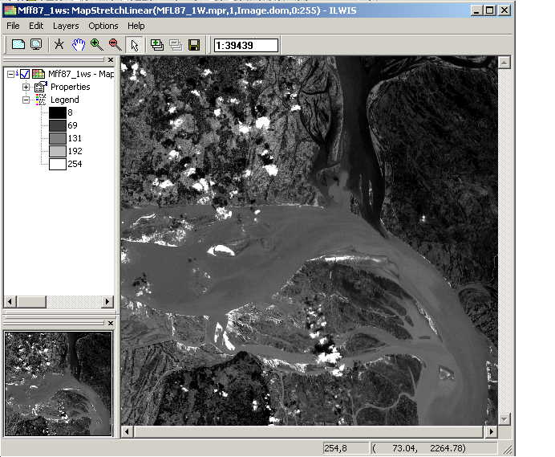

Figure 2: Section 1.2 creating a false color composite moderate flood
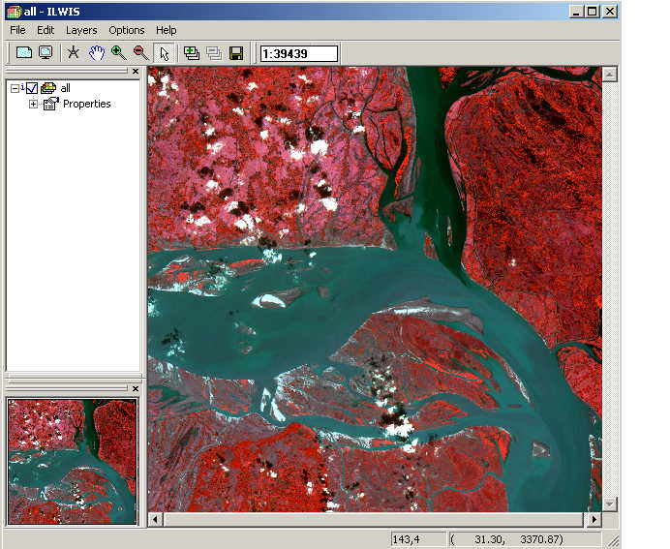

Figure 3: Section 1.3 Computation of band ratio's
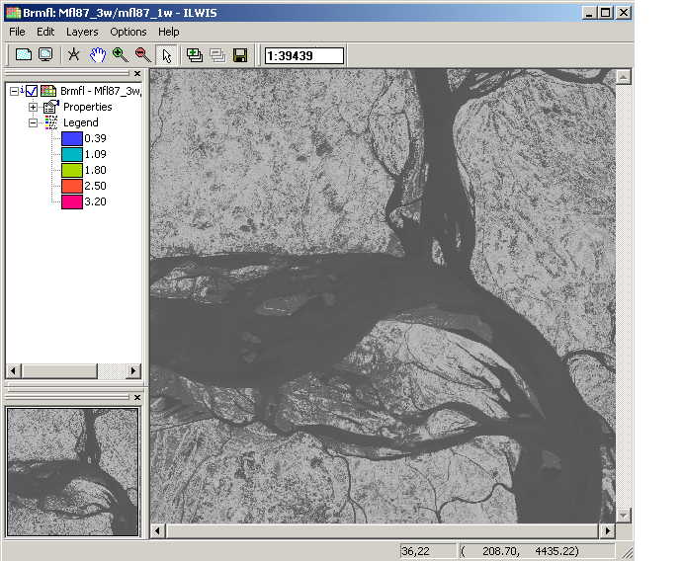

Figure 4: Section 1.3 Computation of band ratio's and slicing operation, moderate flood

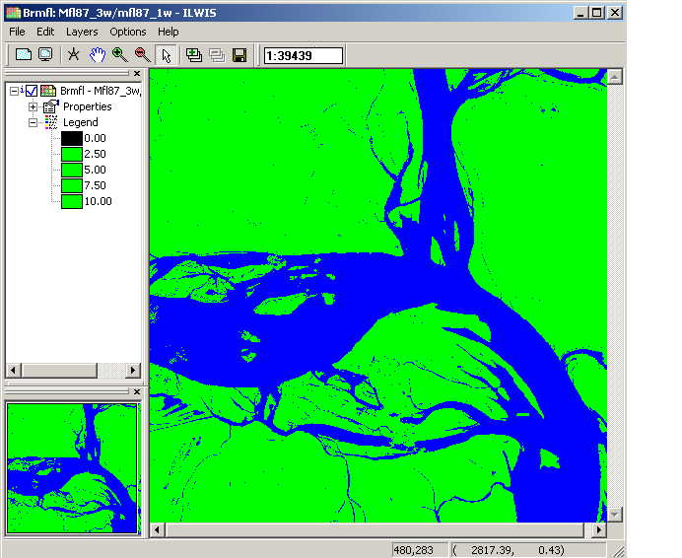

Figure 5: Section 1.3 Computation of band ratio's and slicing operation, severe flood

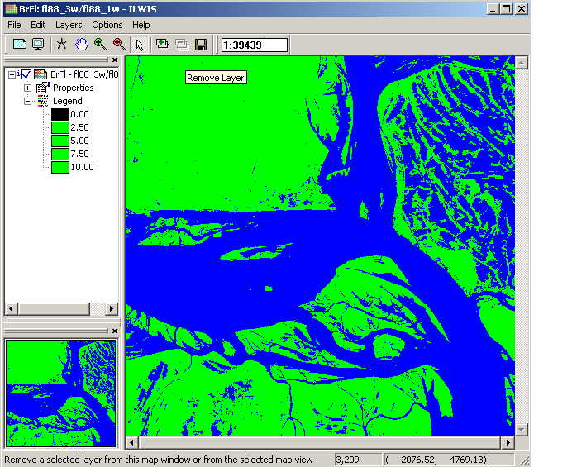

Figure 6: Section 1.3 Computation of band ratio's and slicing operation, dry season

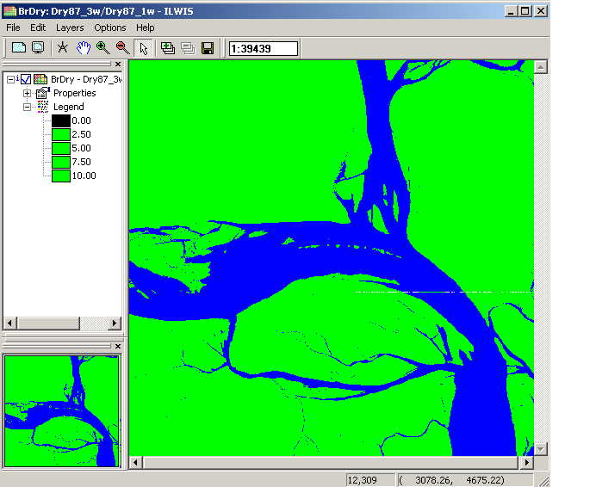

Figure 7: Section 1.3 Color composite severe flood 1988

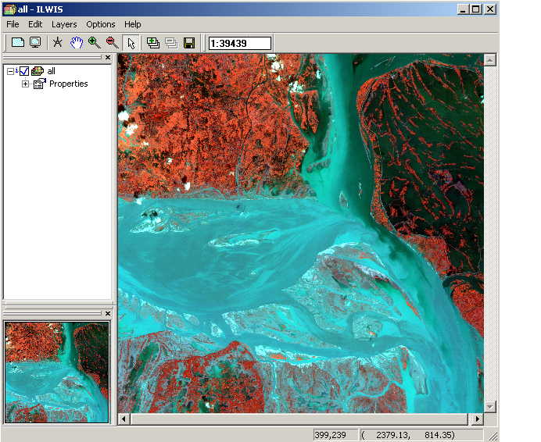

Figure 8: Section 1.4 Combining the three water level maps

