Exercise 3L2. Deterministic landslide hazard assessment
Expected time: 3 hours
Data: data from subdirectory:Riskcity exercises/exercise03L2/data
Objectives: This exercise shows you how to carry out a basic slope stability analysis using the infinite slope model. This will calculate the stability of each pixel for different scenarios of the relation groundwater depth / failure surface depth.

Some background information:
The final aim of large scale landslide hazard analysis (scales larger than 1:10,000) is to create quantitative hazard maps. The hazard degree can be expressed by the Safety Factor, which is the ratio between the forces that make the slope fail and those that prevent the slope from failing. F-values larger than 1 indicate stable conditions, and F-values smaller than 1 unstable. At F=1 the slope is at the point of failure.

in which:
c = cohesion (Pa= N/m²).
A = length of the block (m).
W = weight of the block (kg).
β = slope surface inclination (°).
φ = angle of shearing resistance (°)
According to the formula:
F < 1 unstable slope conditions,
F = 1 slope is at the point of failure,
F > 1 stable slope conditions

The infinite slope model can be used on profiles as well as on pixels. The entire analysis requires first the preparation of the data base. The parts on groundwater modelling and the modelling of seismic acceleration are not shown here. For more information see Van Westen (1993). In this exercise only the calculation of average safety factors will be done for different scenarios. These average safety factor maps could be used in the creation of failure probability maps.
Some background information:
Many different models exist for the calculation of Safety Factors. Here we will use one of the simplest models, the so-called infinite slope model. This one dimensional model describes the slope stability of slopes with an infinitely large failure plane. It can be used in a GIS, as the calculation can be done on a pixel basis. The pixels in the parameter maps can be considered as homogeneous units. The effect of the neighboring pixels is not considered, and the model can be used to calculate the stability of each individual pixel, resulting in a hazard map of safety factors. The safety factor is calculated according the following formula (Brunsden and Prior, 1979) :
$F\text{ = }\frac{{c^{'}\text{ +}(g−mg_{w})\text{z }{\text{cos}}^{2}b\text{tan \{}f}^{'}}{g\text{z sin}b\text{cos}b}$
in which:
c’ = effective cohesion (Pa= N/m²).
γ = unit weight of soil (N/m³).
m = z_{w}/z (dimensionless).
γ_{w} = unit weight of water (N/m³).
z = depth of failure surface below the surface (m).
z_{w} = height of watertable above failure surface (m).
β = slope surface inclination (°).
φ‘ = effective angle of shearing resistance (°).

Visualization of the input data
In this exercise the slope stability analysis is made by using only two parameter maps: Soildepth (thickness of soil) and Slope_map (slope angles in degrees).

- Open the maps Soildepth and Slope_map and check the values in the maps. Click OK in the Display Options dialog box. The map is displayed.
We assume that:
the depth of the possible failure plane is taken at the contact of the soil and the underlying weathered rock material.
All soils have the same values for Cohesion, friction angle and unit weight.
In the first part of the exercise we will calculate the stability of the soil cover using only one single value of cohesion, friction angle and bulk density. The consequence of this is that safety factors will not be calculated for the entire area, but only for the areas where there is soil overlying the bed rock.
Besides soil depth which is assumed to be the same as the depth to the failure surface, and the slope of the terrain, we also need to know the other parameters of the infinite slope formula. From laboratory analysis the following average values are known:
M:
Zw/Z =
Depth to groundwater /
Depth to failure surface
c' = effective cohesion (Pa= N/m²) = 11000 Pa
γ_{w} = unit weight of water (N/m³) = 10000 N/m³
z = depth of failure surface below the surface (m) = map Soildepth
β = slope surface inclination (°) = map Slope_map
φ’ = effective angle of shearing resistance (°) = 32 °
tan(φ') = tangent of the effective angle of shearing resistance = 0.625

The only unknown parameter yet is the depth of the water table. In the formula this is expressed as the value m, which is the relation between the depth of the water table and the depth of the failure surface.

Preparation of the data
Before you can start with the analysis, you need to reorganize the map Slope_map. In the calculation we need three parameters that are derived from the slope:
Sine and Cosine
The ILWIS functions for sine and cosine only work with input values in radians, while our map Slope_map is in degrees. Therefore we need to convert to slope map from degrees to radians first.
sin(slope) = the sine of the slope
cos(slope) = the cosine of the slope
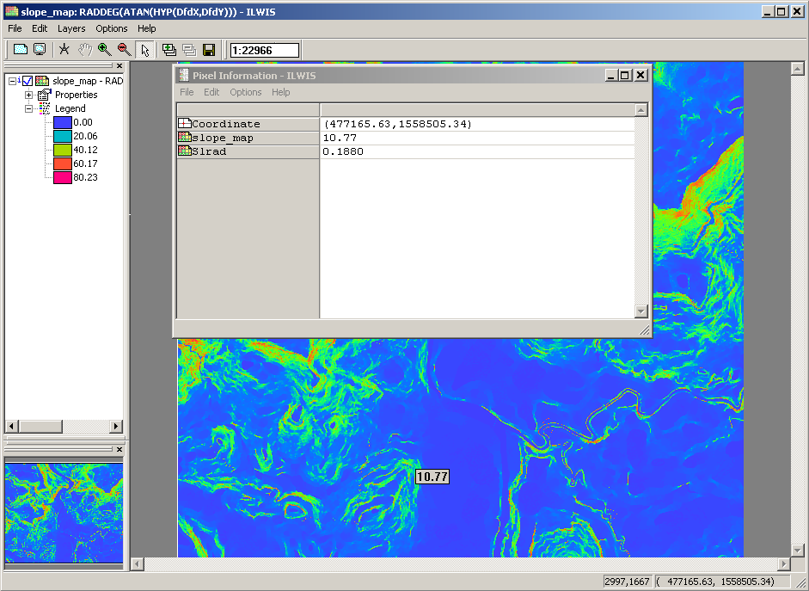
cos2(slope) = cos(slope)*cos(slope)
The ILWIS functions for sine and cosine only work with input values in radians, while our map Slope is in degrees. Therefore we need to convert to slope map from degrees to radians first. ILWIS has the function Degrad for that:
Degrad(Slope) degrees to radians function: slope*2π/360

- Type the following formula on the command line:
- Slrad:=degrad(Slope_map)↵
Accept the default minimum, maximum and precision.
- Open the result map and compare the values of the map Slrad with those of the map Slope_map. With the pixel information click in some points of the map and read the values in degree and in radians. For example: you can type in the command line of ILWIS the following formula:
?10.77*2*3.14/360
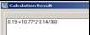
Now you have the slope in radians, and you can calculate the sine and cosine. You will calculate individual maps for these so that the Safety factor formula (formula 6.1) can be calculated easier.

- Type the following formula on the command line:
- Si:=sin(Slrad)↵
- (with this formula you calculate the sine of the slope).
Accept the default minimum (-1), maximum (+1) and give a precision of 0.001.
- Open the result map and compare the values of the map Si with those of the map Slrad. Calculate it with the pocket line calculator or the Windows calculator for some pixels, using the formula given above.
- Type the following formula on the command line:
- Co:=cos(Slrad)↵
- (with this formula you calculate the cosine of the slope).
Accept the default minimum (-1), maximum (+1) and give a precision of 0.001.
- Open the result map and compare the values of the map Co with those of the map Slrad. Check it for some pixels, using the formula given above.
- Type the following formula on the command line:
- Co2=sq(Co)↵
- (with this formula you calculate the square of the cosine, using the ILWIS function Sq()).
Accept the default minimum, maximum and precision
- Check your results again.

Now all necessary parameters for the formula are known, except for the parameter m related to the groundwater depth.

Creating a function for the infinite slope formula
In the following sections you will use the infinite slope formula extensively for different scenarios, and different input data. To avoid that you have to retype the formula each time, it is better to create a user-defined function for it.
Functions
Besides many internal pre-programmed functions, ILWIS gives the user an opportunity to create new functions. Especially when you need to execute certain calculations which require a lot of typing work several times, user-defined functions may be time saving. A user-defined function is an expression which may contain any combination of operators, functions, maps and table columns
- Double-click New Function in the operations list. The Create function dialog box is opened.
- Type for the Function Name: Fs
Type for the expression:
(Cohesion+(Gamma-M*Gammaw)*Z*Co2*Tanphi)/
(Gamma*Z*Si*Co)
Type the Description: Safety factor.
- Click OK. The Edit Function dialog box is opened. Click OK.

In this dialog box you can edit the expression of the function. Now the expression is:

Function fs(Value Cohesion,Value Gamma,Value M,Value Gammaw,Value Z,Value Co2,Value Tanphi,Value Si,Value Co) : Value
Begin
Return (Cohesion +(Gamma-M*Gammaw)*Z*Co2*Tanphi) /(Gamma*Z*Si*Co)
End;

As you can see the function contains the following variables (listed in the first line):
- Value Cohesion: the value for the effective cohesion.
- Value gamma: the value for the unit weight of soil.
- Value m: the value for the relation z_{w}/w.
- Value gammaw: the value for the unit weight of water.
- Value z: the value for the depth of failure surface below the surface.
- Value co2: the value for the square of the cosine of the slope.
- Value tanphi: the value for the tangent of the effective angle of shearing resistance.
- Value si: the value for the sine of the slope.
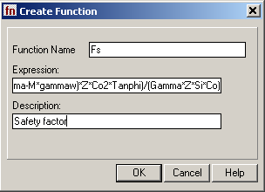
- Value co: the value for the cosine of the slope.

However, a number of these variables are fixed. You will use them for all calculations: The fixed variables are: Value Cohesion (10000 Pa), Value Gammaw (10000 N/m³ ), Value Z (raster map Soildepth), Value Co2 (raster map Co2), Value Tanphi (0.625), Value Si (raster map Si), and Value Co (raster map Co).
So you can simplify the function considerably, so that it looks like:

Function fs(Value Gamma,Value M) : Value
Begin
Return(10000+((Gamma-m*10000)*Soildepth*Co2*0.625))
/(Gamma* Soildepth *Si*Co)
End;

As you can see there are only two variables: Value Gamma and Value M.

- Edit the Function until it is the same as above. Click OK.

Calculating Safety Factors for groundwater scenarios
Now that the function is created, you can start to calculate safety factor maps for different scenarios. In the first part you will calculate the safety factors for different scenarios where only rainfall is the triggering factor. You will not yet look at the influence of an earthquake.
Dry condition

You will first calculate the safety factor for the soils under the assumption that the soil is completely dry. In that case the parameter m is equal to zero.
Remember the other parameter that were given on the previous page:
c' = Effective cohesion (Pa= N/m2) = 11000 Pa
γ = Unit weight of soil (N/m3) = 11000 N/m3
γw = Unit weight of water (N/m3) = 10000 N/m3
z = Depth of failure surface below the surface (m) = map Soildepth
m = Relation zw/z (dimensionless) = 0
β = Slope surface inclination (°) = map Slope_map
φ’ = Effective angle of shearing resistance (°) = 32 °
tan(φ') = Tangent of the effective angle of shearing resistance = 0.625
sin(β) = Sine of slope angle = map Si
cos (β) = Cosine of slope angle = map Co
cos2(β) = Square of the cosine of slope angle = map Co2

Now you can start with the actual calculation of the average safety factor map representing the situation under dry conditions. The two variables for the function fs are 11000 (Value Gamma) and 0 (Value M).

- Type the following formula on the command line:
- Fdry:=fs(11000,0)↵
- Make sure the georeference Somewhere is used. Use a minimum of 0, a maximum of 100, and a precision of 0.1.
- Open the result map and compare the values of the map Fdry with those of the input maps. Calculate the safety factor manually for some pixels with the Pocket line calculator or the Windows calculator, using the infinite slope formula

The resultant map (Fdry) will have some pixels with missing values indicated by a question mark (?). You can investigate these pixels and see that the values of the pixels cannot be calculated either because they lack soil or because they are flat areas. Both conditions indicate stability and thus can be safely grouped as stable.
As you can imagine a situation with a completely dry situation does not occur in a tropical region such as RiskCity, which receives quite a lot of rainfall each year. In any case the map Fdry gives the most stable situation. Let us see how much percent of the area is unstable under these conditions. In order to know that we will first classify the map Fdry into three classes:
Unstable = safety factor lower than 1
Critical = safety factor between 1 and 1.5
Stable = safety factor above 1.5
- Create a new domain Stabil (type class, group) with the following three classes:
Boundary Name
1 Unstable
1.5 Critical
100 Stable
- Use the Slicing operation to classify the map Fdry with the domain Stabil into the map Fdryc.
- Calculate a histogram of the map Fdryc and write down the percentages of the three classes in a table on a sheet of paper with the column name Dry. Later we will calculate the values for other situations.

The percentage of the pixels classified as unstable gives you an indication of the error, since the occurrence of unstable pixels under fully dry conditions is not possible.
Completely saturated condition
The next scenario that you will evaluate is a condition in which the slopes are completely saturated. This is also not a very realistic situation, but it will give us the most pessimistic estimation of slope stability, with only one triggering factor involved (rainfall leading to high perched watertables).
When we have a saturated soil, the m factor from the infinite slope formula is equal to 1. This means that the watertable is at the surface. There is also another parameter that will vary when the soil is completely saturated, which is γ:
c' = Effective cohesion (Pa= N/m²) = 11000 Pa
γ = Unit weight of soil (N/m³) = 16000 N/m³
γ_{w} = Unit weight of water (N/m³) = 10000 N/m³
z = Depth of failure surface below the surface (m) = map Soildepth
m = Relation z_{w}/z (dimensionless) = 1
β = Slope surface inclination (°) = map Slope_map
φ’ = Effective angle of shearing resistance (°) = 32 °
tan(φ') = Tangent of the effective angle of shearing resistance = 0.625
sin(β) = Sine of slope angle = map Si
cos (β) = Cosine of slope angle = map Co
cos²(β) = Square of the cosine of slope angle = map Co2
The two variables for the function fs are 16000 (value gamma) and 1 (value m).

- Type the following formula on the command line:
- Fsat:=fs(16000,1)↵
- Use a minimum of 0, a maximum of 100, and a precision of 0.1. Change the GeoReference to “Somewhere”.
- Open the result map and compare the values of the map Fsat with the maps Fdry and the input map. Calculate the safety factor manually for some pixels with the ILWIS pocket line calculator or the Windows calculator for some pixels, using the formula given above.
- Use the Slicing operation (under image procession) to classify the map Fsat with the domain Stabil into the map Fsatc.
- Calculate a histogram of the map Fsatc and write down the percentages of the three classes in a table on a sheet of paper with the column name Sat. Compare them with the column Dry.

Now that we have calculated all scenarios, we can compare them. This can be done in a table.

- Create a table from the domain Stabil.
- Go to Columns, Join and select Table histogram of Fdryc; use the column Npixpct. Give the name Dry to the output column. Accept the default values and click Ok.
- Also join the histogram file of the map Fsatc. Give the name Sat.
- Click the button Graph in the main menu, Remove the tick mark in the X axis, Select Dry as Y axis and click OK. You will see a histogram of the percentage area under different stability classes in dry condition.
- In the Graph window itself, go to Edit menu, Add Graph and select and from columns. Select Y axis Sat. Now you will see the histograms of the percentage area under different stability classes in dry and saturated conditions side by side.
- Draw conclusions on the effect of the groundwater on the stability of the soils in the area.
Partially saturated condition

- Now design some scenarios yourself where you use M values that vary between 0 and 1, and see the effect on the stability.
- Draw conclusions on the effect of the groundwater on the stability of the soils in the area.

For experienced ILWIS users
- For experienced ILWIS users:
Using different values for cohesion and friction angle
- It is also important to include different values for cohesion, friction angle and unit weight of soils for different soil or lithological types. You can do that by adding columns Cohesion, FrictionAngle and Gamma to the table Lithology.

- For experienced ILWIS users:
Include earthquake acceleration
- Iit is also possible to include earthquake acceleration in the equation for the factor of safety. You could try to make a function for that based on the formula given below, and test this out for a few scenarios of earthquake acceleration and M values.

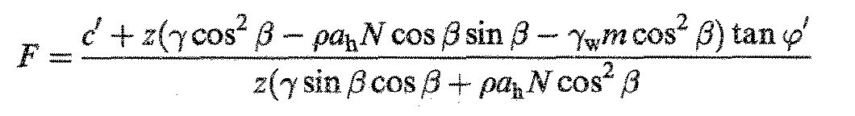
C’ = effective cohesion (Pa)
z = depth of failure surface below terrain surface
γ = unit weight of soil (Nm⁻³)
β = terrain suface inclination (degrees)
ρ = bulk density (kgm⁻³)
Ah = peak horizontal acceleration in rock (ms⁻²)
N = amplification of seismic acceleration in soil
γ_{w} = unit weight of water (Nm⁻³)
M = groundwater/soil thickness ration z_{w}/z
Z_{w} = height of the water table above failure surface (m)
φ’ = effective angle of shearing resistance (degrees)

