Exercise 3E: Earthquake hazard assessment
Expected time: 6 hours
Data: data from subdirectory:Riskcity exercise/exercise03E/data
Objectives: After this exercise you will be able to:
- Evaluate the earthquake catalog, with respect to the location, magnitude and depth of earthquakes
- Display earthquakes according to magnitude and depth
- Develop relations between depth, and magnitude
- Define the distance of the epicenters with respect to RiskCity
- Evaluate the completeness of the earthquake record.
- Estimation of PGA in rock in RiskCity for the various earthquakes in the catalog.
- Estimation of PGA in rock in RiskCity for the various earthquakes in the catalog.
- Application of various attenuation functions and evaluate their difference.
- Select a scenario earthquake, for which PGA values in rock are calculated
- Use the surficial geological information in order to define ranges of soil amplification
- Generate a PGA map for the city
- Convert the PGA to MMI
- Calculate the natural frequency of the soil in RiskCity
- Relate this with the natural frequency of buildings
- Make a zonation for different building altitudes
Introduction
A frequently used method for assessing and mapping earthquake hazards is seismic hazard zonation. It is the division of an area in smaller areas that have the same hazard level. Two types of seismic hazard zonation exist: the general method of macrozonation (mapping hazard on a small scale) and the detailed method of microzonation (on a large scale). The latter one allows for local geological and site conditions to be taken into account. Macrozonation is usually only based on earthquake recurrence and expected magnitude, and does not take local conditions into account.
This exercise deals with the use of GIS for seismic hazard assessment at a large scale, using two different methods:
    - A simple method, followed by the RADIUS methodology, in which Peak Ground Acceleration is calculated for a scenario earthquake, and the amplification of soil is treated by simple multiplication values. This method gives only a very general approximation of the hazard
    - A second method in which we will look more to earthquake spectra, and calculate the natural frequency of the soil, which is used to delineate areas which will experience large ground amplifications at specific frequencies which correspond to natural frequencies of certain building types.
In a real seismic hazard microzonation project the second method should be extended by calculating the response spectra for different soil columns, using strong motion records, and detailed soil column descriptions and properties. This would require a considerable amount of time and input data, and is not feasible within this case study. Here we will not be dealing in detail with the geological conditions of the RiskCity area. For this exercise it is important to know that the center of RiskCity has been filled in by lake-, river-, terrace and talus deposits. The valley is surrounded by steep mountains.
Exploring the input data
In the data catalog you see the icons of the available input data for this introduction to the case study. The following input data gives an overview of the thematic data and how they are derived.

Name | Type | Meaning
Image data
Country_Anglyph | Raster image | An anaglyph image of the country in which RiskCity is located, made from DRTM data.
Geological data
Geology_country | Polygon map | A geological map of the country in which RiskCity is located. This is linked to an attribute table with geological information
Faults_country | Segment map | A map with the main fault zones of the country
Seismic_zones | Polygon map | Seismo-tectonic zones, where a similar type of earthquakes can occur and which are used as earthquake source zones. Having their own magnitude-frequency relationship.
Earthquakes
Earthquakes_countrty | Point map | A point map linked with a table containing information on the location, time, depth and magnitude of earthquakes in Honduras over the period: 1973-2008
Local data for RiskCity
City_Centre | Point map | Location of the city center of RiskCity
Soildepth | Raster map | Flood extend map for a 100-year return period, obtained through modeling with HEC-RAs hydrological software
Lithology | Polygon map | Lithological map of RickCity
Altitude_dif | Raster map | Altitude of buildings

The exercise is made up of the following sections:
- Part 1: Evaluating the earthquake catalog & calculating magnitude-frequency relationships.
- Part 2: Estimation of PGA in rock in RiskCity for the various earthquakes in the catalog.
- Part 3: Generating PGA maps for RiskCity
- Optional exercise: Earthquake microzonation using overburden thickness

Part 1: Evaluating the earthquake catalog & calculating magnitude-frequency relationships.

Expected time: 2 hours
Objectives:
- Evaluate the earthquake catalog, with respect to the location, magnitude and depth of earthquakes
- Display earthquakes according to magnitude and depth
- Develop relations between depth, and magnitude
- Define the distance of the epicenters with respect to RiskCity
- Evaluate the completeness of the earthquake record.
- Estimation of PGA in rock in RiskCity for the various earthquakes in the catalog.
Look at the geological context
First we will start by having a look at the general structure of the country. We have an anaglyph image of the entire country (obtained from SERVIR on: http://www.servir.net/index.php?option=com_content&task=view&id=46). We also have geological map which was obtained from the USGS website. And we have a map with the main fault systems in the region. This was obtained from the following publication, which is also good as background reading for this exercise:
Cáceres, D. and Kulhánek, O. (2000) Seismic Hazard of Honduras. Natural Hazards 22: 49–69, 2000.
- Open the anaglyph image Country_Anaglyp
- Add the layer Geology_country. Display boundaries only, and show with white lines with thickness 1.
- Add also the point map City_centre
- Open Pixel Information and add the map Geology_country.
- Use the red-green glasses to view the terrain and consult the geological information with you mouse while moving over the map.
- Also add the fault map Faults_country. See the relationship between the topography and the faults. Some have very clear topographic expressions.

Display the earthquakes according to their magnitude.

- Overlay the point map Earthquakes_country.
- In the dialog box press OK.

As you can see all earthquakes are indicated with the same symbol size.
- Double click a point in the map. The information on this particular earthquake will appear in the Window, called Attributes.
- Drag the size of the window so that you read all information. Try this for several other earthquakes.
- What do the various attributes mean?

You can also display the catalog according to the earthquake magnitude. We will use the column Magnitude for that.

- Right click on the name of the map (Earthquakes_country) in the Layer Management pane (left part of the map) or in the map itself, and select Display options. The display options dialog box opens again.
- Select Attribute, and select the Attribute Magnitude.
- Click on Symbol. The Symbol dialog box opens.
- Change the line colour to red
- Select the option stretch. Enter the values to stretch from between 4 and 8.0. Use Size (pt) between 1 and 20. Press OK twice

Now you see that the earthquakes are displayed with different sizes according to their magnitude.

- Experiment some more with these options, e.g. display the earthquakes according to their:
- Magnitude: show only those higher than Magnitude 5 (Tip: you can either use Symbols and stretch between 5 and 8, or you can create a new column in the table that only shows the Eq’s above 5 and display these).
- Year: show the ones after 1990.
- Show the earthquakes according to their depth
- Close the point map Earthquakes_country.

It is sometimes better to evaluate the information in the table, and not in the map.

- Open the table Earthquakes_country.
- Click on the graph icon. Select the column Year for the X-axis and Magnitude as Y-axis.
- Why is 1988 so different from the rest?
- Display also the depth against the magnitude.
- Experiment some more with these graphs.
- Close the graph windows.

Defining the distance of the epicenters to RiskCity

One of the aspects which is important to know for defining the potential Peak Ground Acceleration of the earthquakes is the distance of the historic earthquakes to RiskCity. In order to evaluate that we will make a distance map from the city center of RiskCity, and calculate for each earthquake in the catalog, how far away it is from the city.
- Rasterize the point map City_center. Use the georeference: Country and use a pointsize 20.
- The map that is made will contain 20 by 20 pixels with the city center and the rest is undefined.
- Run the distance program on the raster map City center. Name the output map: Distance . Use a precision of 1.
- Display the Earthquake catalog on top of the distance map. Now you can read for each earthquake how far it is to RiskCity.
- Close the map window.

Open a point map as a table: it is possible to open a point map as a table, as it is basically a list of coordinates, each with an identifier. This allows us to make special calculations. What we calculate here is the distance from each point to the RiskCity by taking the distance value from the map Distance for each point. We do that using the command:
Mapvalue.
It read from the map distance, using the coordinate information. The result is divided by 1000 to convert from meters to kilometers.

The next step is that we are going to read in the distance values of the earthquakes to RiskCity for each earthquake in the catalog. We do this using a special feature of ILWIS.

Now you k
- Right click on the point map Earthquakes_country, and select Open as table. Make sure to select the command line option in the view menu
- In the command line, type:
Distance=(mapvalue(distance,coordinate))/1000

- Make sure to use a precision of 1 (we want to know the distance with 1 kilometer accuracy only). As you can see many earthquakes in the catalog are located outside of the country and they do not have a distance.
- Close the pointmap table and open the table Earthquakes_country. Join the column distance from the point map in the table
- Make a plot of Distance against Magnitude. What can you conclude?

Estimate Log N (M) = a- b M relation

In this exercise you can also use the earthquake catalog in order to estimate the Log N (M) = a – b M relation. N(M) is the number of earthquakes occurring within a region in a given time period with magnitude (M) greater or equal to M. a and b are constants to be determined.

- Open the table Earthquakes_country. Order the table according to the column Magnitude, in ascending order (by selecting Columns, Sort) from the menu. You will see that there are a lot of records that do not have a magnitude recorded. We can’t use them in the analysis.

We will now classify the Magnitudes into classes. Since the Magnitude is a value column and we want to classify them into a class domain, we will use a class/group domain for that. The domain/group is called Magnitude_class.

- Open the domain Magnitude_class and look at the classification method used.
- Classify the magnitudes using the group domain Magnitude_class. You can do that using the formula:
- Magn_class = CLFY(magnitude, Magnitude_class)
- We will now count how many earthquakes there are in each class. Use Column, Aggregate. Select the column Magn_class, select the aggregation: Count, select group by Magn_class. Select output table: Magnitude_class, and output column: number.
- Close the table Earthquakes_country, and open the table Magnitude_class that you have just made.

How many records do not have a magnitude ?
What is the total number of records in the table?
For the calculation we only want to work with the records that have a magnitude.

- Open the table Magnitude_Class. Manually change the value in the record that has no magnitude (No_data) to 0. You might first have to break the dependency of the column.
- Add a column Magnitude (value, with 1 decimal) and give for each class the maximum Magnitude.
- Since we want to calculate the cumulative from high to low and not reverse, we need to make a column Order, by which we can later order the table. Order:=9.0-Magnitude
- Sort the table (Column, Sort) by the column Order, so that it is ordered from high to low magnitude.
- Now calculate the cumulative number of earthquakes that have a certain Magnitude or larger. Use Column, Cumulative, select the column Number, and order by the column: Order. Name the output column: N
- You can see now the number of earthquakes that have a certain magnitude or higher. Calculate log N:
- LogN = log(N)
- Display the column Magnitude as X-Axis and LogN as Y-Axis. Calculate the Least square fit using a polynomial function with 2 terms.
- What can you conclude about the a and b values? And what about the fit of the curve?
- You can improve it by making a new column that only displays the LogN for Magnitudes > 4.5 , plot them and calculate the least square fit.
- What is the LogN – Magnitude relationship ?
- Close the map and table windows.
NOTE: You can get a better graph if you omit the low magnitudes.
You can also do the magnitude frequency analysis directly in a spreadsheet, as was explained in the exercise related to the Guide book.

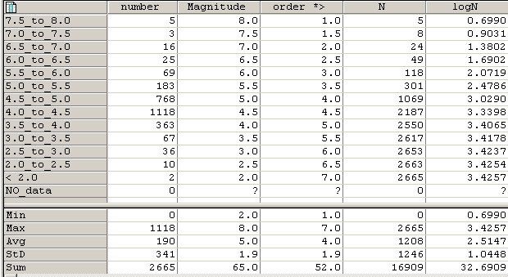

Figure: resulting table of Magnitude-frequency calculation.

For advanced ILWIS users
The Magnitude frequency calculation that we have just calculated is based on the earthquake catalog for the entire country. In a real earthquake hazard study it is required to subdivide the areas into a number of seismotectonic zones, and calculate Magnitude-frequency relations for each of the zones.
The zones are indicated in the paper cited earlier, and are also available as a polygon map Seismic_zones.

- Extract the earthquakes from the Earthquakes_country that are falling within a zone. Make a separate file of these
- Use the method described above to make separate Magnitude-Frequency relationship for the various zones.

Once this part is finished we now have information on the magnitude-frequency relationships for the various seismo-tectonic zones. The next step is to estimate the PGA using attenuation curves.

Part 2: Estimation of PGA in rock in RiskCity for the various earthquakes in the catalog.
Expected time: 2 hours
Objectives:
- Estimation of PGA in rock in RiskCity for the various earthquakes in the catalog.
- Application of various attenuation functions and evaluate their difference.
Now that we know for the earthquake events in the catalog the distance to RiskCity, as well as the magnitude and the depth (only for those earthquakes for which this information is available), we can make an estimation of the Peak Ground Acceleration in rock in RiskCity as a result of these events. Input parameters for the scenario earthquake are location, depth, magnitude and occurrence time (hour during the day or night when the event strikes) (see figure below)
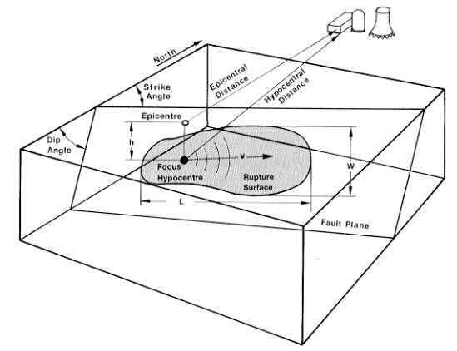

Figure: left: indication of main terms used in the earthquake analysis. Right: several examples of attenuation function, relating distance to fault with the PGA.

The relation between PGA, epicentral or hypocentral distance and Magnitude can be estimated using an attenuation function. An attenuation function gives the relations between Peak Ground Acceleration, and a number of factors related to the distance of the site to the earthquake, the depth of the earthquake and sometimes also the presence of rock or soil. Attenuation functions are derived by statistically analyzing a large number of strong motion records from different stations located at different distances, for the same earthquake events. The type of earthquake is very important (e.g. shallow or deep earthquakes) and the structural setting (different functions for subduction earthquakes, strike slip faults, and shallow earthquakes).
In the RADIUS method, PGA can be calculated using one of three attenuation formulas: Joyner & Boore (1981), Campbell (1981) or Fukushima & Tanaka (1990). See table below for functions.
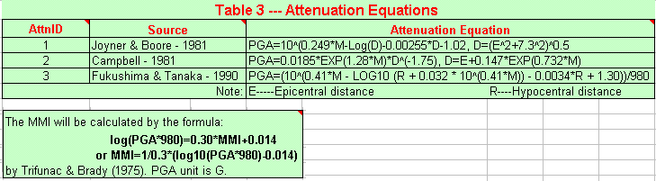
For the study area there are also other attenuation curves proposed by Cáceres, D. and Kulhánek (2000). The first attenuation relation was derived by Climent et. al. (1994) from strong motion records of El Salvador, Nicaragua and Costa Rica with some additional records from Guerrero, Mexico:

where M is the moment magnitude, R is the hypocentral distance (km) and S is a site coefficient (zero for rock sites and 1 for soil sites). The error is normally distributed with zero mean and standard deviation is around 0.6.
ln PGA = −1.687 + 0.553*M − 0.537* ln R − 0.00302*R + 0.327*S
A second attenuation relationship is due to McGuire (1976) for the west coast of the United States:
PGA = 472 x 10^{0:28M}(R +25)^{−1:3I} ; σ_{(logPGA)} = 0:222

The error term is normally distributed and σ is the standard deviation of the regression with zero mean.
The third attenuation relationship is by Schnabel and Seed (1973) for the northwestern United States (Table I). Finally, the fourth attenuation relationship is due to Boore et al. (1997), for shallow earthquakes in western North America:

In this exercise we will use the function of Joyner & Boore – 1981. This formula is:
Ln(PGA) = -1.08 + 1.036(M − 6) − 0.032(M − 6)² − 0.798 ln √(R² +8.41⁾+ 0.429 σ ; ln(PGA)= 0.06
PGA=10^(0.249*M-Log(D)-0.00255*D-1.02)
D=(E^2+7.3^2)^0.5

E = Epicentral distance, M = Earthquake Magnitude
The distance was already calculated in the previous exercise.

- Open the table Earthquakes_country. Join with the Point map Earthquakes_country, and read in the column Distance.
- Calculate a new column D with the formula in the command line:
- D=(distance^2+7.3^2)^0.5
- (Use a precision of 0.001 and 3 decimals. Adjust these values in the calculation window before accepting)
- Then calculate PGA using the formula:
- PGA=10^(0.249*Magnitude-Log(D)-0.00255*D-1.02)
- (Use a precision of 0.001 and 3 decimals. Adjust these values in the calculation window before accepting)
- Make a graph and display the distance against PGA.
- Also display the PGA values for the earthquake events in the map, and add the map Distance to it.

Questions:
- What can you conclude about the PGA values that can be expected based on the earthquake catalog?
- Are these values realistic?
- What can be concluded about the completeness of the catalog.

Now we will also try to calculate the attenutation curve based on the function given by Climent (See above)

- Calculate the hypocentral distance using the formula:
R:=SQRT((Depth^2)+(Distance^2))
- (Use a precision of 0.001 and 3 decimals. Adjust these values in the calculation window before accepting)
- Calculate now the attenuation function of Climent:
LNPGA:= -1.687 + (0.553*Magnitude) - (0.537* ln(R)) - (0.00302*R) + (0.327*0)
- (Use a precision of 0.001 and 3 decimals. Adjust these values in the calculation window before accepting)
- Then calculate PGA using the formula:
PGA_Climent:=EXP(LNPGA)
- (Use a precision of 0.001 and 3 decimals. Adjust these values in the calculation window before accepting)
- Make a graph and display the distance against PGA. Compare these values with the previous attenuation function of Joyner and Boore. What can you conclude?
Advanced exercise. For experienced ILWIS users:
- Calculate the hypocentral distance based on the epicentral distance and the depth. Name it: R
- Try to implement also the other attenuation functions indicated above.
- Compare the differences.

Part 3: Generating PGA maps for RiskCity

Expected time: 2 hours
Objectives:
- Select a scenario earthquake, for which PGA values in rock are calculated
- Use the surficial geological information in order to define ranges of soil amplification
- Generate a PGA map for the city
- Convert the PGA to MMI
Apart from the incomplete earthquake catalog we can also use another source of information, namely the results of the Global Seismic Hazard Assessment Program. The Global Seismic Hazard Assessment Program (GSHAP) was launched in 1992 by the International Lithosphere Program (ILP) with the support of the International Council of Scientific Unions (ICSU), and endorsed as a demonstration program in the framework of the United Nations International Decade for Natural Disaster Reduction (UN/IDNDR). In order to mitigate the risk associated to the recurrence of earthquakes, the GSHAP promotes a regionally coordinated, homogeneous approach to seismic hazard evaluation; the ultimate benefits are improved national and regional assessments of seismic hazards, to be used by national decision makers and engineers for land use planning and improved building design and construction. Regional reports, GSHAP yearly reports, summaries and maps of seismicity, source zones and seismic hazard are on the GSHAP homepage on http://seismo.ethz.ch/GSHAP/. Also we can use the information provided by the following study:
Cáceres, D. and Kulhánek, O. (2000) Seismic Hazard of Honduras. Natural Hazards 22: 49–69, 2000.

Based on this work we are using the following PGA values for RiskCity:

Return period | PGA g)
100 years | 0.2 g
475 years | 0.4 g

In this exercise we will calculate with a scenario earthquake with a magnitude of 7.7 occurring at a distance of 80 kilometers from the city at a depth of 30 kilometers.

- Calculate the corresponding PGA value for this scenario, using the following formulae:
- D=(distance^2+7.3^2)^0.5
- PGA=10^(0.249*M-Log(D)-0.00255*D-1.02)

Soil Amplification
Soil amplification is estimated by the results from the previous steps, combined with a simple map with soil types. For each soil type a general amplification value from the table below will be used (values are according the the RADIUS method). You may also decide to adapt these values, after discussion.

Table --- Soil Type
Code | Description | Amplification Factor
0 | Unknown | 1.00
1 | Hard Rock | 0.55
2 | Soft Rock | 0.70
3 | Medium Soil | 1.00
4 | Soft Soil | 1.30

Soil information can be obtained from the Geological map (called Geological units).

- Rasterize the map Lithology. Use the georeference Somewhere.
- Create an attribute table for the map, and add a column for the amplification values.
- Determine for each lithological unit what will be the amplification value from the table above
- Reclassify the geological units with the amplification factors, and name the map: Amplification_factor
- Multiply the amplification map with the PGA value that you obtained from the previous step. Call the map: PGA

Note:

It should be mentioned here that this method is a simplification, and has severe drawbacks:
- Earthquake acceleration should not be presented as a single PGA value, because the natural frequency for buildings with different number of floors, should be related to accelerations in these specific frequencies, in order to be able to cause building resonance. As a rule of thumb, the frequency for building resonance can be evaluated with the formula: f = 10/N (where N = number of floors). Therefore response spectra should be used in stead of single PGA values.
- The amplification factors in the table are just a rough indication. Apart from the type of material, it is the soil depth which plays a very important role in amplification.
Converting PGA to MMI
In order to convert the Peak Ground Acceleration values to Modified Mercalli Intensity, the general relation of Trifunac & Brady (1975) is used:

MMI=1/0.3*(log10(PGA*980)-0.014)

- Create a formula in Mapcalc (using the command line) for the PGA to MMI conversion and apply this for the map PGA calculated earlier. Name the output map: MMI
- Classify the MMI map in classes of 1 unit (e.g. from 0.5 - 1.5 will be class 1, etc).

Optional exercise: Earthquake microzonation using overburden thickness
Expected time: 2 hours
Objectives:
- Calculate the natural frequency of the soil in Riskcity
- Relate this with the natural frequency of buildings
- Make a zonation for different building altitudes
A very important factor in the response of the subsurface to an earthquake is the (soft) soil or overburden thickness. Soft soil sediments have a certain natural frequency which depend mainly on their internal (stiffness and strength) properties and thickness. Large ground motion at the surface is often a result of the fact that the soft soil start to resonate at their natural frequency under influence of an earthquake.
This exercise demonstrates how soil or overburden thickness can be used to delineate areas which will experience large ground amplifications at specific frequencies which correspond to natural frequencies of certain building types. In this manner a seismic microzonation map can be made for different building types, mainly based on the overburden thickness map.

Calculation of surface response and seismic hazard

Calculate the characteristic site periods of the overburden.

This step will evaluate the characteristic site periods on the basis of the soil thickness map and different assumed overburden properties.

- Read the theory boxes below
- Calculate using MapCalc the characteristic site period of the overburden thickness map (Soildepth) for 2 different soil conditions on the basis of Equation 3:
$$f_{0}=\frac{V_{s}}{4H}$$

- Calculate a raster map T250 with the characteristic site period for an average shear wave velocity (Vs) of 250 m/s (soft soil).
- Calculate a raster map T500 with the characteristic site period for an average shear wave velocity (V3) of 500 m/s (stiff soil)
- Contemplate what the difference of these different site period maps are in terms of hazard for different building types, i.e. high rise buildings vs. low rise buildings?

Theory

Soft ground effects
As the seismic wave travels from its source to the surface, the first part of its path is in rock. The last part, usually not greater than several tens of meters, is traveled through the soils overlying the bedrock. It was recognized as early as 350 BC by the Greek scientist Aristotle that soft ground shakes more than hard rock in an earthquake.
The intensity increments caused by this effects can sometimes be as large as 2 to 3 degrees in on the Mercalli intensity scale (Bard, 1994). Because large urbanised areas often are located along or near fertile ground, usually of alluvial or volcanic origin, this type of site effect is of great importance in earthquake hazard assessment worldwide.

Amplification on soft soils
The fundamental phenomenon responsible for the amplification of motion in soft sediments is the entrapment of body waves in the soft materials. This is caused by the impedance contrast that exists between soft sediments and bedrock. The impedance of a material is defined as:
$I=V_{s}⋅γ$ [1]
Where:
I = Impedance, in kgm-2s-1
V_{s} = Shear wave velocity, in m/s
γ = Mass density, in kg/m³

Shear wave velocity is a very important soil parameter in earthquake engineering. Intuitively, one can already understand that a very strong or rigid soil (or a soil with a high shear wave velocity) behaves differently under vibration by an earthquake. The wave velocity is dependent on the soil's maximum shear modulus. Shear modulus can be determined under laboratory conditions and several theoretical and empirical relationships exist between shear wave velocity and shear modulus.
$G_{\text{max}}=γ⋅V_{s^{2}}$ [2]
Where:
γ = Mass density (kg/m³)
V_{s} = Shear wave velocity (m/s)

The contrast in impedance determines the amount of wave energy that is reflected when a seismic wave passes a layer boundary where the material properties change. This is shown by Zoeppritz’ equation (Drijkoningen, 2000):
$R=\frac{I_{2}−I_{1}}{I_{2}+I_{1}}$  [3]  in which R is the reflection coefficient | 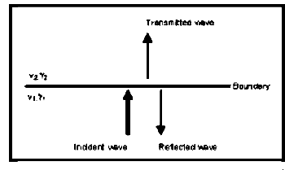  Figure Reflected and transmitted energy at layer boundary (Adapted from Drijkoningen, 2000)

Using some standard values for rock (γ=2700 kgm⁻³, V_{s}=1000 ms⁻¹) and soil (γ=1750 kgm⁻³, V_{s}= 1000 ms⁻¹), it can be concluded that for a wave passing through a boundary between soft soils and bedrock roughly 50% of the wave energy is reflected. At the surface, all of the energy is reflected because in air the shear wave velocity V_{s} is zero.
Upon entrapment, interference of the waves will start to occur. Apart from the initial wave, the reflected waves too become sources of motion. When looking at a horizontally layered structure, the problem simplifies to a one-dimensional one, incorporating only the trapping of body waves that travel up and down in the soft surface layers. When lateral discontinuities occur within the structure, the surface waves are influenced as well, making the situation very complex.
Trapped waves interfere, causing amplification of motion and resonance patterns. Resonance occurs when wave peaks coincide, resulting in a addition of amplitudes and a larger amplitude for the motion caused by these waves. Resonance does not occur at one specific frequency, but at several, resulting in site- and material specific resonance patterns. The mathematics behind this are explained below (from: Kramer, 1996):
The resonance spectrum for a uniform damped soil on rigid rock will look like the one in Figure below.
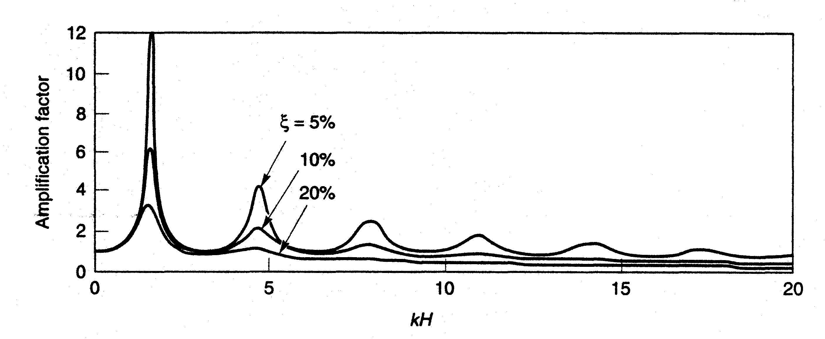
Figure Resonance spectrum for uniform damped soil on rigid rock (From Kramer, 1996).
While amplitude varies with damping, natural frequencies do not. The natural frequencies of a soil deposit are given by:
$f_{0}=\frac{V_{s}}{4H}$ (fundamental) [3]
$f_{n}=\left(2⋅n+1\right)⋅f_{0}$ (harmonics) [4]
With:
f₀, f_{n} = frequency for the first and n-th peak, in Hz
Vs = shear wave velocity, in ms-1
H = thickness of the soft soil layer, in m
As can be seen in Figure 4.3.2, amplification peaks quickly decrease in size due to damping. Because of this, the most important amplification occurs at the fundamental frequency. The fundamental frequency or the associated characteristic site period provides already a very useful indication of the frequency or period of vibration at which the most important amplification can be expected.

Surface motion
Upon arrival at the surface, the seismic waves cause a vibrating motion of this surface. The most important aspect of this motion is the acceleration. When a structure is subjected to a certain acceleration, this will result in a force acting on that structure. The physics behind this can be explained in a very simplified form by stating Newton’s second law of motion:

$F=m⋅a$ [5]

Where:
F = Force, in Newton
m = Mass of the object, in kg
a = Acceleration to which the object is subjected, in m/s²

Since the mass of the object is invariable, the force exerted on it is directly proportional to the acceleration, making this the most important parameter in a microzonation study.
Besides the acceleration, the frequency at which it occurs is another property of surface motion that is of great importance in causing structural damage. Every object has its own natural frequency (f_{N}, mainly determined by its stiffness (k) and mass (M). A relationship is given in the equation below:

$f_{N}=\frac{1}{2π}\sqrt{\frac{k}{M}}$ [6]
Generally, a high building is less stiff (more flexible) than a smaller building and a high building is obviously heavier than a small building. Intuitively, but also considering the previous equation, one can see that taller buildings generally have lower natural frequencies than a small buildings.
In order to determine the exact typical frequency of an object is a very complex issue, and therefore the International Conference of Building Officials have issued a number of rules of thumb for estimating it. The most commonly used one, though originally designed for moment frames and not for concrete and masonry buildings, is:
$T=0\text{.}1⋅N$ or $f_{N}=\frac{\text{10}}{N}$ (Day, 2001) [7]
in which N stands for the number of storeys of the building, and T and f_{N} denote period in seconds and natural frequency in Hertz, respectively.

Response spectra analysis
As mentioned, the frequency at which a certain acceleration takes place is a very important factor in the analysis of surface motion. In order to obtain a good idea on seismic hazard caused by surface motion, the surface response can be plotted against frequency, producing a graph as shown in Error: Reference source not found.
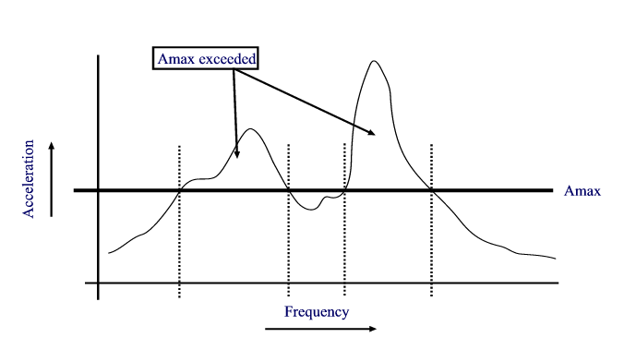
Figure. Frequency dependency of spectral acceleration combined with maximum sustainable acceleration of a building.

As can be seen in the figure, collapse risk of a building capable of sustaining accelerations up to A_{max} depends on the frequency at which shaking takes place. The response spectrum being such an important factor, it usually is the key element in any microzonation study.

Classification of characteristic site period into hazard zonation map

If the natural period of a building corresponds to the natural period of the overburden at that site, there is a potential hazard that this building will experience large damage. This will due to the large ground accelerations as a results of soil resonance.

- On the basis of equation 7, and the altitude map of the city (Altitude_dif) calculate a map with the natural frequencies of the buildings. Name the map: Building_freq.
- Make a class domain (Building class) on the basis of this table
- Re-classify the maps T250 and T500 (use: Slicing) into raster maps T250_class and T500_class, respectively. Compare them with the building_freq map. In which areas resonance might be expected?

Table 1
Building class | N_{max} | Description | Natural period (s) | Natural frequency (Hz)
I | 1 | Single storey buildings
II | 2 | Single family houses
III | 5 | Offices, apartment buildings
IV | 10 | Shopping malls, hospital
V | >10 | High rise buildings

- Compare the two classified maps. Is this what you expected? What are your conclusions?
- What type of additional information would you need in order to make a risk assessment on the basis of this hazard zonation?

References

- Bard, P. 1994. Local effects of strong ground motion: Basic physical phenomena and estimation methods for microzoning studies. Laboratoire Central de Ponts-et-Chausees and Observatoire de Grenoble.
- Day, R.W. 2001. Geotechnical Earthquake Engineering Handbook. McGraw-Hill, 700 pp.
- Kramer, S.L. 1996. Geotechnical Earthquake Engineering. Prentice Hall, Upper Saddle River, New Yersey 07458. 653 pp.

